System-level feedbacks of active fire regimes in large landscapes
Nicholas A. Povak^{1,2,*}, Paul F. Hessburg^{2,3}, R. Brion Salter², Robert W. Gray⁴, and Susan J. Prichard³
¹ USDA-FS, Pacific Southwest Research Station, Conservation of Biodiversity Program, 2480 Carson Road, Placerville, CA 95667-5199
² USDA-FS, Pacific Northwest Research Station, Forestry Sciences Laboratory, Wenatchee, WA 98801-1226
³ University of Washington, School of Forest and Environmental Sciences, Box 352100, Seattle, WA 98195-2100
* Corresponding author
⁴R.W. Gray Consulting, 6311 Silverthorne Rd, Chilliwack, BC V2R2N2

SUPPLEMENTARY MATERIAL

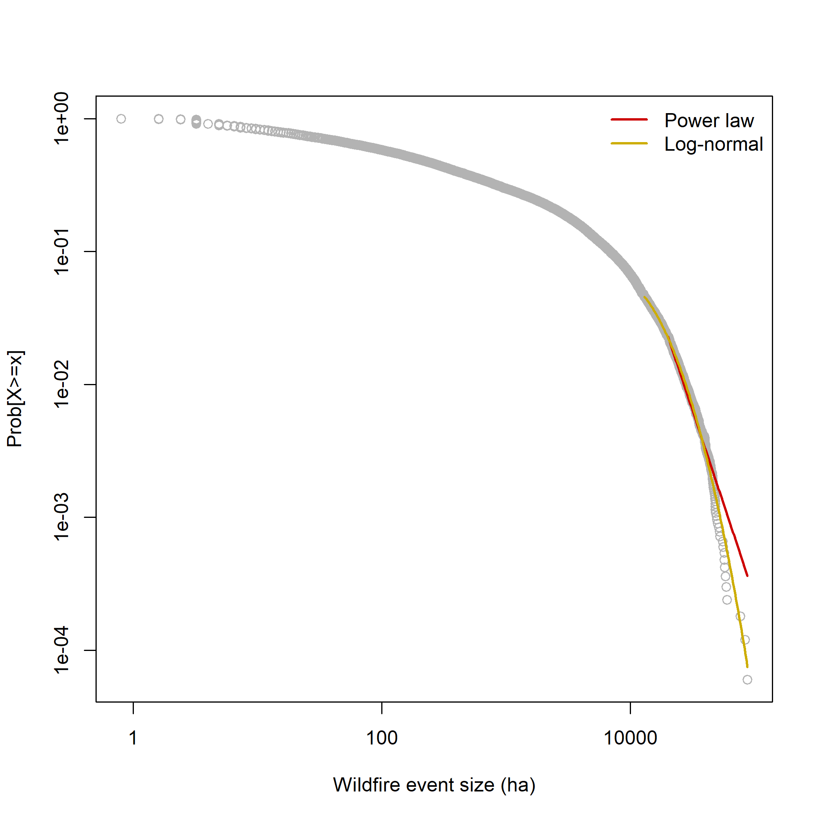7
Figure S1. Fire size distribution for all fires that burned over the 3,000-year simulation. Power law and log-normal distributions were fit to find the best-fit region of the data to each model using methods from Clauset et al. (2009).

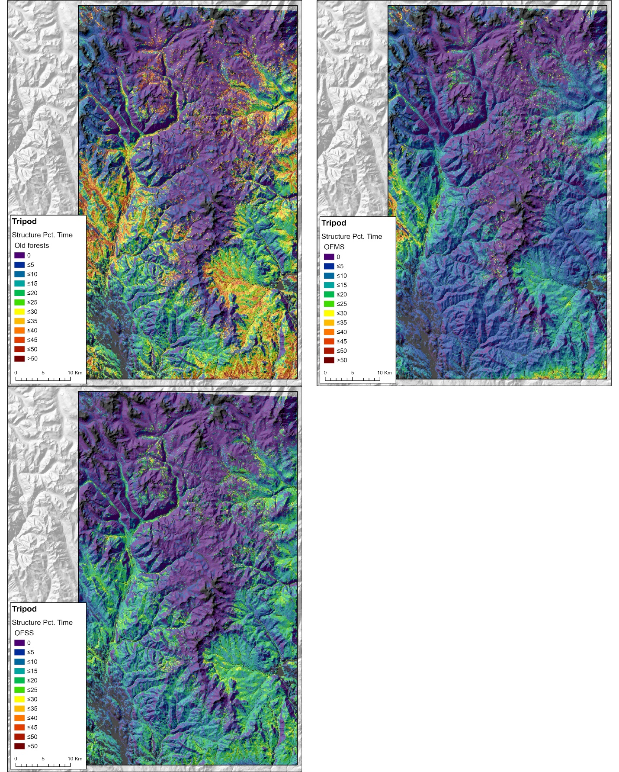
Figure S2. Maps depicting spatial heterogeneity in the residence time (percentage of 3,000-year simulation period) of various old-forest structural classes including A) old-forest multistoried (OFMS) and old-forest single-story (OFSS) combined, B) OFMS only, and C) OFSS only.
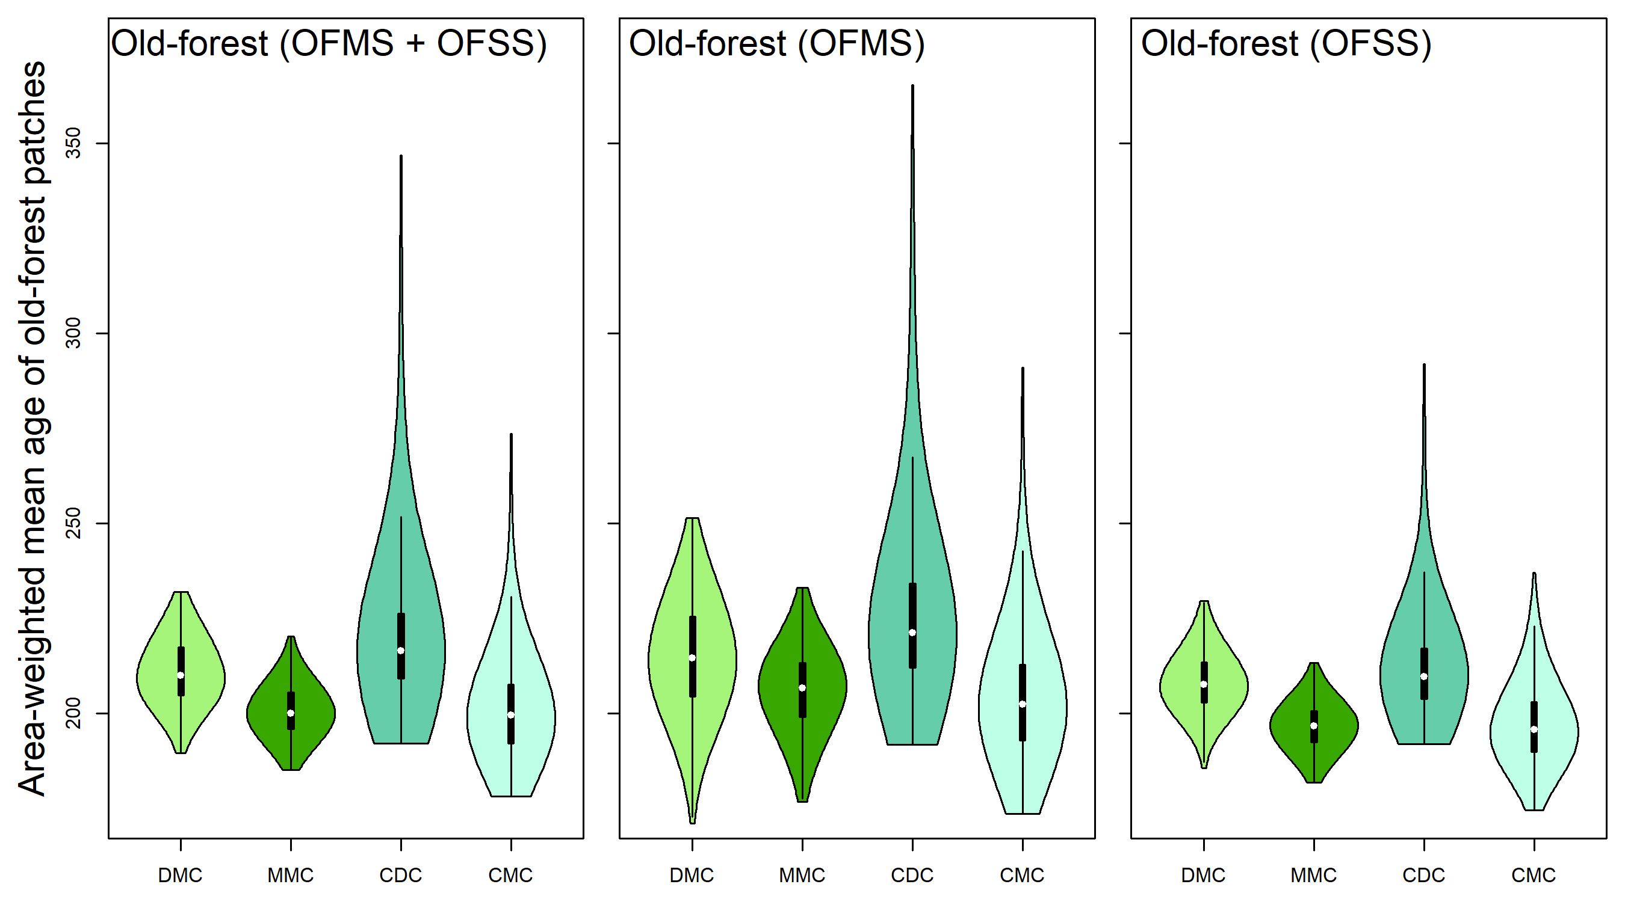 Figure S3. Average stand age for old-forest structural classes for simulation years 800-3300. Abbreviations are OFMS, old-forest multistoried, and OFSS, old-forest single story.
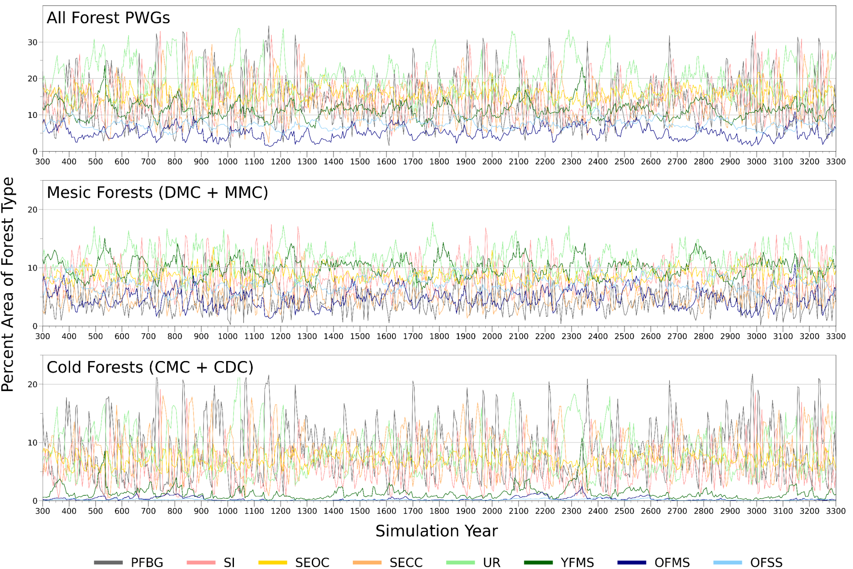

Figure S4. Time-series of structural classes over the 3,000 simulation years for the Tripod complex study area – companion to Fig. 7 in the text. Structure classes are PFBG: post-fire bare ground, SI: stand initiation, SEOC: stem-exclusion open canopy, SECC: stem-exclusion closed canopy, UR: understory re-initiation, YFMS: young forest multi-storied, OFMS: old-forest multi-storied, OFSS: old-forest single-storied. PWG is pathway group and represents unique state-and-transition pathways designed for forests varying in productivity, fire regimes and/or species assemblages. Dry forests are DMC: dry mixed conifer, MMC: moist mixed conifer and cold forests are CMC: cold mixed conifer, and CDC: cold-dry conifer.

Table S1: Surface and canopy fuel properties of dry mixed conifer (DMC) and moist mixed conifer (MMC) states. CC = canopy cover (%), CH = canopy height (m), canopy base height (m), crown bulk density (kg m⁻³). Fire hazard classes are FFE: Fire flow enabler, CFP: Crown fire potential, and None: none burnable or low flame length/low rate of spread.
 |  |  |  | Dry Mixed Conifer |  |  |  |  |  | Moist Mixed Conifer
State ID | Stand structure class | Surface fuel model | Alt fuel model | Time period (yr) | Cover (%) | Height (m) | CBH (m) | CBD (kg/m³) | Fire hazard | Time period (yr) | Cover (%) | Height (m) | CBH (m) | CBD (kg/m³) | Fire hazard
1A | PFBG | NB9 | - | 0-9 | 1 | 2.1 | 0.0 | 0.00 | None | 0-9 | 1 | 5.0 | 0.0 | 0.00 | None
2A | SI | TL7 | - | 10-24 | 40 | 6.0 | 0.5 | 0.06 | FFE | 10-19 | 60 | 9.0 | 0.5 | 0.06 | FFE
3A | SECC | TL7 | - | 25-59 | 80 | 18.0 | 1.5 | 0.22 | FFE | 20-39 | 90 | 19.8 | 1.5 | 0.22 | FFE
4A | UR | TU4 | TL7 | 60-99 | 70 | 22.0 | 1.0 | 0.19 | CFP | 40-79 | 80 | 24.2 | 1.0 | 0.19 | CFP
5A | YFMS | TU5 | TU4 | 100-159 | 65 | 31.0 | 1.0 | 0.18 | CFP | 80-139 | 75 | 34.1 | 1.0 | 0.18 | CFP
6A | OFMS | SB2 | TU4 | ≥ 160 | 80 | 35.0 | 1.0 | 0.22 | CFP | ≥ 140 | 90 | 38.5 | 1.0 | 0.22 | CFP
2B | SI | GR1 | - | 10-24 | 30 | 6.0 | 0.7 | 0.06 | None | 10-19 | 45 | 8.0 | 0.7 | 0.06 | None
3B | SECC | TL4 | - | 25-59 | 68 | 18.0 | 2.0 | 0.16 | None | 20-39 | 77 | 19.8 | 2.0 | 0.16 | FFE
4B | UR | TU4 | TL4 | 60-99 | 60 | 22.0 | 1.0 | 0.19 | FFE | 40-79 | 68 | 22.0 | 1.0 | 0.19 | FFE
5B | YFMS | TU4 | TL7 | 100-159 | 48 | 31.0 | 1.3 | 0.14 | FFE | 80-139 | 60 | 34.1 | 1.3 | 0.14 | FFE
6B | OFMS | TU4 | TL7 | 160-199 | 64 | 35.0 | 1.5 | 0.15 | FFE | 140-179 | 72 | 38.5 | 1.5 | 0.15 | FFE
1C | PFBG | NB9 | - | 0-9 | 1 | 2.0 | 0.0 | 0.00 | None | 0-9 | 1 | 4.0 | 0.0 | 0.00 | None
2C | SI | GR2 | - | 10-24 | 25 | 6.4 | 1.2 | 0.06 | FFE | 10-19 | 38 | 9.0 | 1.2 | 0.06 | FFE
3C | SEOC | GS2 | - | 25-59 | 54 | 17.0 | 2.0 | 0.11 | FFE | 20-39 | 54 | 19.8 | 2.0 | 0.11 | FFE
4C | UR | TU4 | - | 60-99 | 60 | 22.0 | 1.0 | 0.13 | CFP | 40-79 | 70 | 24.2 | 1.0 | 0.13 | CFP
5C | YFMS | TU4 | - | 100-159 | 65 | 31.0 | 1.0 | 0.12 | CFP | 80-139 | 75 | 34.1 | 1.0 | 0.12 | CFP
6C | OFMS | TU5 | TL7 | 160-199 | 75 | 35.0 | 1.0 | 0.16 | CFP | 140-179 | 85 | 38.5 | 1.0 | 0.16 | CFP
1D | SI | GR1 | - | 0-9 | 1 | 2.0 | 0.0 | 0.00 | None | 0-9 | 1 | 4.0 | 0.0 | 0.00 | None
2D | SI | GS1 | - | 10-24 | 19 | 6.0 | 1.5 | 0.04 | FFE | 10-19 | 34 | 9.0 | 1.5 | 0.04 | None
3D | SEOC | GS1 | - | 25-59 | 43 | 18.0 | 2.3 | 0.10 | FFE | 20-39 | 61 | 19.8 | 2.3 | 0.10 | FFE
4D | UR | GR2 | - | 60-99 | 48 | 22.0 | 1.0 | 0.11 | FFE | 40-79 | 54 | 23.1 | 1.5 | 0.11 | FFE
5D | YFMS | GR2 | - | 100-159 | 50 | 31.0 | 1.5 | 0.10 | FFE | 80-139 | 57 | 35.2 | 1.5 | 0.10 | FFE
6D | OFMS | SB2 | - | 160-199 | 52 | 35.0 | 1.5 | 0.12 | CFP | 140-179 | 68 | 38.5 | 1.5 | 0.12 | CFP
3E | SEOC | TU2 | - | 25-59 | 34 | 18.0 | 2.5 | 0.07 | FFE | 20-39 | 21 | 19.8 | 2.5 | 0.07 | FFE
4E | SEOC | TU4 | - | 60-99 | 38 | 22.0 | 2.0 | 0.09 | CFP | 40-79 | 41 | 23.1 | 2.0 | 0.09 | CFP
5E | SEOC | SB2 | - | 100-159 | 40 | 31.0 | 2.0 | 0.09 | CFP | 80-139 | 50 | 35.2 | 2.0 | 0.09 | CFP
6E | OFSS | SB3 | - | 160-200 | 42 | 35.0 | 1.5 | 0.09 | CFP | 140-179 | 60 | 38.5 | 1.5 | 0.09 | CFP
6F | OFSS | GS2 | - | 160-199 | 33 | 35.0 | 2.0 | 0.06 | FFE | 140-179 | 48 | 38.5 | 2.0 | 0.06 | None

Table S2: Surface and canopy fuel properties of cold dry conifer (CDC) and cold moist conifer (CMC) states. CC = canopy cover (%), CH = canopy height (m), CBH = canopy base height (m), CBD = crown bulk density (kg m⁻³). Fire hazard classes are FFE: Fire flow enabler, CFP: Crown fire potential, and None: none burnable or low flame length/low rate of spread.
 |  |  |  | Cold Dry Conifer |  |  |  |  |  |  | Cold Moist Conifer
State | Stand structure class | Surface fuel model | Alt fuel model | Time period (yr) | CC (%) | CH (m) | CBH (m) | CBD (kg/m³) | Fire hazard | Time period (yr) |  | Cover (%) | Height (m) | CBH (m) | CBD (kg/m³) | Fire hazard
1A | PFBG | NB9 | - | 0-14 | 14 | 2.0 | 0.0 | 0.00 | None | 0-9 |  | 14 | 2.0 | 0.0 | 0.00 | None
2A | SI | TL4 | - | 15-24 | 43 | 7.6 | 0.2 | 0.12 | FFE | 10-19 |  | 43 | 8.4 | 0.2 | 0.12 | FFE
3A | SECC | TL4 | - | 25-39 | 75 | 15.2 | 0.5 | 0.22 | CFP | 20-29 |  | 75 | 16.8 | 0.5 | 0.22 | CFP
4A | SECC | TL7 | TL7 | 40-59 | 80 | 18.3 | 0.5 | 0.30 | CFP | 30-49 |  | 85 | 20.1 | 0.5 | 0.30 | CFP
5A | UR | TU4 | TL4 | 60-119 | 90 | 24.4 | 1.2 | 0.30 | CFP | 50-109 |  | 86 | 26.8 | 0.7 | 0.22 | CFP
6A | YFMS | TU5 | TL4 | 120-179 | 95 | 25.0 | 1.2 | 0.31 | CFP | 110-169 |  | 90 | 27.5 | 0.7 | 0.31 | CFP
7A | OFMS | SB3 | TL4 | ≥ 180 | 85 | 27.4 | 1.2 | 0.31 | CFP | ≥ 170 |  | 94 | 30.2 | 0.7 | 0.31 | CFP
1B | SI | TU4 | SB1 | 0-14 | 14 | 2.0 | 0.0 | 0.00 | FFE | 0-9 |  | 14 | 2.0 | 0.0 | 0.00 | FFE
2B | SI | GS1 | TL4 | 15-24 | 26 | 7.6 | 0.3 | 0.06 | None | 10-19 |  | 34 | 8.4 | 0.3 | 0.09
3B | SEOC | TL4 | TL4 | 25-39 | 45 | 15.2 | 0.5 | 0.08 | None | 20-29 |  | 45 | 16.8 | 0.5 | 0.08 | None
4B | SEOC | TU4 | TL4 | 40-59 | 48 | 18.3 | 0.3 | 0.09 | CFP | 30-49 |  | 60 | 20.1 | 0.3 | 0.11 | CFP
5B | SEOC | TU4 | TL4 | 60-119 | 54 | 24.4 | 0.5 | 0.11 | CFP | 50-109 |  | 60 | 26.8 | 0.5 | 0.12 | CFP
6B | SEOC | TU4 | TL4 | 120-179 | 57 | 25.0 | 0.5 | 0.12 | CFP | 110-169 |  | 63 | 27.5 | 0.5 | 0.13 | CFP
7B | OFSS | TU4 | TL4 | 180-219 | 51 | 27.4 | 1.2 | 0.10 | CFP | 170-209 |  | 66 | 30.2 | 1.2 | 0.14 | CFP
1C | PFBG | NB9 | - | 0-14 | 7 | 2.0 | 0.0 | 0.00 | None | 0-9 |  | 7 | 2.0 | 0.0 | 0.00
2C | SI | GR1 | TL4 | 15-24 | 30 | 7.6 | 0.3 | 0.09 | FFE | 10-19 |  | 30 | 8.4 | 0.3 | 0.09 | FFE
3C | SEOC | GS1 | TL4 | 25-39 | 55 | 15.2 | 0.5 | 0.16 | FFE | 20-29 |  | 65 | 16.8 | 0.5 | 0.16 | FFE
4C | UR | TL4 | TL4 | 40-59 | 70 | 18.3 | 0.5 | 0.22 | FFE | 30-49 |  | 75 | 20.1 | 0.5 | 0.20 | CFP
5C | UR | TL7 | TL4 | 60-119 | 85 | 24.4 | 1.2 | 0.28 | CFP | 50-109 |  | 79 | 26.8 | 0.7 | 0.21 | CFP
6C | YFMS | TU4 | TL4 | 120-179 | 90 | 25.0 | 1.2 | 0.31 | CFP | 110-169 |  | 86 | 27.5 | 0.7 | 0.22 | CFP
7C | OFMS | TU5 | TL4 | 180-219 | 85 | 27.4 | 1.2 | 0.31 | CFP | 170-209 |  | 93 | 30.2 | 0.7 | 0.31 | CFP

Table S3: Surface and canopy fuel properties of states that are not within a STM pathway. CC = canopy cover (%), CH = canopy height (m), CBH = canopy base height (m), CBD = crown bulk density (kg m⁻³). Fire hazard classes are FFE: Fire flow enabler, CFP: Crown fire potential, and None: none burnable or low flame length/low rate of spread.
State | Stand structure class | Surface fuel model | Alt FBFM | Time period (yr) | CC (%) | CH (m) | CBH (m) | CBD (kg/m³) | Fire hazard
1A | Bare ground  (rock, water, ice) | NB9 | - | - | 0 | 0.0 | 0.0 | 0.00 | None
1B | Grassland/herbland | GR4 | - | - | 0 | 0.0 | 0.0 | 0.00 | None
1C | Shrubland | GS2 | - | - | 0 | 0.0 | 0.0 | 0.00 | FFE
1D | Hardwood forest | TL2 | TU1 | - | 60 | 15.0 | 5.0 | 0.13 | FFE
1E | Montane meadow | TU1 | - | - | 0 | 0.0 | 0.0 | 0.00 | None

Table S4. Abbreviations and definitions of pathway groups, forest structural classes and landscape metrics.
 | Name | Description
Pathway groups
CDC | Cold dry conifer
CMC | Cold mixed conifer
DMC | Dry mixed conifer
MMC | Moist mixed conifer
Forest structural classes
PFBG | Post-fire bare ground | Post-fire vegetation with little to no ability to carry fire
SI | Stand initiation | Post-fire vegetation dominated by seedlings, saplings, grasses, forbs, and shrubs
SEOC | Stem exclusion open canopy | Vegetation dominated by poles, small trees with open canopy
SECC | Stem exclusion closed canopy | Closed canopy formed by poles, small, and medium sized trees
UR | Understory re-initiation | Canopy differentiation proceeding with poles or larger trees in overstory and seedlings, saplings, and non-forest vegetation in understory
YFMS | Young forest multi-storied | Multi-aged tree vegetation dominant with large trees absent
OFMS | Old forest multi-storied | Multi-aged tree vegetation dominant, including large and old trees
OFSS | Old forest single-storied | Medium and large old trees dominant with understory absent or consisting of some seedlings, saplings, and non-forest vegetation
Fire hazard metrics
None |  | States that were non-burnable or were associated with very low flame length and rate of spread
FFE | Fire flow enabler | States that supported fast spreading but low flame length fire behavior
CFP | Crown fire potential | States that supported crown fire initiation and spread
Landscape metrics
ED | Edge density | The ratio of the total edge between class types (m) to the total area (m²)
IJI | Interspersion-juxtaposition index
LPI | Largest patch index | The ratio of the area in the largest patch (m²⁾ to the total area (m²)
PL | Percent land | Percentage of pixels represented by class i.

