9. Supplementary materials

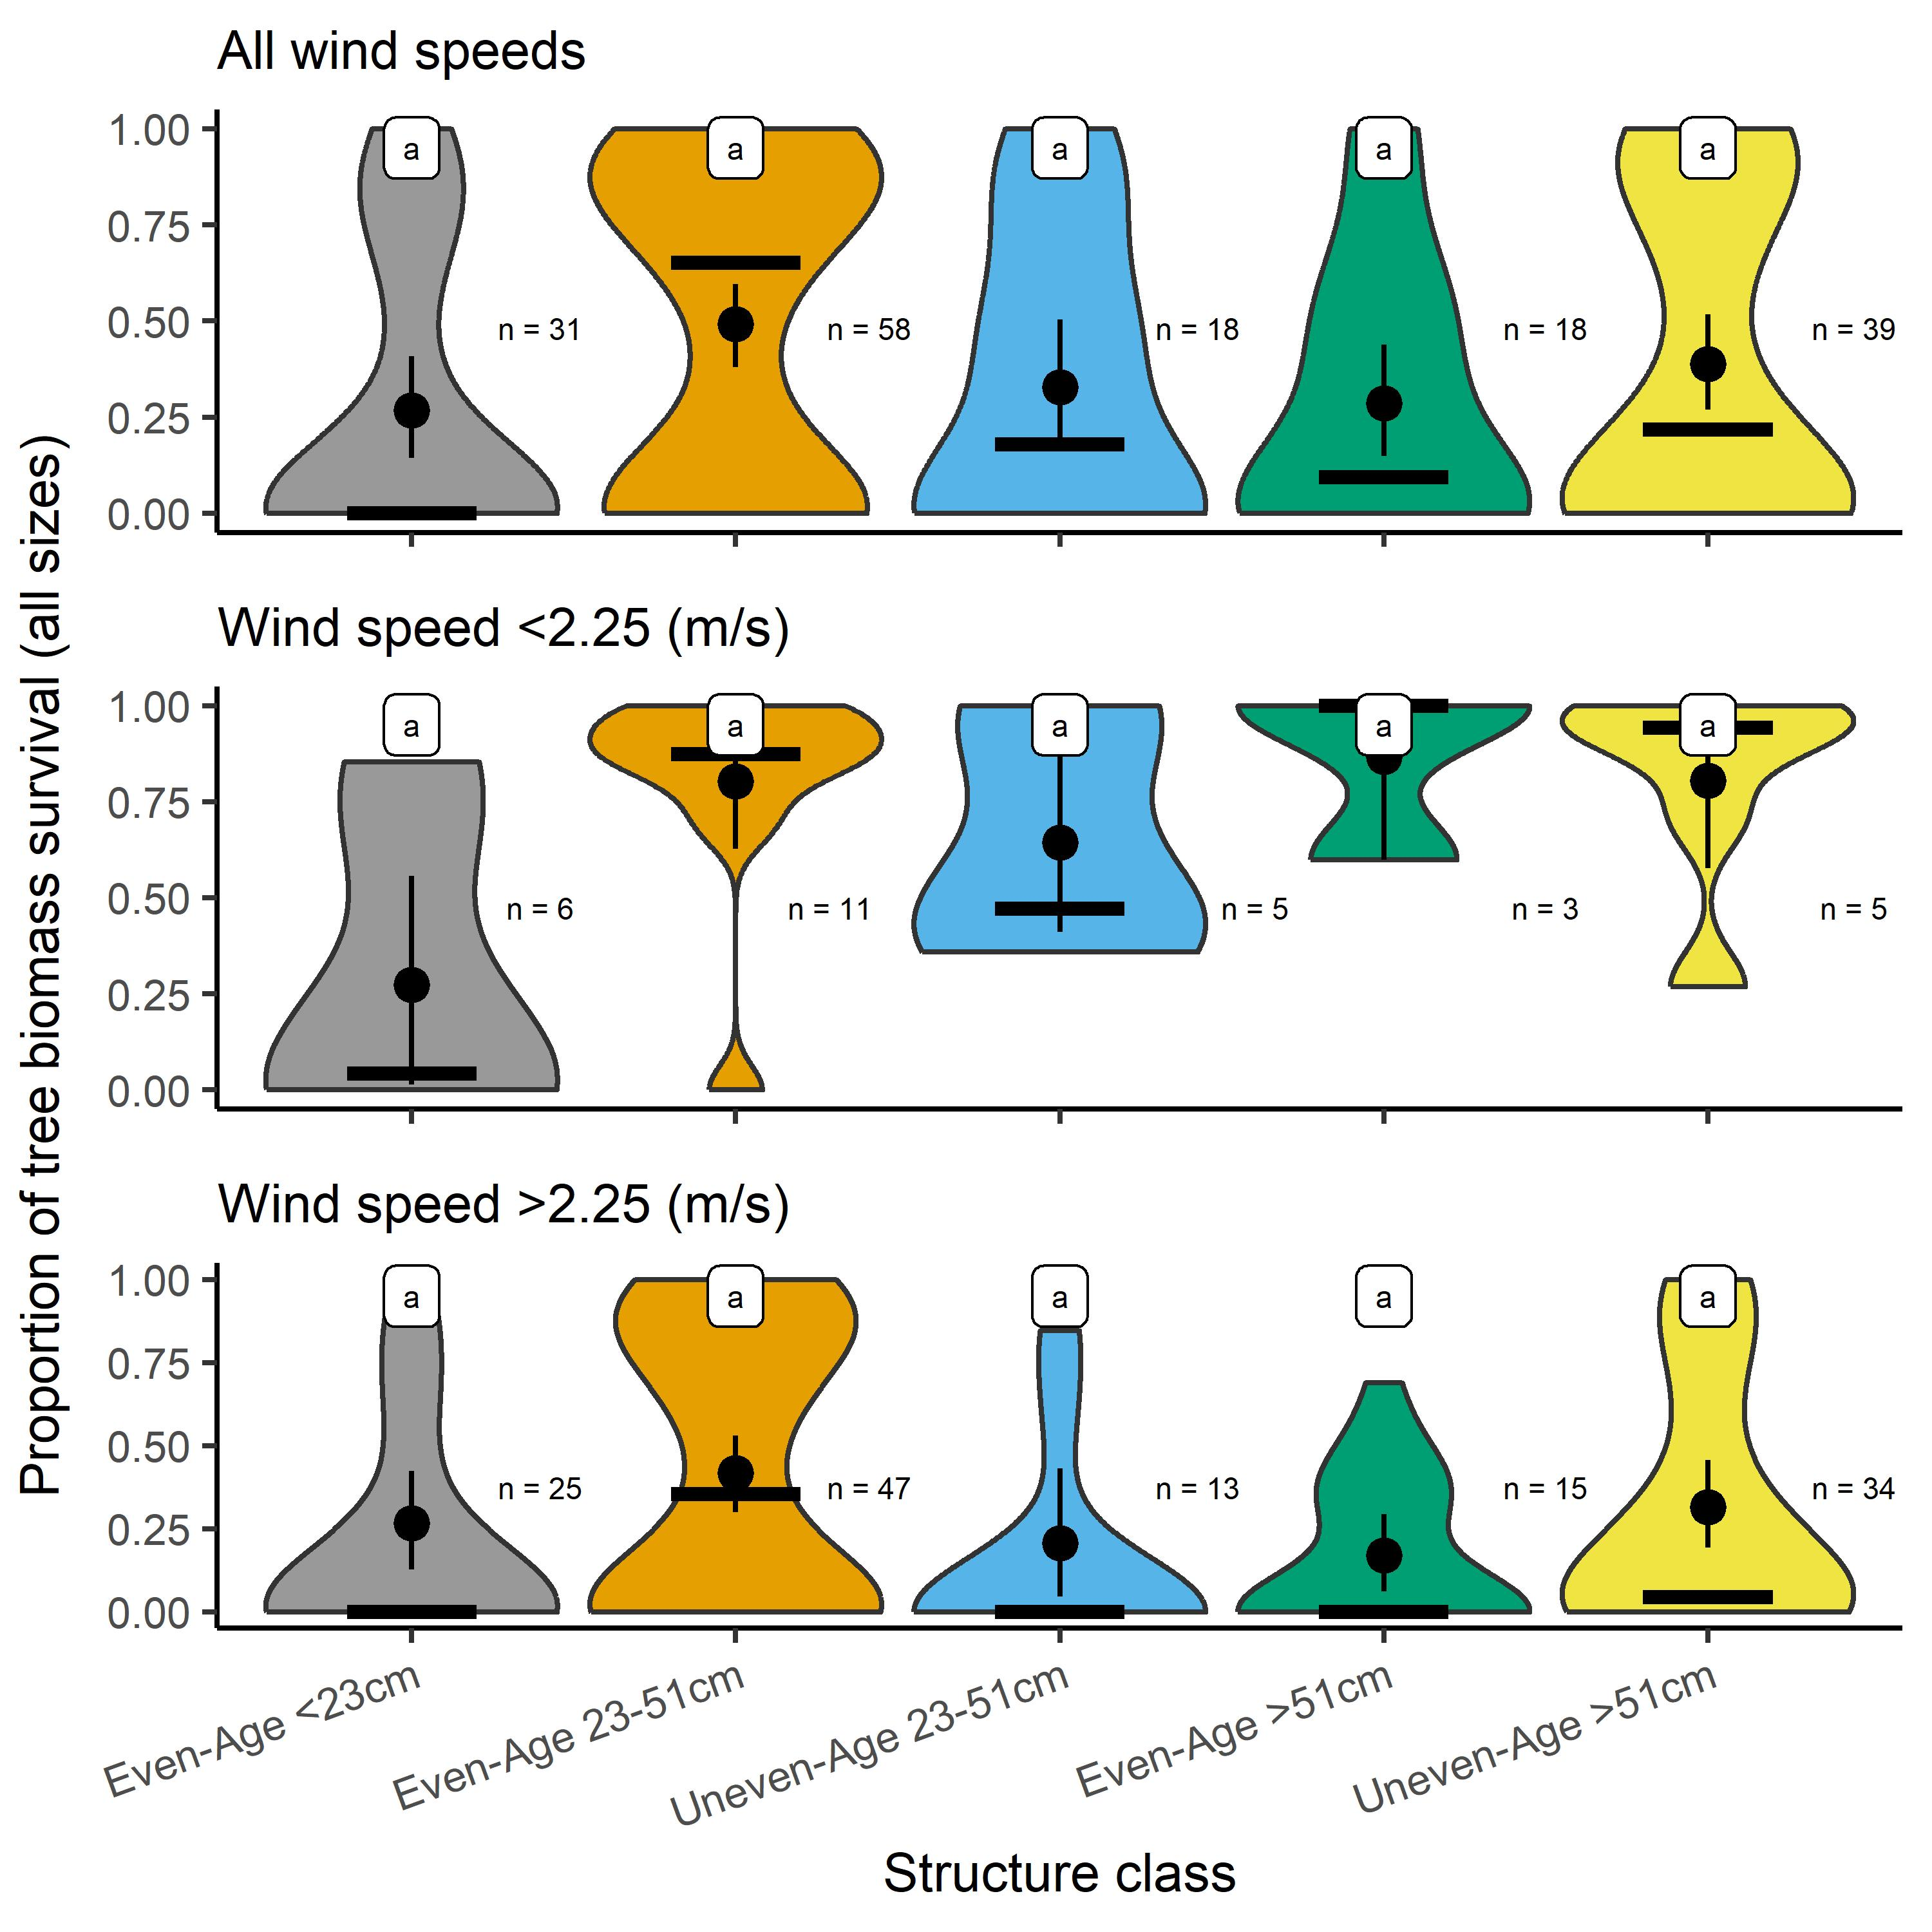
Figure S1. Distribution of the proportion of surviving tree biomass (post-fire live biomass / pre-fire live biomass) by stand structure class and modeled plot-local wind speed class at fire arrival. Metrics represented are means (black circles), medians (black horizonal bars), 95% confidence intervals (black vertical line), and “n” which references the number of forested conditions on which trees were present in the associated fire event and tree diameter class. Statistical differences are indicated by letter assignments among groups in each tree diameter class (Wilcoxon rank sum test; α = 0.05). To control for the structural variability different forest types can exhibit, only Douglas-fir dominated stands are presented here (164 out of 215 total conditions).

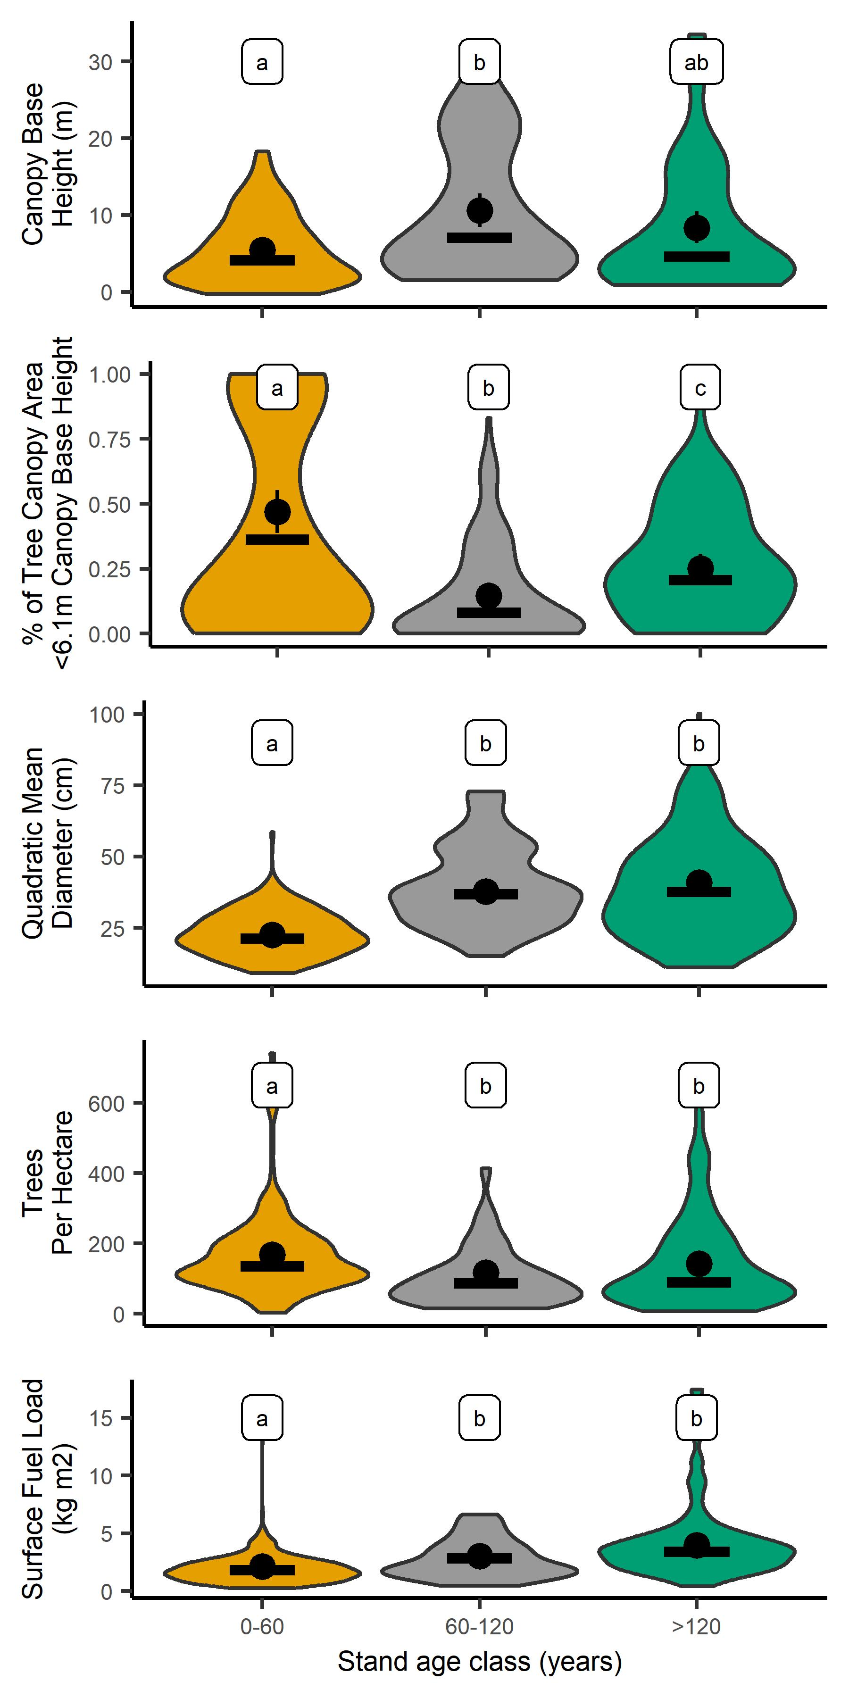
Figure S2. Distributions of five forest structure metrics that relate to fire effects and behavior, by stand age class, within the 2020 Labor Day fires. Means are represented by black circles, medians by black bars, and 95% confidence intervals by a black vertical line. Statistical differences for a structure metric are indicated by different tree diameter class letter assignments (Wilcoxon rank sum test; α = 0.05).

Table S1. Pre-fire tree species composition (volume and proportion of total volume) by fire and all fires combined.
 | Fire
 | Archie Creek |  | Holiday Farm |  | Beachie Creek |  | Lionshead |  | Riverside |  | Big Hollow |  | All Fires
Species | volume million m³; proportion of total volume (trees > 12.7 cm [5 in] diameter)
Douglas-fir | 15.91 | 0.75 | 27.02 | 0.80 | 13.93 | 0.71 | 9.75 | 0.67 | 8.96 | 0.56 | 2.96 | 0.63 | 78.55 | 0.71
Western hemlock | 1.45 | 0.07 | 3.16 | 0.09 | 1.85 | 0.09 | 1.83 | 0.13 | 3.40 | 0.21 | 1.18 | 0.25 | 12.84 | 0.12
Western redcedar | 1.02 | 0.05 | 0.55 | 0.02 | 0.12 | 0.01 | 0.75 | 0.05 | 0.89 | 0.06 | 0.03 | 0.01 | 3.36 | 0.03
Pacific silver fir | 0.0 | 0.00 | 0.008 | 0.00 | 1.21 | 0.06 | 0.99 | 0.07 | 0.69 | 0.04 | 0.40 | 0.09 | 3.30 | 0.03
Noble fir | 0.0 | 0.00 | 0.82 | 0.02 | 0.91 | 0.05 | 0.57 | 0.04 | 0.70 | 0.04 | 0.08 | 0.02 | 3.08 | 0.03
Bigleaf maple | 0.22 | 0.01 | 1.56 | 0.03 | 0.90 | 0.04 | 0.04 | 0.00 | 0.52 | 0.03 | 0.0 | 0.00 | 2.81 | 0.03
Red alder | 0.16 | 0.01 | 0.49 | 0.01 | 0.53 | 0.03 | 0.06 | 0.00 | 0.76 | 0.05 | 0.03 | 0.01 | 2.03 | 0.02
Ponderosa pine | 0.53 | 0.03 | 0.0 | 0.00 | 0.0 | 0.00 | 0.0 | 0.00 | 0.0 | 0.00 | 0.0 | 0.00 | 0.54 | <0.01
Black cottonwood | 0.11 | 0.01 | 0.25 | 0.01 | 0.11 | 0.01 | 0.0 | 0.00 | 0.06 | 0.00 | 0.0 | 0.00 | 0.53 | <0.01
Mountain hemlock | 0.0 | 0.00 | 0.0 | 0.00 | 0.001 | 0.00 | 0.50 | 0.03 | 0.008 | 0.00 | 0.0 | 0.00 | 0.52 | <0.01
Other hardwood* | 0.46 | 0.02 | 0.26 | 0.01 | 0.07 | 0.00 | 0.005 | 0.00 | 0.008 | 0.00 | 0.0 | 0.00 | 0.81 | 0.01
Other conifer ** | 1.93 | 0.09 | 0.25 | 0.01 | 0.07 | 0.00 | 0.13 | 0.01 | 0.02 | 0.00 | 0.0 | 0.00 | 2.40 | 0.02
All species | 21.79 | 1.00 | 34.37 | 1.00 | 19.70 | 1.00 | 14.63 | 1.00 | 16.02 | 1.00 | 4.68 | 1.00 | 110.77 | 1.00
* Pacific madrone, giant chinkapin, bitter cherry, tanoak, Oregon ash, Pacific dogwood, California black oak, Oregon white oak
** Engelmann spruce, sugar pine, incense cedar, grand fir, white fir, western white pine, Alaska yellow cedar, Pacific yew, lodgepole pine, whitebark pine

Table S2. Key for assigning stand-level soil post-fire index (PFI) based on ocular estimates of organic matter cover and mineral soil char class plurality.
Soil characteristics |  |  |  | Soil PFI Class
 | 1: No evidence of recent fire—“Unburned” |  |  | 0.0
 | Evidence of recent fire—“Burned”
1: |  | Surface organic cover ≥85% |  | 1.0
2: |  | Surface organic cover ≥40 to <85% and mineral soil charring: |  | 2.0
 |  | 2a | Unburned | 2.1
 |  | 2b | Light (black) | 2.2
 |  | 2c | Moderate (gray/white) | 2.3
 |  | 2d | Deep (orange) | 2.4
3: |  | Surface organic cover >0 to <40% and mineral soil charring: |  | 3.0
 |  | 3a | Unburned | 3.1
 |  | 3b | Light (black) | 3.2
 |  | 3c | Moderate (gray/white) | 3.3
 |  | 3d | Deep (orange) | 3.4
4: |  | Surface organic cover = 0% and mineral soil charring: |  | 4.0
 |  | 4a | Unburned | 4.1
 |  | 4b | Light (black) | 4.2
 |  | 4c | Moderate (gray/white) | 4.3
 |  | 4d | Deep (orange) | 4.4

Table S3. Summary statistics (mean and standard deviation [SD]) of important weather variables at time when fire arrived at the plot.
Fire event | Wind speed (m/s) ¹ mean ± SD | Wind speed  range | Temp (°C)  mean ± SD | Temp  range | Relative humidity (%)  mean ± SD | Relative humidity  range
Big Hollow | 4.4 ± 3.5 | 1.3-11.2 | 13.5 ± 1.8 | 9.4-15.0 | 30.9 ± 9.6 | 18-43
Riverside | 5.9 ± 2.5 | 1.3-9.4 | 14.5 ± 3.5 | 10.6-23.9 | 20.8 ± 7.7 | 13-43
Beachie Creek | 9.1 ± 4.0 | 0.9-13.0 | 13.1 ± 3.6 | 8.9-23.9 | 28.7 ± 7.4 | 16-43
Lionshead | 5.2 ± 3.5 | 1.3-12.5 | 13.0 ± 1.8 | 10.6-16.7 | 28.8 ± 8.5 | 18-43
Holiday Farm | 6.3 ± 3.7 | 0.9-13.0 | 14.5 ± 4.8 | 8.9-23.9 | 22.3 ± 8.4 | 13-43
Archie Creek | 3.8 ± 1.5 | 1.3-5.4 | 12.7 ± 3.8 | 10.0-23.3 | 25.2 ± 8.6 | 13-43
¹Wind speed (1 m/s = 2.25 mph)

Table S4. Estimated totals and standard errors (SE) of carbon stocks in live trees, pre- and post-fire, and in fire-killed trees, immediately post-fire, and in trees harvested via salvage logging within 1-year post-fire by ownership and stand age class. Proportion entries (Prop) on post-fire live lines are survival proportions relative to pre-fire live tree carbon. Proportion entries on salvaged lines are the proportion of carbon in fire-killed trees that were removed from the forest via salvage within 1-year post-fire.
 |  | Stand age class (years)
Ownership |  | 1-60 |  |  | 61-120 |  |  | >120 |  |  | All Age Classes
 |  | Total | SE | Prop | Total | SE | Prop | Total | SE | Prop | Total | SE | Prop
 |  | Gigagrams CO₂e from pre-fire tree measurements, post-fire tree status
National Forest
 | Pre-fire live | 9,233 | 2,015 |  | 21,383 | 4,282 |  | 23,173 | 4,668 |  | 53,789 | 4,787
 | Post-fire live | 4,781 | 1,366 | 0.52 | 10,028 | 2,785 | 0.47 | 8,674 | 3,028 | 0.37 | 23,483 | 3,819 | 0.44
 | Fire-killed | 4,429 | 1,212 |  | 11,267 | 2,749 |  | 14,302 | 3,353 |  | 29,998 | 3,833
 | Salvaged | 1 | 2 | 0.00 | 173 | 252 | 0.02 | 592 | 594 | 0.04 | 766 | 645 | 0.03
BLM
 | Pre-fire live | 5,014 | 1,284 |  | 9,387 | 3,004 |  | 14,740 | 4,228 |  | 29,144 | 3,747
 | Post-fire live | 2,229 | 779 | 0.44 | 2,366 | 754 | 0.25 | 6,605 | 2,681 | 0.45 | 11,202 | 2,686 | 0.38
 | Fire-killed | 2,786 | 1,050 |  | 7,021 | 2,502 |  | 8,135 | 3,115 |  | 17,942 | 3,358
 | Salvaged | -- | -- | 0.00 | -- | -- | 0.00 | 534 | 461 | 0.07 | 534 | 461 | 0.03
State
 | Pre-fire live | 859 | 313 |  | 933 | 679 |  | 1,651 | 982 |  | 3,443 | 876
 | Post-fire live | 620 | 336 | 0.72 | -- | -- | 0.00 | 241 | 176 | 0.15 | 862 | 508 | 0.25
 | Fire-killed | 238 | 136 |  | 933 | 679 |  | 1,410 | 1,026 |  | 2,582 | 1,126
 | Salvaged | -- | -- | 0.00 | -- | -- | 0.00 | -- | -- | 0.00 | -- | -- | 0.00
Private
 | Pre-fire live | 23,726 | 2,592 |  | 2,387 | 1,249 |  | -- | -- |  | 26,113 | 2,880
 | Post-fire live | 6,605 | 1,330 | 0.28 | 367 | 285 | 0.15 | -- | -- | -- | 6,971 | 1,393 | 0.27
 | Fire-killed | 16,986 | 2,501 |  | 2,020 | 1,130 |  | -- | -- |  | 19,006 | 2,702
 | Salvaged | 9,420 | 2,071 | 0.55 | 1,163 | 1,039 | 0.58 | -- | -- | -- | 10,584 | 2,274 | 0.56
All Owners
 | Pre-fire live | 38,833 | 3,532 |  | 34,090 | 5,421 |  | 39,564 | 6,374 |  | 112,489 | 6,757
 | Post-fire live | 14,235 | 2,084 | 0.37 | 12,760 | 2,899 | 0.37 | 15,520 | 4,049 | 0.39 | 42,518 | 4,902 | 0.38
 | Fire-killed | 24,440 | 2,973 |  | 21,241 | 3,943 |  | 23,847 | 4,690 |  | 69,528 | 5,856
 | Salvaged | 9,422 | 2,071 | 0.39 | 1,336 | 1,069 | 0.06 | 1,127 | 751 | 0.05 | 11,884 | 2,408 | 0.17

Table S5: Comparison of areal proportions in hectares and percent between the post fire soil index, classified by field observations of organic matter cover and bare soil char characteristics for each fire and two remotely sensed burn severity metrics: Monitoring Trends in Burn Severity Thematic Class (MTBS-TC) and Burned Area Emergency Response Soil Burn Severity (BAER-SBS). Spatial extents were calculated in a GIS using remotely sensed raster data within the finalized fire perimeters.
 | Fire event (south to north)
Burn severity metric | Archie Creek | Holiday Farm | Beachie Creek | Lionshead | Riverside | Big Hollow
MTBS-TC class
Unburned | - | 7,569 (11%) | - | 372 (1%) | 6,554 (21%) | 1,611 (20%)
Low | 15,953 (32%) | 15,497 (23%) | 11,557 (25%) | 6,978 (27%) | 7,411 (24%) | 4,309 (53%)
Moderate | 8,421 (17%) | 22,939 (33%) | 10,892 (24%) | 5,095 (19%) | 9,094 (30%) | 830 (10%)
High | 25,587 (51%) | 22,812 (33%) | 23,386 (51%) | 13,691 (52%) | 7,673 (25%) | 1,395 (17%)
BAER-SBS class
Unburned | 5,785 (12%) | 3,292 (5%) | - | 777 (3%) | 6,818 (22%) | 6,066 (74%)
Low | 7,992 (16%) | 14,445 (21%) | 8,169 (18%) | 10,520 (40%) | 10,779 (35%) | -
Moderate | 20,782 (42%) | 47,897 (70%) | 35,204 (77%) | 10,120 (39%) | 11,666 (38%) | 684 (8%)
High | 15,401 (31%) | 3,183 (5%) | 2,461 (5%) | 4,720 (18%) | 1,469 (5%) | 1,395 (17%)
Soil organic matter cover percent, soil char class
≥85 | - | 7,356 (11%) | 667 (1%) | 777 (3%) | 4,378 (14%) | 1,444 (18%)
≥40 - <85, unburned | 2,741 (5%) | 4,038 (6%) | - | 771 (3%) | 1,356 (4%) | -
≥40 - <85, light | 1,330 (3%) | 3,110 (4%) | - | 991 (4%) | 7,604 (25%) | 3,634 (45%)
≥40 - <85, moderate | - | - | - | 1,030 (4%) | - | -
>0 - <40, unburned | 1,859 (4%) | - | 11,106 (24%) | 1,897 (7%) | 2,579 (8%) | -
>0 - <40, light | 28,869 (58%) | 41,733 (61%) | 26,694 (58%) | 9,706 (37%) | 12,715 (41%) | 2,030 (25%)
>0 - <40, moderate | 8,644 (17%) | 10,175 (15%) | 5,705 (12%) | 9,086 (35%) | 2,099 (7%) | 1,037 (13%)
0, unburned | 356 (1%) | - | - | - | - | -
0, light | 4,593 (9%) | 2,406 (3%) | 1,662 (4%)
0, moderate | 1,569 (3%) | - | - | 1,879 (7%) | - | -
Total area | 49,960 | 68,817 | 45,835 | 26,136 | 30,732 | 8,145

