Supplemental for Fire regimes of the Southern Appalachians may radically shift under climate change. S
Z.J Robbins, E.L. Loudermilk, T.G. Mozelewski, K. Jones, R.M. Scheller.

Table of contents
Study Overview……………………………………………………………………………….2
Figure S.1: The climate regions used in the LANDIS-II simulation, based on clustering of PRSIM 30-year historical normals for precipitation and temperature (1991-2020; Daly et al., 1997). .2
Figure S.2: The monthly mean temperature (℃) at each climate region (1979-2016)....3
Figure S.3: A histogram of the annual precipitation (mm) of each climate region (1979-2016)....4
Table S.1: Species functional groups (based on analyses from Flatley et al., 2015). Functional group in bold, species in italics. *Indicates a species not included in Flately et al., 2015…..5
Climate Scenarios……………………………………………………………………………..6
Table S.2: The 20 RCP 8.5 models available from the MACA database (Abatzoglou and Brown, 2012)…..6
Figure S.4: 20 MACA climate models ranked by the slope of a fixed intercept linear model fit to the annual ratio of PPT:PET over the period of 2006-2100….7
Figure S.5: 20 MACA climate models ranked by the summed intra-decadal variability in the annual ratio of PPT:PET over the period of 2006-2100…8
Figure S.6. Precipitation and potential evapotranspiration of four climate models representing divergent future scenarios of drought and drought variability. …9
Parameterizing LANDIS-II Model……………………………………………………………10
Fig. S.7 Species parameter validation.:...12
Parameterizing SCRPPLE Model……………………………………………………………12
Table S3: Results from the statistical fitting of the SCRPPLE ignitions model to data from Short, 2021: A) Lightning ignitions model and B) human accidental ignitions model….15
Figure S.8: Visualization of the SCRPPLE fire ignition model results as a response to fire weather index(FWI)….16
Table S.4: Literature sources for the prescribed burning levels used in the study.…17
Validating fire regime…………………………………………………………………………20
Table S.5: A summary of the fire size distribution, as observed from Short., 2021 for our study area….21
Figure S.9: Comparison of SCRPPLE ignitions model to ignition records…22
Figure S.10: Comparison of the total hectares burned 1992-2016….23
Figure S.11: The distribution of large fires (>500 ha) for the 10 LANDIS-II model runs used in validation and the fire record (Short 2021),….24
Figure S.12. Comparison of ha burned for three separate fire suppression areas. Observed represents the combinations of MTBS fire boundaries (for fires greater than 500 acres) and point data from Short (2021).....25
Future Simulations………………………………………………………………………….…26
Figure S.13: Change in fire spread variables over time as output from LANDIS-II and SCRPPLE fire model…..27
Figure S.14: Changes in fire severity over time as output from LANDIS-II and SCRPPLE fire model…29
Table S.6: The difference in the climate model simulations of the southern Appalachians regarding the fire return interval and model fire suppression level…..30
Table S.7: The difference in the climate model simulations of the southern Appalachians regarding the fire return interval and WUI classification….32
Figure S.15: Probability of establishment under the Historical Random simulations….34
Figure S.16: Probability of establishment under the MRI-CGCM3 (Low T/ Low V) simulations…..35
Figure S.17: Probability of establishment under the CRNM-CM5 (Low T/ High V) simulations…..36
Figure S.18: Probability of establishment under the IPSL-CM5A-MR (High T/ Low V) simulations…..37
Figure S.19: Probability of establishment under the HadGEM-ES365 (High T/ High V) simulations….38
Figure S.20: Landscape proportions of the functional groups represented in each by fire return interval (FRI: years simulated/fires that occurred) for the climate scenario representing Low T / Low V (MRI CGCM3 RCP 8.5 )......39
Figure S.21: Landscape proportions of the functional groups represented in each by fire return interval (FRI: years simulated/fires that occurred) for the climate scenario representing High T / Low V (IPSL CM5A MR RCP 8.5).:.....40
Figure S.22: Landscape proportions of the functional groups represented in each by fire return interval (FRI: years simulated/fires that occurred) for the climate scenario representing Low T / High V (CNRM CM5 RCP 8.5).......41
Figure S.23: Landscape proportions of the functional groups represented in each by fire return interval (FRI: years simulated/fires that occurred) for the climate scenario High T / High V (HadGEM2 ES365 RCP 8.5).:......42
Additional Documentation……………………....……….........………………………………43

Study Overview
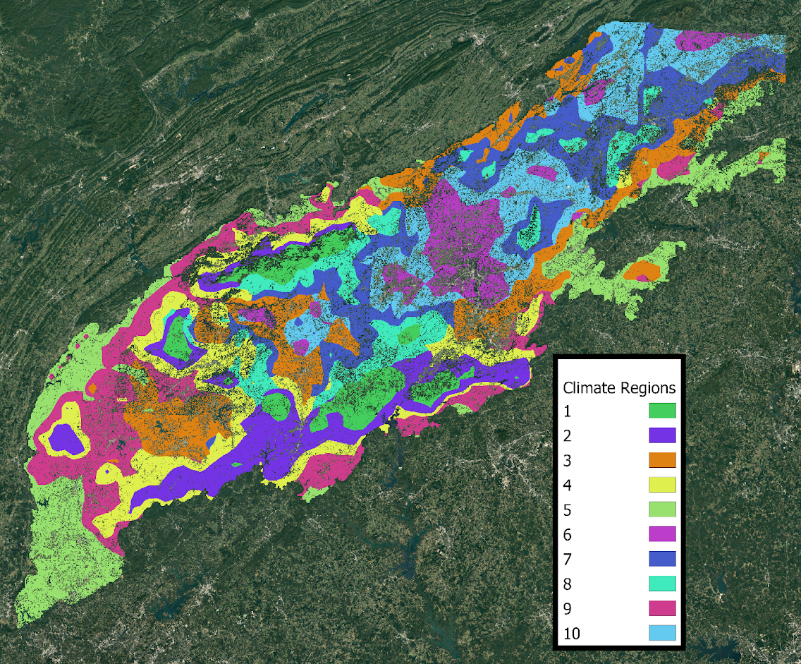

Figure S.1: The climate regions used in the LANDIS-II simulation, based on clustering of PRSIM 30-year historical normals for precipitation and temperature (1991-2020; Daly et al., 1997). Please see https://github.com/LANDIS-II-Foundation/Project-Southern-Appalachians/tree/master/Parameterizing/Climate for more information on the climate regions

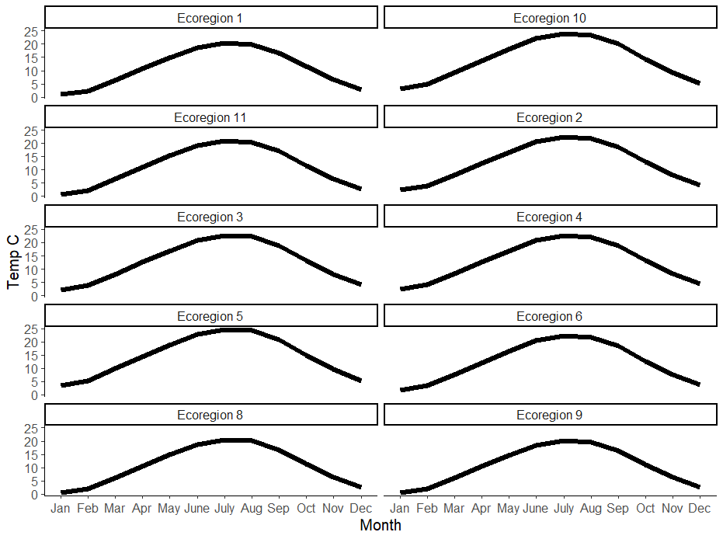

Figure S.2: The monthly mean temperature (℃) at each climate region (1979-2016).

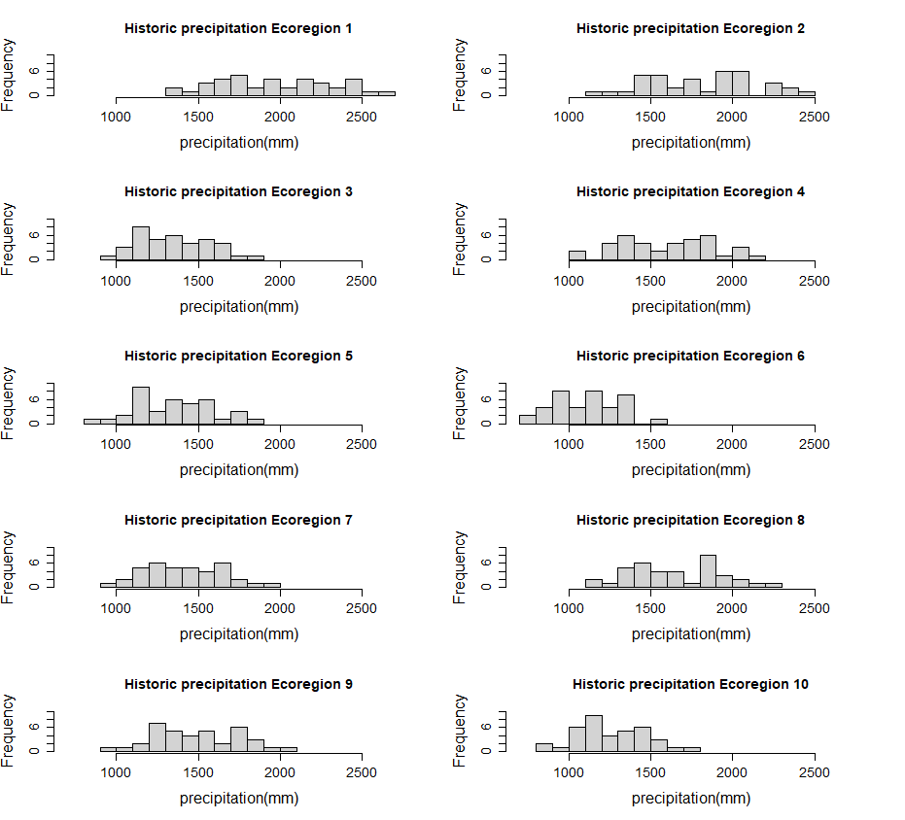
Figure S.3: A histogram of the annual precipitation (mm) of each climate region (1979-2016).

Table S.1: Species functional groups (based on analyses from Flatley et al., 2015). Functional group in bold, species in italics. *Indicates a species not included in Flately et al., 2015
Xeric Species | Mesic Species
Xeric White oaks  Quercus montana  Quercus alba | Hemlock  Tsuga canadensis
Xeric red oaks  Quercus coccinea  Quercus velutina | Maples  Acer rubrum  Acer saccharum  Acer pensylvanicum
Yellow Pines  Pinus pungens  Pinus rigida  Pinus taeda *  Pinus virginiana*  Xeric hardwoods  Nyssa sylvatica  Oxydendrum arboreum  Sassafras albidum  White pine  Pinus strobus | Mesic hardwoods  Aesculus octandra  Betula letna  Carya glabra  Carya ovata  Carya alba  Fraxinus americana  Halesia Carolina  Quercus rubra

Climate Scenarios
Table S.2: The 20 RCP 8.5 models available from the MACA database (Abatzoglou and Brown, 2012)
Climate models
MRI.CGCM3 | GFDL.ESM2M
bcc.csm1.1 | bcc.csm1.1.m
MIROC.ESM.CHEM | NorESM1.M
CCSM4 | MIROC5
GFCL.ESM2G | BNU.ESM
MIROC.ESM | CSIRO.MK3.6.0
IPSL.CM5A.LR | CNRM.CM5
IPSL.CM5A.MR | inmcm4
HadGEM2.CC365 | HadGem2.ES365
IPSL.CM5B.LR | CanESM2

Models were assessed for linear trend in PET:PPT using the code included at https://github.com/LANDIS-II-Foundation/Project-Southern-Appalachians/tree/master/Research_Projects/Future_fire. All models were analyzed to select the final four.
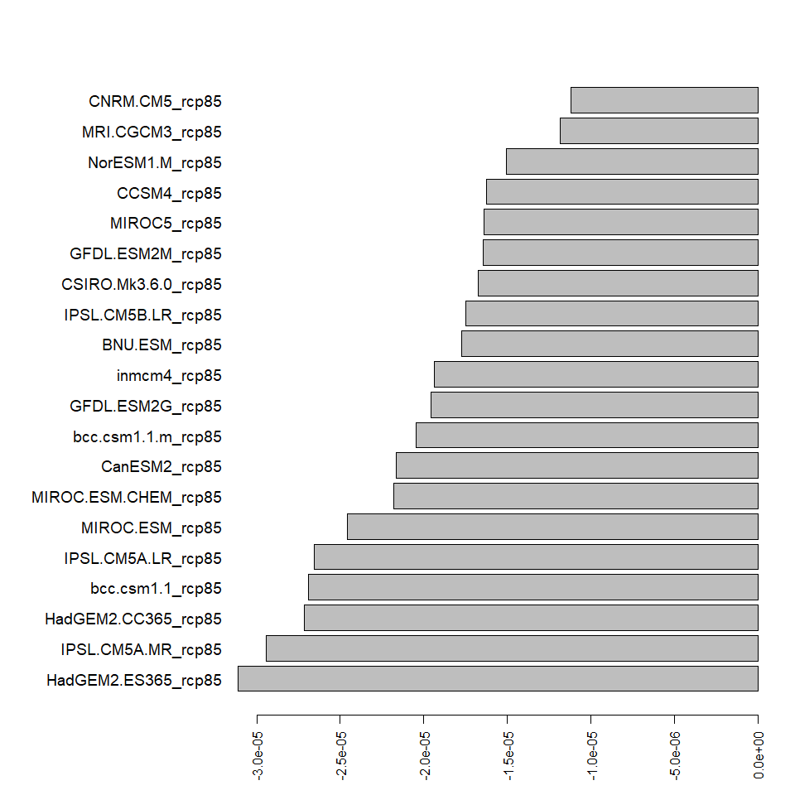
Figure S.4: 20 MACA climate models ranked by the slope of a fixed intercept linear model fit to the annual ratio of PPT:PET over the period of 2006-2100. Lower slope denotes a greater increase in overall drought trend over time. Models selected for this study are HadGEM2_ES365_rcp8. (High drought trend/ high drought variance High T/ High V), IPSL_CM5A_MR_rcp8.5(High drought trend/ low drought variance : High T/ Low V), CNRM_CM5_rcp8.5(Low drought trend/ high drought variance : Low T/ High V), and MRI.CGCM_rcp8.5(Low drought trend/ low drought variance : Low T/Low V).
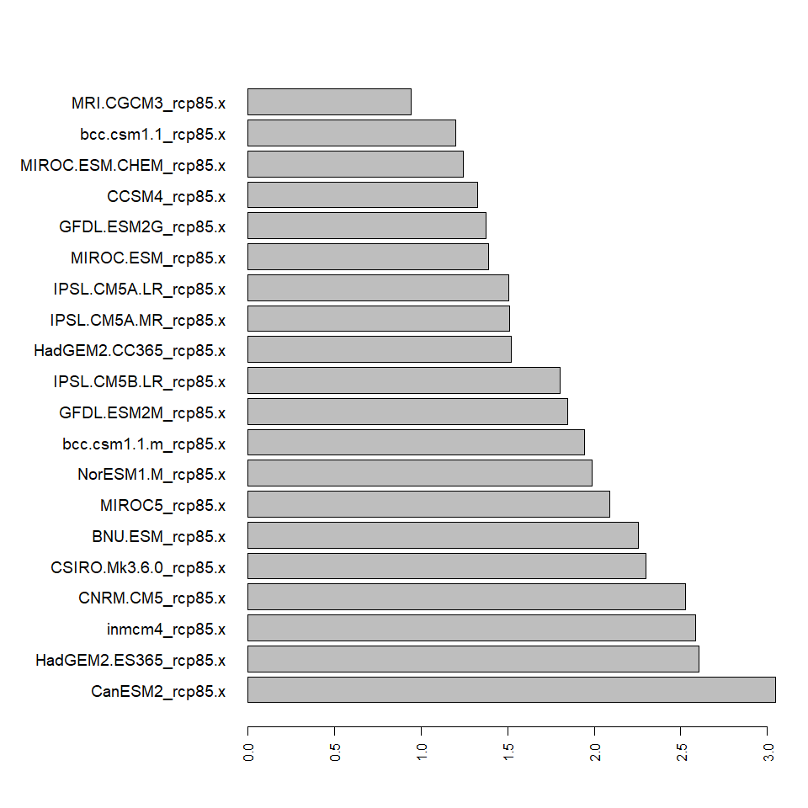
Figure S.5: 20 MACA climate models ranked by the summed intra-decadal variability in the annual ratio of PPT:PET over the period of 2006-2100. Higher numbers represent more variability in drought within the climate model. Models selected for this study are HadGEM2_ES365_rcp8. (High T/ High V), IPSL_CM5A_MR_rcp8.5 (High T/ Low V), CNRM_CM5_rcp8.5(Low T/ High V), and MRI.CGCM_rcp8.5(Low T/Low V).

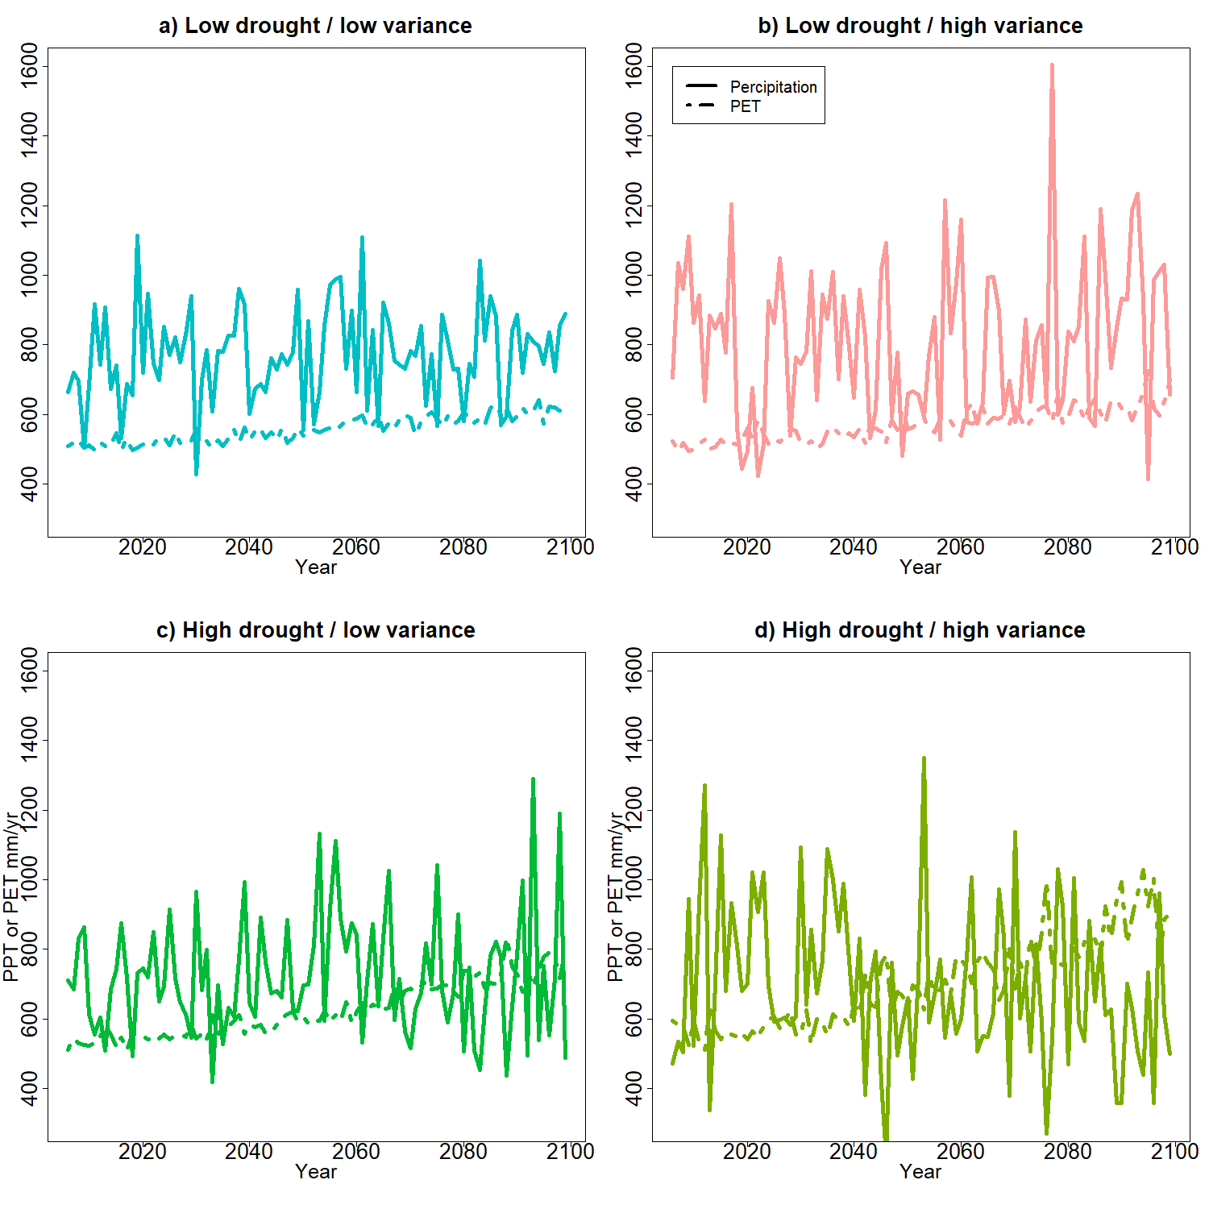
Figure S.6. Precipitation and potential evapotranspiration of four climate models representing divergent future scenarios of drought and drought variability. The Y-axis represents the mm/yr of either potential evapotranspiration (PET: Thornwaite method; dashed lines) or precipitation (PPT: solid lines). These models represent: (a) a small increase in drought and low variability (Low T/Low V; MRI CGCM3 RCP 8.5), (b) a small increase in drought and high variability (Low T/High V CNRM CM5 RCP 8.5),(c) a large increase in drought and low variability (High T/Low V) IPSL CM5A MR RCP 8.5 (d) and a large increase in drought and high variability (High T/High V HadGEM2 ES 365 RCP 8.5),
Parameterizing LANDIS-II Model
Initial Communities
The LANDIS-II model simulates from initial communities (cell level species-cohorts measurements of age and biomass. These were calculated for the study area using basal area imputation maps (Wilson et al., 2013) at the 250m scale. Each cell was then associated with a Forest Inventory and Analysis site from the states of NC, SC, GA, TN based on a Sorrenson’s dissimilarity index of each species' basal area and the sites total basal area. This allowed for the calculation of age and biomass for initial communities. Total landscape estimations were compared with basal area imputations and found to underestimate the biomass on the landscape by 11.53% on average.
See details of analysis here https://github.com/LANDIS-II-Foundation/Project-Southern-Appalachians/tree/master/Parameterizing/Forests/InitialCommunities
Forest parameterization:
Species growth and functional traits were derived either by prior publication or within the TRY database (Fraser, 2020) those decisions can be found https://github.com/LANDIS-II-Foundation/Project-Southern-Appalachians/blob/master/Parameterizing/Forests/SpeciesParameters/Species%20by%20Species%20parameters_Documentation.xlsx
And here https://github.com/LANDIS-II-Foundation/Project-Southern-Appalachians/blob/master/Parameterizing/Forests/SpeciesParameters/NECN_folder_12_20.xlsx
To test these parameters we simulated the most prevalent species for each functional group as a single cell simulation with an initial density of 100 g m⁻² and an age of 10 years. These were compared to the plot equivalents of biomass and age within the FIA record (Fig S.7). Additionally, a published value for LAI was compared to the LANDIS-II outputs. Where appropriate functional group LAI parameters (KLAI, LAImax) were adjusted to match LAI. Individual species (not the most prevalent in each functional group) were simulated and visually examined for obvious patterns of failure. Subsequently, individual stands were initiated with multiple species (derived from FIA plots) to examine competition among cohorts. Where appropriate, maximum ANPP and maximum biomass (both per species) were adjusted to improve the correlation with FIA growth. However, we used this approach for only a subset of cells and to check for obviously incorrect behavior, as the combination of varied soils, species, and temperature ranges on the landscape makes full validation across all cells impossible. These simulations of succession are also discussed extensively in Robbins et al., 2022.

Fig. S.7: Species parameter validation. LANDIS-II results under three representative soil conditions are compared to the AGB biomass distributions from representative FIA plots. Cumulative LAI in studies is compared to He, et al., 2012 estimations of plot level LAI for stands of that type.
Functional Type | Representative Species | AGB g/m2  n= FIA samples | LAI plot | LAI published.  (He et al., 2012)
Northern Hardwoods | Acer rubra | 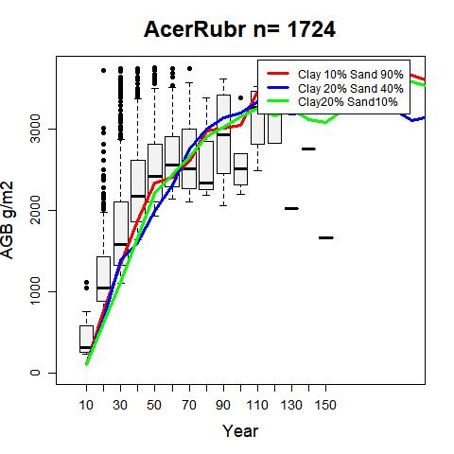 | 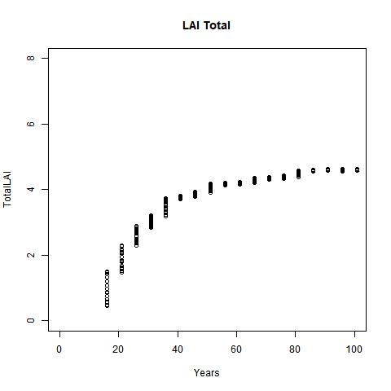 | 6.0 (Maple, Beech, Birch).
Northern Hardwoods | Quercus Montana | 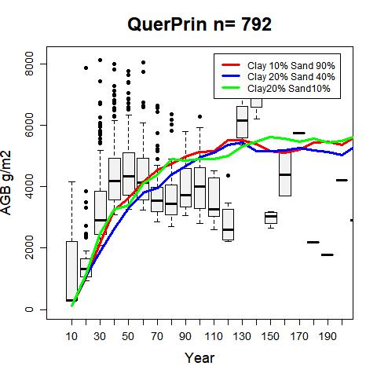 | 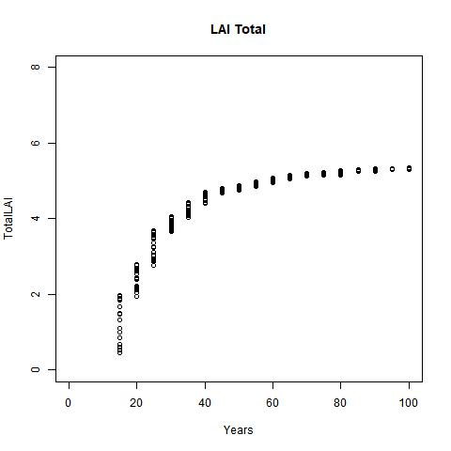 | Between 4.0-6.0 (Oak-Hickory).
Southern Hardwoods | Carya glabra | 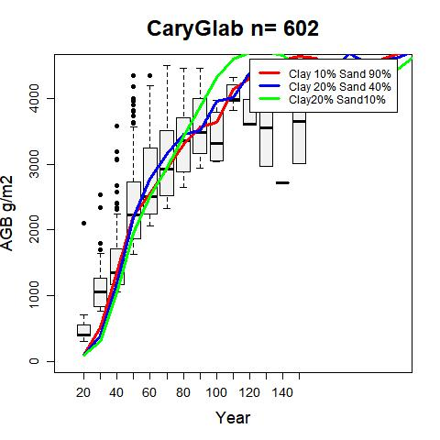 | 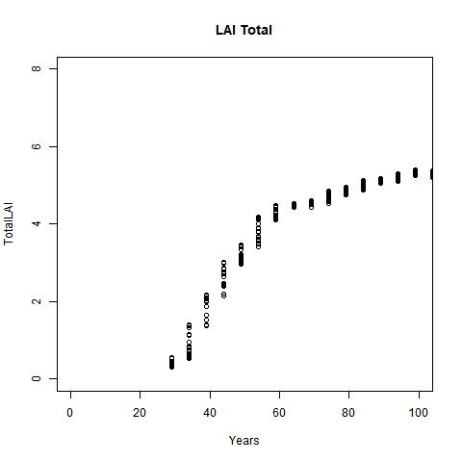 | Between 4.0-6.0 (Oak-Hickory).
Fir | Abies fraseri | 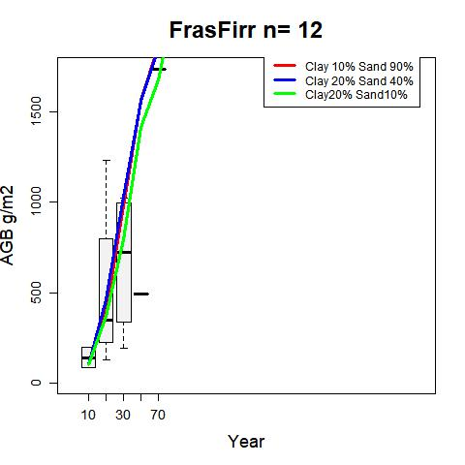 | 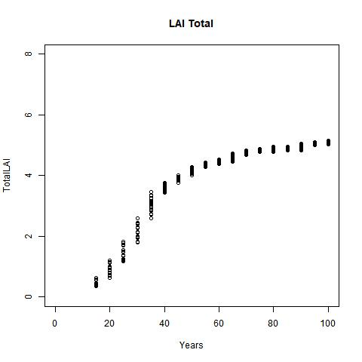 | 5.0 (Spruce-Fir)
Northern Pine | Pinus strobus | 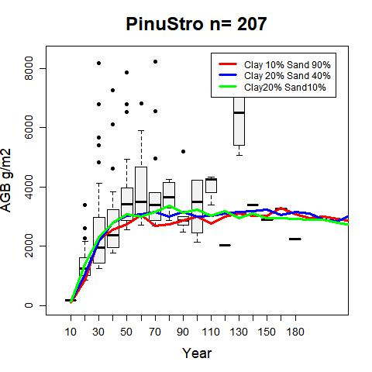 | 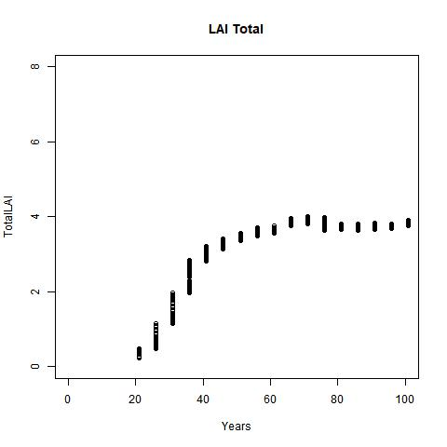 | Between 4-5 (White, Red, Jack, Pine group).
Southern Pine | Pinus taeda | 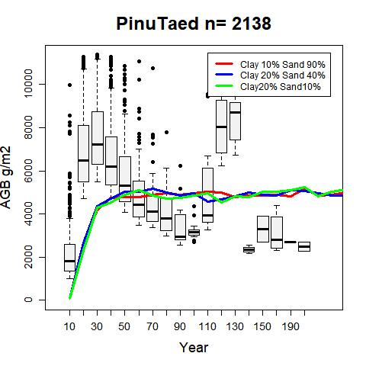 | 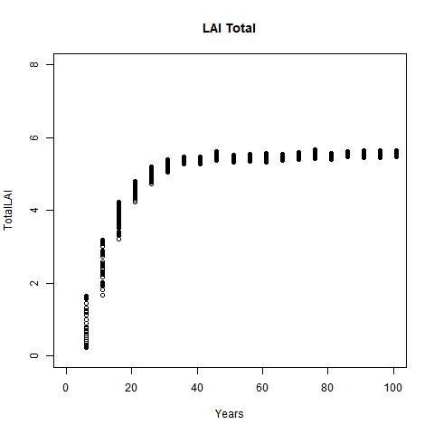 | Between 4 and 8  (Loblolly Shortleaf.)
Southern Pine | Pinus virginania |  | 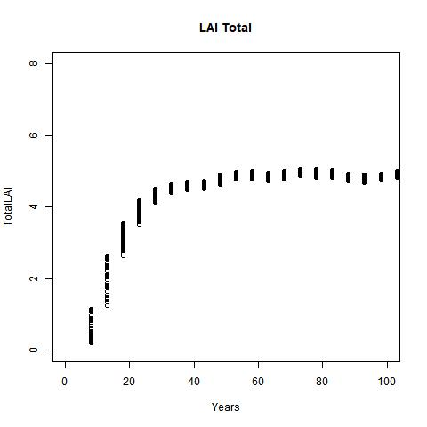 | Between 3 and 6  (Long leaf/ slash pine group).
Wetlands | Betula alleghaniensis | 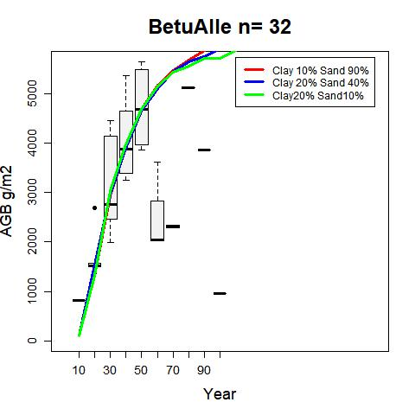 | 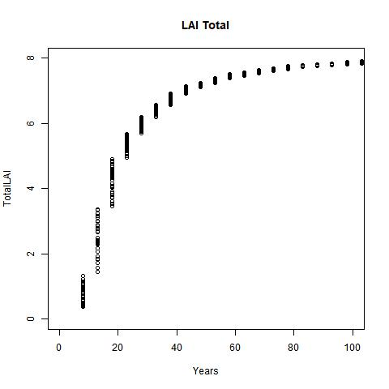 | 6.0 (Maple, Beech, Birch).
Wetlands | Tsuga canadensis | 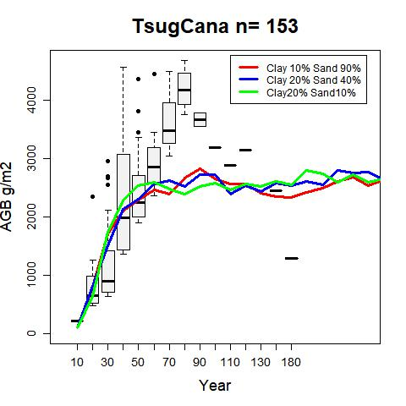 | 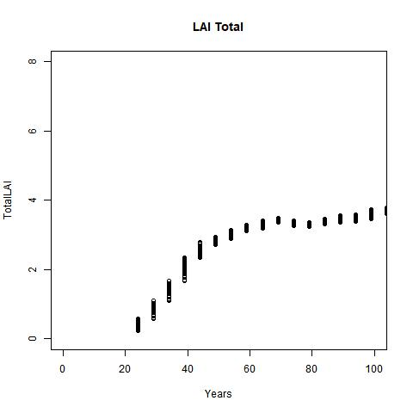 | 5-8 (Hemlock, Sitka Spruce group).

Please see more information on species validation here.
https://github.com/LANDIS-II-Foundation/Project-Southern-Appalachians/tree/master/Parameterizing/Forests/SpeciesParameters

Parameterizing SCRPPLE Model
Three sources were primarily used in the calibration for the fire model. The database of fire occurrence (Short, 2021) was used to calibrate the fire ignition likelihood model, the GeoMac database of daily fire spread was used to calibrate the fire spread model, and the remote sensing +field data on mortality (Robbins et al., 2022) was used to calibrate the fire severity and resulting mortality parameter.
Table S3: Results from the statistical fitting of the SCRPPLE ignitions model to data from Short, 2021: A) Lightning ignitions model and B) human accidental ignitions model.
- Lightning ignition model:
Zero inflated Poisson model portion | Variable | Estimation | p-value:
Count model coefficients | Intercept | -0.45334 | 0.4233
 | Fire weather index | -0.06882 | 0.0161
Binomial | Intercept | 6.17411 | <2e-16
 | Fire weather index | -0.26377 | 3.55e-10

- Human accidental ignition model:
Zero inflated Poisson model portion | Variable | Estimation | p-value:
Count model coefficients | Intercept | -0.167024 | 0.0149
 | Fire weather index | 0.027328 | 7.61e-11
Binomial | Intercept | 1.735716 | <2e-16
 | Fire weather index | -0.003042 | 0.601

- Lightning ignitions model behavior
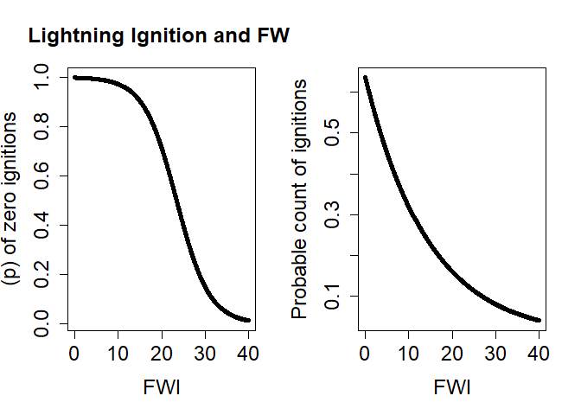
- Human accidental ignitions model behavior
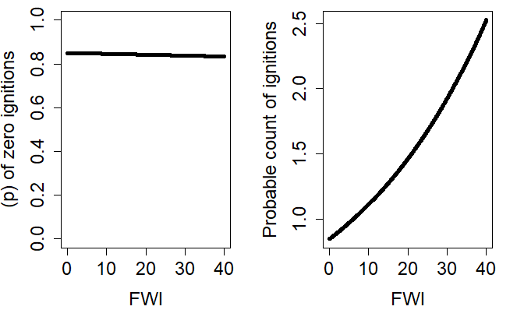
Figure S.8: Visualization of the SCRPPLE fire ignition model results as a response to fire weather index (FWI): A) lightning ignitions model, and B) human accidental ignitions model

For a step-by-step analysis of the fitting of the SCRPPLE ignition and spread model please see:
https://github.com/LANDIS-II-Foundation/Project-Southern-Appalachians/blob/master/Research_Projects/Future_fire/Scrpple_Param/Scrrple-_setup_9_21.md
Forest mortality as a result of fire is calculated the same as Robbins et al., 2022.
Additional parameterization of the managed prescribed fire regime was parameterized using literature sources (Table S4).
Table S.4: Literature sources for the prescribed burning levels used in the study.
Plan | Location | Wording
- Nantahala and Pisgah National Forests | Page 78 section Eco-0-06 | Tier 1: Prioritize prescribe burns to restore the most fire-adapted ecozones and across ecozones where reducing fuel loads will improve public safety on adjacent private lands. Annually prescribe burn for 6,500 to 10,000 acres. Prioritize 50% of the annual burns within the following four types, consisting of the following desired acre ranges: Shortleaf Pine: 1000-1500 acres Pine-Oak/Heath: 1000-1500 acres Dry-Mesic Oak: 850-1300 acres Dry Oak: 400-600 acres in order to maximize restoration, include approximately 10% as growing season burns  Tier 2: Expand the extent of prescribed fire up to approximately 20,000 acres (annually) with emphasis on restoring the fire-adapted ecozones and across ecozones where reducing fuel loads will improve public safety on adjacent private lands. Include approximately 10% growing season burns, designed to ensure compatibility with federally threatened and endangered species needs.  Total 6,500-20,000 acres
b) Chattahoochee -Oconee National Forests | Table 6.2 (Different treatments by fiscal year). | Blue Ridge Rangers District 4,921-8,244  Chattooga River Rangers District: 4,739-11,795  Total: 9,660-20,039 acres
c) Cherokee National Forest | Goal 21  Objective 21.01  Objective 21.03  Objective 21.03  Objective 21.04 | Prescribe burn an average of at least 1,100 acres per year of shortleaf/pitch/table-mountain pine forest, in an effort to maintain a fire return cycle of 4-12 years. Prescribe burn an average of at least 5,200 acres per year of oak and oak-pine forests in an effort to maintain a 4–12-year fire return cycle. Prescribe burn an average of 2,600 acres per year of open woodlands, savannas, and grasslands, in an effort to maintain a fire return cycle of 4- 12 years in dry and xeric oak forests, woodland, grasslands, and savannas. Prescribe burn an average of at least 1,200 acres per year of pine-oak forests, in an effort to maintain a fire return cycle of 4-12 years.  Total ~ 9000 acres
Cleaves, Martinez, and Haines, 2000. | Table 1 | National forest survey and response 1997:  Chattahoochee-Oconee- 7,389 acres burned annually  Cherokee- 2,200 acres burned annually.  North Carolina National Forest’s 10,000 acres  Total: 19,589 acres
a) https://www.fs.usda.gov/detail/nfsnc/home/?cid=stelprdb5397660
b) https://www.fs.usda.gov/Internet/FSE_DOCUMENTS/fseprd587101.pdf
c) https://www.fs.usda.gov/Internet/FSE_DOCUMENTS/stelprdb5269436.pdf
Additionally, sources on tribal, state, private, and tribal lands are documented at https://github.com/LANDIS-II-Foundation/Project-Southern-Appalachians/tree/master/Parameterizing/Fire/Rx_Fire.
Fire suppression:
We defined suppression levels using a combination of wildland-urban interface (WUI) definitions (Radeloff and others, 2018), maps of roads, topography, and USFS roadless wilderness designation (U.S. Forest Service, 2021). These spatial data were overlaid, and zones were classified by the following logic: 1) Areas within the WUI or within 0.5 miles of a road were assigned high suppression, 2) Areas with a slope greater than 30 and within the WUI or 0.5 miles of a road were assigned moderate suppression, 3) Areas in the USFS roadless zone were assigned to the lowest suppression zone, regardless of other status. All other areas were assigned to the lowest suppression zone. Suppression ratings were parameterized using landscape simulations for the historical period (1992-2016) and comparing the relative burned area to the fire record (See S.10). Our validation results were shared with fire ecology experts of the southeastern United States for additional feedback, and model calibration was judged to be complete when generally alignment in the burned area was achieved.

Validating the fire regime
Through an ensemble of ~100 simulations, parameters were estimated to capture the response to change in FWI in various suppression areas as evaluated by hectares burned per year (Fig S10), the overall fire size distribution (Fig.3) and the total area burned within each of the separate zones of suppression (Fig S.12). Comparing ten calibration simulations to the observed record, we found that the model simulated 92.62% of fires < 50 ha, compared to 79.5% in the observed record (Fig. 3). 9.72% of fires were 50-100 ha as compared to 10.2% in the observational record. 7.69% of simulated fires were 100-1,000 ha as compared to 9.16% in the observational record. 0.45% of fires were 1,000-5,000 ha as compared to 0.93 % in the observation record. 0.18% of fires were 5,000-10,000 ha as compared to 0.05 % in the observational record, and 0.17% of fires were 10,000-50,000 ha as opposed to 0.11% in the observed record. To compare the burned area in each suppression zone to the historical record, fire events were geolocated within a suppression zone based on ignition source for fires less than 500 acres and distributed across the final fire footprint for fires larger than 500 acres. Raster outputs from the 10 LANDIS-II calibration replicates were used to compare the area of wildfire burned in each suppression zone (Fig S.12). The simulated high suppression zone (between 1992-2016), saw 71,162.5 (95% CI [61,103-81,222]) ha burned while the observed data showed 75,385.2 ha burned. In the medium suppression zone (note this makes up a minor part of the landscape) 6,351(5,134.065- 7,567.185) ha burned as compared to 8,271 ha in the observed data. In the low suppression areas, the model simulated an average of 62,803.125 (95% CI [51,437.458-74,168.792]) ha burned per simulation while 56,140 hectares burned in the observational data set.
Table S.5: A summary of the fire size distribution, as observed from Short 2021 for our study area.
Fire size | Occurrence (1992-2016)
< = 1 ha | 21,062
1.01-10 ha | 5,280
10.01-100 ha | 1,218
100.01 ha -1,000 ha | 176
1,000.01 ha - 1,0000 ha | 19
> 10000 ha | 2

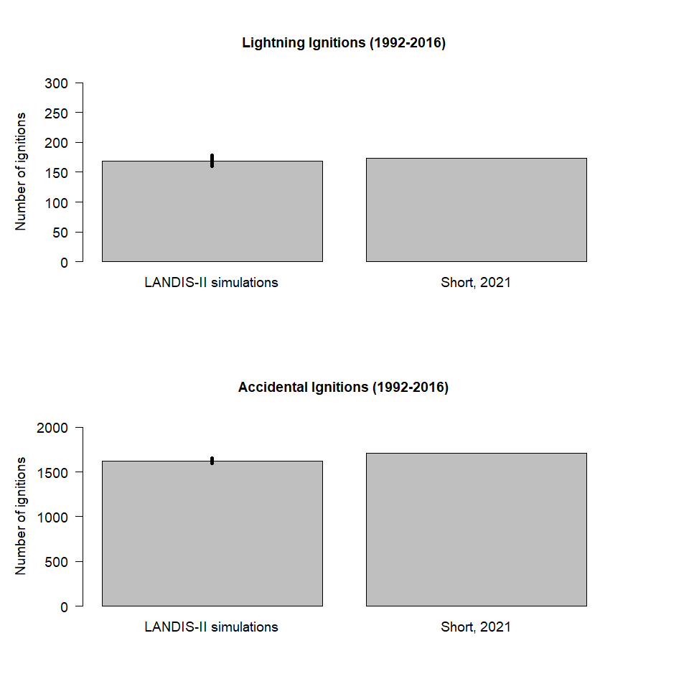
Figure S.9: Comparison of SCRPPLE ignitions model to ignition records. The lightning model has a mean of 160 [95% CI: 153-177]] ignitions compared to the observed record of 174, the human accidental had a mean of 1,623 [95% CI: 1,598-1,649] ignitions while the record had 1,709 (Short, 2021).
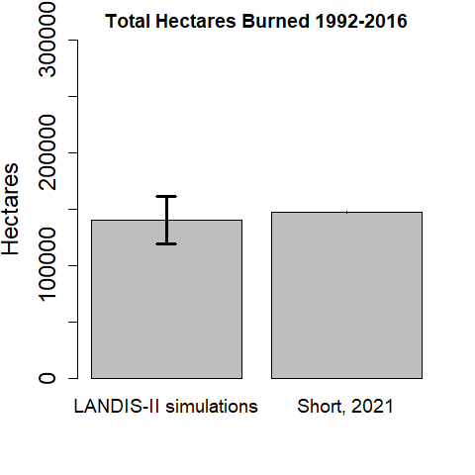

Figure S.10: Comparison of the total hectares burned 1992-2016. During the period for which there are extensive observations (1992-2006) our model simulated 140,316 ha ([95% CI: [119,067-161,565]) burned compared to 147,366 ha in the observed record.
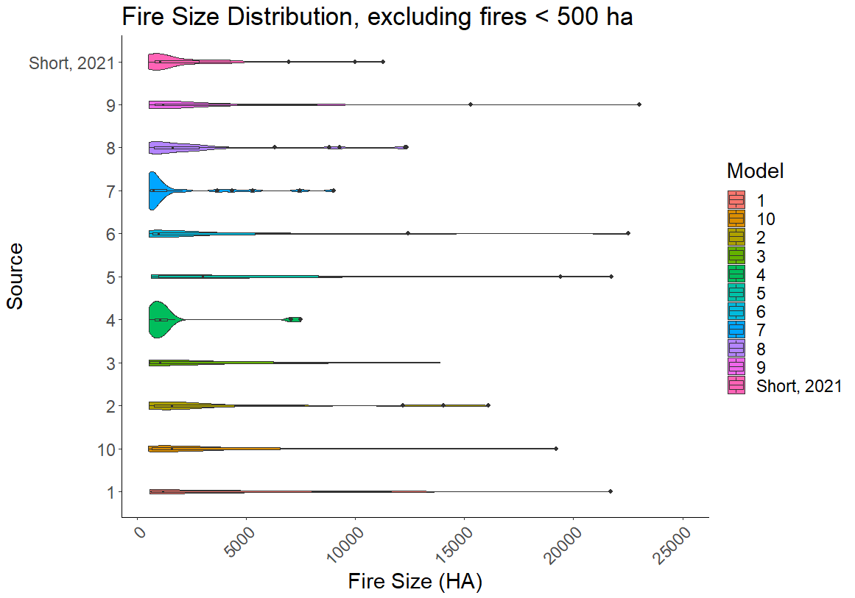
Figure S.11: The distribution of large fires (>500 ha) for the 10 LANDIS-II model runs used in validation and the fire record (Short 2021), in order to show the maximum fire size in each simulation and variation in the stochastic elements of the SCRPPLE fire model.

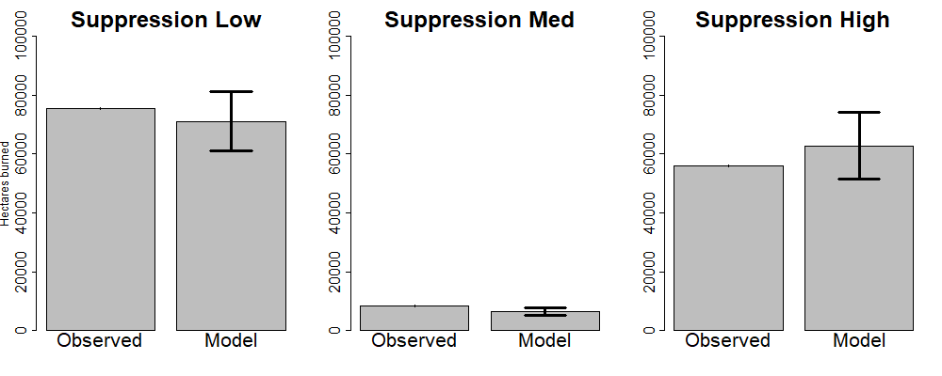
Figure S.12. Comparison of ha burned for three separate fire suppression areas. Observed represents the combinations of MTBS fire boundaries (for fires greater than 500 acres) and point data from Short (2021). Model data represents the mean and 95 % CI for 10 model replicates. Suppression Low, Med, and High represent the three suppression rankings defined in the paper. Note that each of these areas represents different total areas, for example while high suppression has a lower likelihood of spread it represents a much larger area.

Future Simulations
This section includes additional referenced results from climate simulations.
Variables affecting fire spread on the landscape are the primary reason for the change in burned area over time, as ignitions seem relatively stable through the simulations. Fire weather index (Fig. S13) increased the most drastically in those simulations that see the greatest increase in burned area (High T/ High V and High T/Low V). Fine fuel rating (0-1.0, Fig. S13b) increases in all simulations except in High T/High V which begins to fall in the middle of the 21st century. Though, this does not appear to reduce fire spread dramatically, as there is still sufficient fuel to burn, and the loss of fine fuels is offset by an increase in fire weather.

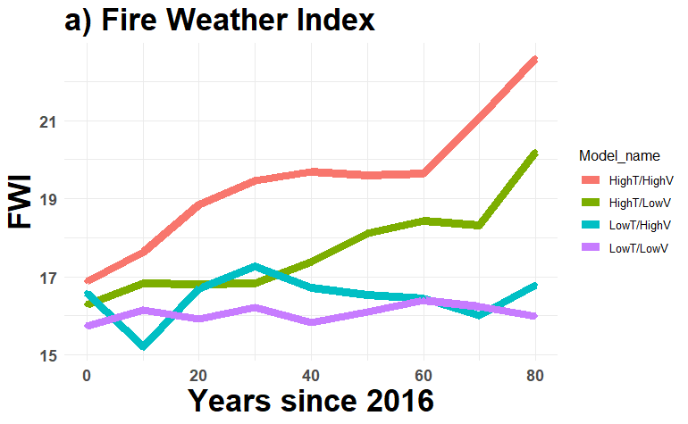
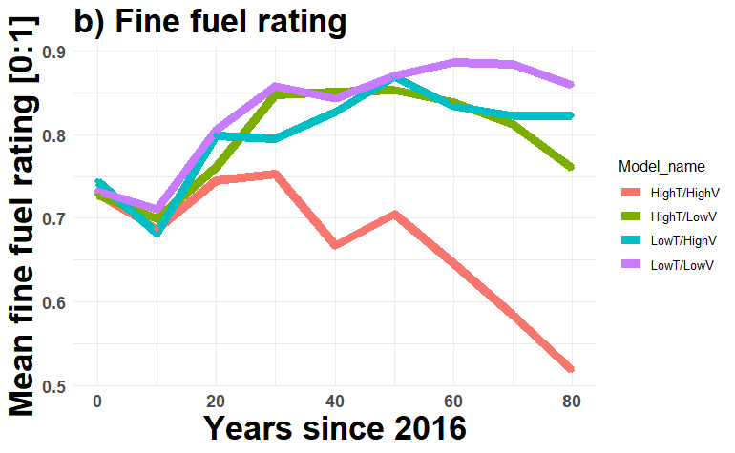
Figure S.13: Change in fire spread variables over time as output from LANDIS-II and SCRPPLE fire model. These represent the mean value during fire events to capture the overall change in landscape state during fire.

Overall fire severity is relatively stable under most climate scenarios as was the proportion of high severity fires. The Low T/Low V climate model consistently had higher severity than the other three models. This is driven primarily by this climate model having a higher mean windspeed, which is calculated into effective windspeed in the fire severity sub model (not shown). Mean severity oscillated between RdNBR 130 and 180 for the entire simulation (Fig S.14a). The percentage of fires that were high severity (mean RdNBR >300 at 250 m scale) was between 3 and 7 percent of fires in any year (Fig S.14b).
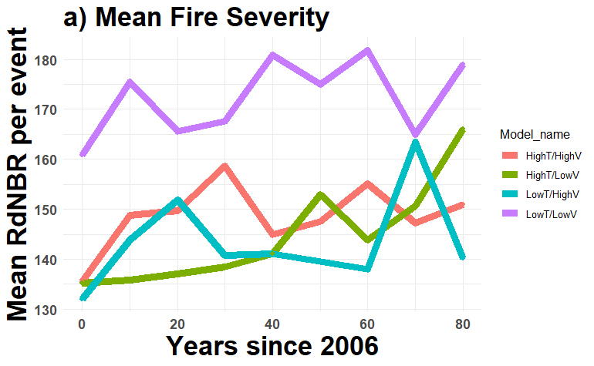 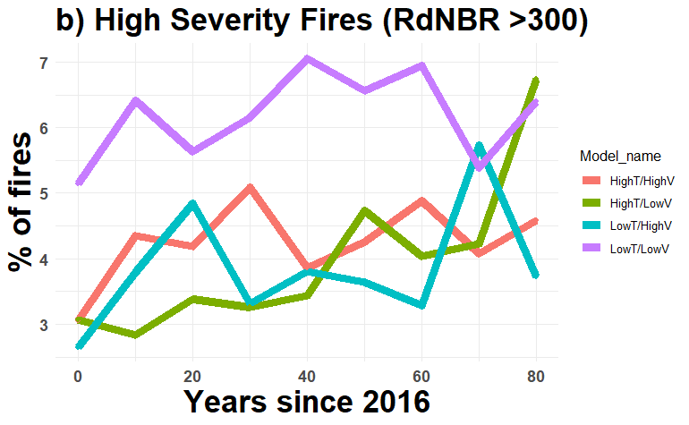
Figure S.14: Changes in fire severity over time as output from LANDIS-II and SCRPPLE fire model.

Table S.6: The difference in the climate model simulations of the southern Appalachians regarding the fire return interval and model fire suppression level. These tables were created as the intersections of model results for FRI (2016-2096) and the model fire suppression levels. Fire suppression level one represents the least suppression, and fire suppression level 3 represents the most suppression.
- Fire suppression level 1
Fire return interval | Low T/ Low V | Low T/ High V | High T / Low V | High T/ Hight V
0-25 | 0.00% | 0.01% | 0.40% | 28.59%
25-50 | 0.17% | 4.81% | 12.38% | 34.04%
50-100 | 7.35% | 22.00% | 29.20% | 17.34%
100-200 | 23.26% | 28.45% | 27.34% | 8.72%
200-Inf | 69.22% | 44.72% | 30.67% | 11.31%

- Fire suppression level 2

Fire return interval | Low T/ Low V | Low T/ High V | High T / Low V | High T/ Hight V
0-25 | 0.00% | 0.00% | 0.00% | 5.2
25-50 | 0.01 % | 0.21% | 1.25% | 27.11 %
50-100 | 2.08 % | 6.82 % | 14.45% | 24.72 %
100-200 | 15.46 % | 22.07% | 28.78% | 17.53 %
200-Inf | 82.46% | 70.90 % | 55.52 % | 25.41%

- Fire suppression level 3
Fire return interval | Low T/ Low V | Low T/ High V | High T / Low V | High T/ Hight V
0-25 | 0.00% | 0.00% | 0.00% | 8.15 %
25-50 | 0.01% | 0.32% | 1.93% | 25.61 %
50-100 | 1.73% | 7.14% | 15.62% | 23.06 %
100-200 | 13.53% | 21.31% | 26.14% | 15.07 %
200-Inf | 84.72% | 71.23 % | 56.29% | 28.12 %

Table S.7: The difference in the climate model simulations of the southern Appalachians regarding the fire return interval and WUI classification. These tables were created as the intersections of model results for FRI (2016-2096) and WUI classification (Fig. 1).

Wildfire Regimes change within WUI
Fire return interval | Low T/ Low V | Low T/ High V | High T / Low V | High T/ Hight V
0-25 | 0.00% | 0.00% | 0.01% | 4.17%
25-50 | 0.02% | 0.23% | 1.31% | 20.05%
50-100 | 1.60% | 4.82% | 11.47% | 24.34%
100-200 | 11.57% | 17.96% | 24.16% | 17.94%
200-Inf | 86.79% | 76.98% | 63.03% | 33.48%

Wildfire Regimes change outside WUI
Fire return interval | Low T/ Low V | Low T/ High V | High T / Low V | High T/ Hight V
0-25 | 0.00% | 0.22% | 0.01% | 22.51%
25-50 | 0.09% | 8.39% | 3.00% | 34.46%
50-100 | 5.134% | 56.27% | 17.37% | 19.00%
100-200 | 20.73% | 28.45% | 27.84% | 9.63%
200-Inf | 74.04% | 36.66% | 51.79% | 14.38%

Probability of establishment under climate scenarios.
Within LANDIS-II regeneration is handled by a probability of establishment. This is controlled both by the light availability (as calculated by LAI), being within the temperature range (as determined by growing degree days) and the soil conditions (moisture and temperature requirements) (Scheller et al., 2011). Light based regeneration is determined within the model by a combination of plant traits and stand LAI. (For greater detail see the supplemental in Robbins et al., 2022). LAI and regeneration were calculated from the FIA plots for species with the study area. These were divided into the 6 shade classes used by NECN and each species categorized into a shade category. A probability density distribution for each species was calculated and used to categorize each into a shade tolerance class. This controls the likelihood of regeneration. Values for the minimum January temperature and soil moisture requirements were determined from previous studies and can be found here. Growing degree day ranges were calculated using the historical normals from PRISM and the range of the species regeneration found in the FIA site record. To do this a map of the growing degree days was calculated from the normals, then the estimated latitude and longitude of each plant species regeneration was plotted along it. We then calculated the maximum and minimum GDD that this plant
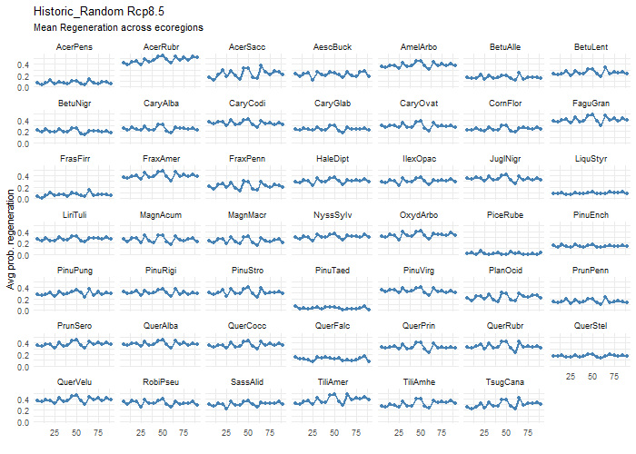Figure S.15: Probability of establishment under the Historical Random simulations.
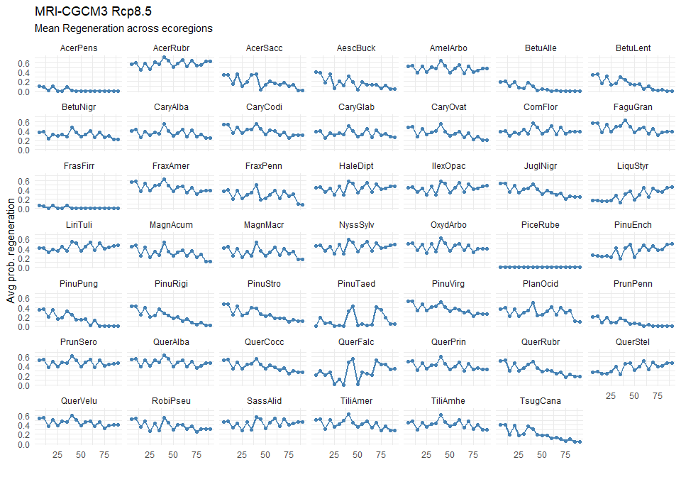
Figure S.15: Probability of establishment under the MRI-CGCM3 (Low T/ Low V) simulations.

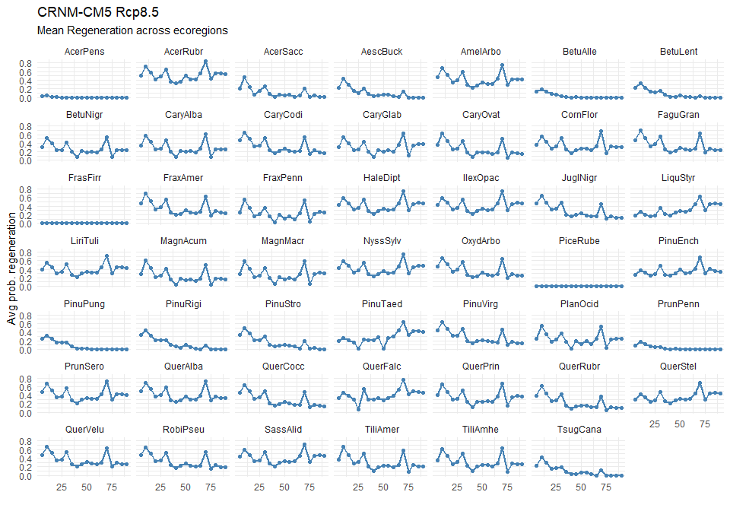
Figure S.17: Probability of establishment under the CRNM-CM5 (Low T/ High V) simulations.

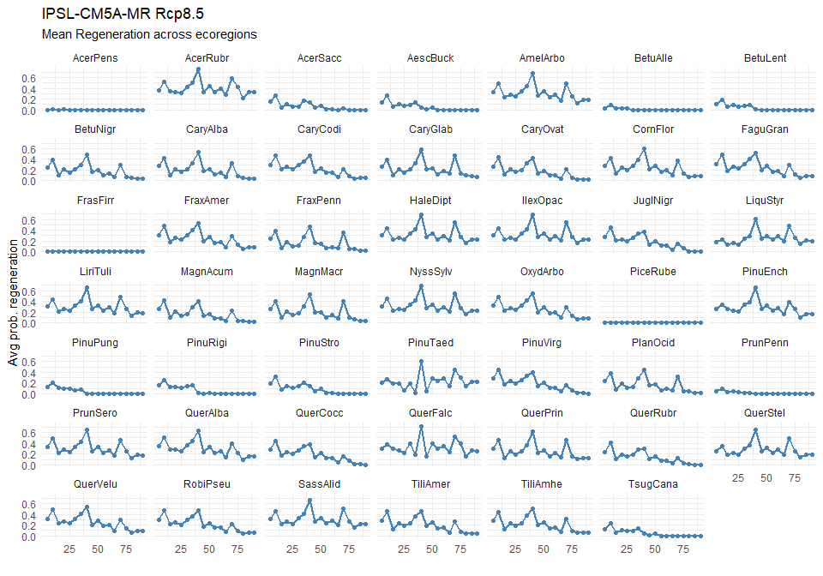
Figure S.18: Probability of establishment under the IPSL-CM5A-MR (High T/ Low V) simulations.

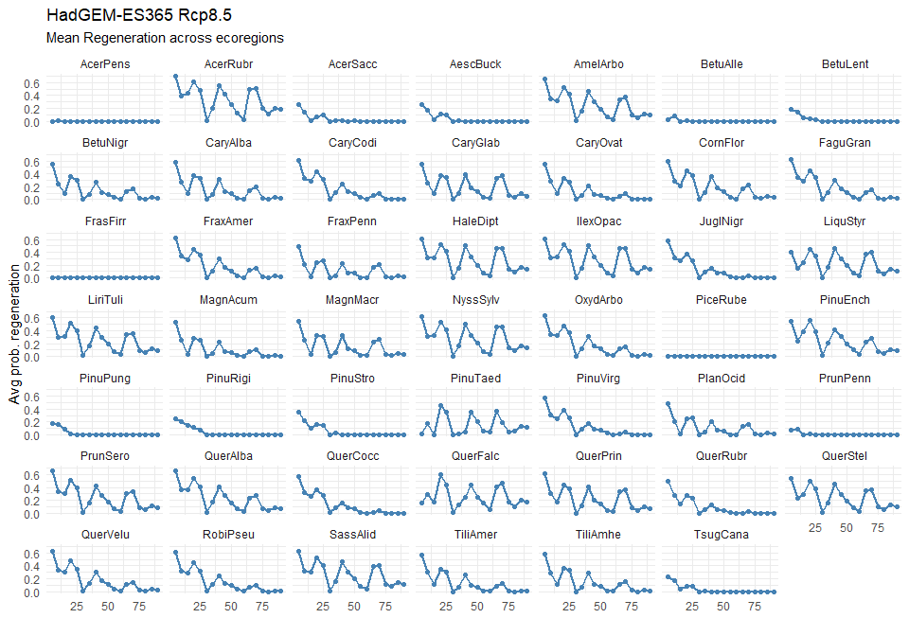
Figure S.19: Probability of establishment under the HadGEM-ES365 (High T/ High V) simulations.

Biomass by Climate
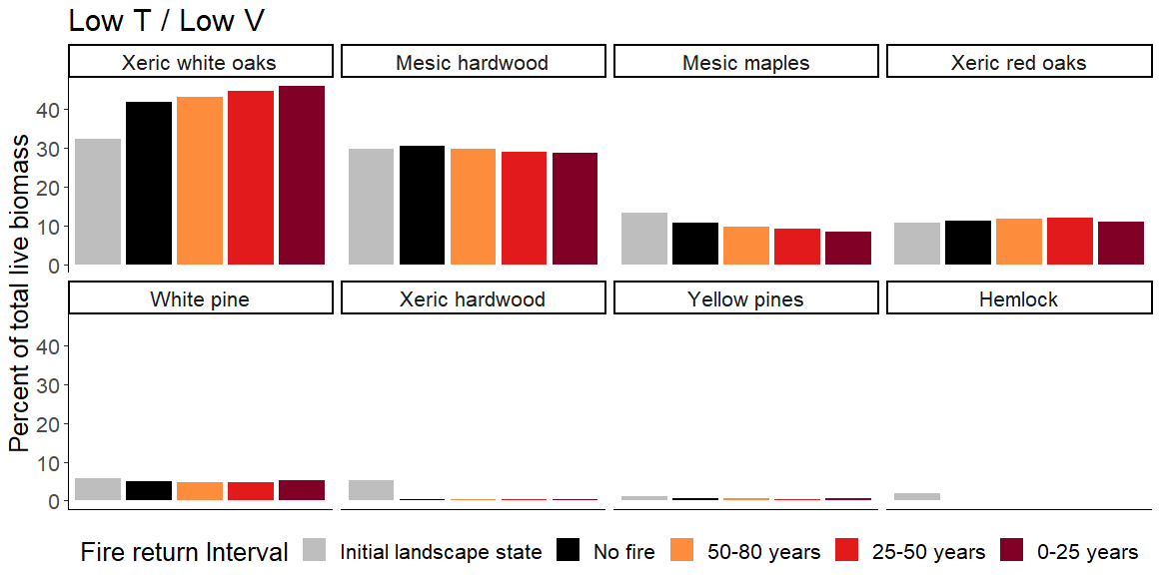
Figure S.20: Landscape proportions of the functional groups represented in each by fire return interval (FRI: years simulated/fires that occurred) for the climate scenario representing Low T / Low V (MRI CGCM3 RCP 8.5). Each bar represents the mean percent of total live biomass of each functional group of all locations that experience that FRI across the landscape in all simulations. Functional groups are defined in Table S.1.
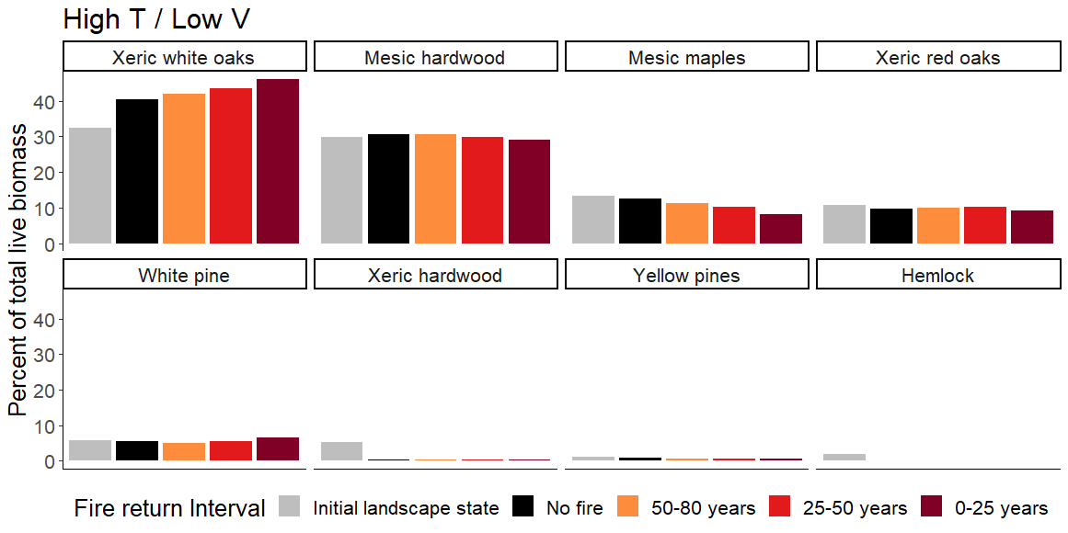Figure S.21: Landscape proportions of the functional groups represented in each by fire return interval (FRI: years simulated/fires that occurred) for the climate scenario representing High T / Low V (IPSL CM5A MR RCP 8.5). Each bar represents the mean percent of total live biomass of each functional group of all locations that experience that FRI across the landscape in all simulations. Functional groups are defined in Table S.1.

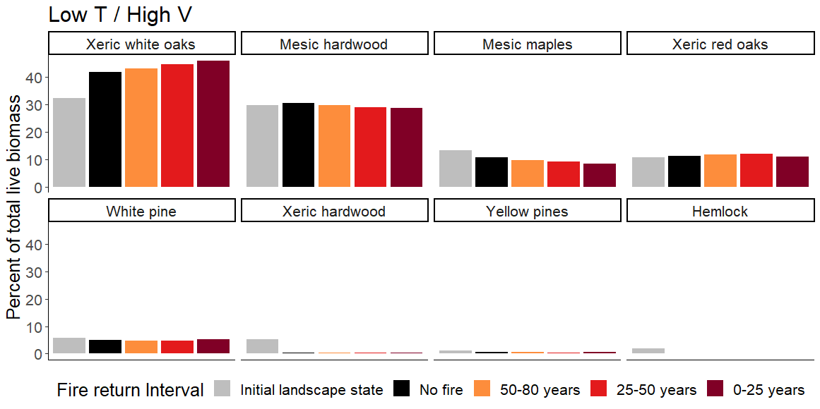
Figure S.22: Landscape proportions of the functional groups represented in each by fire return interval (FRI: years simulated/fires that occurred) for the climate scenario representing Low T / High V (CNRM CM5 RCP 8.5). Each bar represents the mean percent of total live biomass of each functional group of all locations that experience that FRI across the landscape in all simulations. Functional groups are defined in Table S.1.

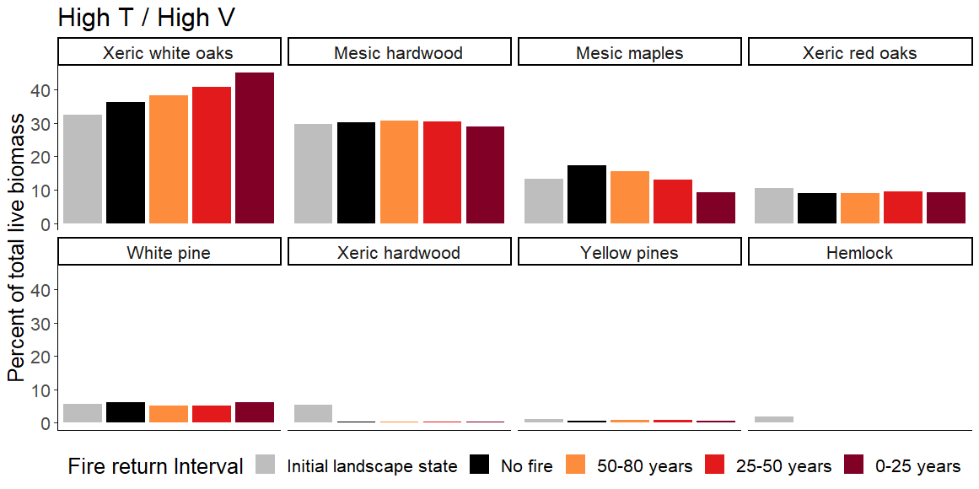
Figure S.23: Landscape proportions of the functional groups represented in each by fire return interval (FRI: years simulated/fires that occurred) for the climate scenario High T / High V (HadGEM2 ES365 RCP 8.5). Each bar represents the mean percent of total live biomass of each functional group of all locations that experience that FRI across the landscape in all simulations. Functional groups are defined in Table S.1.

Additional Documentation:
Please see https://github.com/LANDIS-II-Foundation/Project-Southern-Appalachians/tree/master/Research_Projects/Future_fire for further information on calibration and validation

Citations
Abatzoglou JT, Brown TJ. 2012. A comparison of statistical downscaling methods suited for wildfire applications. International Journal of Climatology 32:772–80.
Cleaves DA, Martinez J, Haines TK. 2000. Influences on Prescribed Burning Activity and Costs in the National Forest System. Gen Tech Rep SRS-37 Asheville, NC: US Department of Agriculture, Forest Service, Southern Research Station 34 p 37.
Daly, C., Taylor, G., Gibson, W., 1997. The PRISM approach to mapping precipitation and temperature, in: 10th Conference on Applied Climatology, American Meteorological Society, 20-23 October, Reno NV. pp. 10–12.
Flatley WT, Lafon CW, Grissino-Mayer HD, LaForest LB. 2015. Changing fire regimes and old-growth forest succession along a topographic gradient in the Great Smoky Mountains. Forest Ecology and Management 350:96–106.
Fraser, L. H. (2020). TRY—A plant trait database of databases. Global change biology, 26(1), 189-190.
Gesch, D. B., Evans, G. A., Oimoen, M. J., & Arundel, S. (2018). The National Elevation Dataset. Accessed (10/2020).
He, L., Chen, J. M., Pan, Y., Birdsey, R., & Kattge, J. (2012). Relationships between net primary productivity and forest stand age in US forests. Global Biogeochemical Cycles, 26(3).
Lucash MS, Scheller RM, Gustafson EJ, Sturtevant BR. 2017. Spatial Resilience of Forested Landscapes Under Climate Change and Management. Landscape Ecology:1.
Omernik JM. 1995. Ecoregions: A Framework for Managing Ecosystems. The George Wright Forum 12:35–50.
Radeloff VC, Helmers DP, Kramer HA, Mockrin MH, Alexandre PM, Bar-Massada A, Butsic V, Hawbaker TJ, Martinuzzi S, Syphard AD, Stewart SI. 2018. Rapid growth of the US wildland-urban interface raises wildfire risk. PNAS 115:3314–9.
Scheller RM, Hua D, Bolstad PV, Birdsey RA, Mladenoff DJ. 2011. The effects of forest harvest intensity in combination with wind disturbance on carbon dynamics in Lake States Mesic Forests. Ecological Modelling 222:144–53.
Short KC. 2021. Spatial wildfire occurrence data for the United States, 1992-2018 [FPA_FOD_20210617] (5th Edition). https://www.fs.usda.gov/rds/archive/Catalog/RDS-2013-0009.5. Last accessed 15/11/2021
United States Forest Service. 2001. S_USA.RoadlessArea_2001. https://data.fs.usda.gov/geodata/edw/edw_resources/meta/S_USA.RoadlessArea_2001.xml. Last accessed 01/12/2021
Van Wagner CE. 1974. Structure of the Canadian forest fire weather index. Environment Canada, Forestry Service Ontario

