Prescribed burning mitigates the severity of subsequent wildfires in Mediterranean shrublands
SUPPLEMENTARY MATERIAL
José Manuel Fernández-Guisuraga^{1,2}, Paulo M. Fernandes¹

¹Centro de Investigação e de Tecnologias Agroambientais e Biológicas, Universidade de Trás-os-Montes e Alto Douro, 5000-801 Vila Real, Portugal
²Departamento de Biodiversidad y Gestión Ambiental, Facultad de Ciencias Biológicas y Ambientales, Universidad de León, 24071 León, Spain

Corresponding author: José Manuel Fernández-Guisuraga
Email: joseg@utad.pt

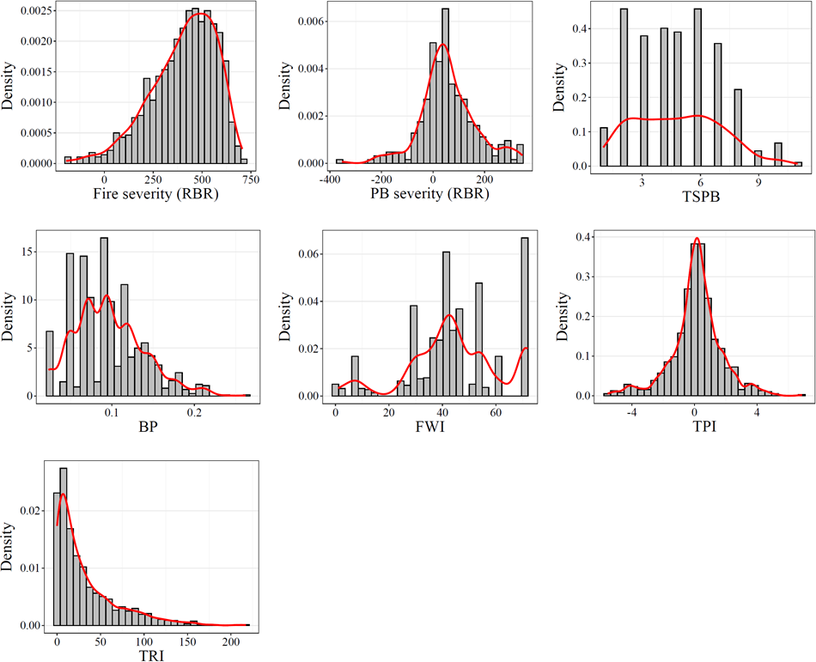
Figure SM1. Histograms with kernel density estimation for the variables considered in this study for PB units and untreated counterparts. Please refer to the Table 1 of the main text for variable codes.

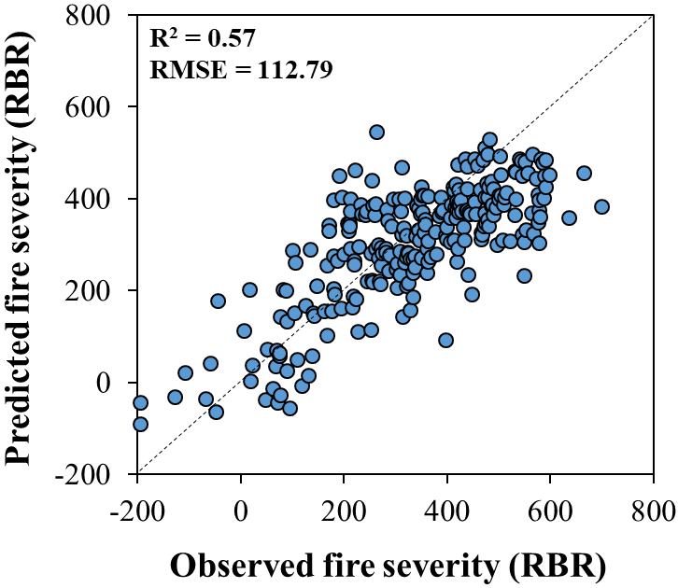
Figure SM2. Relationship between observed and predicted wildfire severity (RBR) in prescribed burning (PB)-wildfire intersection areas using the Random Forests regression (RFR) algorithm. The dotted line represents the 1:1 line.
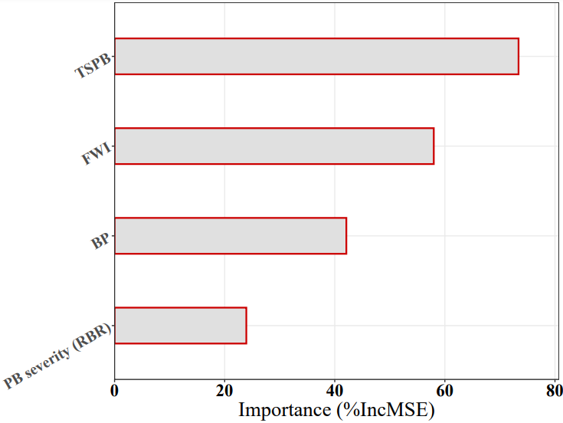
Figure SM3. Variable importance (%IncMSE) of the wildfire severity (RBR) descriptors in prescribed burning (PB)-wildfire intersection areas using the Random Forests regression (RFR) algorithm. Please refer to the Table 1 of the main text for variable codes.

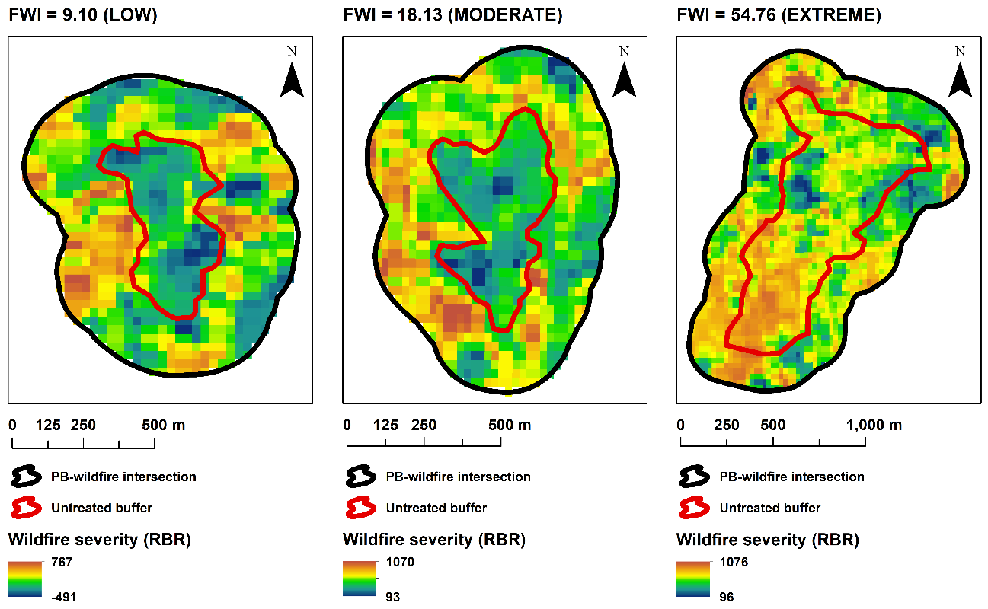
Figure SM4. Example of PB-wildfire intersections and untreated buffers with low fuel ages (2-years) and different FWI.

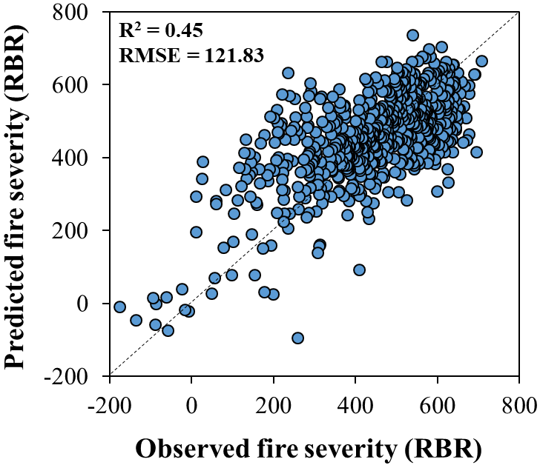
Figure SM5. Relationship between observed and predicted wildfire severity (RBR) in untreated areas of the vicinity of PB treatment units using the Random Forests regression (RFR) algorithm. The dotted line represents the 1:1 line.

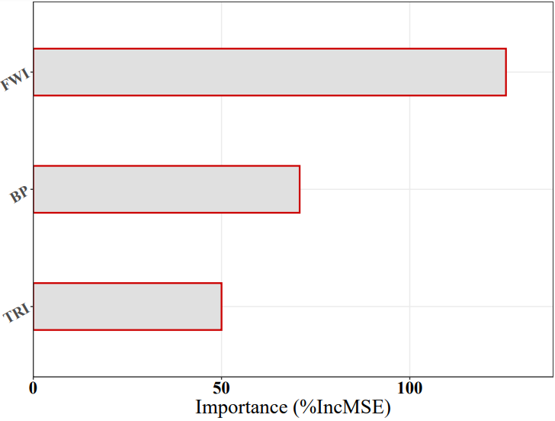
Figure SM6. Variable importance (%IncMSE) of the wildfire severity (RBR) descriptors in untreated areas of the vicinity of PB treatment units using the Random Forests regression (RFR) algorithm. Please refer to the Table 1 of the main text for variable codes.

Table SM1. Interaction strength of RFR predictors in prescribed burning (PB)-wildfire intersection areas.
Variable | H-statistic
TSPB | 0.456
FWI | 0.447
PB severity (RBR) | 0.312
BP | 0.298

Table SM2. Interaction strength of RFR predictors in untreated areas of the vicinity of PB treatment units.
Variable | Interaction strength
FWI | 0.498
BP | 0.471
TRI | 0.365

