Supplement 1
Table S1. Community type descriptions for plot selection
Community Type | Relative pH | Geologic Descriptions | Ecological Land Types
Glades | Acidic | - Rhyolite  - Upper Gasconade dolomite  - Roubidoux and Gunter sandstones | - Cherty, exposed variable depth to dolomite unit  - Dolomite glade
Glades | Alkaline | - Eminence dolomite  - Lower Gasconade dolomite  - Upper Gasconade Dolomite | - Non cherty, exposed variable depth to dolomite unit
Dry woodlands | Acidic | - Chert and Sandstone residuum  - Rhyolite | - Exposed Ultic RO/UG backslope  - Ultic LG/EM benches/shoulder ridges  - Rocky RO/UG summit  - Ultic, rocky RO/UG shoulder and shoulder ridges
Dry woodlands | Alkaline | - Lower Gasconade and Eminence dolomite | - Silty RO/UG summit  - Alfic RO/UG shoulders, shoulder ridges, and benches  - Exposed Alfic RO/UG backslope
Dry-mesic woodlands | Acidic | - Chert, igneous and sandstone residuum | - Protected Ultic RO/UG backslope  - Exposed Ultic LG/EM backslope  - Cherty protected variable depth to dolomite units  - Ultic LG/EM benches/shoulder ridges
Dry-mesic woodlands | Alkaline | - Lower Gasconade and Eminence dolomite | - Protected Alfic RO/UG backslope  - Exposed Alfic LG/EM backslope  - Protected Alfic LG/EM backslope  - Non cherty protected variable depth to dolomite units  - Alfic LG/EM benches/shoulder ridges

Community type descriptions for plot selection at Ozark National Scenic Riverways (ONSR), adapted from ONSR fire effects monitoring plan. Plot selection began in 1999 and continued through 2015 as new plots were added through duration of this study. RO = Roubidoux sandstone; UG = Upper Gasconade dolomite; LG = Lower Gasconade dolomite; EM = Eminence dolomite. Ecological Land Types were determined based on Missouri Department of Conservation classifications in an unpublished manual (Nigh,T, Buck, C, Grabner, J, Kabrick, J, and Meinert, D 2000. An ecological classification system for the Current River Hills subsection. Missouri Department of Conservation, Jefferson City, MO).

Table S2. Data collection dates for all plots.
Dry-mesic woodland plots
Plot | Data collection dates by burn number |  |  |  |  |  | Date range
 | Preburn | Burn 1 | Burn 2 | Burn 3 | Burn 4 | Burn 5 | Earliest | Latest
1 | 7/19/1999 | 7/24/2000 | 7/7/2004 | 7/26/2007 | 7/27/2010 | 7/7/2014 | 7/7 | 7/27
2 | 8/4/1999 | 8/14/2000 | 8/25/2003 | 8/26/2009 | 7/29/2013 | 9/7/2016 | 7/29 | 9/7
3 | 9/14/2001 | 9/11/2002 | 8/22/2013 | 9/6/2016 |  |  | 8/22 | 9/14
4 | 7/17/2000 | 7/31/2001 | 8/6/2003 | 8/24/2009 | 8/26/2013 | 7/18/2016 | 7/17 | 8/26
5 | 7/26/2000 | 8/6/2001 | 8/7/2003 | 8/26/2009 | 9/4/2013 | 7/13/2016 | 7/13 | 9/4
6 | 8/28/2000 | 9/17/2001 | 8/2/2004 | 7/26/2007 | 7/26/2010 | 7/11/2014 | 7/11 | 9/17
7 | 7/8/2002 | 7/28/2003 | 7/11/2006 | 7/19/2010 |  |  | 7/8 | 7/28
8 | 7/9/2002 | 7/29/2003 | 7/11/2006 | 7/19/2010 |  |  | 7/9 | 7/29
9 | 7/8/2002 | 9/8/2003 | 7/26/2006 | 8/10/2010 | 9/11/2013 | 8/18/2016 | 7/8 | 9/11
10 | 7/25/2002 | 9/4/2003 | 7/25/2006 | 8/10/2010 | 9/18/2013 | 9/20/2016 | 7/25 | 9/20
11 | 7/7/2005 | 6/26/2006 | 6/15/2010 |  |  |  | 6/15 | 7/7
12 | 7/5/2005 | 6/27/2006 | 6/15/2010 |  |  |  | 6/15 | 7/5
13 | 6/12/2006 | 6/18/2007 | 6/20/2011 |  |  |  | 6/12 | 6/20
14 | 6/15/2006 | 6/18/2007 | 6/23/2011 |  |  |  | 6/15 | 6/23
Dry woodland plots
Plot | Data collection dates by burn number |  |  |  |  |  | Date range
 | Preburn | Burn 1 | Burn 2 | Burn 3 | Burn 4 | Burn 5 | Earliest | Latest
1 | 6/8/1999 | 6/5/2000 | 6/29/2004 | 8/27/2007 | 8/12/2010 | 6/8/2017 | 6/5 | 8/27
2 | 8/18/1999 | 8/23/2000 | 8/26/2004 | 8/23/2007 | 8/18/2010 | 8/23/2017 | 8/18 | 8/26
3 | 8/30/1999 | 9/11/2000 | 8/31/2004 | 7/23/2007 | 7/27/2010 | 7/15/2014 | 7/15 | 9/11
4 | 9/7/1999 | 9/13/2000 | 8/26/2004 | 8/23/2007 | 8/18/2010 | 9/5/2017 | 8/18 | 9/13
5 | 8/16/2000 | 8/22/2001 | 8/26/2003 | 8/24/2009 | 9/5/2013 | 8/12/2016 | 8/12 | 9/5
6 | 7/12/2000 | 7/30/2001 | 7/7/2004 | 7/26/2007 | 7/26/2010 | 7/14/2014 | 7/7 | 7/30
7 | 8/13/2000 | 9/18/2001 | 8/31/2004 | 7/23/2007 | 7/26/2010 | 7/23/2014 | 7/23 | 9/18
8 | 9/18/2000 | 9/27/2001 | 9/21/2005 | 9/10/2009 |  |  | 9/10 | 9/27
9 | 8/5/2002 | 7/30/2003 | 8/1/2006 | 7/21/2010 |  |  | 7/21 | 8/5
10 | 9/9/2002 | 9/15/2003 | 8/28/2006 | 8/19/2010 |  |  | 8/19 | 9/15
11 | 8/6/2002 | 9/17/2003 | 7/26/2006 | 8/11/2010 | 9/10/2013 | 9/15/2016 | 7/26 | 9/17
12 | 9/18/2003 | 9/28/2004 | 9/10/2007 | 9/7/2010 | 7/31/2017 | 9/15/2020 | 7/31 | 9/28
13 | 7/19/2005 | 6/28/2006 | 7/1/2010 |  |  |  | 6/28 | 7/19
14 | 7/6/2005 | 6/28/2006 | 7/1/2010 |  |  |  | 6/28 | 7/6
15 | 6/13/2006 | 5/30/2007 | 6/23/2011 |  |  |  | 5/30 | 6/23
16 | 6/14/2006 | 5/31/2007 | 6/22/2011 |  |  |  | 5/31 | 6/22
17 | 6/20/2007 | 7/1/2009 | 6/20/2012 | 8/4/2016 | 6/13/2017 | 6/16/2020 | 6/13 | 8/4
18 | 6/20/2007 | 7/1/2009 | 6/21/2012 | 6/21/2016 | 6/13/2017 | 6/18/2020 | 6/13 | 7/1
19 | 6/20/2007 | 7/1/2009 | 6/21/2012 | 6/21/2016 | 6/14/2017 | 6/17/2020 | 6/14 | 7/1
20 | 6/10/2014 | 6/3/2015 | 5/29/2018 |  |  |  | 5/29 | 6/10
21 | 6/11/2014 | 6/4/2015 | 5/30/2018 |  |  |  | 5/30 | 6/11
Glade Plots
Plot | Data collection dates by burn number |  |  |  |  |  | Date range
 | Preburn | Burn 1 | Burn 2 | Burn 3 | Burn 4 | Burn 5 | Earliest | Latest
1 | 6/14/1999 | 6/13/2000 | 6/11/2003 | 6/29/2009 | 6/4/2013 | 6/14/2016 | 6/4 | 6/29
2 | 6/29/1999 | 6/22/2000 | 7/2/2003 | 6/15/2009 | 6/5/2013 | 6/17/2016 | 6/5 | 7/2
3 | 6/30/1999 | 7/10/2000 | 6/8/2004 | 5/26/2010 | 5/27/2014 | 6/25/2019 | 5/26 | 7/10
4 | 6/12/2000 | 6/18/2001 | 6/14/2004 | 5/28/2010 | 5/29/2014 | 6/10/2019 | 5/28 | 6/18
5 | 6/19/2000 | 6/28/2001 | 6/9/2004 | 6/25/2007 | 5/27/2010 | 5/30/2014 | 5/27 | 6/28
6 | 7/6/2000 | 7/9/2001 | 6/14/2004 | 5/28/2010 | 5/28/2017 | 6/24/2019 | 5/28 | 7/9
7 | 6/27/2000 | 7/2/2001 | 6/9/2003 | 7/11/2013 | 7/6/2016 |  | 6/9 | 7/11
8 | 6/7/2000 | 6/6/2001 | 6/6/2005 |  |  |  | 6/6 | 6/7
9 | 7/3/2001 | 6/30/2003 | 7/31/2006 | 7/12/2010 | 7/12/2013 | 7/11/2016 | 6/30 | 7/31
10 | 7/23/2001 | 7/11/2002 | 7/9/2013 | 9/13/2016 |  |  | 7/9 | 9/13
11 | 6/6/2002 | 5/29/2003 | 5/31/2006 | 5/24/2010 |  |  | 5/24 | 6/6
12 | 6/5/2002 | 5/28/2003 | 6/5/2006 | 5/24/2010 |  |  | 5/24 | 6/5
13 | 6/23/2002 | 7/16/2003 | 8/1/2006 | 7/12/2010 | 7/15/2013 | 7/12/2016 | 6/23 | 8/1
14 | 7/3/2002 | 7/16/2003 | 8/28/2006 | 7/12/2010 | 7/12/2013 | 8/17/2016 | 7/3 | 8/28
15 | 7/14/2003 | 6/17/2004 | 6/16/2010 | 7/13/2017 | 7/13/2020 |  | 6/16 | 7/14
16 | 7/21/2003 | 8/2/2011 | 7/1/2014 |  |  |  | 7/1 | 8/2
17 | 7/22/2003 | 7/19/2004 | 7/8/2010 | 6/18/2013 | 5/20/2016 | 7/23/2019 | 5/20 | 7/23
18 | 9/23/2003 | 7/19/2004 | 7/8/2010 | 6/19/2013 | 6/22/2016 | 9/23/2019 | 6/19 | 9/23
19 | 6/21/2007 | 6/30/2009 | 6/26/2012 | 8/4/2016 | 6/14/2017 | 6/22/2020 | 6/14 | 8/4
20 | 6/28/2007 | 7/8/2009 | 6/26/2012 | 6/16/2016 | 6/27/2017 | 6/23/2020 | 6/16 | 7/8
21 | 6/2/2010 | 5/29/2012 | 6/3/2021 |  |  |  | 5/29 | 6/3
22 | 6/4/2010 | 6/1/2012 | 6/3/2021 |  |  |  | 6/1 | 6/4
23 | 7/20/2010 | 8/10/2011 | 6/27/2014 |  |  |  | 6/27 | 8/10
24 | 6/10/2014 | 6/2/2015 | 5/30/2018 |  |  |  | 5/30 | 6/10
25 | 6/9/2014 | 6/1/2015 | 5/30/2018 |  |  |  | 5/30 | 6/9
26 | 6/22/2015 | 6/23/2016 | 6/22/2021 |  |  |  | 6/22 | 6/23
27 | 6/24/2015 | 7/5/2016 | 6/22/2021 |  |  |  | 6/22 | 7/5
Data collection dates for all plots at Ozark National Scenic Riverways from 1999 to 2021. This includes initial preburn data collection date (designated as “Preburn”) and post burn collection dates in the growing season after fire by each burn number (designated by “Burn 1,” “Burn 2,” etc.). Dates where data collection occurred outside of a 2-week window from initial preburn data collection are bolded. Date range indicates the overall range of dates in which data was collected for a specific plot.

Table S3. Burn unit size and plot distribution.
Original burn unit | Ha | Number of plots |  |  |  | Final burn unit | Ha | Number of plots
 |  | DMW | DW | G | Total |  |  | DMW | DW | G | Total
Alley Glade | 29.1 | 0 | 0 | 2 | 2 | Alley Natural Area | 317.7 | 0 | 0 | 2 | 2
Angel Ridge | 197.9 | 2 | 2 | 0 | 4 | Angel Ridge | 197.9 | 2 | 2 | 0 | 4
Beaver Pond | 68.4 |  | 1 | 1 | 2 | Beaver Pond | 68.4 | 0 | 1 | 1 | 2
Booming Shoal II | 243.6 | 1 | 2 | 3 | 6 | Booming Shoals | 448.0 | 2 | 3 | 4 | 9
Little Booming Shoal | 138.8 | 1 | 1 | 1 | 3
Brandeweide | 37.2 | 1 | 0 | 2 | 3 | Thorny Creek | 903.3 | 6 | 2 | 7 | 15
Lower Thorny | 119.4 | 1 | 0 | 1 | 2
Russell Mt | 109.7 | 2 | 1 | 3 | 6
West Thorny | 55.0 | 2 | 1 | 1 | 4
Campbell Point | 141.2 | 0 | 3 | 0 | 3 | Campbell Point | 141.2 | 0 | 3 | 0 | 3
Chilton (expansion) | 535.0 | 2 | 2 | 0 | 4 | Chilton | 535.0 | 4 | 4 | 2 | 10
Chilton Creek | 390.9 | 2 | 2 | 2 | 6
Jerktail Mt | 743.4 | 0 | 2 | 2 | 4 | Jerktail Mt | 743.4 | 0 | 2 | 2 | 4
Mill & Buzzard Mts | 498.2 | 0 | 0 | 2 | 2 | Mill & Buzzard Mts | 498.2 | 0 | 0 | 2 | 2
Peavine | 29.5 | 0 | 3 | 2 | 5 | Peavine | 29.5 | 0 | 3 | 2 | 5
Pulltite | 233.5 | 0 | 0 | 2 | 2 | Pulltite | 233.5 | 0 | 0 | 2 | 2
Quarry | 51.0 | 0 | 1 | 1 | 2 | Quarry | 51.0 | 0 | 1 | 1 | 2
Vance & Barnett Mts | 694.1 | 0 | 0 | 2 | 2 | Vance & Barnett Mts | 694.1 | 0 | 0 | 2 | 2

Burn unit names and sizes (ha) for all plots at Ozark National Scenic Riverways during preburn data collection (‘original burn unit’) and corresponding burn unit names and sizes (ha) for all plots during final data collection (‘final burn unit’) as well as number of plots within each burn unit. Data was collected from 1999 to 2021. DMW indicates dry-mesic woodland plots, DW indicates dry woodland plots, and G indicates glade plots. Units that have changed are bolded. Note that the 4 plots in the original Chilton unit were not created until after the smaller Chilton Creek unit was expanded to the larger Chilton unit. Thus, for preburn collection, there were six plots in the Chilton Creek unit and four plots in the Chilton unit (established at a later date), but in final data collection for each plot, there were 10 plots all in the Chilton unit.

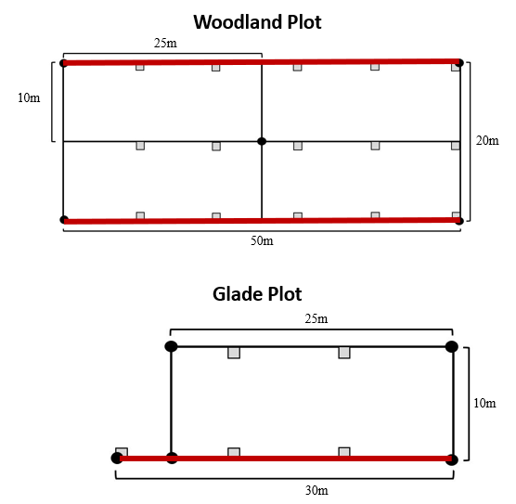
Figure S1. Plot orientation at Ozark National Scenic Riverways from 1999 to 2021. Orientation of 1 m² quadrats in woodland and glade plots is represented by grey-filled squares. Location of herbaceous species abundance transects is designated by bold red lines.
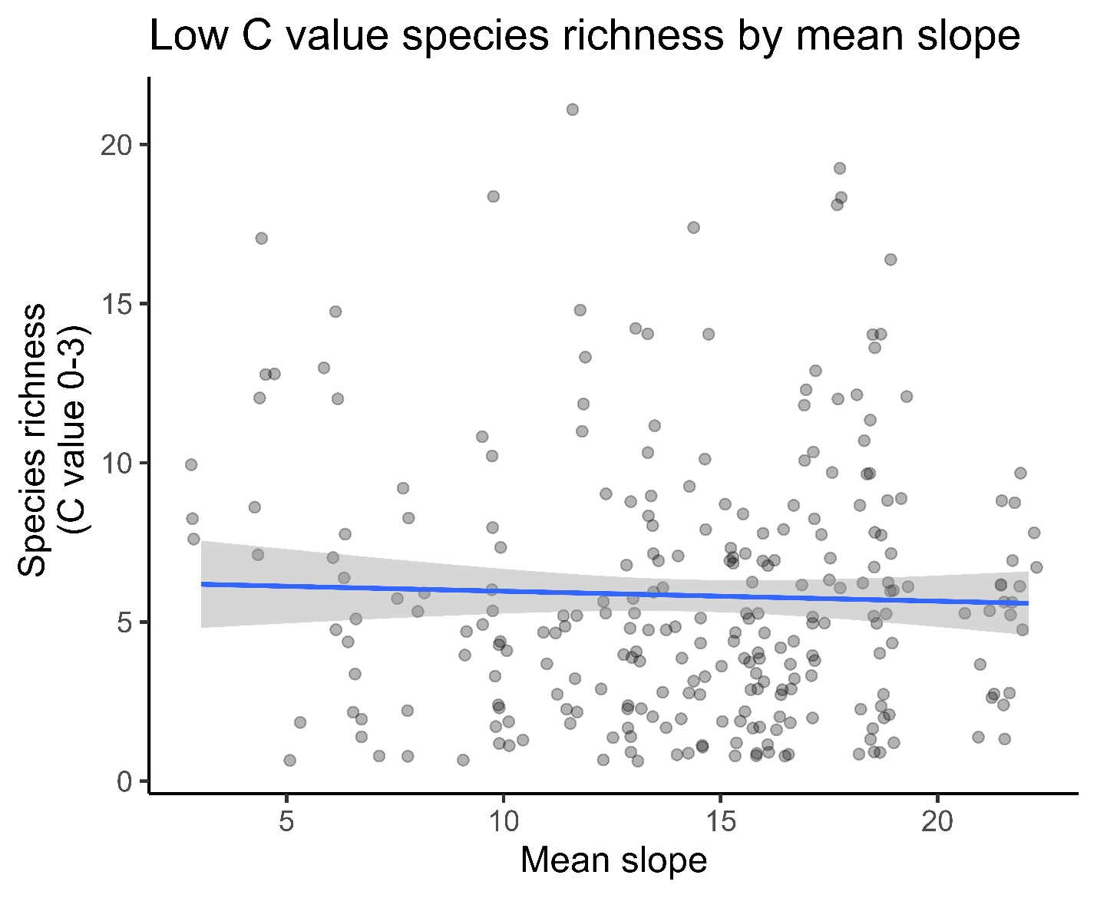
Figure S2. Species richness by mean slope for low C value species. Species richness for species with C values (coefficients of conservatism) 0-3 declines slightly as slope increases at Ozark National Scenic Riverways. Data collection was from 1999 to 2021.

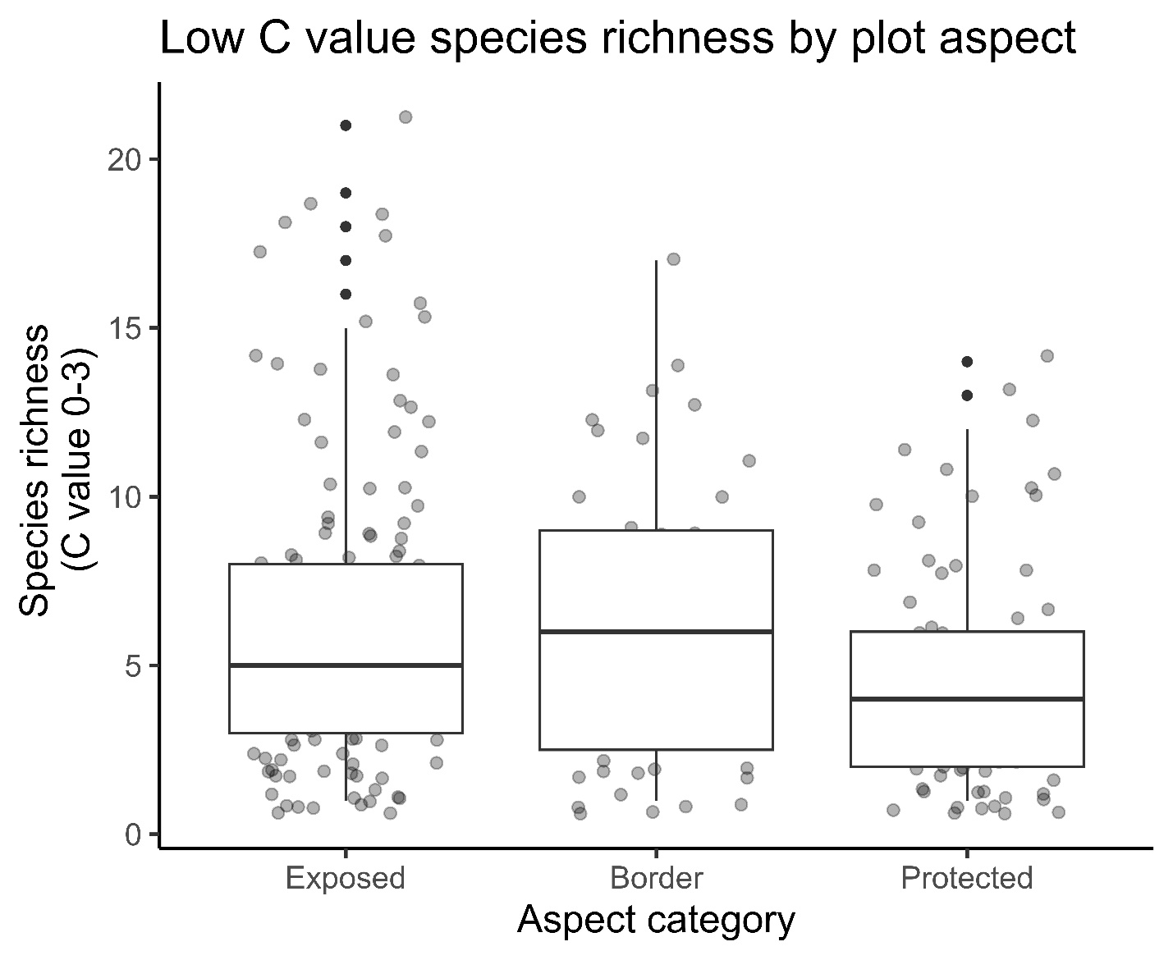
Figure S3. Species richness by aspect for low C value species. Species richness for species with C values 0-3 (coefficients of conservatism) is marginally lower for protected sites when compared with exposed and border sites at Ozark National Scenic Riverways. Data collection was from 1999 to 2021.
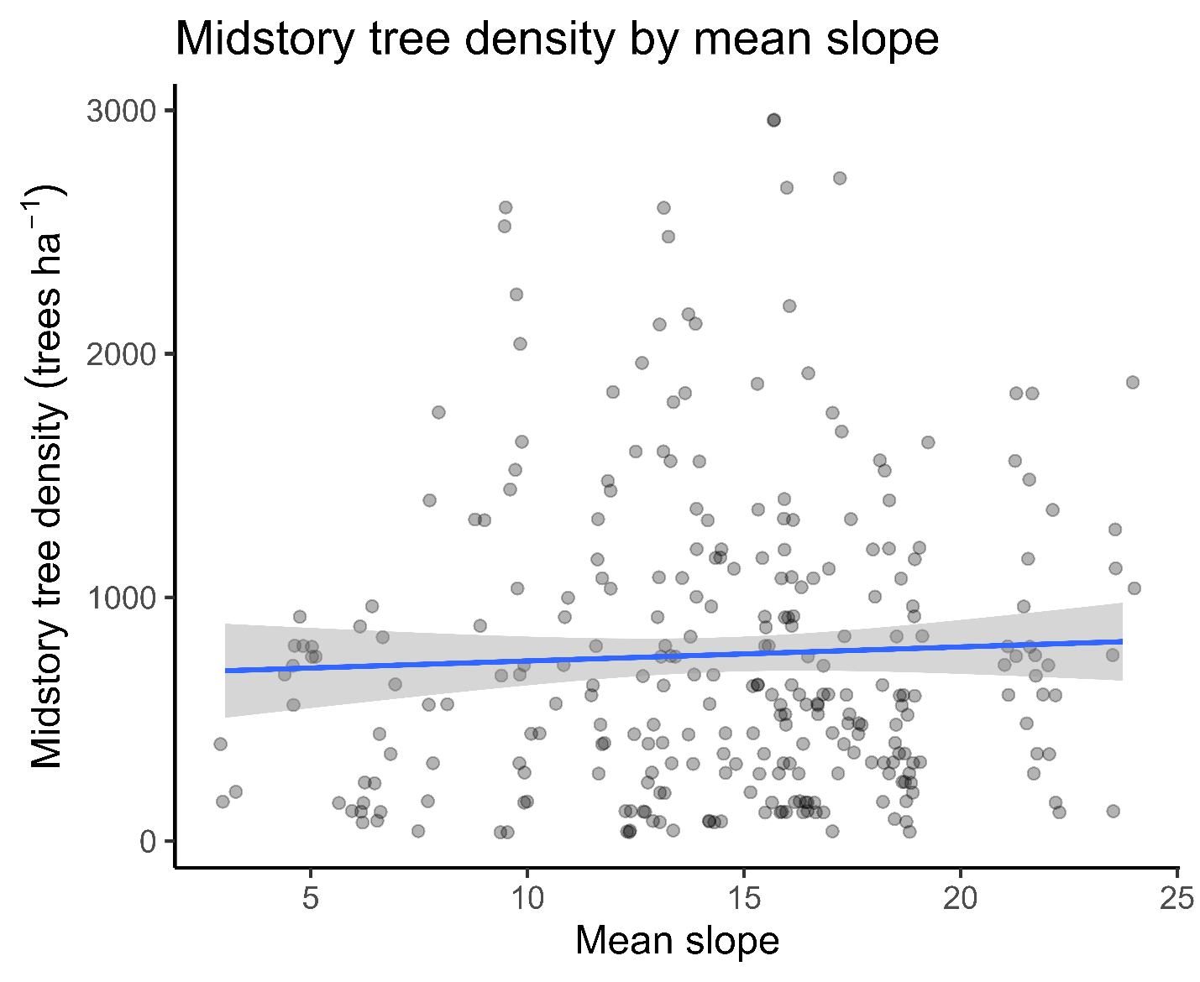
Figure S4. Midstory tree density by mean slope. Midstory (2.5-14.9 cm DBH) tree density as mean plot slope increases at Ozark National Scenic Riverways. Data was collected from 1999 to 2021. Midstory tree density increased marginally with mean plot slope increasing.

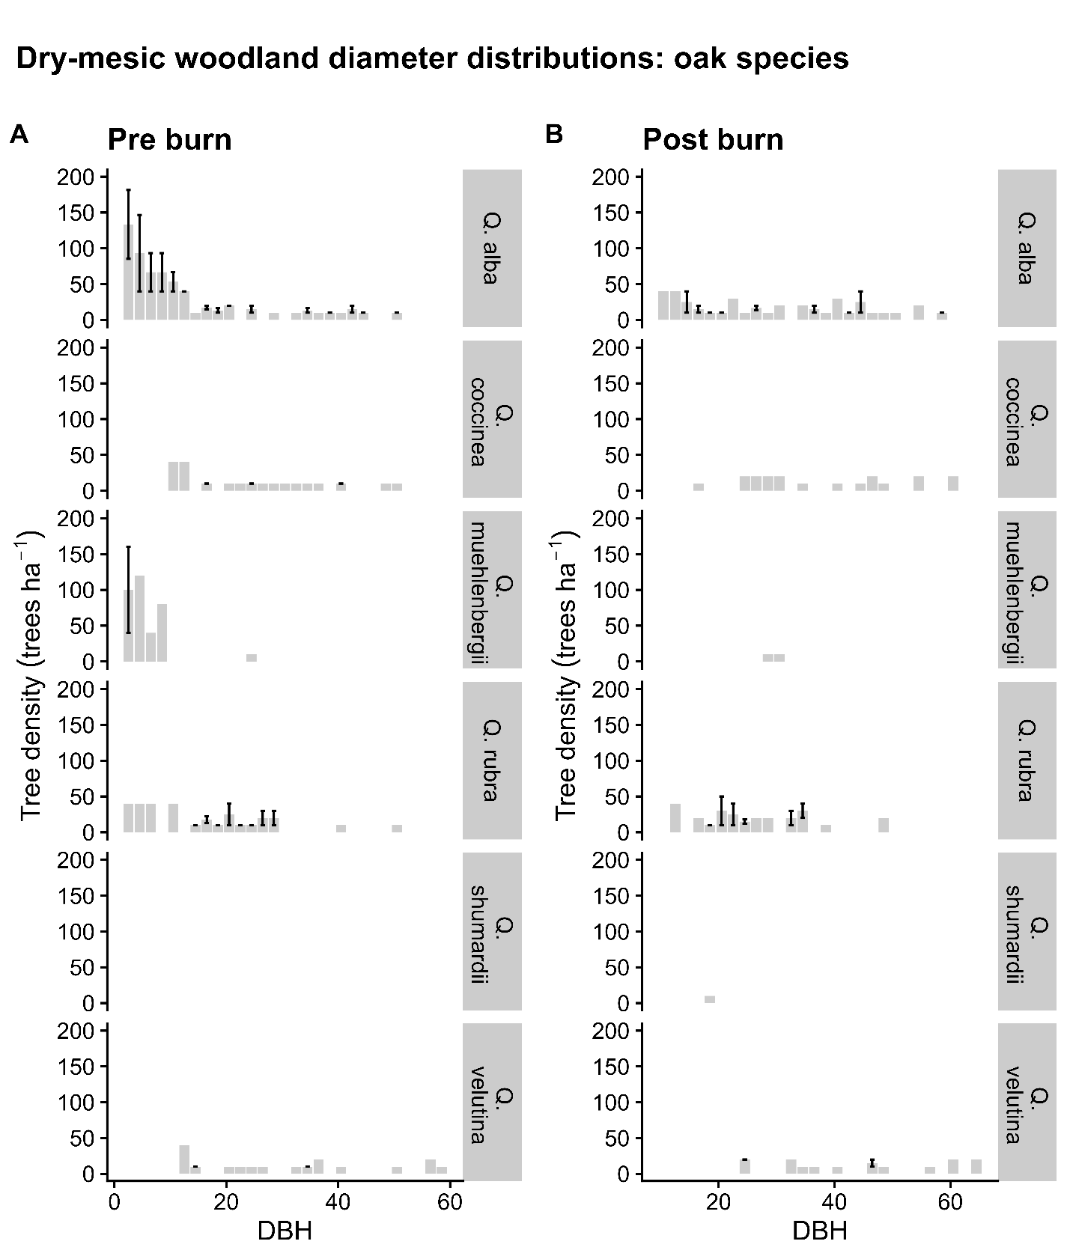
Figure S5. Dry-mesic woodland diameter distributions for oak species. Diameter distributions for dry-mesic woodlands at Ozark National Scenic Riverways. Post burn data indicates data collected after 5 burns. A lack of error bar indicates that only one plot had trees in that species group for a given diameter at breast height (DBH). Data was collected from 1999 to 2021. (A) Pre burn oak species diameter distributions. (B) Post burn oak species diameter distributions. The dominant species was Q. alba. Q. alba saw a decline in midstory trees but did not completely lose presence in the midstory layer in post burn treatments.

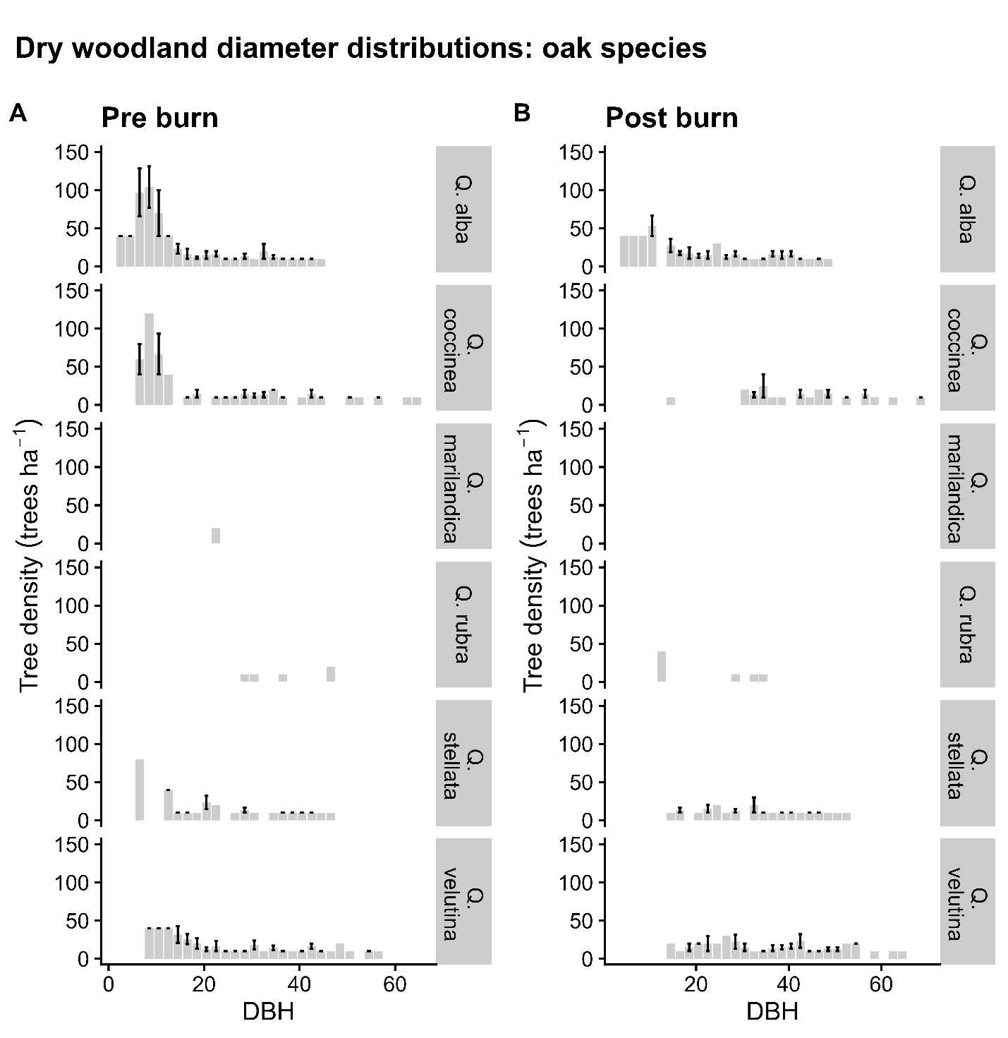
Figure S6. Dry woodland diameter distributions for oak species. Diameter distributions for dry woodlands at Ozark National Scenic Riverways. Post burn data indicates data collected after 5 burns. A lack of error bar indicates that only one plot had trees in that species group for a given diameter at breast height (DBH). Data was collected in post burn years from 1999 to 2021. (A) Pre burn oak species diameter distributions. (B) Post burn oak species diameter distributions. All species but white oak (Q. alba) appear to lose their midstory layer, and even for Q. alba, very few to only single plots contain midstory size trees.
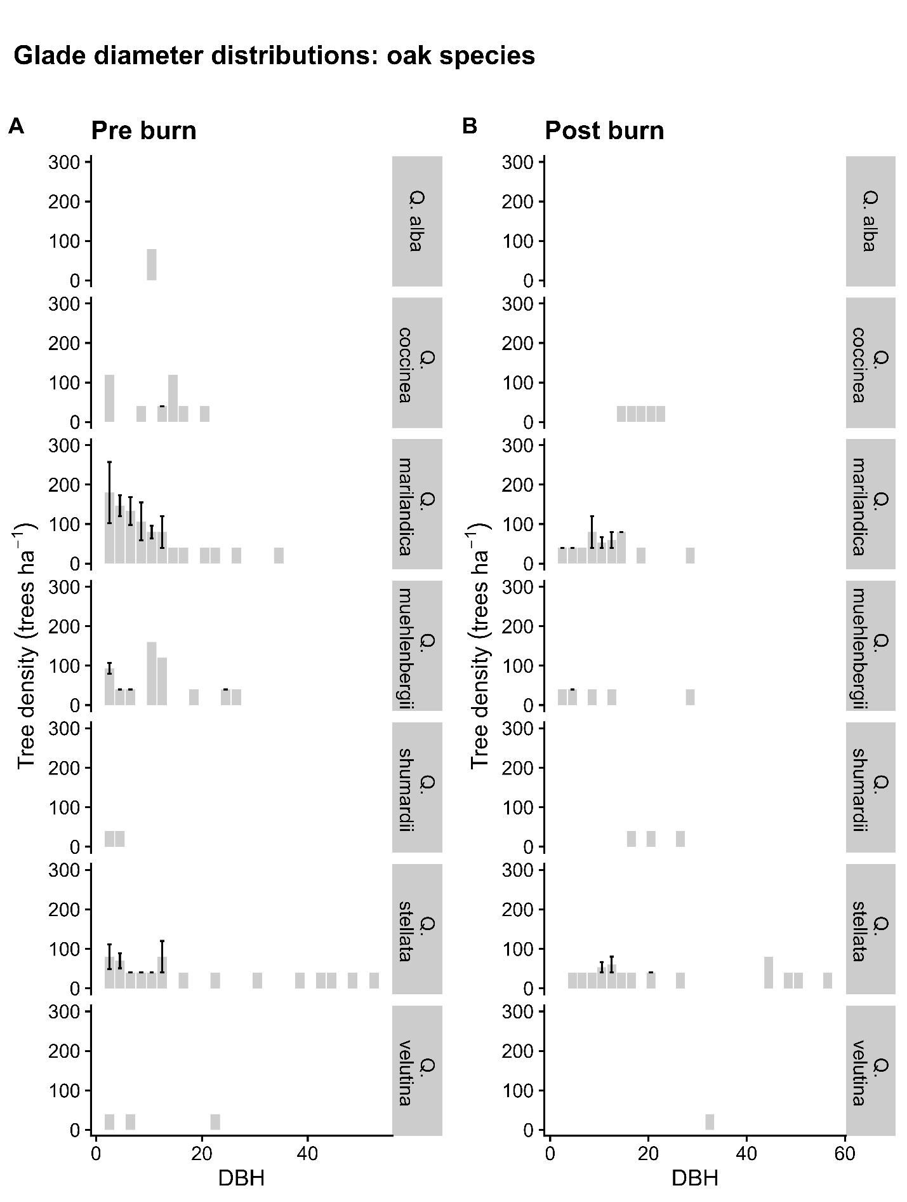
Figure S7. Glade diameter distributions for oak species. Diameter distributions for glades at Ozark National Scenic Riverways. Post burn data indicates data collected after 5 burns. A lack of error bar indicates that only one plot had trees in that species group for a given diameter at breast height (DBH). Data was collected in post burn years from 1999 to 2021. (A) Pre burn oak species diameter distributions. (B) Post burn oak species diameter distributions.

