SUPPORTING INFORMATION

Data S1. Post-fire trait and recovery strategy classifications Nothofagus spp. and Araucaria araucana in Andean temperate Araucaria-Nothofagus forests following the framework of Prior and Bowman (2020).

The classification of post-fire responses of the main tree species present in Araucaria-Nothofagus forests has been implemented following the framework of Prior and Bowman (2020) which considers post-fire responses of woody plant species in pyrophobic communities. Their work was an effort to incorporate functional traits of those species that are “fire-intolerant”—in the sense that are infrequently exposed to high severity fires, into a broader perspective, as the post-fire species’ responses and traits from fire-prone ecosystems have been previously described and categorized (Pausas et al. 2004; Pausas and Keeley 2014; Clarke et al. 2015). Under current climatic trends towards warmer and drier conditions resulting in more frequent and severe wildfires, many plant species that have evolved with less fire pressure than those in fire-prone ecosystems, are likely to experience unprecedented impacts of fire. Araucaria-Nothofagus forests are characterized by mixed severity regimes, with infrequent stand-replacing fires as well as frequent low severity surface fires, which has promoted species dominance by both fire-adapted and fire-sensitive species (González et al. 2010; Paritsis et al. 2015; Mundo et al. 2017). However, altered fire regimes may increase the exposure of these forests to more frequent severe wildfires. In this section, we are following Prior and Bowman’s (2020) general framework illustrated for Australasian species to describe and classify southern South American Andean fire traits of the principal tree species of temperate forests in south-central Chile, including Araucaria araucana and four species from the Nothofagus genus.
The long-lived conifer A. araucana undoubtedly has fire adaptations that allows it to survive low-to-moderate burn severity fires, although individuals are mostly killed in high severity fires (crown fires). Adult individuals can grow to around 40 m height, develop bark up to 20 cm thick that protects the cambium, have self-pruning lower branches (i.e., to reduce vertical fuel connectivity), and possesses seeds that are protected in non-serotinous cones (Veblen 1982; Burns 1993; González et al. 2013b). After fire, some live and apparently killed Araucaria individuals resprout vegetatively from epicormic buds located at the base of the trunk, from suckering on large lateral roots, and from protected terminal buds on branches (Veblen et al. 2005). In cases where mature female Araucaria individuals survive fire disturbance (low-to-moderate damage), they continue their seed production cycles, which may or may not coincide with their masting production years. Thus, A. araucana qualifies as a species suitable for the post-fire facultative resprouter/seeder classification (PFFRS) — a species that can resprout and produce seeds after fire.
Fire disturbance also importantly influences seedling recruitment and resprouting responses of the angiosperm southern beech species (i.e., N. alpina, N. dombeyi, N. obliqua, N. pumilio), which are fire-sensitive species that easily burn under moderate-to-high burn severity fires killing most individuals due to their thin bark. However, N. alpina and N. obliqua are species that can persist in the ecosystem after being burned due to their rapid resprouting capacity (Veblen et al. 1996); however, they are not cued to produce seeds after fire. Our observations indicate that these two species can resprout from the base and trunk of live and dead trees following a single high severity fire and even high-high severity reburns (i.e., partial to complete scorching and charring). If there are surviving individuals from these species in areas less severely affected by wildfire or in unburned patches within or next to the fire perimeter, these trees also can colonize burned areas over time according to their mast seeding cycles (Donoso et al. 2006a; Sola et al. 2022). However, fire itself does not induce seed production. Considering the traits of N. alpina and N. obliqua, and according to Prior and Bowman (2020)’s framework we classified these species as post-fire obligate resprouters (PFOR). Like both PFOR species, N. dombeyi and N. pumilio are also easily killed by fire, but these species cannot resprout after wildfire, and therefore cannot persist in severely burned areas (Veblen et al. 2003). Seeds of N. dombeyi and N. pumilio however, can colonize if there are surviving seed-bearing trees within fire refugia and/or at the burn perimeter if the distances from seed-bearing trees are not greater than their dispersal range (Kitzberger and Veblen 1999; Veblen et al. 2003; Urretavizcaya et al. 2022). Although we observed rare resprouts of these species (N. dombeyi, N. pumilio) within our study areas, these resprouts are uncommon and did not appear to be a response to fire damage. N. pumilio may produce basal shoots when a tree experiences damage or vertical growth from fallen trees in areas disturbed by winds (Veblen et al. 1996; Barrera et al. 2000) which may explain our observations. Given that N. dombeyi and N. pumilio do not resprout after fire and that seedlings can colonize severely burned areas by dispersal from unburned patches, we consider that in the framework of Prior and Bowman (2020) post-fire obligate colonizer (PFOC) is the most suitable classification for these species. Finally, and although all of these five tree species have masting seeding cycles, fire does not stimulate high production of seed of any of these species (Veblen et al. 1996, 2003; Donoso et al. 2006b; González et al. 2013a; Fajardo et al. 2016; Urretavizcaya et al. 2022).

Barrera, M. D., Frangi, J. L., Richter, L. L., Perdomo, M. H., and Pinedo, L. B. (2000). Structural and functional changes in Nothofagus pumilio forests along an altitudinal gradient in Tierra del Fuego, Argentina. J. Veg. Sci. 11, 179–188. doi: 10.2307/3236797.
Burns, B. R. (1993). Fire-Induced Dynamics of Araucaria araucana-Nothofagus antarctica Forest in the Southern Andes. J. Biogeogr. 20, 669–685. doi: 10.2307/2845522.
Clarke, P. J., Lawes, M. J., Murphy, B. P., Russell-Smith, J., Nano, C. E. M., Bradstock, R., et al. (2015). A synthesis of postfire recovery traits of woody plants in Australian ecosystems. Sci. Total Environ. 534, 31–42. doi: 10.1016/j.scitotenv.2015.04.002.
Donoso, P., Donoso, C., Gallo, L., Azpilicueta, M., Baldini, A., and Escobar, B. (2006a). “Nothofagus obliqua,” in Las especies arbóreas de los bosques templados de Chile y Argentina. Autoecología. (Valdivia, Chile), 471–485.
Donoso, P., Donoso, C., Navarro, C., and Escobar, B. (2006b). “Nothofagus dombeyi,” in Las especies arbóreas de los bosques templados de Chile y Argentina. Autoecología. (Valdivia, Chile), 423–432.
Fajardo, A., Torres-Díaz, C., and Till-Bottraud, I. (2016). Disturbance and density-dependent processes (competition and facilitation) influence the fine-scale genetic structure of a tree species’ population. Ann. Bot. 117, 67–77. doi: 10.1093/aob/mcv148.
González, M., Donoso, C., Ovalle, P., and Martinez-Pastur, G. (2013a). “Nothofagus pumilio,” in Las especies arbóreas de los bosques templados de Chile y Argentina. Autoecología, ed. C. Donoso (Valdivia, Chile: Marisa Cuneo Ediciones), 486–500.
González, M. E., Cortés, M., Gallo, L., Bekessy, S., and Echeverría, C. (2013b). “Coníferas Chilenas (Gimnospermas): Araucaria araucana,” in Las especies arbóreas de los bosques templados de Chile y Argentina. Autoecología, ed. C. Donoso (Valdivia, Chile: Marisa Cuneo Ediciones), 36–53.
González, M. E., Veblen, T. T., and Sibold, J. S. (2010). Influence of fire severity on stand development of Araucaria araucana–Nothofagus pumilio stands in the Andean cordillera of south-central Chile. Austral Ecol. 35, 597–615. doi: 10.1111/j.1442-9993.2009.02064.x.
Kitzberger, T., and Veblen, T. T. (1999). Fire-induced changes in northern Patagonian landscapes. Landsc. Ecol. 14, 1–15. doi: http://dx.doi.org/10.1023/A:1008069712826.
Mundo, I. A., Villalba, R., Veblen, T. T., Kitzberger, T., Holz, A., Paritsis, J., et al. (2017). Fire history in southern Patagonia: human and climate influences on fire activity in Nothofagus pumilio forests. Ecosphere 8, e01932. doi: 10.1002/ecs2.1932.
Paritsis, J., Veblen, T. T., Holz, A., and Gilliam, F. (2015). Positive fire feedbacks contribute to shifts from Nothofagus pumilio forests to fire-prone shrublands in Patagonia. J. Veg. Sci. 26, 89–101. doi: 10.1111/jvs.12225.
Pausas, J. G., Bradstock, R. A., Keith, D. A., Keeley, J. E., and Network, T. G. (Global C. of T. E. F.) (2004). Plant Functional Traits in Relation to Fire in Crown-Fire Ecosystems. Ecology 85, 1085–1100.
Pausas, J. G., and Keeley, J. E. (2014). Evolutionary ecology of resprouting and seeding in fire-prone ecosystems. New Phytol. 204, 55–65. doi: 10.1111/nph.12921.
Prior, L. D., and Bowman, D. M. J. S. (2020). Classification of Post-Fire Responses of Woody Plants to include Pyrophobic Communities. Fire 3, 15. doi: 10.3390/fire3020015.
Sola, G., Marchelli, P., Gallo, L., Chauchard, L., and El Mujtar, V. (2022). Stand development stages and recruitment patterns influence fine-scale spatial genetic structure in two Patagonian Nothofagus species. Ann. For. Sci. 79, 21. doi: 10.1186/s13595-022-01137-9.
Urretavizcaya, M. F., Albarracín, V., Orellana, I., Rago, M. M., López Bernal, P., Monelos, L., et al. (2022). Composition and Spatial Variation of Germinable Seed Bank in Burned Nothofagus pumilio Forests in Patagonia Argentina. Forests 13, 1902. doi: 10.3390/f13111902.
Veblen, T. T., Armesto, J. J., Burns, B. R., Kitzberger, T., Lara, A., León, B., and Young K. R. (2005). The coniferous forests of South America. Pages 701-725 in: F. Andersson and S. Gessel (eds.), Ecosystems of the World: Coniferous Forests. Elsevier, Amsterdam.
Veblen, T. T., Donoso, C., Kitzberger, T., and Rebertus, A.J. (1996). Ecology of southern Chilean and Argentinean Nothofagus forests. Pages 293-353 in: T.T. Veblen, R.S. Hill, and J. Read (eds.), Ecology and Biogeography of Nothofagus Forests. Yale University Press.
Veblen, T. T. (1982). Regeneration Patterns in Araucaria araucana Forests in Chile. J. Biogeogr. 9, 11–28. doi: 10.2307/2844727.
Veblen, T. T., Kitzberger, T., Raffaele, E., and Lorenz, D. C. (2003). “Fire History and Vegetation Changes in Northern Patagonia, Argentina,” in Fire and Climatic Change in Temperate Ecosystems of the Western Americas Ecological Studies., eds. T. T. Veblen, W. L. Baker, G. Montenegro, and T. W. Swetnam (New York, NY: Springer), 265–295. doi: 10.1007/0-387-21710-X_9.

Figure S1. Post-fire tree basal area boxplots by burn severity class (20 plots/class), separated by study area: (A) China Muerta and (B) Malleco-Tolhuaca. Basal area of live and dead (snags and downed logs) trees are shown separately by post-fire traits of the dominant tree species: PFFRS (post-fire facultative resprouter/seeder: A. araucana), PFOC (post-fire obligate colonizers: N. dombeyi, N pumilio), and PFOR (post-fire obligate resprouters: N. alpina, N. obliqua). Vertical lines (whiskers) indicate variability outside of the interquartile range, thick horizontal lines represent the median, and black dots are outliers. Individual observations (points) are included to better show the distribution of basal area within each postfire regeneration-trait group.

Figure S2. Summary of resprout abundances (resprouts/ha) of the main tree species in terms of median and interquartile range (IQR) in each study site and mean and standard error (SE) in each fire severity history.

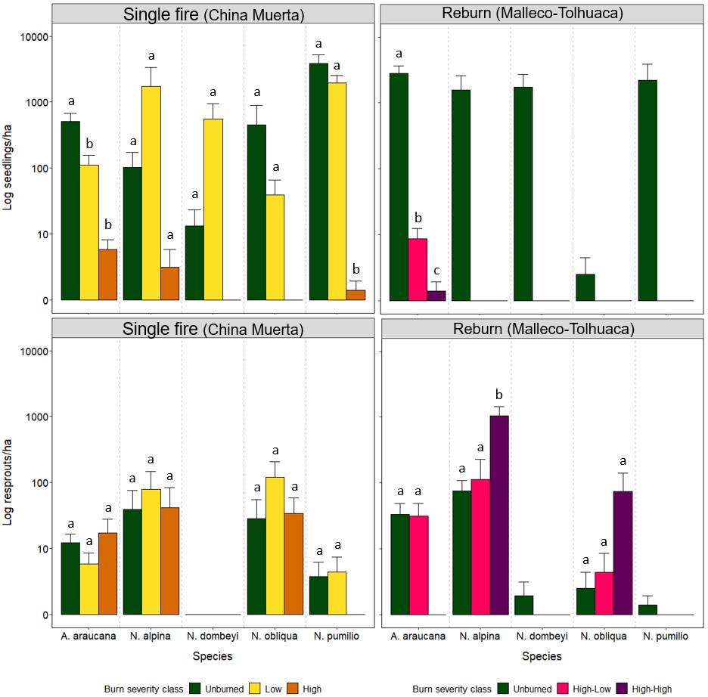

Table S1. Tree species recorded at China Muerta National Reserve (CM), and Malleco National Reserve and Tolhuaca National Park (MT) study sites. The presence of seedlings and resprouts within both study sites are also indicated. There is also reported the taxonomical family and the origin of the species (i.e., native or exotic species) with an asterisk.
Scientific name | Family | Growth stage |  |  | Comments
Scientific name | Family | Trees | Seedlings | Resprout | Comments
Gymnosperm
Araucaria araucana | Araucariaceae | X | X | X | Individuals found in all fire severity classes in both study areas.
Pinus radiata* | Pinaceae | X | - | - | Single tree individual found in unburned plot at CM.
Podocarpus salignus | Podocarpaceae | - | X | - | Single seedling individual found in unburned plot at MT.
Pseudotsuga menziesii* | Pinaceae | - | X | - | Few seedling individuals found in unburned plots at CM and reburned plots at MT.
Prumnopitys andina | Podocarpaceae | X | X | - | Tree individual and seedlings found in one unburned plot at CM.
Angiosperm
Aextoxicon puntatum | Aextoxicaceae | X | X | X | Resprout individuals found in reburned, and seedlings found in unburned plots at MT.
Dasyphyllum diacanthoides | Asteraceae | X | X | X | Tree, seedling and resprout individuals found in unburned plots at MT.
Embothrium coccineum | Proteaceae | X | - | - | Tree individual found in unburned plot at CM.
Gevuina avellana | Proteaceae | X | - | X | Tree and resprout individuals found in reburned areas at MT.
Lomatia dentata | Proteaceae | X | X | X | Tree and resprout individuals found in reburned, and seedlings in unburned plots at MT.
Lomatia hirsuta | Proteaceae | X | - | X | Tree and resprouts found in reburned plots at MT.
Nothofagus alpina | Nothofagaceae | X | X | X | Tree, seedlings and resprout individuals found at CM and MT.
Nothofagus antarctica | Nothofagaceae | X | - | X | Tree and resprout individuals found in reburned plots at MT.
Nothofagus dombeyi | Nothofagaceae | X | X | X | Tree, seedlings and resprout individuals found at CM and MT.
Nothofagus obliqua | Nothofagaceae | X | X | X | Tree, seedlings and resprout individuals found at CM and MT.
Nothofagus pumilio | Nothofagaceae | X | X | X | Tree, seedlings and resprout individuals found at CM and MT.
Nothofagus sp. | Nothofagaceae | X | - | - | Tree charred individuals found in reburned areas at MT.
Persea lingue | Lauraceae | X | X | - | Tree and seedlings individuals found in unburned plots at MT.

Table S2. Pairwise multilevel comparison results (ρ values) from permutational multivariate analysis (PERMANOVA) of post-fire forest structure (e.g., basal area) among nine field-measured variables grouped by burn severity at China Muerta (CM) and Malleco-Tolhuaca (MT) study sites.
Study sites | Burn severity
 |  | Unburned | Low | High
China Muerta  (single fire) | Unburned | - | 0.228 | 0.001
China Muerta  (single fire) | Low |  | - | 0.014
China Muerta  (single fire) | High |  |  | -
 |  | Unburned | High-Low | High-High
Malleco-Tolhuaca  (reburn) | Unburned | - | 0.001 | 0.002
Malleco-Tolhuaca  (reburn) | High-Low |  | - | 0.056
Malleco-Tolhuaca  (reburn) | High-High |  |  | -
Burn severity was the grouping factor for the nine field-measured variables included in the PERMANOVA analysis: percent of ground cover of bare soil, coarse and fine woody debris; relative vegetation cover; abundance coverage of herbs, shrubs, and bamboos; and live and dead tree density. Bolded ρ values indicate significant differences (P < 0.05) in forest structure among burn severity classes. Pairwise comparisons were corrected with Holm adjustment method.

Table S3. Summary of seedling abundances (seedlings/ha) of the principal tree species in terms of median and interquartile range (IQR) in each study site and mean and standard error (SE) in each fire severity history.
Site | Burn severity classification | Median (IQR) | Mean seedling abundance and standard error (SE)
Site | Burn severity classification | Median (IQR) | Araucaria araucana | Nothofagus alpina | Nothofagus dombeyi | Nothofagus obliqua | Nothofagus pumilio
China Muerta  (single burn) | All plots | 0.0 (0.0 – 14.3) | 209.8 (62.8) | 615.5 (531.2) | 187.7 (133.5) | 164.9 (145.9) | 1936.2 (526.7)
China Muerta  (single burn) | Unburned | 0.0 (0.0 – 297.0) | 513.0 (164.6) | 102.7 (71.3) | 13.4 (9.8) | 455.4 (436.8) | 3855.4 (1359.1)
China Muerta  (single burn) | Low | 0.0 (0.0 – 71.4) | 110.7 (45.3) | 1741.1 (1588.5) | 549.8 (394.5) | 39.3 (27.0) | 1952.7 (587.9)
China Muerta  (single burn) | High | 0.0 (0.0 – 0.0) | 5.7 (2.4) | 2.9 (2.9) | 0.0 (0.0) | 0.0 (0.0) | 0.7 (0.7)
Malleco-Tolhuaca (reburned | All plots | 0.0 (0.0 – 0.0) | 941.3 (325.6) | 524.8 (340.1) | 578.4 (329.2) | 0.7 (0.7) | 732.3 (558.3)
Malleco-Tolhuaca (reburned | Unburned | 0.0 (0.0 – 759.0) | 2814.6 (842.9) | 1574.3 (995.3) | 1735.2 (950.9) | 2.1 (2.1) | 2196.8 (1653.5)
Malleco-Tolhuaca (reburned | High-Low | 0.0 (0.0 – 0.0) | 8.6 (3.9) | 0.0 (0.0) | 0.0 (0.0) | 0.0 (0.0) | 0.0 (0.0)
Malleco-Tolhuaca (reburned | High-High | 0.0 (0.0 – 0.0) | 0.7 (0.7) | 0.0 (0.0) | 0.0 (0.0) | 0.0 (0.0) | 0.0 (0.0)

Table S4. Summary of resprout abundances (resprouts/ha) of the principal tree species in terms of median and interquartile range (IQR) in each study site and mean and standard error (SE) in each fire severity history.
Site | Burn severity classification | Median (IQR) | Mean resprout abundance and standard error (SE)
Site | Burn severity classification | Median (IQR) | Araucaria araucana | Nothofagus alpina | Nothofagus dombeyi | Nothofagus obliqua | Nothofagus pumilio
China Muerta  (single burn) | All plots | 0.0 (0.0 – 0.0) | 11.7 (4.0) | 53.8 (29.0) | 0.0 (0.0) | 60.6 (32.0) | 2.6 (1.3)
China Muerta  (single burn) | Unburned | 0.0 (0.0 – 0.0) | 12.1 (1) | 36.6 (36.1 | 0.0 (0.0) | 28.3 (26.8) | 3.5 (2.5)
China Muerta  (single burn) | Low | 0.0 (0.0 – 0.0) | 5.7 (2.8) | 79.9 (69.0) | 0.0 (0.0) | 119.5 (89.2) | 4.2 (3.1)
China Muerta  (single burn) | High | 0.0 (0.0 – 0.0) | 17.1 (10.8) | 41.7 (41.7) | 0.0 (0.0) | 34.0 (24.2) | 0.0 (0.0)
Malleco-Tolhuaca (reburned | All plots | 0.0 (0.0 – 0.0) | 21.7 (7.9) | 416.2 (145.6) | 0.5 (0.5) | 27.1(3.0) | 0.2 (0.2)
Malleco-Tolhuaca (reburned | Unburned | 0.0 (0.0 – 0.0) | 33.6 (15.1) | 75.7 (34.3) | 1.4 (1.4) | 2.1 (2.1) | 0.7 (0.7)
Malleco-Tolhuaca (reburned | High-Low | 0.0 (0.0 – 0.0) | 31.4 (18.0) | 114.6 (114.6) | 0.0 (0.0) | 4.2 (4.2) | 0.0 (0.0)
Malleco-Tolhuaca (reburned | High-High | 0.0 (0.0 – 0.0) | 0.0 (0.0) | 1058.2 (388.1) | 0.0 (0.0) | 75.0 (66.6) | 0.0 (0.0)

