Supporting information

Ecological trade-offs associated with fuel breaks in sagebrush ecosystems
Authors:
Morgan D. Roche^{1,2*}, D. Joanne Saher², Erin K. Buchholtz^{1,6}, Michele R. Crist³, Douglas J. Shinneman⁴, Cameron L. Aldridge^{1^}, Brianne E. Brussee^{5^}, Peter S. Coates^{5^}, Cali L. Weise^{5^}, Julie A. Heinrichs²

*Corresponding author: Morgan D. Roche, mroche@usgs.gov
^ Alphabetical
Affiliations:
- U.S. Geological Survey, Fort Collins Science Center, Fort Collins, CO 80526, USA
- Natural Resources Ecology Laboratory, Colorado State University, in cooperation with U.S. Geological Survey, Fort Collins Science Center, Fort Collins, CO 80526, USA
- Bureau of Land Management, Fire and Aviation, National Interagency Fire Center, Boise, ID 83705, USA
- U.S. Geological Survey, Forest and Rangeland Ecosystem Science Center, Boise, ID 83702, USA
- U.S. Geological Survey, Western Ecological Research Center, Dixon, CA 95620, USA
- U.S. Geological Survey, South Carolina Cooperative Fish & Wildlife Research Unit, Clemson, SC 29631, USA

Supporting Figures
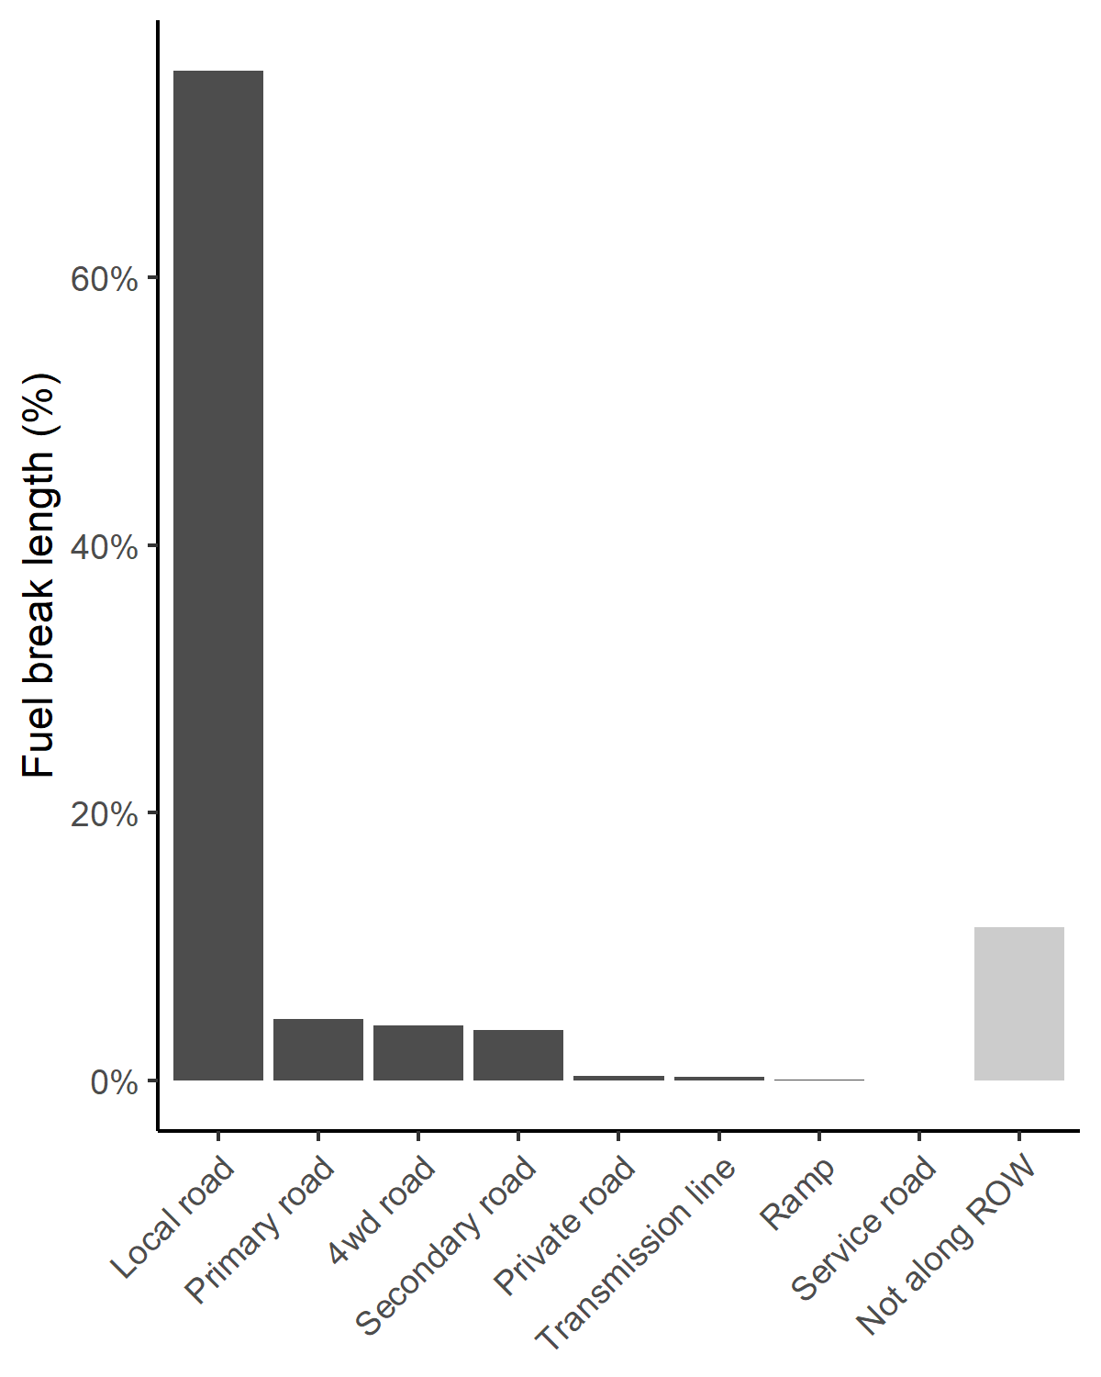
Figure S1. Fuel break lengths as a percent of the total length of the fuel break network. Dark gray colored bars indicate fuel breaks that are associated with rights-of-way (ROW; i.e., within 300m of a road or transmission line), while light gray indicates the fuel break length that is not within 300m of a right-of-way. Primary road = divided highways, secondary road = highway with at-grade intersections, local road = paved or unpaved single lane road, 4wd road = unpaved road with four-wheel drive required for access, ramp = highway access road, service road = a road that provides service structure access along primary road, private road = privately maintained road, transmission line = high voltage electric power lines (U.S. Census Bureau 2019).

Table S1. Environmental variables summarized for individual fuel breaks in the sagebrush biome. Columns include the method of data extraction, the units or calculations needed, the citation of the original data, and an ecological justification for inclusion. Asterisks indicate variables used in data cleaning or analyses. NA = not applicable, BLM = Bureau of Land Management, PAC = Priority Areas for Conservation.
Parameter | Extracted from | Units/calculations | Citation | Justification
Area | Fuel break polygon | km² | NA | Larger fuel breaks may be more successful
Perimeter | Fuel break polygon | km | NA | Larger fuel breaks may be more successful
Length* | Centerline | km | NA | Larger fuel breaks may be more successful
Within city* | Fuel break polygon | Intersect by location | Cartographic boundary shapefiles: Urban Areas (U.S. Census Bureau 2018) | Fuel breaks within city limits may function more to protect human life and infrastructure in contrast to habitat
Within wildland urban interface (WUI)* | Centroid | Extract | National fire risk assessment residentially developed populated areas (Bureau of Land Management 2021) | Fuel breaks within WUI may function more to protect human life and infrastructure in contrast to habitat
Intersects with road | Fuel break polygon | Intersect by location | TIGER/Line Shapefiles (U.S. Census Bureau 2019) | Roads provide fire crew access to the fuel break
State | Centroid | Extract | NA | Local governments may allocate resources differently to fuel breaks or to fire suppression activities
County | Centroid | Extract | NA | Local governments may allocate resources differently to fuel breaks or to fire suppression activities
BLM district office | Centroid | Extract | Rapid ecoregional assessment Colorado Plateau 2010 Field offices (Bureau of Land Management 2010) | BLM offices may allocate resources differently to fuel break construction or maintenance
BLM field office* | Centroid | Extract | Rapid ecoregional assessment Colorado Plateau 2010 Field offices (Bureau of Land Management 2010) | BLM offices may allocate resources differently to fuel break construction or maintenance
Distance to road* | Centroid | Extract | TIGER/Line Shapefiles (U.S. Census Bureau 2019) | Fuel breaks along rights-of-way are accessible to fire crews
Distance to transmission line* | Centroid | Extract | TIGER/Line Shapefiles (U.S. Census Bureau 2019) | Fuel breaks along rights-of-way are accessible to fire crews
Resistance* | Fuel break polygon + 150m buffer | Majority | Ecological resilience (Chambers et al. 2023) | Areas with low resistance and resilience may be more likely to develop a grass-fire cycle
Resilience* | Fuel break polygon + 150m buffer | Majority | Invasion resistance (Chambers et al. 2023) | Areas with low resistance and resilience may be more likely to develop a grass-fire cycle
Burn probability* | Fuel break polygon + 150m buffer | Mean | Spatial dataset of probabilistic wildfire risk components for the conterminous United States (Short et al. 2020) | Areas with high wildfire risk are more likely to burn, fuel breaks in these areas are more likely to intersect a wildfire
Predicted fuel break effectiveness* | Fuel break polygon + 150m buffer | Mean | Predictive maps of fuel break effectiveness by treatment type and underlying resilience to disturbance and resistance to invasion across the western U.S. (Brussee et al. 2023) | Fuel breaks predicted to be more likely to alter wildfire behavior when fuel break effectiveness is high
Sagebrush fractional component (2020) | Fuel break polygon + 150m buffer | Mean | Rangeland Condition Monitoring Assessment and Projection (RCMAP) fractional component time series data (Rigge et al. 2021) | Placing fuel breaks in intact sagebrush habitats may increase the chances of degrading high quality habitat
Annual herbaceous fractional component (2020)* | Fuel break polygon + 150m buffer | Mean | Rangeland Condition Monitoring Assessment and Projection (RCMAP) fractional component time series data (Rigge et al. 2021) | Placing fuel breaks in annual grasslands may disconnect fine fuels
Habitat type | Fuel break polygon + 150m buffer | Majority | National Land Cover Database (NLCD) 2019 (Dewitz 2021) | The fuel context surrounding fuel breaks may influence fuel break success
Distance to sage-grouse PAC* | Centroid | km | Greater sage-grouse Priority Areas for Conservation (PAC) (U.S. Fish and Wildlife Service 2013) | Sage-grouse are sensitive to both linear features and wildfires
Distance to sagebrush avian obligate core habitat* | Centroid | km | Sagebrush bird core areas (Tack 2022) | Sagebrush obligate birds are sensitive to both linear features and wildfires
Distance pygmy rabbit habitat* | Centroid | km | Primary and suitable pygmy rabbit habitat (Smith et al. 2019) | Pygmy rabbits are sensitive to both linear features and wildfires

Table S2. Results of the main and random effects of a generalized linear mixed-effects model with a beta distributed error structure. BLM = Bureau of Land Management
 | Resistance |  | Resilience
 | Estimated coefficient | Standard error | Estimated coefficient | Standard error
Fuel break effectiveness
Low | 0.26 | 0.03 | 0.27 | 0.03
Moderate – Low | 0.26 | 0.03 | 0.22 | 0.03
Moderate | 0.20 | 0.02 | 0.20 | 0.02
Moderate – High + High | 0.10 | 0.02 | 0.08 | 0.01
 | Variance | Standard deviation | Variance | Standard deviation
Random effect
BLM field office | 0.97 | 0.98 | 0.88 | 0.94

Table S3. Results of the main and random effects of a generalized linear mixed-effect model with a negative binomial error structure. BLM = Bureau of Land Management.
 | Resistance |  | Resilience
 | Estimated coefficient | Standard error | Estimated coefficient | Standard error
Annual herbaceous cover (%)
Low | 5.05 | 0.53 | 4.09 | 1.02
Moderate – Low | 3.76 | 0.66 | 2.27 | 0.58
Moderate | 3.40 | 0.59 | 2.81 | 0.71
Moderate – High + High | 2.85 | 0.87 | 1.38 | 0.36
 | Variance | Standard deviation | Variance | Standard deviation
Random effect
BLM field office | 1.32 | 1.15 | 0.88 | 0.94

References

Brussee BE, Weise CL, Coates PS, et al (2023) Predictive maps of fuel break effectiveness by treatment type and underlying resilience to disturbance and resistance to invasion across the western U.S.: U.S. Geological Survey data release. https://doi.org/10.5066/P9OPI1N3
Bureau of Land Management (2021) National fire risk assessment Residentially Developed Populated Areas (RDPA) moving window. https://blm-egis.maps.arcgis.com/home/item.html?id=c5a265eadbbd4f858bf231b70e26d2de
Bureau of Land Management (2010) BLM Rapid Ecoregional Assessment Colorado Plateau 2010 BLM Field Offices. In: https://www.sciencebase.gov/catalog/item/5d810456e4b0c4f70d0540ee
Chambers J, Brown J, Bradford J, et al (2023) New indicators of ecological resilience and invasion resistance to support prioritization and management in the sagebrush biome, United States. Dryad. https://doi.org/10.5061/dryad.h18931zpb
Dewitz J (2021) National Land Cover Database (NLCD) 2019 products. US Geological Survey. https://doi.org/https://doi.org/10.5066/P9KZCM54
Rigge MB, Bunde B, Shi H, Postma K (2021) Rangeland condition monitoring assessment and projection (RCMAP) fractional component time-series across the Western U.S. 1985-2020: U.S. Geological Survey data release
Short KC, Finney MA, Vogler KC, et al (2020) Spatial datasets of probabilistic wildfire risk components for the United States (270m). 2nd Edition. Fort Collins, CO: Forest Service Research Data Archive. https://doi.org/https://doi.org/10.2737/RDS-2016-0034-2
Smith IT, Rachlow JL, Svancara LK, et al (2019) Habitat specialists as conservation umbrellas: Do areas managed for greater sage-grouse also protect pygmy rabbits? Ecosphere 10:e02827. https://doi.org/10.1002/ecs2.2827
Tack J (2022) Sagebrush bird core areas. https://www.sciencebase.gov/catalog/item/6203f4ecd34e622189de5a4c
U.S. Census Bureau (2019) 2019 TIGER/Line Shapefiles (machine readable data files)
U.S. Census Bureau (2018) Cartographic boundary shapefiles: Urban areas. https://www.census.gov/geographies/mapping-files/2018/geo/carto-boundary-file.html
U.S. Fish and Wildlife Service (2013) Greater sage-grouse conservation objectives: Final report. Denver, CO

