The impact of a severe wildfire on canopy structure and composition in a lowland mixed-eucalypt forest in southeastern Australia – supplementary material
Table S1 Mean and 95% confidence intervals of species parameters for the crown loss and crown death models
 |  | α |  |  | β |  |  | γ
 |  | 95% CI |  |  | 95% CI |  |  | 95% CI
Model and species | Mean | Min | Max | Mean | Min | Max | Mean | Min | Max
Crown loss
E. baxteri | -32.6 | -38.1 | -29.1 | 64.86 | 57.88 | 75.35 | 0.008 | 0.001 | 0.025
E. botryoides | -31.8 | -35.6 | -26.7 | 64.09 | 55.09 | 72.21 | 0.026 | 0.010 | 0.055
E. consideniana | -31.3 | -34.9 | -24.1 | 61.48 | 47.64 | 68.28 | 0.008 | 0.001 | 0.023
E. globoidea | -32.6 | -35.7 | -29.8 | 63.43 | 58.12 | 69.02 | 0.012 | 0.003 | 0.024
E. mackintii | -32.5 | -37.3 | -28.7 | 64.01 | 56.40 | 72.69 | 0.012 | 0.002 | 0.031
E. sieberi | -32.6 | -36.1 | -29.9 | 66.15 | 60.33 | 73.91 | 0.029 | 0.021 | 0.039
Crown death
E. baxteri | -3.26 | -4.00 | -2.68 | 117.53 | 42.86 | 371.48 | 0.92 | 0.66 | 1.49
E. botryoides | -2.92 | -3.83 | -2.04 | 110.17 | 46.14 | 301.00 | 0.75 | 0.54 | 1.13
E. consideniana | -2.35 | -3.01 | -1.75 | 55.07 | 25.81 | 113.13 | 0.82 | 0.58 | 1.15
E. globoidea | -3.20 | -3.71 | -2.77 | 51.99 | 30.51 | 87.23 | 0.66 | 0.51 | 0.83
E. mackintii | -2.98 | -3.79 | -2.23 | 58.67 | 21.50 | 120.14 | 0.65 | 0.40 | 0.90
E. sieberi | -3.33 | -3.87 | -2.87 | 73.34 | 46.51 | 114.48 | 0.64 | 0.52 | 0.78
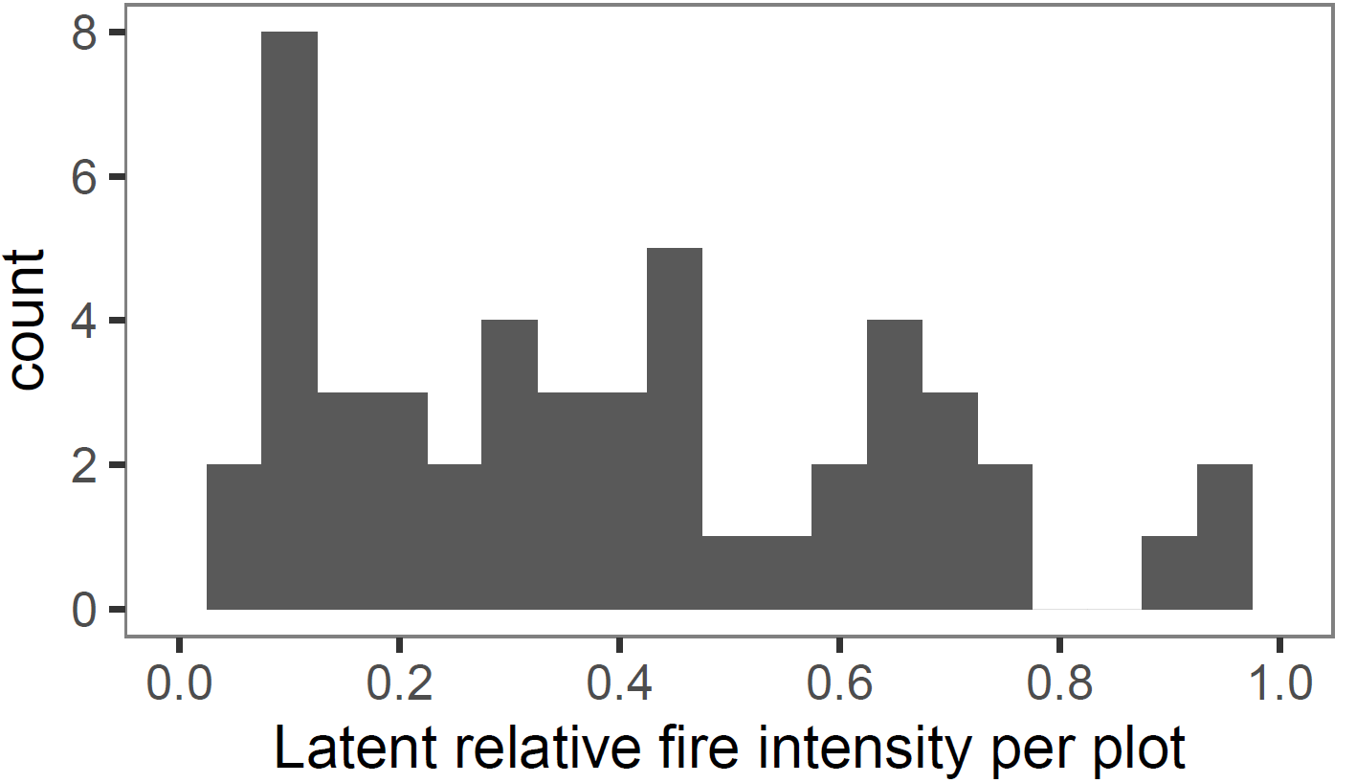Figure S1 The distribution of plot-level relative fire intensity estimates derived from the crown death model (n=49).
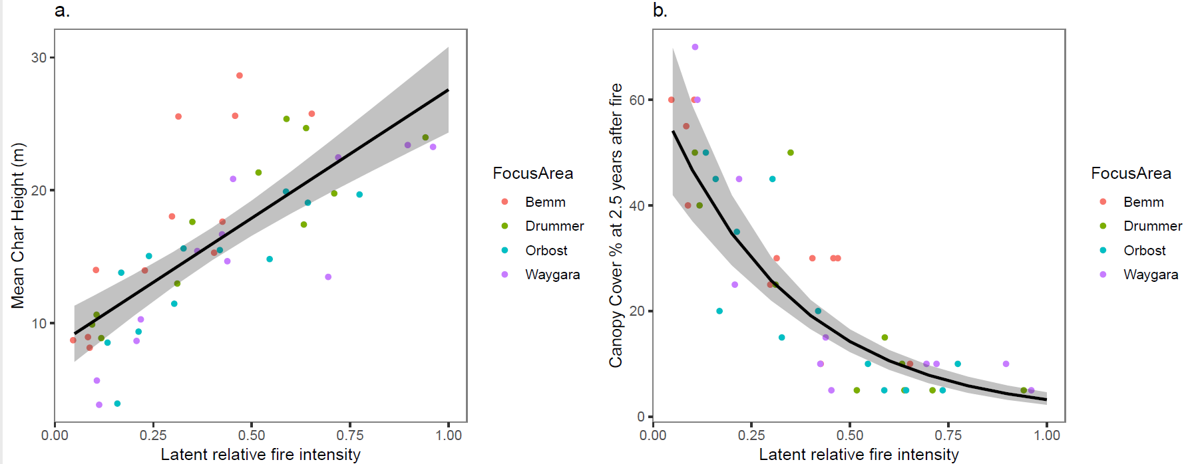Figure S2 Plot-level estimated relative fire intensity vs (a) mean char height (m) and (b) canopy cover (%) 2.5 years after fire. The fitted linear models showed the relationships to be significant (R² = 0.58, p<0.001 and R² = 0.72, p<0.001 respectively).
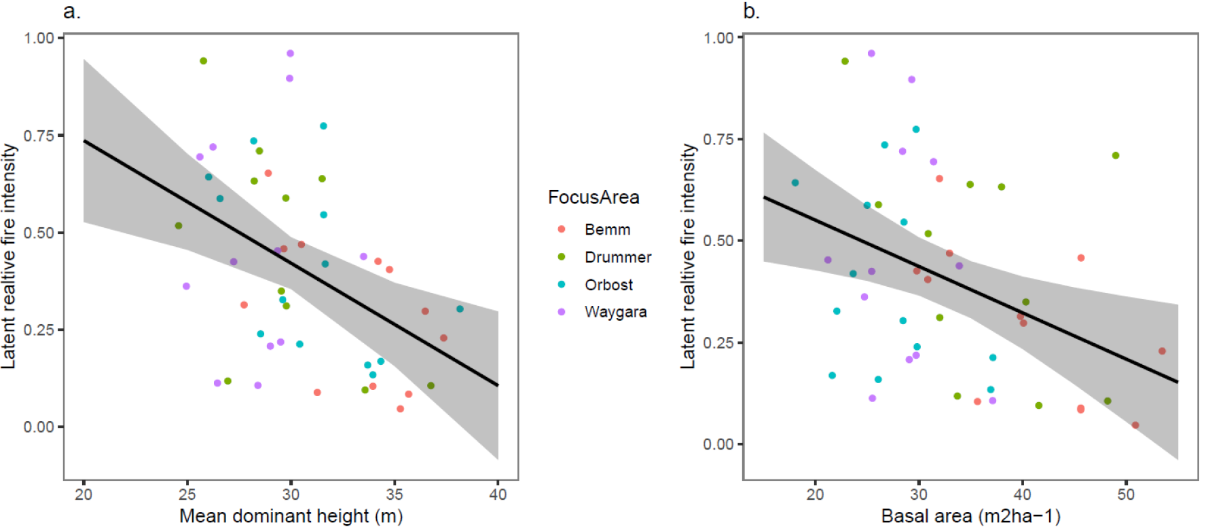Figure S3 Plot-level estimated relative fire intensity vs (a) mean dominant height (m) and (b) basal area (m²ha⁻¹) 2.5 years after fire. The fitted linear models showed the relationships to be significant but weak (R² = 0.22, p<0.01 and R² = 0.23, p<0.01 respectively).
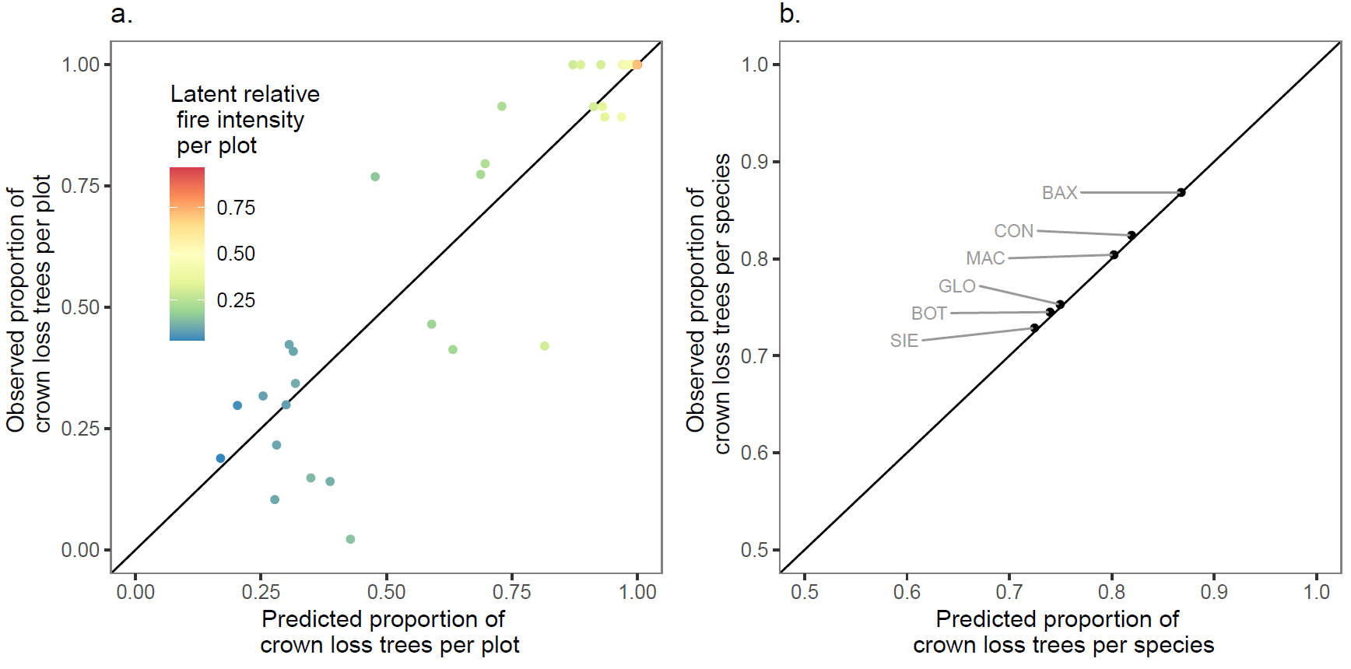Figure S4 Observed versus predicted proportion of trees with >50% crown loss summarised by plot and species. The crown loss model predicts crown loss status (0 or 1) in response to latent relative fire intensity (as shown in a), species (as shown in b) and DBHOB. The points showing observed vs predicted fall close to the 1:1 line indicating high goodness of fit for the model.
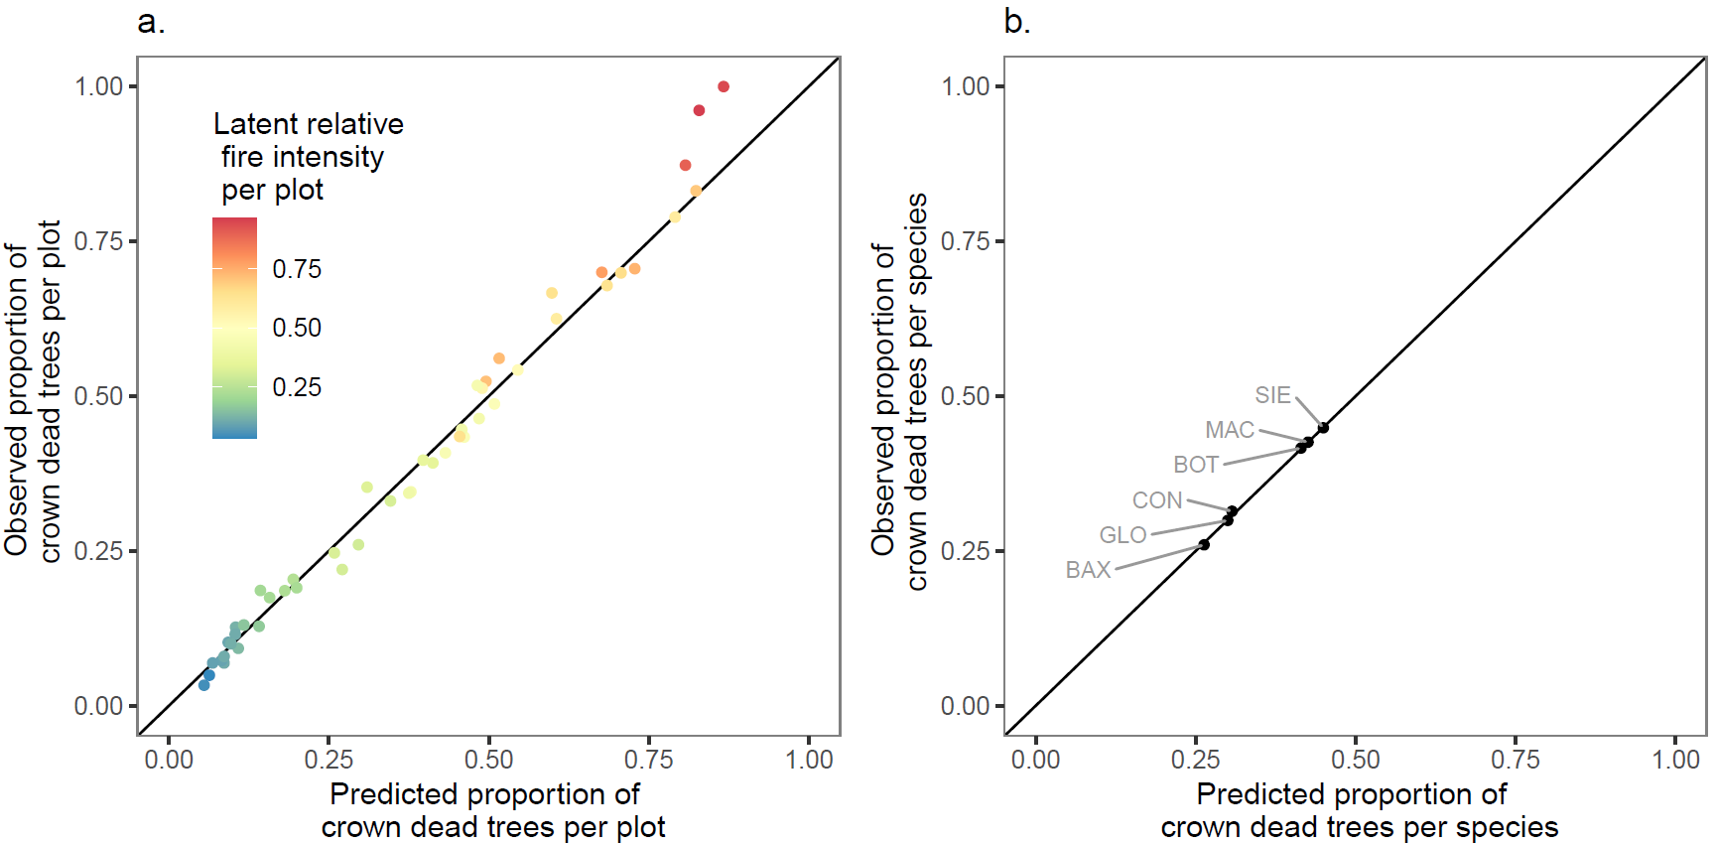Figure S5 Observed versus predicted proportion of crown dead trees summarised by plot and species. The crown death model predicts crown death status (0 or 1) in response to latent or unobserved fire intensity (as shown in a), species (as shown in b) and DBHOB. The points showing observed vs predicted fall close to the 1:1 line indicating high goodness of fit for the model.
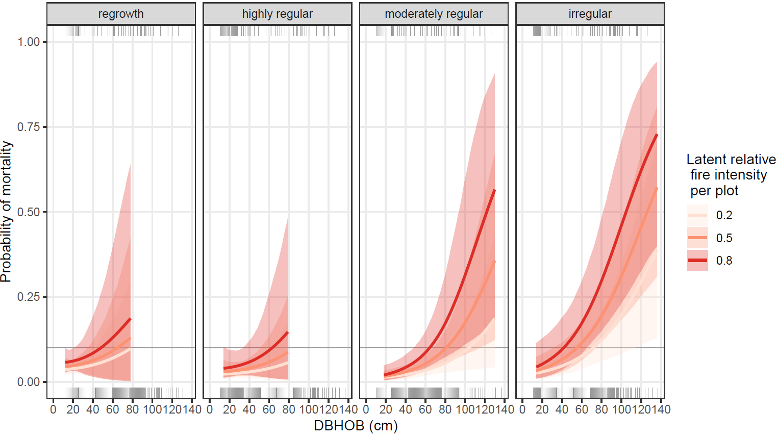Figure S6 Predicted proportion of E. sieberi trees that died as a function of DBHOB, relative fire intensity, and crown form (regrowth, highly regular, moderately regular and irregular).
Table S2 Mean and 95% confidence intervals of crown form parameters for the E. sieberi and E. globoidea mortality models. For each species the model is of the form: y_{ijk} = Bernoulli (p_{ijk})
p_{ijk} = a_{0j} + a_{1j} * D_{ijk} + a_{2j} * I_{i} + a_{3j} * D_{ijk} * I_{i}
where y_{ijk} is the observed mortality status (0 = alive, 1 = dead) of the kth individual of crown form j in plot i, which is assumed to be sampled from a Bernoulli distribution with probability of crown death p_{ijk}. The probability of mortality per individual p_{ijk} depends on relative fire intensity, tree diameter and crown form. I_{i} is the relative fire intensity for plot i (on a scale of 0 to 1, with 0 being unburnt and 1 being the most intensely burnt plot). D_{ijk} is the DBHOB (in cm) of the kth individual of crown form j in plot i, and a_{1j}, a_{2j}, and a_{3j} are crown form specific parameters to be estimated.
Species and crown form | a₀ |  |  | a₁ |  |  | a₂ |  |  | a₃
Species and crown form |  | 95% CI |  |  | 95% CI |  |  | 95% CI |  |  | 95% CI
Species and crown form | mean | min | max | mean | min | max | mean | min | max | mean | min | max
E. sieberi
Regrowth | -3.58 | -4.56 | -2.39 | 0.009 | -0.048 | 0.045 | 0.76 | -0.72 | 2.40 | 0.002 | -0.090 | 0.058
Highly regular | -4.14 | -5.49 | -2.66 | 0.008 | -0.044 | 0.041 | 0.70 | -1.15 | 2.67 | 0.012 | -0.051 | 0.067
Moderately regular | -4.94 | -6.62 | -3.59 | 0.021 | -0.002 | 0.043 | 0.23 | -2.20 | 2.09 | 0.023 | -0.010 | 0.062
Irregular | -4.28 | -5.77 | -2.98 | 0.024 | 0.004 | 0.045 | 0.62 | -1.24 | 2.48 | 0.015 | -0.017 | 0.047
E.globoidea
Regrowth | -4.17 | -5.29 | -2.86 | 0.016 | -0.060 | 0.070 | 0.52 | -1.37 | 2.46 | -0.010 | -0.103 | 0.092
Highly regular | -4.56 | -6.37 | -3.01 | -0.006 | -0.110 | 0.053 | 0.41 | -1.92 | 3.10 | -0.001 | -0.106 | 0.137
Moderately regular | -4.23 | -5.59 | -2.92 | 0.021 | -0.012 | 0.049 | 0.48 | -1.50 | 2.59 | -0.014 | -0.070 | 0.043
Irregular | -4.25 | -5.65 | -2.89 | 0.034 | 0.006 | 0.063 | 0.40 | -1.97 | 2.31 | -0.019 | -0.081 | 0.034

Table S3 Morphology (crown form) and growth stage of trees found in the lowland mixed-eucalypt forest study (after Woodgate et al. 1994). The predominant diameter (DBHOB) distribution by species in each crown form class is summarised – smaller and/or larger trees of each species occurred in all classes. The impact of moderate and high intensity fire on tree and stand structure and composition is also summarised.
Growth Stage (% stand composition) | Crown form | Species representation and tree size in the study sites | Tree level impact of fire | Residual stand condition  (Moderate and high fire intensity)
Regrowth (40% by number  10% by basal area) | Pointed crown forms; height may be lower than other older trees on the site | Common in all species with DBHOB < 40 cm – trees become less pointed and more rounded with increasing age. Height range 10m to 20m. | Low intensity fire: crown loss high for E. consideniana and E. baxteri, moderate other species; low levels of crown death.  Moderate to high intensity fire: crown loss high in all species; high levels of crown death in all species.  Crown death usually results in basal resprouting (i.e. top kill) | Cover of all species has been reduced with crowns being reduced to small saplings associated with basal resprouting.
Early Mature (20% by number  10% by basal area) | Rounded, highly regular crown form; height and crown size may be less than other older trees | E. sieberi DBHOB range 20 to 60 cm. Other species DBHOB range 20 cm to 50 cm. Height range 15 m to 25 m. E. globoidea over-represented in this crown class | Low intensity fire: crown loss high for E. consideniana and E. baxteri, moderate other species; low levels of crown death.  Moderate to high intensity fire: crown loss high in all species; high levels of crown death in E. sieberi and E. botryoides, moderate in other species. | Extreme reduction in cover. Canopy level has been reduced. E. globoidea becomes more dominant
Mature (30% by number  55% by basal area) | Rounded, moderately regular crown form; height and crown size are at their maximum for the site | E. sieberi DBHOB range 30 to 140 cm. Other species DBHOB range 30 cm to 100 cm. Height range 20 m to 35 m | Low intensity fire: crown loss high for E. consideniana and E. baxteri, moderate other species; low levels of crown death.  Moderate to high intensity fire: crown loss high in all species; moderate levels of crown death in E. sieberi, E. botryoides and E. mackintii, low in other species. | Extreme reduction in cover. Canopy level has been reduced. E. baxteri, E. consideniana and E. globoidea become more dominant
Senescent (10% by number  25% by basal area) | Irregular crown form; crown may be smaller and sparser than mature trees on the site; dead branches may be present. | Two species predominant. E. consideniana over-represented in this crown class DBHOB > 40 cm.  E. sieberi DBHOB> 50 cm  Some of the largest trees occur in this crown class | Similar impact to mature but levels of mortality are higher particularly in E. sieberi. | As for mature but further reduction in E. sieberi proportion

