Assessing fuel treatments and burn severity using global and local analyses
Astrid Sanna¹*, Caden Chamberlain¹, Susan J. Prichard¹, C. Alina Cansler², Andrew T. Hudak³, Craig Bienz^{4,5}, L. Monika Moskal¹, Van R. Kane¹.
Affiliations: ¹School of Environmental and Forest Sciences, University of Washington, Seattle, WA 98195, USA; ²W.A. Franke College of Forestry & Conservation, University of Montana, Missoula, MT 59812, USA; ³USDA Forest Service, Rocky Mountain Research Station, 1221 South Main Street, Moscow, ID 83843; ⁴The Nature Conservancy, 821 SE 14th Avenue, Portland, Oregon, 97214, USA; ⁵The Klamath Tribes, 644 Joe Wright Road. Klamath Falls. Oregon, USA.
Corresponding author: Astrid Sanna, astrid87@uw.edu

Supplementary material

LiDAR metrics description
Forest metrics considered in this study included canopy cover, mean canopy height, canopy base height, standard deviation canopy height, and canopy rumple (Parker et al. 2004).
We also computed LiDAR-derived individuals, clumps, and openings metrics (LICO) to quantify individual trees (1-tree clump canopy), tree clumps (1-tree clump canopy, 2-to-4-tree clump canopy, 5-to-9-tree clump canopy, 10-plus-tree clump canopy), and openings (canopy core gap) (Churchill et al. 2016). LICO metrics representing individual trees and tree clumps correspond to the percentage of the canopy area in each 30-m pixel, in clumps of different sizes; openings correspond to the percentage of the area at least 6 m from the nearest canopy. This measure indicates the presence of very large gaps.
Topographic metrics included aspect, elevation, curvature, plan curvature, profile curvature, slope (moving windows: 15 m, 45 m, 135 m, 270 m), solar radiation index (SRI), and topographic position index (TPI; moving windows: 200 m, 500 m, 1000 m, 2000 m, 4000 m). We computed these metrics using post-fire LiDAR data given its greater extent compared to pre-fire LiDAR data. For instance, to calculate topographic position index with a 4000-m moving window, a 4000-m radius in all directions was required with respect to each pixel within the study area (as delimited by the pre-fire LiDAR footprint). Methods used to calculate forest and topographic LiDAR-derived metrics are detailed in the FUSION/LDV manual (McGaughey 2020).

Tables

Table S1: Comprehensive list of rasterized predictors included in the initial data frame. All topographic variables were calculated applying 15-, 45-, 135-, 270-m windows, except for topographic position index which was calculated applying 200-, 500-, 1000-, 2000-, 4000-m windows. The reduced list of predictors used in the analysis are shown with a *.
Predictors | Resolution (m) | Unit | Source/software
Management
Broadcast burning * | 10 | unitless | TNC; IFTDSS
Mechanical thinning * | 10 | unitless | TNC; IFTDSS
Firefighting * | 10 | unitless | Survey
Forest structure
Canopy cover * | 30 | % | FUSION
Mean canopy height | 30 | m | FUSION
Canopy base height | 30 | m | FUSION
Dominant canopy height | 30 | m | FUSION
Standard deviation canopy height | 30 | m | FUSION
Canopy rumple * | 30 | unitless | FUSION
LICO metrics
Canopy core gap | 30 | % | NA
1-tree clump canopy | 30 | % | NA
2to4-tree clump canopy | 30 | % | NA
5to9-tree clump canopy | 30 | % | NA
10plus-tree clump canopy | 30 | % | NA
Topography
Aspect * | 15 | degrees AZ | FUSION
Elevation | 15 | m | FUSION
Curvature | 15 | unitless | FUSION
Plan curvature | 15 | unitless | FUSION
Profile curvature | 15 | unitless | FUSION
Slope * | 15 | degrees | FUSION
Solar radiation index * | 15 | unitless | FUSION
Topographic position index * | 15 | unitless | FUSION
Weather
Energy release component | 4 km | NFDRS fire danger index | (Abatzoglou 2013); NIROPS
Fuel moisture (100 and 1000 h) | 4 km | % | Abatzoglou 2013; NIROPS
Vapor pressure deficit | 4 km | % | Abatzoglou 2013; NIROPS
Maximum temperature * | 4 km | Kelvin | Abatzoglou 2013; NIROPS
Minimum relative humidity | 4 km | % | Abatzoglou 2013; NIROPS
Maximum wind speed | 90 m | mph | WindNinja
Eastwestness maximum wind speed | 90 m | sine transformed radians | WindNinja
Northsouthness maximum wind speed * | 90 m | cosine transformed radians | WindNinja
Climate
Actual Evapotranspiration 1981-2010 * | 90 | mm | (Cansler et al. 2022) (Appendix B)
Water deficit 1981-2010 | 90 | mm | Cansler et al. 2022 (Appendix B)
Hargreaves climatic moisture deficit 1991-2020 | 90 | mm | (Wang et al. 2016)
Mean annual precipitation 1991-2020 | 90 | mm | Wang et al. 2016
May-September precipitation 1991-2020 | 90 | mm | Wang et al. 2016
Precipitation as snow 1991-2020 | 90 | mm | Wang et al. 2016
Snow cover frequency * | 500 | % | (Crumley et al. 2020)
Snow disappearance date | 500 | Julian days | Crumley et al. 2020
Vegetation
Existing Vegetation Type 2020 | 30 | unitless | LANDFIRE
Evaporative stress index * | 70 | unitless | (Fisher 2018)
Fire Resistance Score | 250 | unitless | (Stevens et al. 2020)
Distance to streams and wetlands * | 10 | m | ODSL; ODFW

References
Abatzoglou, John T. 2013. “Development of Gridded Surface Meteorological Data for Ecological Applications and Modelling.” International Journal of Climatology 33 (1): 121–31. https://doi.org/10.1002/joc.3413.
Cansler, C. Alina, Van R. Kane, Paul F. Hessburg, Jonathan T. Kane, Sean M.A. Jeronimo, James A. Lutz, Nicholas A. Povak, Derek J. Churchill, and Andrew J. Larson. 2022. “Previous Wildfires and Management Treatments Moderate Subsequent Fire Severity.” Forest Ecology and Management 504 (January):119764. https://doi.org/10.1016/j.foreco.2021.119764.
Churchill, Derek J, Sean MA Jeronimo, Andrew J Larson, Paul Fischer, Matt C Dahlgreen, and Jerry F Franklin. 2016. “The ICO Approach to Quantifying and Restoring Forest Spatial Pattern: Implementation Guide.”
Crumley, Ryan L., Ross T. Palomaki, Anne W. Nolin, Eric A. Sproles, and Eugene J. Mar. 2020. “SnowCloudMetrics: Snow Information for Everyone.” Remote Sensing 12 (20): 3341. https://doi.org/10.3390/rs12203341.
Fisher, Joshua B. 2018. “Level-4 Evaporative Stress Index.”
McGaughey, Robert J. 2020. “FUSION/LDV: Software for LIDAR Data Analysis and Visualization.” 2020. http://forsys.cfr.washington.edu/software/fusion/FUSION_manual.pdf.
Parker, Geoffrey G., Mark E. Harmon, Michael A. Lefsky, Jiquan Chen, Robert Van Pelt, Stuart B. Weis, Sean C. Thomas, William E. Winner, David C. Shaw, and Jerry F. Frankling. 2004. “Three-Dimensional Structure of an Old-Growth Pseudotsuga-Tsuga Canopy and Its Implications for Radiation Balance, Microclimate, and Gas Exchange.” Ecosystems 7 (5). https://doi.org/10.1007/s10021-004-0136-5.
Stevens, Jens T., Matthew M. Kling, Dylan W. Schwilk, J. Morgan Varner, and Jeffrey M. Kane. 2020. “Biogeography of Fire Regimes in Western U.S. Conifer Forests: A Trait‐based Approach.” Edited by Thomas Gillespie. Global Ecology and Biogeography 29 (5): 944–55. https://doi.org/10.1111/geb.13079.
Wang, Tongli, Andreas Hamann, Dave Spittlehouse, and Carlos Carroll. 2016. “Locally Downscaled and Spatially Customizable Climate Data for Historical and Future Periods for North America.” Edited by Inés Álvarez. PLOS ONE 11 (6): e0156720. https://doi.org/10.1371/journal.pone.0156720.

Figures
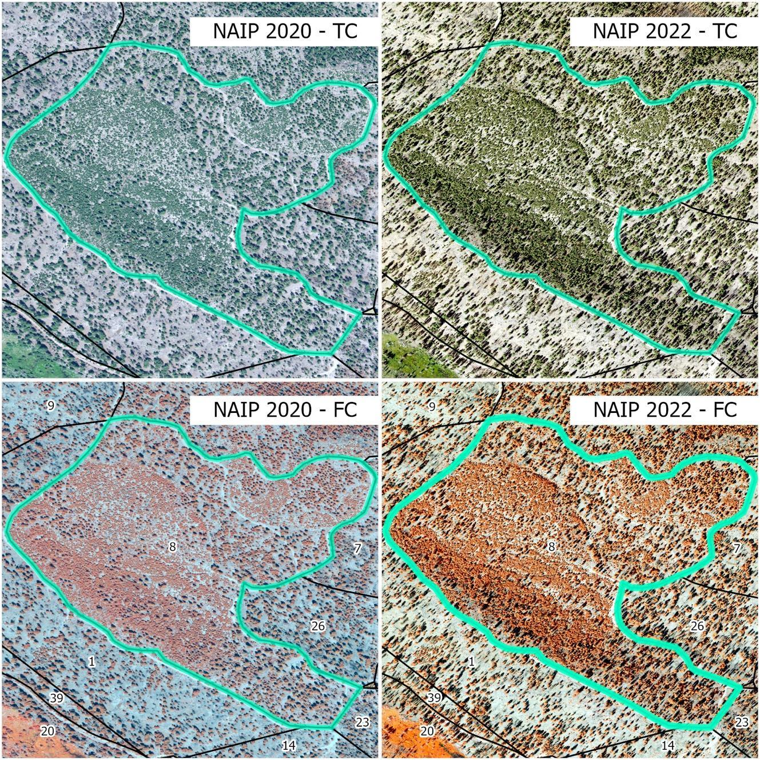
Fig. S1: Unit 8 (highlighted, see Fig. 1) as captured by NAIP 2020 in true color (TC), NAIP 2020 in false color (FS; NIR band in the red channel), NAIP 2022 in TC, and NAIP 2022 in FS. This figure shows how vegetation cover before the broadcast burning (Rx) treatment conducted in 2021 did not visibly change compared to vegetation cover after the 2021 Bootleg Fire (South-Central Oregon, US). This indicates that both the Rx and the Bootleg Fire burned at very low severity in unit 8.

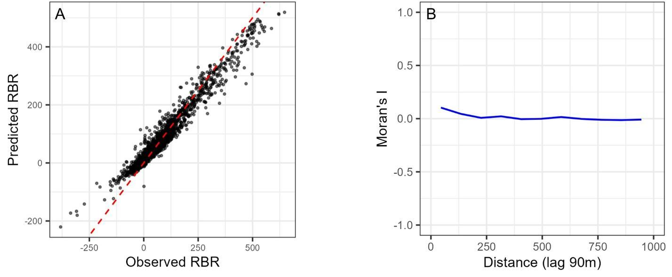
Fig. S2: A) Random Forests model performance represented by a scatterplot of observed vs. predicted Bootleg-RBR (Relativized Burn Ratio) values against a 1:1 fit line (red dotted line), and B) Moran’s I plot representing residuals’ spatial autocorrelation.

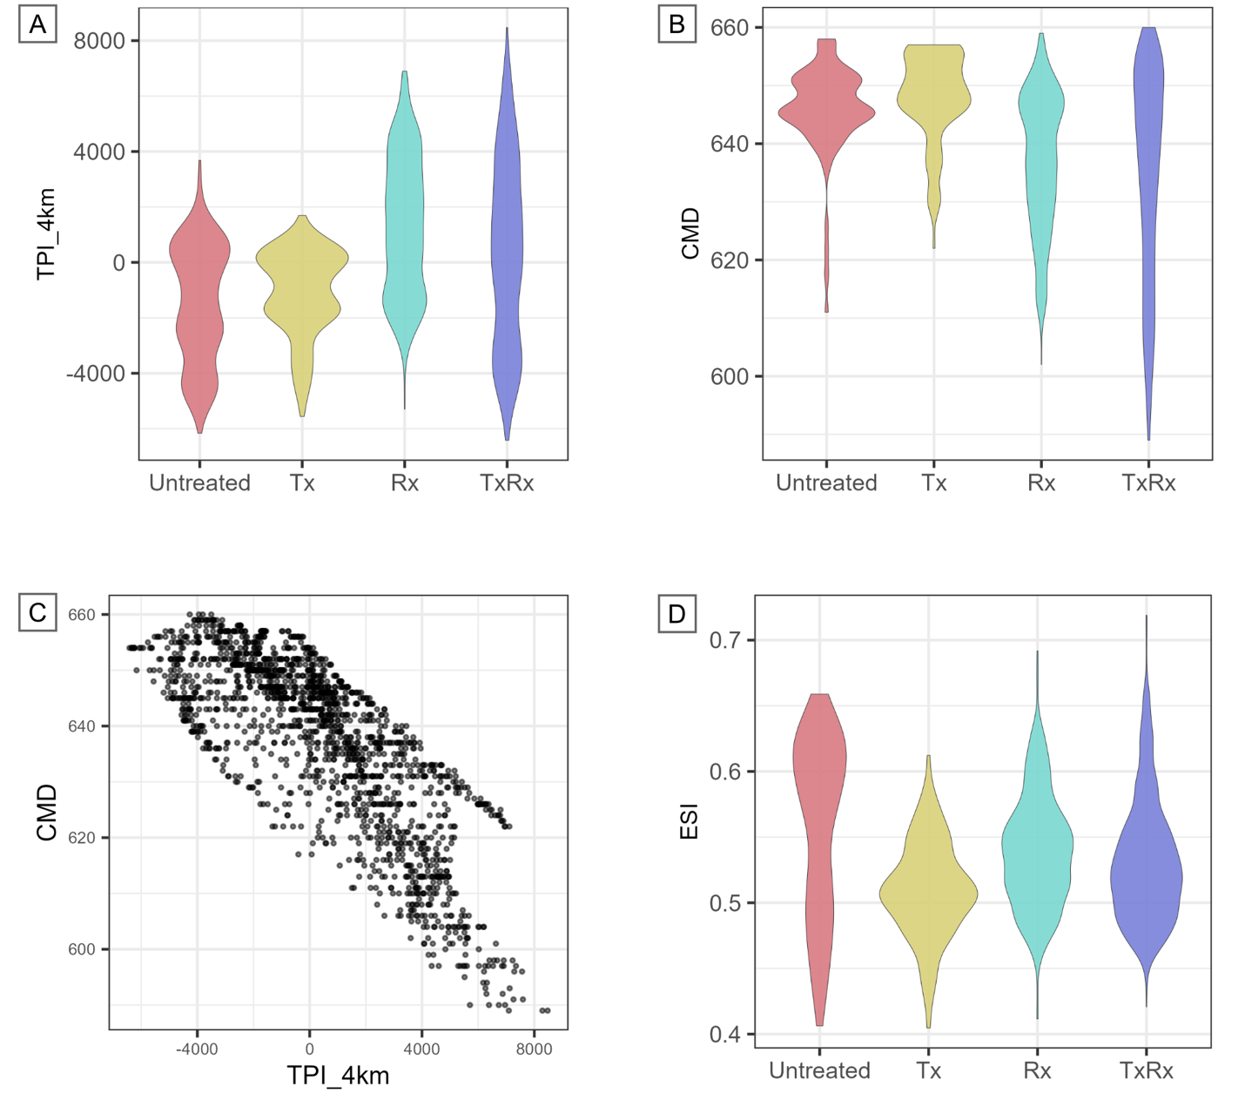
Fig. S3: A) Topographic position index (TPI-4km) distribution by treatment type; on the y-axis, 0 indicates flatter terrains, and negative values indicate valleys, while positive values indicate hilltops and ridges. B) Climatic moisture deficit (CMD) distribution by treatment type (thinning = Tx, broadcast burning = Rx; Tx followed by Rx = TxRx); values on the y-axis indicate increasing moisture deficit. C) Relationship between CMD and TPI-4km (correlation = -0.8); the scatterplot showsTPI-4km values on the x-axis and CMD values on the y-axis. D) Evaporative stress index (ESI) distribution by treatment type; on the y-axis, lower ESI values indicate higher water stress, while higher ESI values indicate lower water stress.
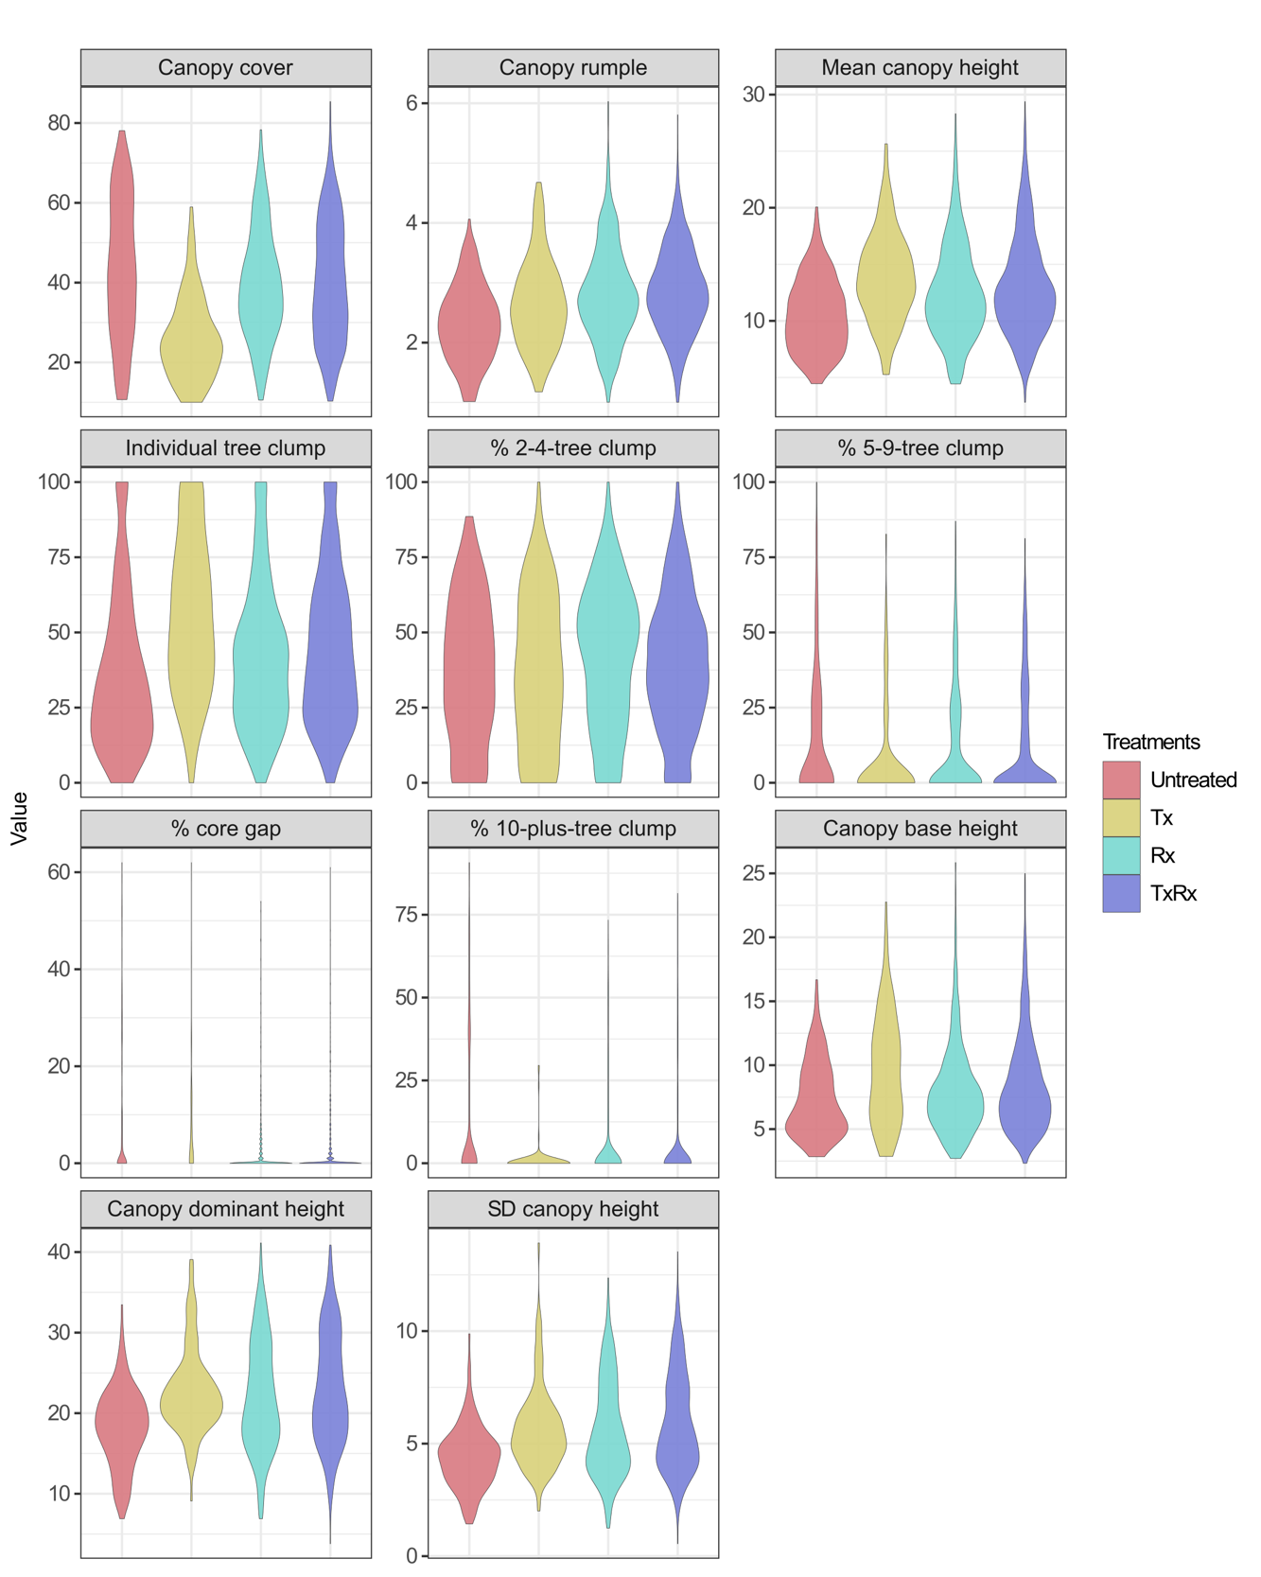
Fig. S4: Pre-Bootleg, 2018 LiDAR-derived forest metrics by treatment type (thinning = Tx, broadcast burning = Rx; Tx followed by Rx = TxRx). The dataset includes only observations with at least 10% canopy cover. LiDAR was collected in 2018.

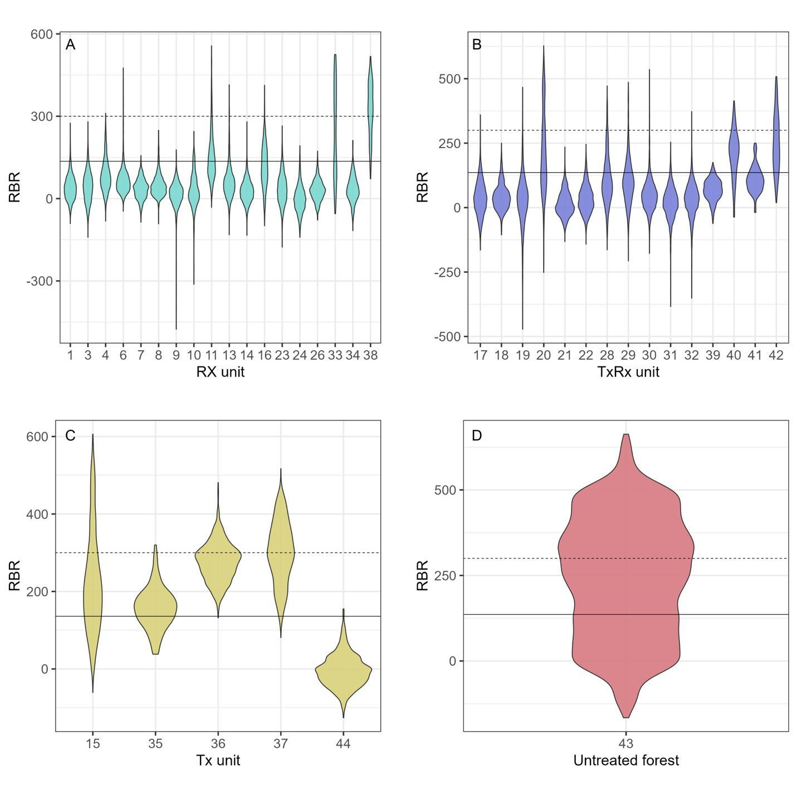
Fig. S5: Bootleg-RBR (relativized burn ratio) distributions for individual units treated with (A) broadcast burning (Rx), (B) thinning followed by broadcast burning (TxRx), (C) thinning (Tx), (D) and untreated forests. Low (≤135) and moderate (136-300) burn severity thresholds are shown with solid and dotted black lines, respectively.

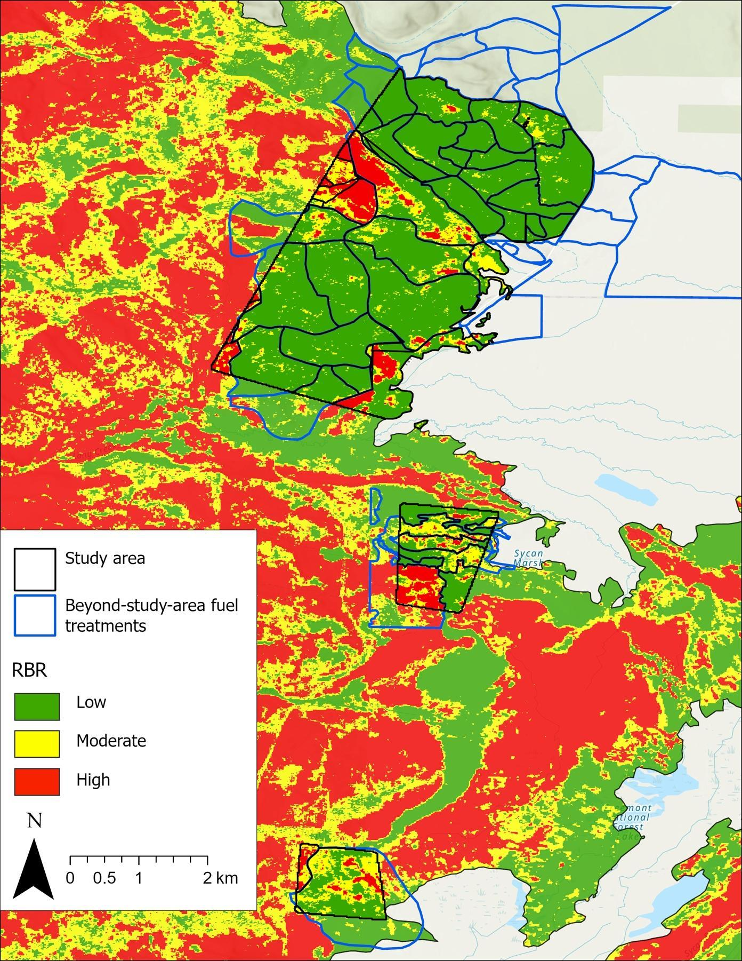
Fig. S6: Map of the 2021 Bootleg-Fire burn severity and fuel treatments conducted by TNC extending beyond our study area. Only treatments within our study area were considered in our analysis (see Fig. 1).

