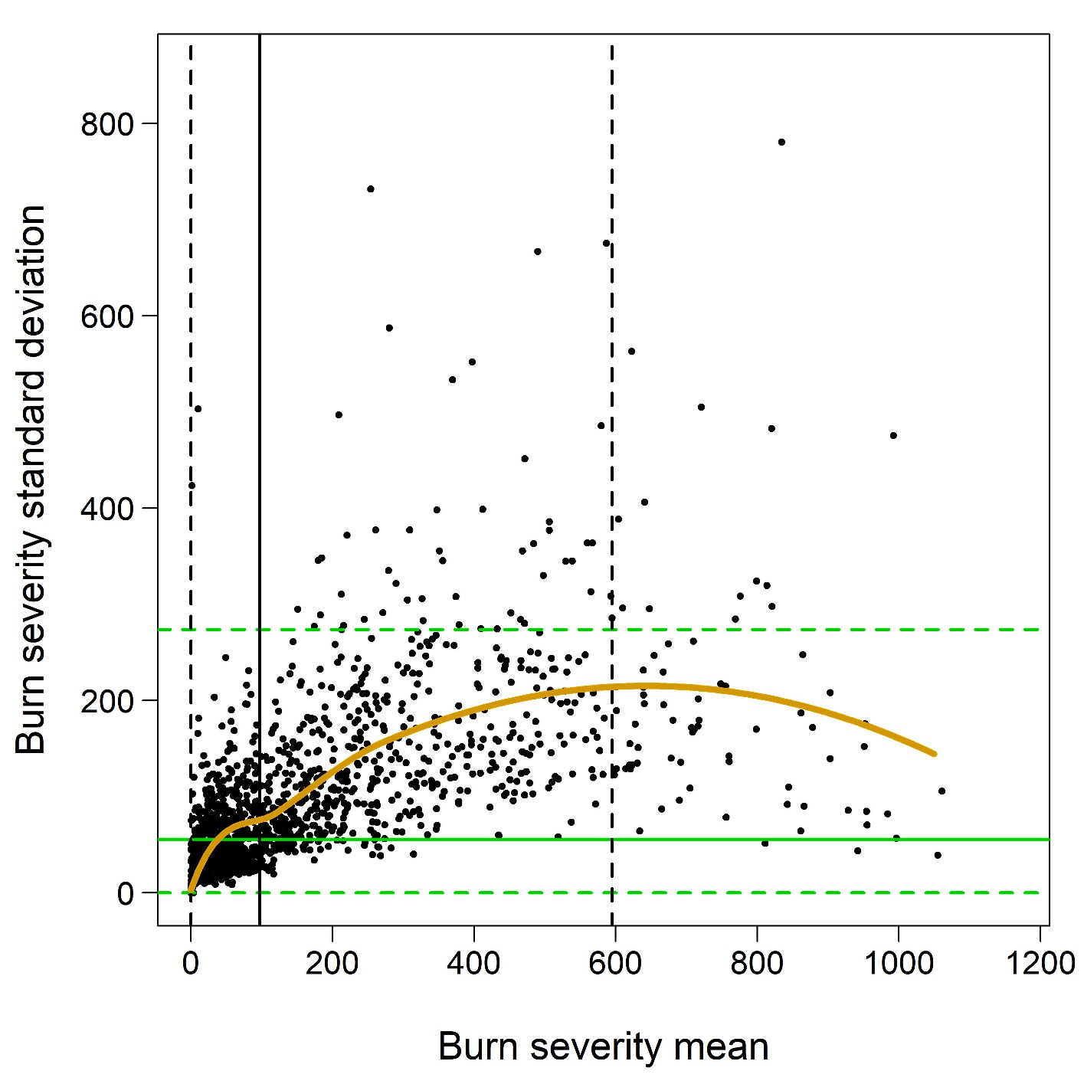
Figure S1. Burn severity mean (x axis) and standard deviation (y axis) for each fire occurring at an avian point-count station between 1984 and 2018 in Yosemite and Sequoia & Kings Canyon national parks, California, USA. Burn severities were estimated from Landsat imagery using a compositing approach cited in the main text. A Loess fit (gold curve) summarizes the relationship in this study between burn severity mean (µ) and standard deviation (σ). Black vertical lines represent observed µ values with mean = 97 (solid line) and dashed 95% reference interval = (0, 595). Green horizontal lines represent observed σ values with mean = 58 (solid line) and dashed 95% reference interval = (0, 274).
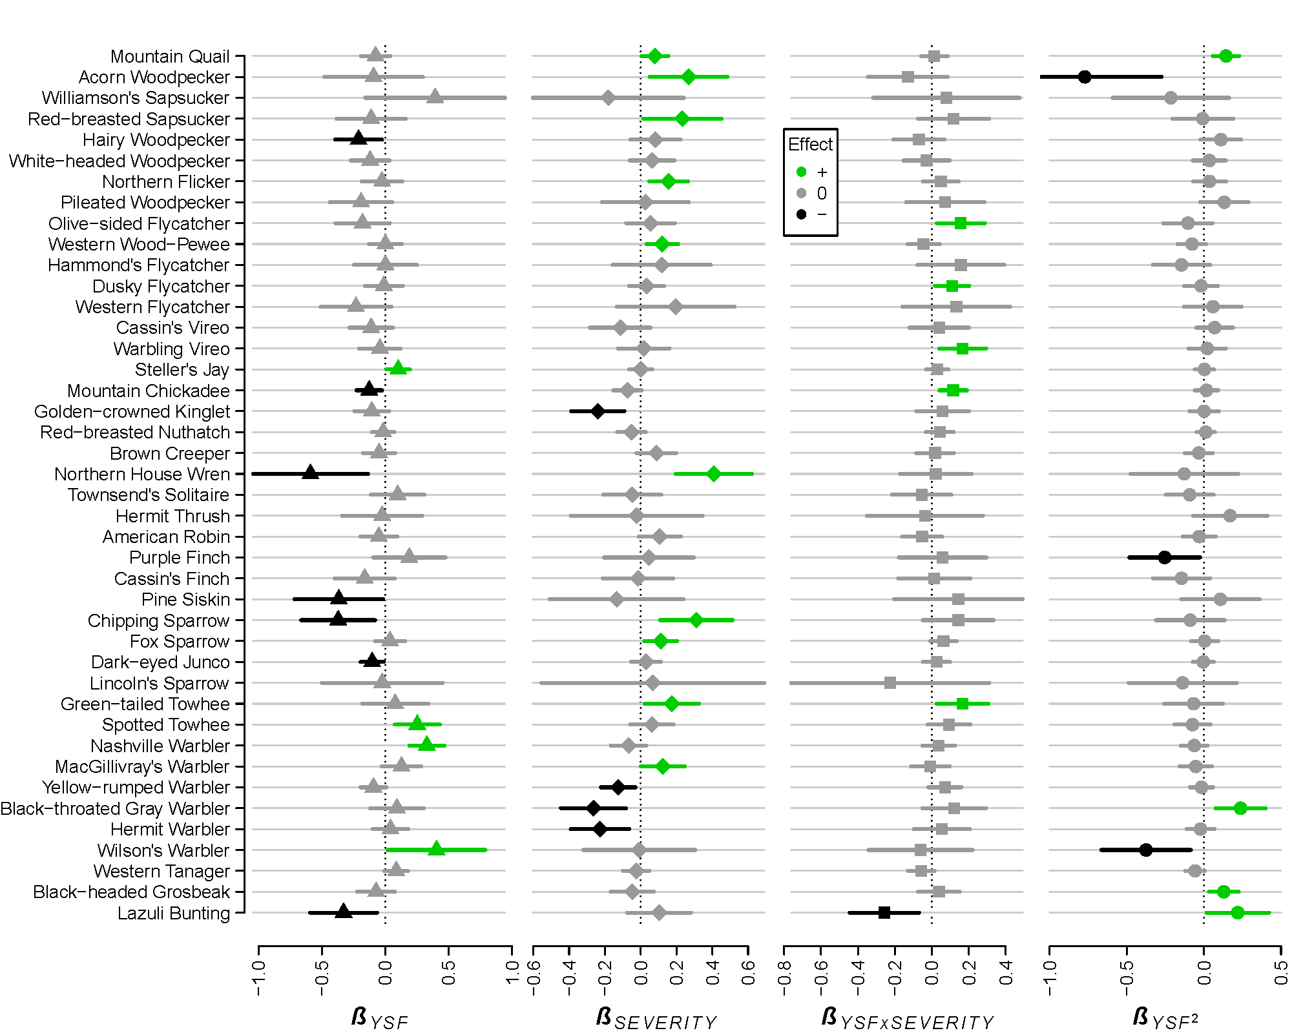
Figure S2. Effects of years since fire (YSF) and burn severity on population densities of 42 landbird species. Fitted coefficients (β) were estimated from point-count surveys conducted during 1999-2019 in Yosemite and Sequoia & Kings Canyon national parks, California, USA. Mean population densities (symbols) and 95% credible intervals (thick horizontal lines) were estimated using Bayesian hierarchical models that accounted for several additional covariates (Fig. S4) as well as imperfect detection of individual birds.

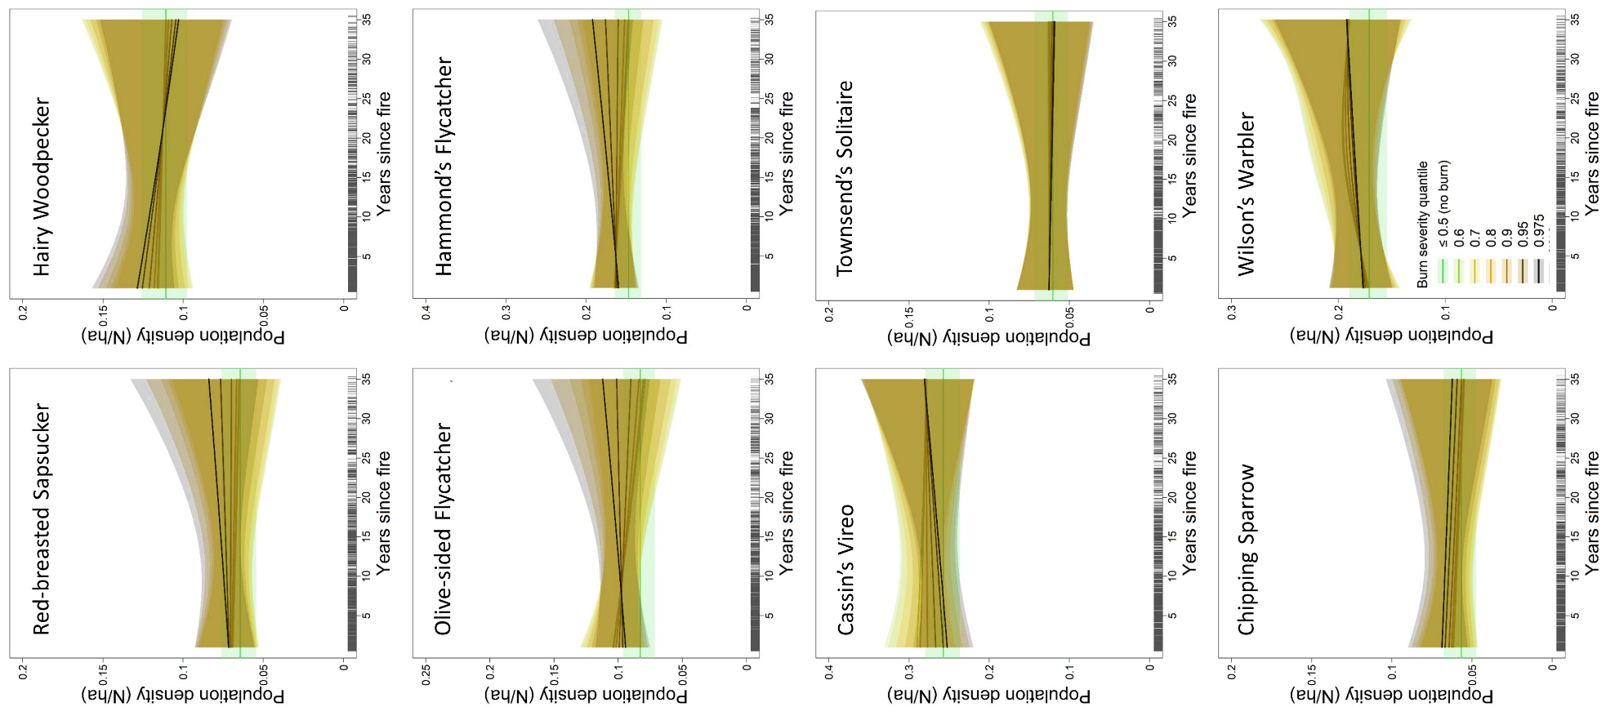
Figure S3. Population density estimates by years since fire and burn severity for eight species with little or no apparent response to fire. Each curve represents the fit (mean and 95% confidence interval) of a generalized additive model to the posterior point estimates of population density at 1-35 years after a burn of the indicated severity. Colors indicate the average initial burn severity observed within each avian point-count station), ranging from stations that did not burn (green) to stations that burned most severely (black). Mean population density at unburned stations extends across each panel for ease of comparison with the progression of densities at stations that burned. Data were collected in Yosemite and Sequoia & Kings Canyon national parks, California, USA.

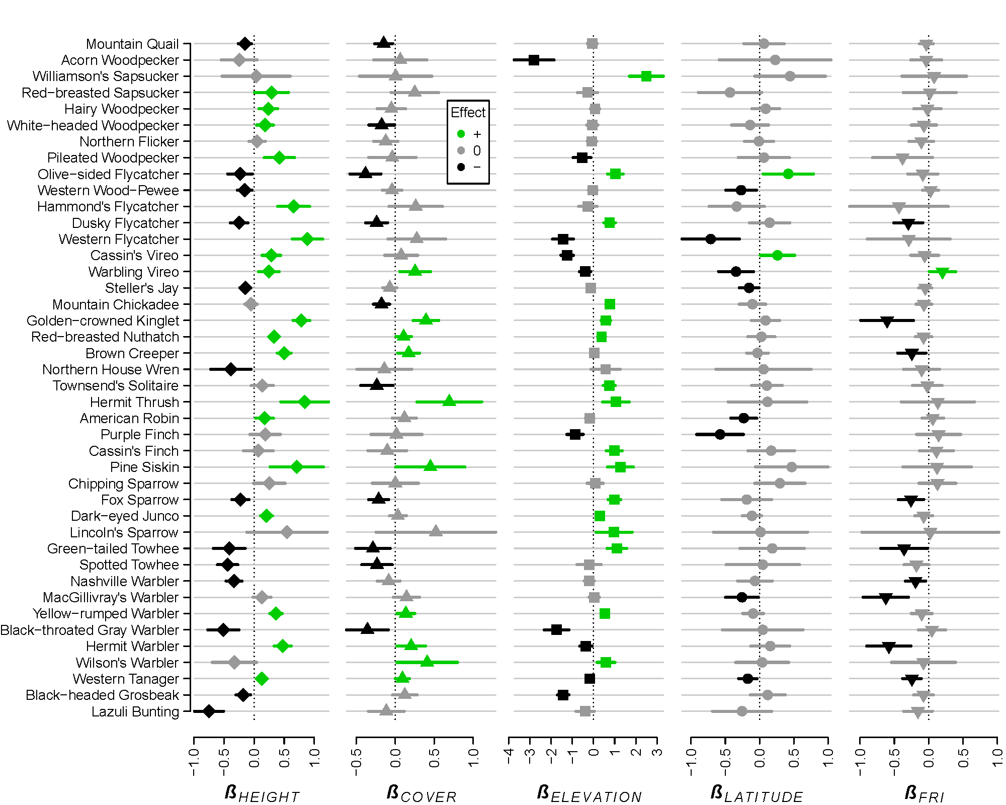
Figure S4. Effects of forest stand height, forest canopy cover, elevation, latitude and expected fire return interval on population densities of 42 landbird species. Fitted coefficients (β) were estimated from point-count surveys conducted during 1999-2019 in Yosemite and Sequoia & Kings Canyon national parks, California, USA. Mean β values (symbols) and 95% credible intervals (thick horizontal lines) were estimated using Bayesian hierarchical models that accounted for several additional covariates (Fig. S2) as well as imperfect detection of individual birds.

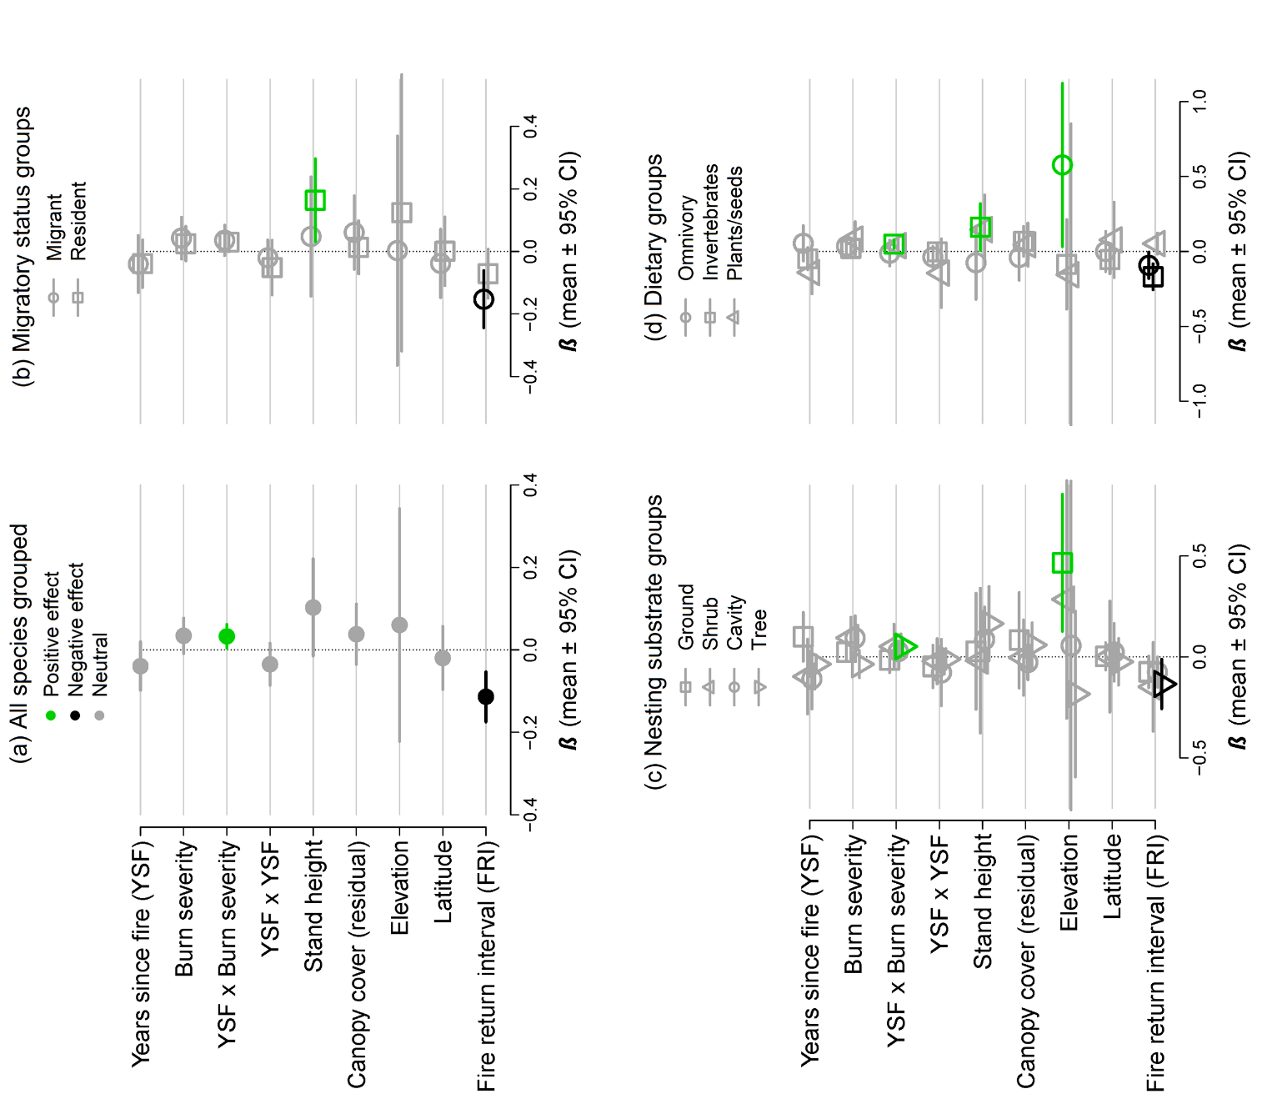
Figure S5. Model-based effects of each covariate on population density, summarized across all species (a) or by functional trait group (b-d). Means (symbols) and 95% confidence intervals (thick horizontal lines) are presented for each fitted coefficient, aggregated across fits for (a) all 42 species analyzed; (b) species classified as migrants (n = 22) versus residents (n = 20); (c) species classified as nesting on the ground (n = 9), in shrubs (n = 7), in cavities (n = 10) or in trees (n = 15); and (d) species with diets based on omnivory (n = 10), invertebrates (n = 25) or plants/seeds (n = 7). Green, gray and black symbols indicate positive, neutral and negative responses, respectively.

