Supplemental Material
Table S1. Tree size (dbh) and crown scorch volume of 253 longleaf pine trees using ocular estimates included in the training data stratified across a wide range of sizes and crown scorch severity.
 | Tree size, dbh (cm)
Scorch | 0-10 | 10-20 | 20-30 | 30-40 | 40-50 | 50-60
0% | 4 | 6 | 6 | 6 | 4 | 1
1-10% | 5 | 6 | 4 | 5 | 3 | 2
10-20% | 5 | 5 | 4 | 5 | 4 | 1
20-30% | 5 | 5 | 5 | 4 | 4 | 1
30-40% | 5 | 5 | 3 | 2 | 2 | 2
40-50% | 4 | 6 | 3 | 2 | 4 | 2
50-60% | 5 | 5 | 3 | 4 | 4 | 1
60-70% | 5 | 5 | 1 | 3 | 4 | 1
70-80% | 5 | 7 | 2 | 4 | 2 | 0
80-90% | 5 | 6 | 2 | 2 | 3 | 2
90-100% | 10 | 12 | 3 | 2 | 4 | 1
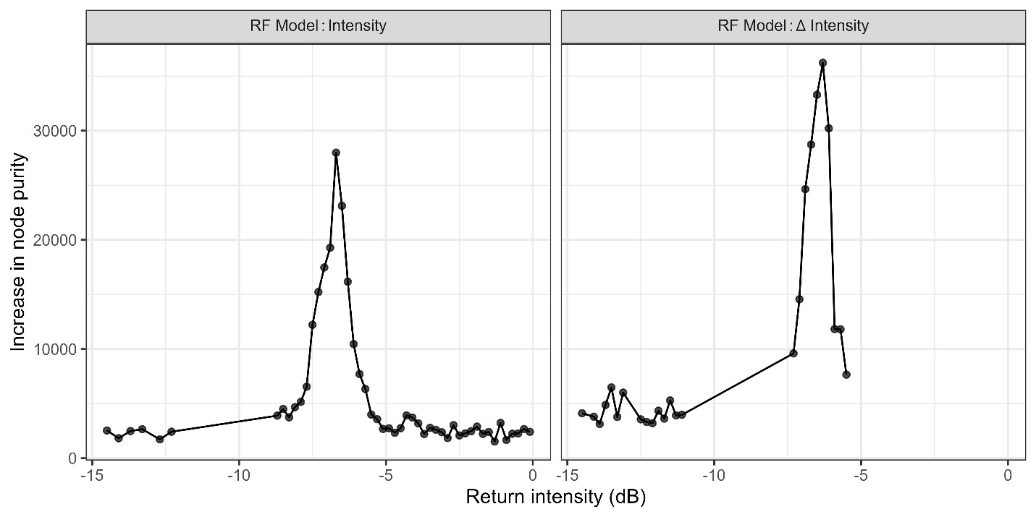
Fig. S1. Feature importance for random forests model using post-burn Intensity and Δ Intensity features, indicating high importance of returns in the range of intensities between -7.5 to -5dB.
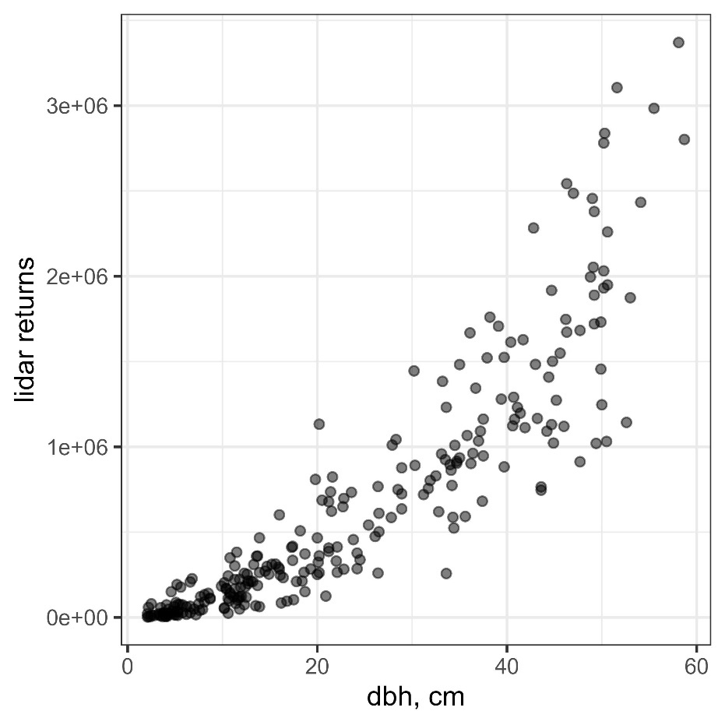
Fig. S2. Relationship between tree size (dbh) and the total number of lidar point returns per tree. Larger trees are associated with more returns, which may contribute to more robust estimates of canopy scorch.
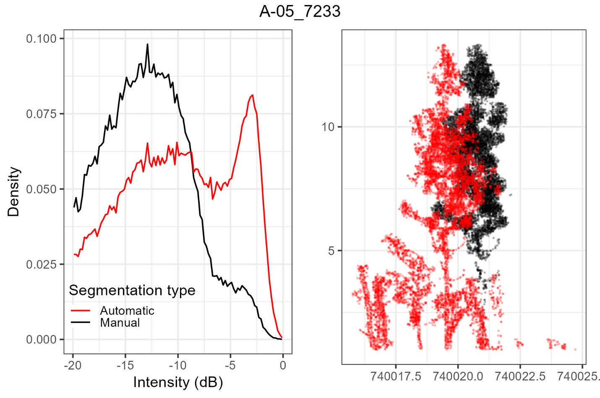
Fig. S3. Comparison of return intensity histograms (left) and overlaid point clouds (right) for a small tree segmented manually and automatically. The automatic segmentation includes non-target vegetation and fails to fully remove the tree bole, unlike the manual segmentation. These differences are evident in the altered intensity distribution and contribute to a reduction in model accuracy.
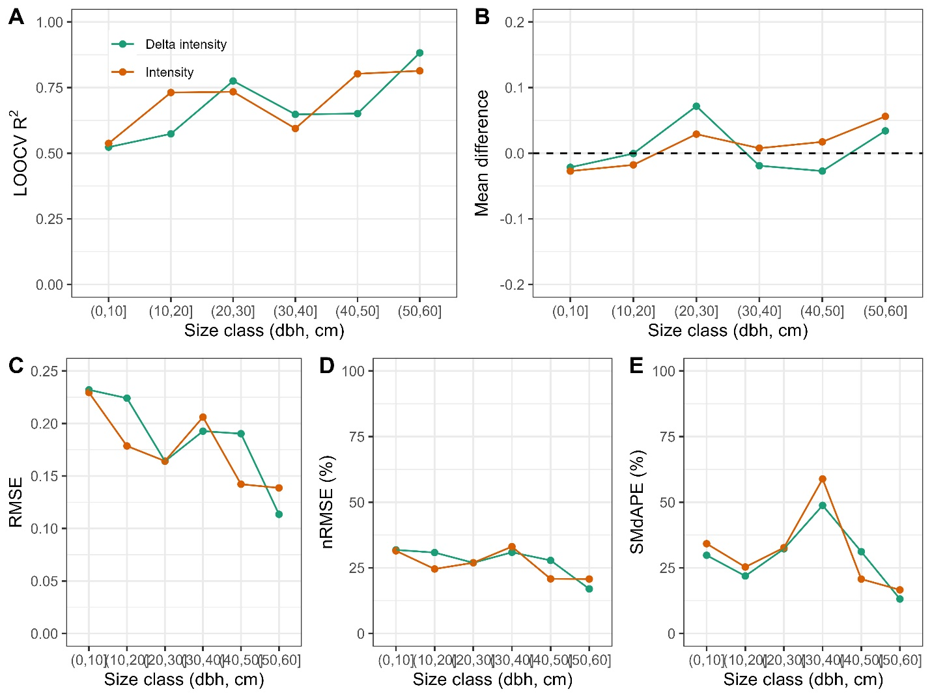
Fig. S4. Changes in prediction accuracy and bias for random forests model of tree scorch using post-burn intensity and Δintensity across tree size classes including (A) model R² based on leave one out cross validation (LOOCV) (B) mean differences, (C) root mean square error (RMSE) of crown scorch, (D) normalized RMSE, and symmetric median absolute percentage error (SMdAPE). See Fig. 6 for complete datasets and model fits.

