Supplementary material
Table S 1. Time of ignition of individual plots in the prescribed fire campaign carried out in 2022.
Date | Ignition Time | Unit
3-Feb | 10:17 | E4
3-Feb | 11:45 | E2
3-Feb | 12:00 | E1
3-Feb | 13:00 | A1, A2
3-Feb | 14:22 | F1
4-Feb | 9:45 | 4C
4-Feb | 10:20 | B4
4-Feb | 11:15 | B2
4-Feb | 12:10 | B1
4-Feb | 13:00 | D1
4-Feb | 13:45 | D2
1-Mar | 12:15 | A4, F4
1-Mar | 13:10 | C1, F2
1-Mar | 13:45 | C2, 4D

Table S 2. Hourly weather observations from a nearby fire weather station (30° 11' 03" N, 82° 35' 40" W). Data courtesy of the Western Regional Climate Center - Desert Research Institute - Reno, Nevada, USA.
Date and Time (EST, M/D/Y HH:MM) | Solar Radiation KW-hr/m² | Mean Wind Speed m/s | Mean Wind Direction (degrees) | Maximum Wind Speed (m/s) | Mean Air Temperature (°C) | Mean 10 Hour Fuel Stick Temperature (°C) | Mean 10 Hour Fuel Stick Moisture % | Mean RH % | Dew Point (°C) | Total Rainfall (mm)
2/3/2022 1:00 | 0 | 1.8 | 113 | 4 | 15.6 | 14.4 | 6.5 | 78 | 11.7 | 0
2/3/2022 2:00 | 0 | 1.8 | 128 | 3.6 | 15.6 | 14.4 | 6.7 | 77 | 11.5 | 0
2/3/2022 3:00 | 0 | 1.3 | 120 | 3.6 | 15 | 13.9 | 6.7 | 79 | 11.4 | 0
2/3/2022 4:00 | 0 | 2.2 | 109 | 3.1 | 15 | 13.3 | 6.7 | 82 | 12 | 0
2/3/2022 5:00 | 0 | 2.2 | 112 | 4 | 14.4 | 12.8 | 6.7 | 82 | 11.4 | 0
2/3/2022 6:00 | 0 | 2.7 | 105 | 4 | 14.4 | 12.8 | 6.7 | 85 | 12 | 0
2/3/2022 7:00 | 0 | 1.3 | 115 | 4 | 13.3 | 12.2 | 6.7 | 89 | 11.6 | 0
2/3/2022 8:00 | 0.02 | 2.2 | 110 | 3.6 | 14.4 | 12.8 | 6.5 | 87 | 12.3 | 0
2/3/2022 9:00 | 0.15 | 1.8 | 134 | 4.9 | 17.8 | 17.2 | 6.4 | 79 | 14.1 | 0
2/3/2022 10:00 | 0.31 | 2.7 | 142 | 7.2 | 21.1 | 21.7 | 6.5 | 69 | 15.2 | 0
2/3/2022 11:00 | 0.49 | 3.1 | 157 | 8 | 23.3 | 26.1 | 6.3 | 60 | 15.1 | 0
2/3/2022 12:00 | 0.58 | 3.6 | 151 | 9.4 | 25 | 27.8 | 5.9 | 51 | 14.2 | 0
2/3/2022 13:00 | 0.63 | 3.1 | 151 | 8 | 26.1 | 30 | 5.6 | 50 | 14.9 | 0
2/3/2022 14:00 | 0.56 | 3.1 | 182 | 7.2 | 26.7 | 29.4 | 5.2 | 46 | 14.1 | 0
2/3/2022 15:00 | 0.47 | 2.2 | 155 | 7.6 | 27.2 | 29.4 | 5 | 45 | 14.3 | 0
2/3/2022 16:00 | 0.14 | 1.8 | 160 | 5.4 | 26.1 | 26.7 | 4.9 | 48 | 14.2 | 0
2/3/2022 17:00 | 0.06 | 1.8 | 137 | 3.6 | 25.6 | 25.6 | 5 | 50 | 14.4 | 0
2/3/2022 18:00 | 0.03 | 1.3 | 132 | 2.7 | 24.4 | 24.4 | 5.1 | 53 | 14.2 | 0
2/3/2022 19:00 | 0 | 0.9 | 132 | 2.7 | 23.3 | 22.8 | 5.4 | 57 | 14.3 | 0
2/3/2022 20:00 | 0 | 0.4 | 142 | 2.2 | 22.2 | 21.1 | 5.6 | 60 | 14.1 | 0
2/3/2022 21:00 | 0 | 1.3 | 154 | 3.6 | 21.7 | 20 | 5.8 | 62 | 14.1 | 0
2/3/2022 22:00 | 0 | 0 | 243 | 1.8 | 20 | 18.3 | 6 | 69 | 14.1 | 0
2/3/2022 23:00 | 0 | 0.9 | 129 | 2.7 | 18.3 | 16.7 | 6.5 | 77 | 14.2 | 0
2/4/2022 0:00 | 0 | 0.9 | 156 | 3.1 | 18.9 | 17.2 | 6.2 | 74 | 14.2 | 0
2/4/2022 1:00 | 0 | 0.9 | 149 | 2.2 | 18.3 | 16.7 | 6.5 | 79 | 14.6 | 0
2/4/2022 2:00 | 0 | 0 | 219 | 2.2 | 17.2 | 15.6 | 6.3 | 84 | 14.5 | 0
2/4/2022 3:00 | 0 | 0.9 | 135 | 1.8 | 16.7 | 15 | 6.6 | 87 | 14.5 | 0
2/4/2022 4:00 | 0 | 1.3 | 185 | 4.5 | 17.8 | 16.1 | 6.6 | 86 | 15.4 | 0
2/4/2022 5:00 | 0 | 1.8 | 171 | 4.9 | 17.2 | 16.1 | 6.6 | 86 | 14.9 | 0
2/4/2022 6:00 | 0 | 1.3 | 157 | 4 | 17.2 | 16.1 | 6.6 | 88 | 15.2 | 0
2/4/2022 7:00 | 0 | 1.8 | 185 | 4.5 | 17.8 | 16.7 | 6.5 | 91 | 16.3 | 0
2/4/2022 8:00 | 0.02 | 1.8 | 182 | 5.8 | 18.9 | 18.3 | 6.5 | 88 | 16.9 | 0
2/4/2022 9:00 | 0.14 | 2.2 | 202 | 5.8 | 20.6 | 20 | 6.1 | 83 | 17.6 | 0
2/4/2022 10:00 | 0.24 | 2.7 | 204 | 5.8 | 22.2 | 23.3 | 6.4 | 78 | 18.2 | 0
2/4/2022 11:00 | 0.36 | 4 | 203 | 8.9 | 23.9 | 25.6 | 6.3 | 72 | 18.5 | 0
2/4/2022 12:00 | 0.4 | 3.6 | 203 | 7.6 | 25.6 | 27.8 | 6 | 65 | 18.5 | 0
2/4/2022 13:00 | 0.39 | 3.6 | 203 | 9.4 | 26.7 | 29.4 | 5.7 | 60 | 18.3 | 0
2/4/2022 14:00 | 0.28 | 3.6 | 208 | 8 | 26.7 | 28.9 | 5.5 | 60 | 18.3 | 0
2/4/2022 15:00 | 0.25 | 3.1 | 204 | 7.6 | 26.1 | 27.8 | 5.4 | 62 | 18.3 | 0
2/4/2022 16:00 | 0.17 | 3.1 | 211 | 8.9 | 26.1 | 27.2 | 5.5 | 63 | 18.5 | 0
2/4/2022 17:00 | 0.09 | 2.7 | 221 | 7.6 | 25 | 25.6 | 5.6 | 68 | 18.7 | 0
2/4/2022 18:00 | 0.02 | 1.8 | 255 | 6.7 | 22.2 | 22.2 | 5.9 | 84 | 19.4 | 5.08
2/4/2022 19:00 | 0 | 2.2 | 291 | 6.7 | 20 | 20 | 6.2 | 93 | 18.8 | 0.25
2/4/2022 20:00 | 0 | 1.3 | 304 | 5.8 | 18.3 | 17.8 | 6.3 | 93 | 17.2 | 0
2/4/2022 21:00 | 0 | 0.9 | 303 | 5.4 | 17.8 | 17.2 | 6.3 | 91 | 16.3 | 0
2/4/2022 22:00 | 0 | 2.2 | 315 | 4.5 | 15.6 | 15.6 | 6.4 | 94 | 14.6 | 6.1
2/4/2022 23:00 | 0 | 0.9 | 319 | 4.9 | 14.4 | 14.4 | 6.4 | 95 | 13.7 | 2.03
2/5/2022 0:00 | 0 | 0.4 | 275 | 2.7 | 14.4 | 14.4 | 6.8 | 95 | 13.7 | 0.25
3/1/2022 1:00 | 0 | 0.4 | 346 | 2.2 | 11.7 | 10.6 | 2.5 | 80 | 8.3 | 0
3/1/2022 2:00 | 0 | 0.4 | 337 | 2.2 | 10.6 | 8.9 | 2.5 | 85 | 8.1 | 0
3/1/2022 3:00 | 0 | 0.4 | 347 | 2.7 | 10.6 | 8.9 | 2.5 | 82 | 7.6 | 0
3/1/2022 4:00 | 0 | 0.4 | 33 | 1.8 | 9.4 | 7.8 | 2.5 | 85 | 7.1 | 0
3/1/2022 5:00 | 0 | 0 | 357 | 1.3 | 8.3 | 6.7 | 2.5 | 89 | 6.6 | 0
3/1/2022 6:00 | 0 | 0 | 342 | 0.9 | 7.8 | 6.1 | 2.5 | 92 | 6.6 | 0
3/1/2022 7:00 | 0 | 0.4 | 4 | 1.8 | 7.8 | 6.1 | 2.5 | 91 | 6.4 | 0
3/1/2022 8:00 | 0.08 | 0.9 | 21 | 2.2 | 10.6 | 8.9 | 2.5 | 74 | 6.1 | 0
3/1/2022 9:00 | 0.28 | 2.7 | 32 | 4.5 | 13.3 | 13.9 | 2.4 | 59 | 5.5 | 0
3/1/2022 10:00 | 0.48 | 1.8 | 11 | 6.3 | 16.7 | 19.4 | 2.4 | 56 | 7.9 | 0
3/1/2022 11:00 | 0.66 | 3.1 | 34 | 6.7 | 18.9 | 22.8 | 2.4 | 51 | 8.5 | 0
3/1/2022 12:00 | 0.7 | 1.8 | 20 | 5.8 | 20.6 | 23.9 | 2.3 | 39 | 6.1 | 0
3/1/2022 13:00 | 0.8 | 2.7 | 11 | 5.8 | 21.7 | 28.3 | 2.1 | 30 | 3.3 | 0
3/1/2022 14:00 | 0.78 | 1.8 | 312 | 5.4 | 21.7 | 23.9 | 2 | 30 | 3.3 | 0
3/1/2022 15:00 | 0.65 | 2.2 | 9 | 5.8 | 22.8 | 23.9 | 2 | 28 | 3.3 | 0
3/1/2022 16:00 | 0.57 | 1.3 | 2 | 4.9 | 23.3 | 27.8 | 1.9 | 26 | 2.8 | 0
3/1/2022 17:00 | 0.12 | 1.8 | 23 | 4 | 23.3 | 28.3 | 1.8 | 27 | 3.3 | 0
3/1/2022 18:00 | 0.03 | 1.3 | 10 | 3.1 | 21.7 | 25 | 1.7 | 31 | 3.8 | 0
3/1/2022 19:00 | 0.01 | 0 | 341 | 2.2 | 17.8 | 15.6 | 1.8 | 45 | 5.7 | 0
3/1/2022 20:00 | 0 | 0 | 323 | 0 | 15 | 12.8 | 1.9 | 60 | 7.3 | 0
3/1/2022 21:00 | 0 | 0 | 323 | 0.9 | 12.8 | 10.6 | 2 | 66 | 6.6 | 0
3/1/2022 22:00 | 0 | 0 | 11 | 0.9 | 12.8 | 10 | 2.2 | 72 | 7.9 | 0
3/1/2022 23:00 | 0 | 0 | 309 | 1.3 | 12.2 | 10 | 2.3 | 73 | 7.5 | 0
3/2/2022 0:00 | 0 | 0 | 298 | 0.9 | 10.6 | 8.3 | 2.5 | 85 | 8.1 | 0

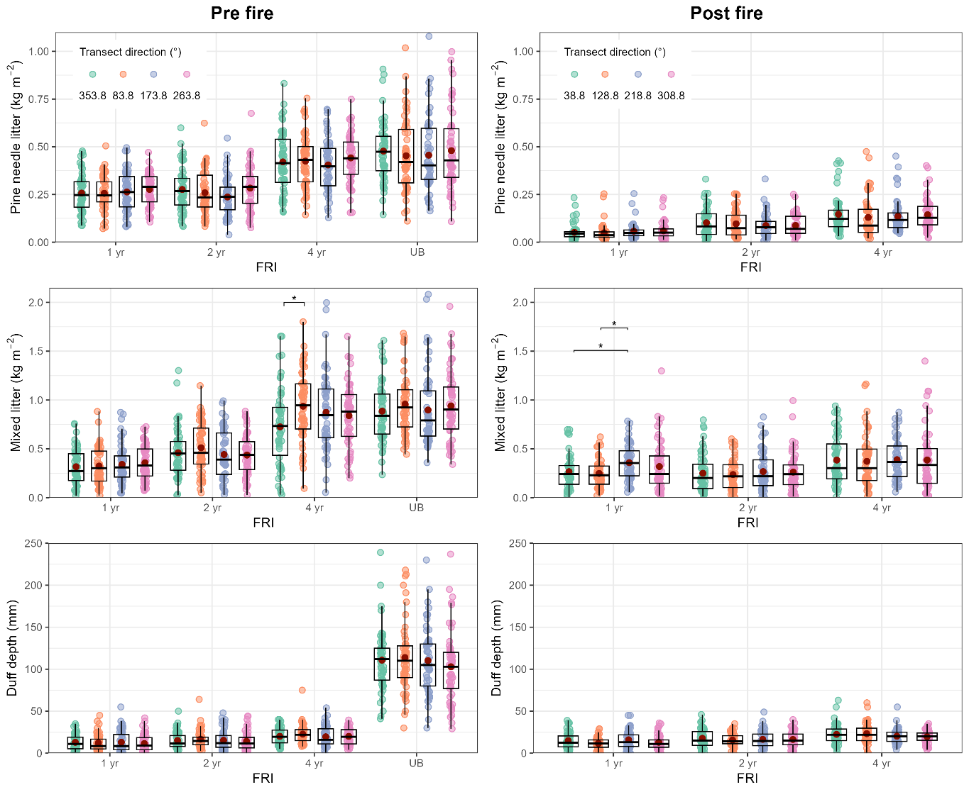
Fig. S 1. Boxplots of pre- and post-fire pine needle litter load, mixed litter load, and duff depth of the samples collected at three fire return intervals (FRI: 1 yr, 2 yr, 4 yr) and unburned (UB) treatments given the transect direction (shown in true coordinates on the legend). Boxes represent the interquartile range (25th-75th percentiles) with the median as the central line, and the whiskers extend to the most extreme values within 1.5 times the interquartile range. The red dot indicates the mean value. Asterisk indicates significance (* p<0.05) for post hoc pairwise comparisons as determined by Dunn’s test given the transect direction and FRI. For visualization purposes, some outliers beyond the y-axis label range are not displayed.
Table S 2. Basal area (BA) and tree density. Statistics are reported per fire return interval (FRI) based on the unit where the tree inventory data were collected. The number of plots per fire return interval was 18. Letters indicate statistical differences based on ANOVA and Tukey’s HSD test. Values are presented as Mean ± Standard Deviation (Coefficient of Variation %).
 | 1 yr | 2 yr | 4 yr | UB
Basal Area (m² ha⁻¹) | 26.5 ± 9.6^{ab} (36.2) | 20.0 ± 8.9 ^{b} (44.3) | 24.2± 6.0 ^{ab} (24.7) | 29.2 ± 8.7ª (29.6)
Tree density (tree ha⁻¹) | 303.9 ± 114.3^{b} (37.6) | 240.4± 105.5^{b} (43.9) | 301.2 ± 57.8^{b} (19.2) | 425.5 ± 126.8ª (29.8)

