Supplementary Material
USFS Region | Wilderness (hectares) | Inventoried Roadless areas (hectares) | Other national forest lands (hectares) | 50-meter road buffers (hectares) | All national forest lands (hectares)
1 (Northern) | 1,558,230 | 3,562,977 | 4,349,490 | 893,288 | 10,363,984
2 (Rocky Mountain) | 2,732,454 | 2,359,950 | 3,057,703 | 776,284 | 8,926,391
3 Southwestern) | 1,110,289 | 1,058,826 | 5,325,609 | 813,918 | 8,308,643
4 (Intermountain) | 2,463,038 | 6,027,960 | 3,451,033 | 970,618 | 12,912,650
5 (Pacific Southwest) | 1,766,836 | 1,458,509 | 3,902,267 | 1,063,684 | 8,191,297
6 (Pacific Northwest) | 1,931,683 | 1,488,290 | 4,945,449 | 1,742,730 | 10,108,152
8 (Southern) | 309,053 | 333,694 | 3,946,401 | 850,798 | 5,439,947
9 (Eastern) | 690,357 | 233,699 | 3,285,244 | 721,263 | 4,930,562
All Regions | 12,561,941 | 16,523,905 | 32,263,197 | 7,832,584 | 69,181,626
Table S1: Area (in hectares) of land-use categories across U.S. Forest Service regions.

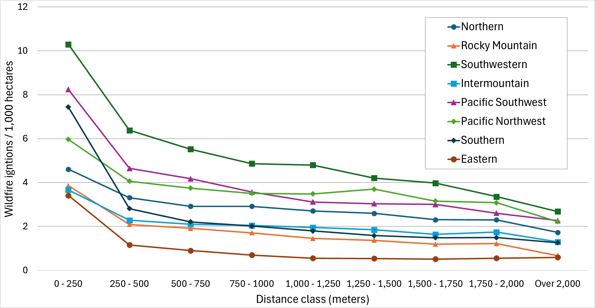
Figure S1: Total wildfire-ignition density by road-buffer-distance class for all national forests in the contiguous United States by U.S. Forest Service region.

