Supplementary Material
Fire reverses the effect of climate on longleaf pine savanna tree growth
Nicole E. Zampieri^{1,2,3,4*}, Monica T. Rother^{5,2} , Stephanie Pau^{6,7,1}

¹Department of Geography, Florida State University, 113 Collegiate Loop, Tallahassee, FL, 32306, USA
²Tall Timbers, 13093 Henry Beadel Drive, Tallahassee, FL 32312, USA
³The Jones Center at Ichauway, 3988 Jones Center Drive, Newton, GA 39870, USA
⁴Department of Biology, University of Central Florida, 4110 Libra Dr, Orlando, FL 32816, USA
⁵Department of Environmental Sciences, University of North Carolina Wilmington, 601 South College Road, Wilmington, NC 28403, USA
⁶Department of Geography, University of California, Berkeley; Berkeley, CA 94704, USA
⁷Department of Environmental Science, Policy and Management, University of California, Berkeley; Berkeley, CA 94704, USA
∗Corresponding author e-mail: nicole.zampieri@ucf.edu
List of Figures
Figure S1. Fire histories from eight sites in FL, USA.
Figure S2. Correlation coefficients between longleaf pine (Pinus palustris) residual latewood tree-ring chronologies from eight sites in Florida and monthly and seasonal temperature (maximum, mean, and minimum), precipitation, and PDSI.
List of Tables
Table S1. Selected variables from climate-tree growth correlation analysis for inclusion in subsequent site level models.
Table S2. Random effect and residual variance from final site level models.

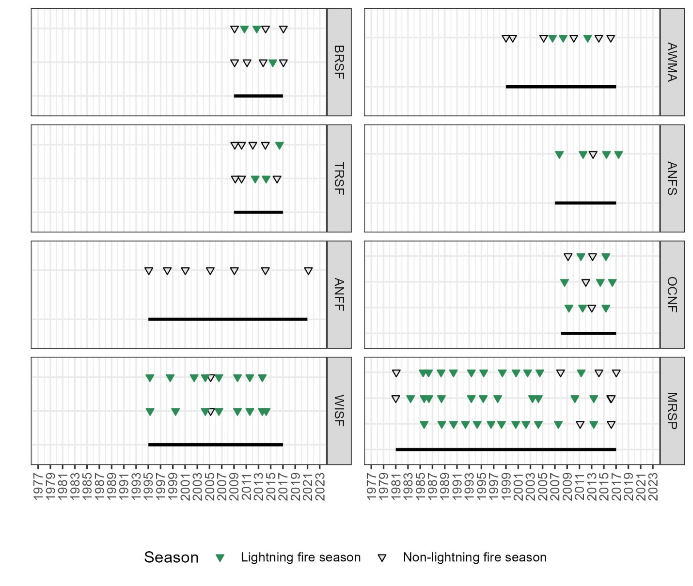
Figure S1. Fire histories from eight sites in FL, USA. Triangles denote recorded fire as reported by land managers. Green triangles indicate lightning fire season burns while black indicates non-lightning fire season burns. Some sites have multiple burn records from the different burn units where trees were sampled. Black line indicates length of the fire record. All burn records extend through 2018 except for ANFF which extends to 2021.
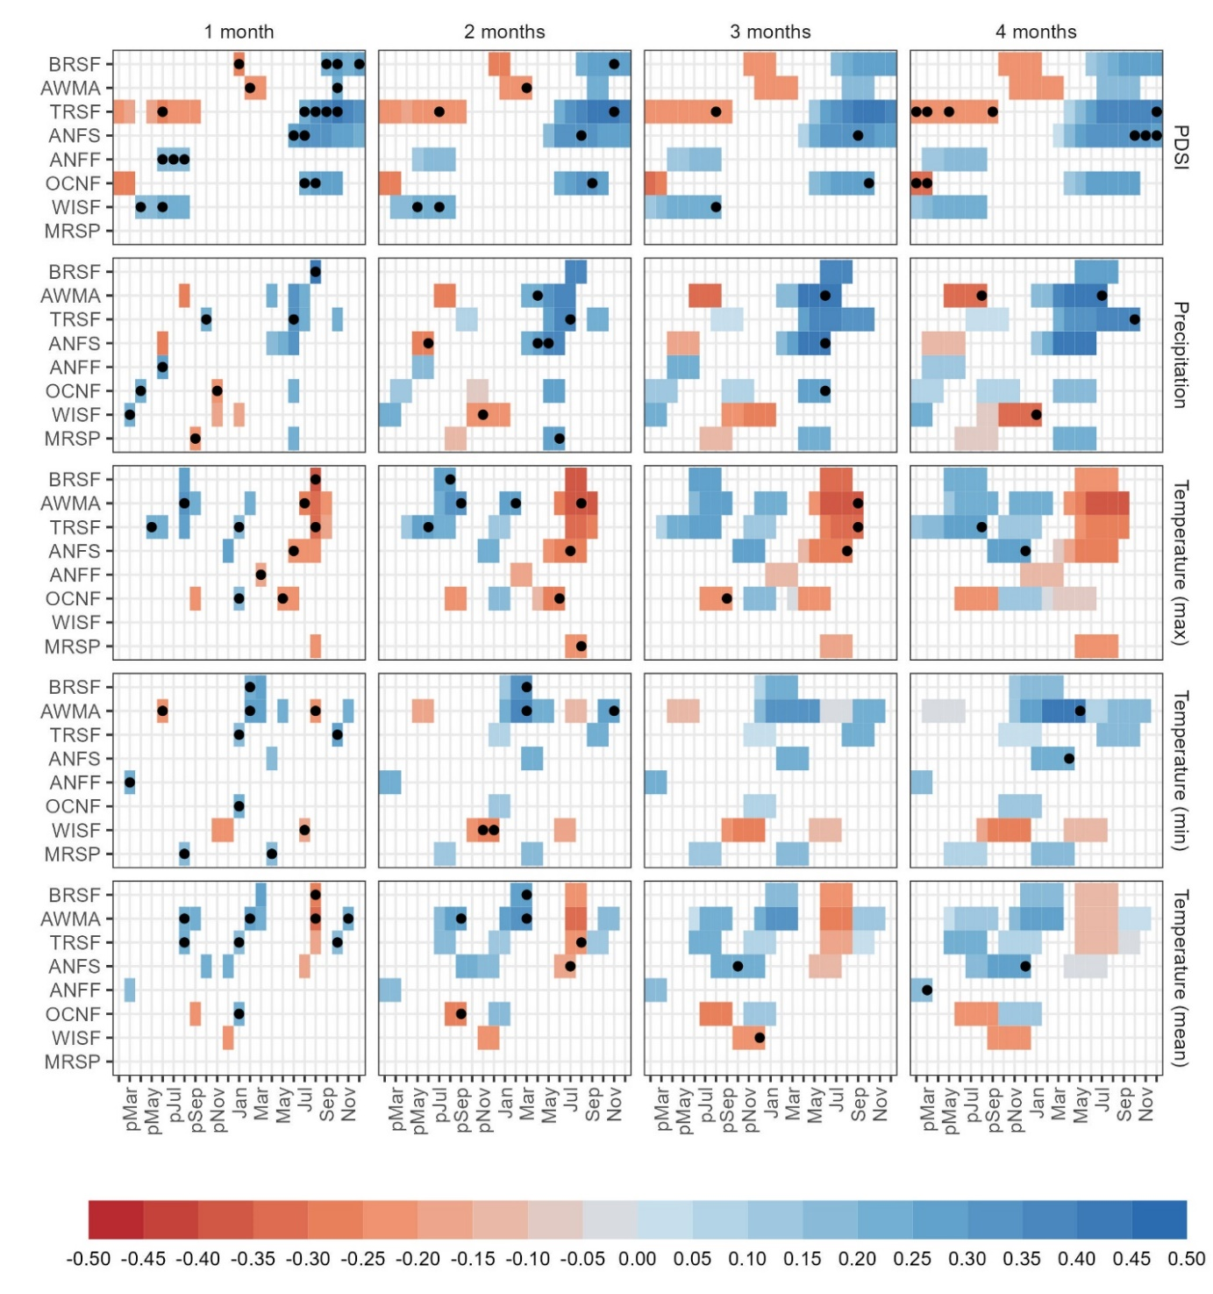
Figure S2. Correlation coefficients between longleaf pine (Pinus palustris) residual latewood tree-ring chronologies from eight sites in Florida and monthly and seasonal temperature (maximum, mean, and minimum), precipitation, and PDSI. Correlations were determined with climatic conditions from previous February through current December for each year of tree growth. Only significant relationships are plotted. Every other label removed from the x-axis to improve readability. These climatic correlations were used to determine what climatic variables to include as parameters in the subsequent models of climate and fire interactions. For each site and climate type, when a climatic variable is considered significant for one or more months, the month or season with the highest correlation was selected for use as a potential parameter, indicated with a black dot (See Table S1 for a list). For example, for the significant negative relationship between PDSI and growth at BRSF for January, January-February, January-March, and January-April, January PDSI alone was selected for inclusion in subsequent models because it had the highest correlation within that seasonal grouping.
Table S1. Selected variables from climate-tree growth correlation analysis for inclusion in subsequent site level models.
 | PDSI |  |  | Precipitation |  |  | Temperature (max) |  |  | Temperature (mean) |  |  | Temperature (min)
 | month | lag | corr | month | lag | corr | month | lag | corr | month | lag | corr | month | lag | corr
ANFF | pAug | 1 | 0.2 | pJun | 1 | 0.29 | Mar | 1 | -0.18 | pMar | 4 | 0.19 | pMar | 1 | 0.21
ANFF | pJul | 1 | 0.18
ANFF | pJun | 1 | 0.17
ANFS | Aug | 2 | 0.35 | Apr | 2 | 0.21 | Aug | 3 | -0.3 | Jul | 2 | -0.18 | Apr | 4 | 0.22
ANFS | Dec | 4 | 0.29 | Jun | 3 | 0.43 | Jul | 2 | -0.28 | pDec | 4 | 0.26
ANFS | Jul | 1 | 0.33 | May | 2 | 0.29 | Jun | 1 | -0.24 | pOct | 3 | 0.24
ANFS | Jun | 1 | 0.25 | pJun | 2 | -0.26 | pDec | 4 | 0.27
ANFS | Nov | 4 | 0.31
ANFS | Oct | 4 | 0.34
ANFS | Sep | 3 | 0.34
AWMA | Feb | 1 | -0.23 | Apr | 2 | 0.21 | Aug | 2 | -0.37 | Aug | 1 | -0.33 | Aug | 1 | -0.22
AWMA | Mar | 2 | -0.22 | Jul | 4 | 0.45 | Feb | 2 | 0.25 | Feb | 1 | 0.28 | Feb | 1 | 0.29
AWMA | Oct | 1 | 0.23 | Jun | 3 | 0.4 | Jul | 1 | -0.28 | Mar | 2 | 0.32 | Mar | 2 | 0.36
AWMA |  |  |  | pAug | 4 | -0.34 | pAug | 1 | 0.3 | Nov | 1 | 0.22 | May | 4 | 0.4
AWMA |  |  |  |  |  |  | pAug | 1 | 0.3 | pAug | 1 | 0.22 | Nov | 2 | 0.28
AWMA |  |  |  |  |  |  | pSep | 2 | 0.32 | pSep | 2 | 0.29 | pJun | 1 | -0.24
AWMA |  |  |  |  |  |  | Sep | 3 | -0.39
BRSF | Dec | 1 | 0.27 | Aug | 1 | 0.42 | Aug | 1 | -0.37 | Aug | 1 | -0.28 | Feb | 1 | 0.23
BRSF | Jan | 1 | -0.27 |  |  |  | pAug | 2 | 0.3 | Mar | 2 | 0.26 | Mar | 2 | 0.31
BRSF | Nov | 2 | 0.26
BRSF | Oct | 1 | 0.26
BRSF | Sep | 1 | 0.23
MRSP |  |  |  | Jun | 2 | 0.28 | Aug | 2 | -0.23 |  |  |  | Apr | 1 | 0.19
MRSP |  |  |  | pSep | 1 | -0.22 |  |  |  |  |  |  | pAug | 1 | 0.19
OCNF | Aug | 1 | 0.29 | Jun | 3 | 0.29 | Jan | 1 | 0.2 | Jan | 1 | 0.21 | Jan | 1 | 0.22
OCNF | Jul | 1 | 0.24 | pApr | 1 | 0.23 | Jun | 2 | -0.28 | pSep | 2 | -0.25
OCNF | Oct | 3 | 0.3 | pNov | 1 | -0.24 | May | 1 | -0.23
OCNF | pFeb | 4 | -0.33 |  |  |  | pSep | 3 | -0.25
OCNF | pMar | 4 | -0.3
OCNF | Sep | 2 | 0.3
TRSF | Aug | 1 | 0.34 | Jul | 2 | 0.38 | Aug | 1 | -0.31 | Aug | 2 | -0.21 | Jan | 1 | 0.18
TRSF | Dec | 4 | 0.4 | Jun | 1 | 0.3 | Jan | 1 | 0.2 | Jan | 1 | 0.2 | Oct | 1 | 0.27
TRSF | Jul | 1 | 0.24 | Oct | 4 | 0.37 | pAug | 4 | 0.29 | Oct | 1 | 0.19
TRSF | Nov | 2 | 0.41 | pOct | 1 | 0.23 | pJun | 2 | 0.26 | pAug | 1 | 0.23
TRSF | Oct | 1 | 0.42 |  |  |  | pMay | 1 | 0.2
TRSF | pAug | 3 | -0.24 |  |  |  | Sep | 3 | -0.32
TRSF | pFeb | 4 | -0.22
TRSF | pJul | 2 | -0.24
TRSF | pJun | 1 | -0.25
TRSF | pMar | 4 | -0.21
TRSF | pMay | 4 | -0.2
TRSF | pSep | 4 | -0.24
TRSF | Sep | 1 | 0.36
WISF | pApr | 1 | 0.18 | Jan | 4 | -0.31 |  |  |  | pDec | 3 | -0.23 | Jul | 1 | -0.19
WISF | pAug | 3 | 0.24 | pMar | 1 | 0.22 |  |  |  |  |  |  | pDec | 2 | -0.29
WISF | pJul | 2 | 0.23 | pNov | 2 | -0.24 |  |  |  |  |  |  | pNov | 2 | -0.22
WISF | pJun | 1 | 0.22
WISF | pMay | 2 | 0.18
Correlation coefficients between longleaf pine (Pinus palustris) residual latewood tree-ring chronologies from eight sites in Florida and monthly and seasonal temperature (maximum, mean, and minimum), PDSI, and precipitation were generated using the Treeclim package in R (Figure S2). Correlations were determined using climatic conditions from previous February (pFeb) through current December (Dec) for each year of tree growth. We tested for correlations between growth and each month and seasonal windows of two to four months for each climate variable. Lag indicates the length of the season from one to four months. Month indicates the last month for the season window (e.g., pOct with a lag of 4 means the season made of pJun, pJul, pSep, and pOct). We used the resulting significant monthly or seasonal climate windows as potential parameters in the subsequent climate and fire models. We kept all climatic variables with significant correlations at each site, except when a variable was significant for multiple time periods (one to four months). In those cases, only the month or seasonal window with the highest correlation was kept, shown here.

Table S2. Random effect and residual variance from final site level models.
Site | Random Effect Coefficient (tree ID) | Residual Variance | Total Variance | % of variance explained by tree ID
BRSF | 0 | 0.853 | 0.853 | 0%
AWMA | 0.115 | 0.47 | 0.585 | 19.62%
TRSF | 0.187 | 0.873 | 1.061 | 17.66%
ANFS | 0.007 | 1.058 | 1.066 | 0.68%
ANFF | 0.122 | 0.148 | 0.269 | 45.21%
OCNF | 0.347 | 0.127 | 0.474 | 73.24%
WISF | 0.153 | 0.112 | 0.265 | 57.82%
MRSP | 0.022 | 0.223 | 0.245 | 8.88%

