Supplemental Tables and Figures: Breigenzer et al.
Table S1. Forest inventory summaries showing the ranges for each study location of basal area per hectare (BAPH), trees per hectare (TPH), and canopy openness (CO).
Location | BAPH (m²/ha) | TPH | CO (%)
Penobscot | 0—66.74 | 120—3192 | 3.12—99.58
Zealand | 0.03—52.53 | 152—6400 | 4.94—99.84

Table S2. Description of variables derived from terrestrial laser scanning (TLS), as defined by Gallagher et al., 2021 and Maxwell et al., 2023.
Variable | Description
zmax | Max height
zmean | Mean height
zsd | Std. deviation of height distribution
zskew | Skewness of height distribution
zkurt | Kurtosis of height distribution
zentropy | Entropy of height distribution
zqx | x^{th} percentile (quantile) of height distribution
zpcumx | Cumulative percentage of return in the x^{th} layer
X_cnt | Number of X returns
X_per | Percent of total returns for X
hrX | Estimated fuel time lag class (e.g., 10-hour)
Stratification | Definition
ground | Points classified as ground
nground | Points classified as not ground
L1 | Substrate (height > 0.001 m & height ≤ 0.3 m)
L2 | Herbs and low shrubs (height > 0.3 m & height ≤ 1 m)
L3 | Tall shrubs (height > 1 m & height ≤ 3 m)
L4 | Pole-size trees and tall trees (height > 3 m)

Table S3. Summaries for each study area. T_{max} = observed mean daily maximum temperature averaged across all study plots for entire study period; RH_{min} = observed mean daily minimum relative humidity averaged across all plots for entire study period. Study period occurred from 7 July 202 to 6 September 2023. Regional climate data are 30-year normals (1991-2020) for each location from PRISM Group, Oregon State University, https://prism.oregonstate.edu.
Study area | Location | Elevation  range (m) | T_{max} (°C) | RH_{min} (%) | Temperature  (°C; PRISM) | Precipitation  (cm; PRISM)
Penobscot | 44.8533°,  -68.6273° | 8 – 80 | 28 ± 0.03 | 55 ± 0.13 | 6.6 | 111
Zealand | 44.2668°,  -71.5059° | 400 - 450 | 24 ± 0.03 | 67 ± 0.14 | 5 | 148

Table S4. Results of the top AIC selected linear mixed effects models predicting T_{max} from traditional forest inventory metrics, with a random effect for study area. Values in columns for each variable denote coefficients; n/a’s in variable columns denote when that variable was not used for a particular model. BA = basal area (m²/ha); CO = canopy openness (%); TPH = trees per hectare; R²_{m} = marginal r-square; R²_{c} = conditional r-square; RMSE = root mean square error; nRMSE = normalized root mean square error, which is a measure of model error standardized across response variable units. All models included 24 observations.
Intercept | BA | CO | TPH | R²_{c} | R²_{m} | RMSE | nRMSE | AICc
30.016 | -0.136 | n/a | n/a | 0.892 | 0.387 | 1.908 | 0.072 | 97.4
23.591 | n/a | 0.076 | n/a | 0.854 | 0.424 | 1.840 | 0.069 | 98.4

Table S5. Results of the top AIC selected linear mixed effects models predicting RH_{min} from traditional forest inventory metrics, with a random effect for study area. Values in columns for each variable denote coefficients; n/a’s in variable columns denote when that variable was not used for a particular model. BA = basal area (m²/ha); CO = canopy openness (%); TPH = trees per hectare; R²_{m} = marginal r-square; R²_{c} = conditional r-square; RMSE = root mean square error; nRMSE = normalized root mean square error, which is a measure of model error standardized across response variable units. All models included 24 observations.
Intercept | BA | CO | TPH | R²_{c} | R²_{m} | RMSE | nRMSE | AICc
50.884 | 0.424 | n/a | n/a | 0.901 | 0.395 | 5.780 | 0.094 | 137.8
70.799 | n/a | -0.235 | n/a | 0.855 | 0.426 | 5.659 | 0.092 | 143.2

Table S6. Results of the top AIC selected linear mixed effects models predicting FMC from traditional forest inventory metrics, with a random effect for days since rain nested within study area. Values in columns for each variable denote coefficients; n/a’s in variable columns denote when that variable was not used for a particular model. BA = basal area (m²/ha); CO = canopy openness (%); TPH = trees per hectare; R²_{m} = marginal r-square; R²_{c} = conditional r-square; RMSE = root mean square error. All models included 48 observations.
Intercept | BA | CO | TPH | R²_{c} | R²_{m} | RMSE | AICc
17.678 | n/a | -0.079 | n/a | 0.600 | 0.513 | 2.217 | 214.8
11.145 | 0.135 | n/a | n/a | 0.607 | 0.449 | 2.318 | 222.3

Table S7. Results of the top AIC selected linear mixed effects models predicting FMC from microclimate metrics, with a random effect for days since rain nested within study area. Values in columns for each variable denote coefficients; n/a’s in variable columns denote when that variable was not used for a particular model. T_{max,ant} = 5-day antecedent average daily maximum temperature (°C); RH_{min,ant} = 5-day antecedent average daily minimum relative humidity (%); R²_{m} = marginal r-square; R²_{c} = conditional r-square; RMSE = root mean square error. All models included 48 observations.
Intercept | T_{max,ant} | RH_{min,ant} | R²_{c} | R²_{m} | RMSE | AICc
39.070 | -0.872 | n/a | 0.878 | 0.707 | 1.57 | 178.2
-1.733 | n/a | 0.287 | 0.869 | 0.651 | 1.59 | 184.1

Table S8. Results of the top AIC selected linear mixed effects models predicting FMC from TLS metrics, with a random effect for days since rain nested within study area. Values in columns for each variable denote coefficients; n/a’s in variable columns denote when that variable was not used for a particular model. Per_gap = percent gap fraction; s_l5_prop_sd = standard deviation of returns occurring above 2-meter height; R²_{m} = marginal r-square; R²_{c} = conditional r-square; RMSE = root mean square error. PA = percent agreement between observed and predicted values. All models included 48 observations.
Intercept | per_gap | s_l5_prop_sd | R²_{c} | R²_{m} | RMSE | AICc | PA
20.804 | -0.226 | 0.259 | 0.799 | 0.728 | 1.63 | 170.3 | 90.1
29.454 | -0.326 | n/a | 0.686 | 0.493 | 2.26 | 178.7 | 87.6

Table S9. Top predictor variables derived from terrestrial laser scanning (TLS) used for modeling traditional forest inventory (TFI) response variables. TLS-derived predictor variables were identified from variable selection using random forests (VSURF).
Response variables | Predictor variables | Description
Canopy openness (%) | per_gap | Percent gap fraction
Canopy openness (%) | h_zq5 | 5th percentile of height distribution of returns
Basal area (m²ha⁻¹) | h_zq35 | 35th percentile of height distribution of returns
Basal area (m²ha⁻¹) | h0_10_l1_median | Median of 10-hour fuels at height 0.001-0.3m
Trees per hectare | h_l3_per | Percent of returns recorded at height 1-3m
Trees per hectare | hr0_10_l1_cnt | Number of returns for 10-hr fuels at height 0.001-0.3m

Table S10. Results of multiple linear model predicting canopy openness (%) from TLS-derived predictor variables identified from variable selection using random forests (VSURF). R² = multiple r-square; R²_{adj} = adjusted r-square; RMSE = root mean square error; nRMSE = normalized root mean square error, which is a measure of model error standardized across response variable units. PA = percent agreement between observed and predicted values. Model included 24 observations.
Coefficients and test statistics |  |  |  |  | Goodness of fit
Variable | Coefficient | Std. Error | t-value | p-value | R² | R²_{adj} | RMSE | nRMSE | PA
Intercept | -81.54 | 21.78 | -3.743 | 0.0017 | 0.913 | 0.902 | 8.95 | 0.222 | 84.3
per_gap | 2.815 | 0.3925 | 7.173 | 2.22e-06
h_zq5 | -53.06 | 26.73 | -1.985 | 0.0645

Table S11. Results of multiple linear model predicting basal area (m²ha⁻¹) from TLS-derived predictor variables identified from variable selection using random forests (VSURF). R² = multiple r-square; R²_{adj} = adjusted r-square; RMSE = root mean square error; nRMSE = normalized root mean square error, which is a measure of model error standardized across response variable units. PA = percent agreement between observed and predicted values. Model included 24 observations.
Coefficients and test statistics |  |  |  |  | Goodness of fit
Variable | Coefficient | Std. Error | t-value | p-value | R² | R²_{adj} | RMSE | nRMSE | PA
Intercept | -7.359 | 2.918 | -2.522 | 0.0227 | 0.911 | 0.900 | 5.455 | 0.223 | 78.2
h_zq35 | 9.518 | 1.581 | 6.021 | 1.78e-05
h0_10_l1_median | 15.780 | 2.988 | 5.282 | 7.45e-05

Table S12. Results of multiple linear model predicting trees per hectare from TLS-derived predictor variables identified from variable selection using random forests (VSURF). R² = multiple r-square; R²_{adj} = adjusted r-square; RMSE = root mean square error; nRMSE = normalized root mean square error, which is a measure of model error standardized across response variable units. PA = percent agreement between observed and predicted values. Model included 24 observations.
Coefficients and test statistics |  |  |  |  | Goodness of fit
Variable | Coefficient | Std. Error | t-value | p-value | R² | R²_{adj} | RMSE | nRMSE | PA
Intercept | -1.150e+03 | 5.585e+02 | -2.060 | 0.0560 | 0.826 | 0.805 | 643.72 | 0.265 | 68.9
h_l3_per | 6.732e+01 | 2.644e+01 | 2.546 | 0.0216
hr0_10_l1_cnt | 5.225e-02 | 2.613e-02 | 2.000 | 0.0628

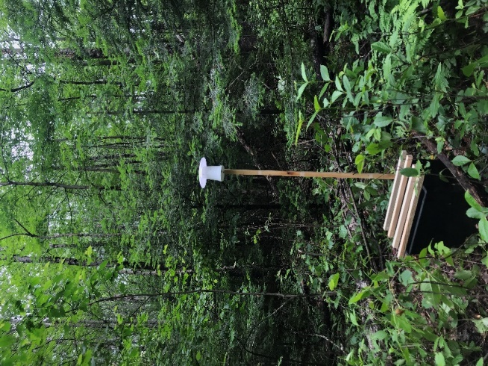
Figure S1. Microclimate and fuel moisture array established at each plot.

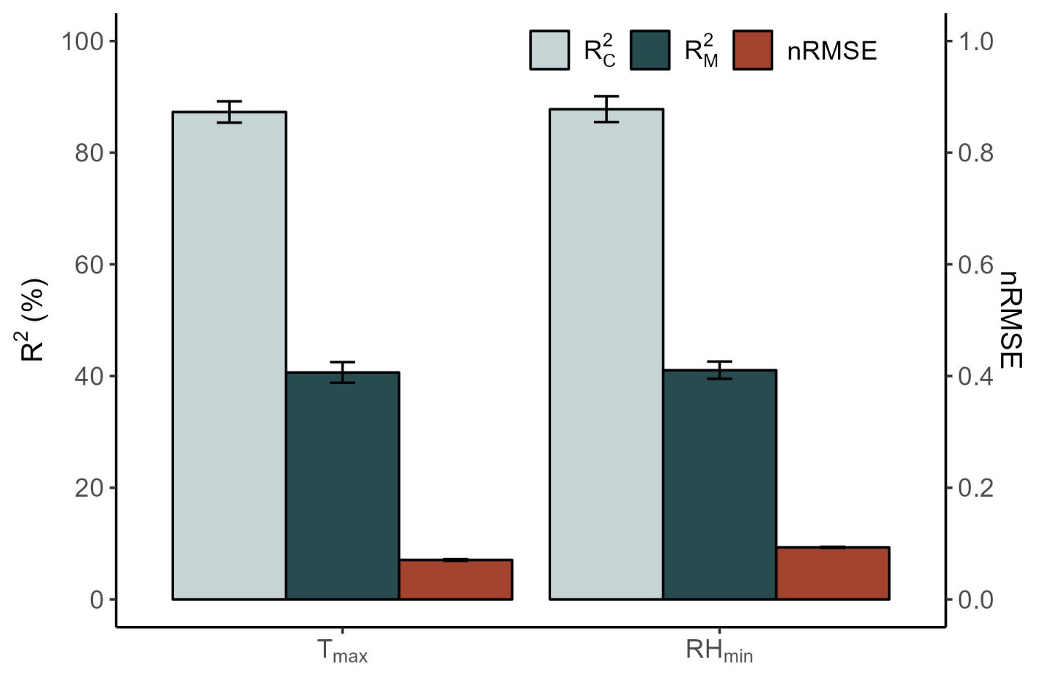
Figure S2. Performance from linear mixed models (LMEs) predicting mean daily maximum temperature (T_{max}) and mean daily minimum relative humidity (RH_{min}) from estimates of canopy openness, basal area, and trees per acre measured at each plot. Error bars depict one standard error. For each response variable, we ran all LMEs within 10 ΔAIC of the top model (n = 2 for each response variable), and the figure shows the mean output of these models. All models included a random effect for study location. Conditional R² (R²_{c}) depicts the total variation explained by fixed and random effects, while marginal R² (R²_{m}) depicts the variation explained by fixed effects. nRMSE is normalized root mean square error, which is a measure of model error standardized across response variable units.

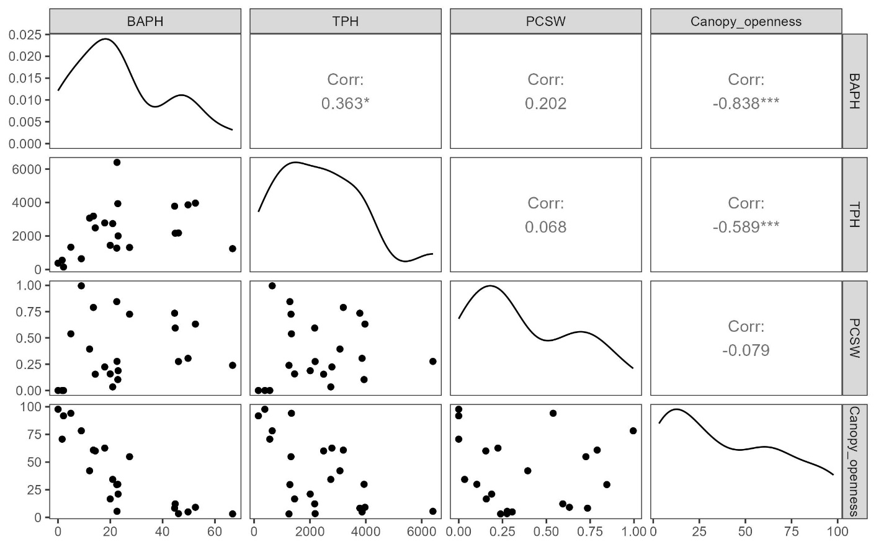
Figure S3. Correlations between forest structure metrics measured with traditional forest inventory. BAPH = basal area (m²/ha); TPH = trees per hectare; PCSW = evergreen cover by basal area.

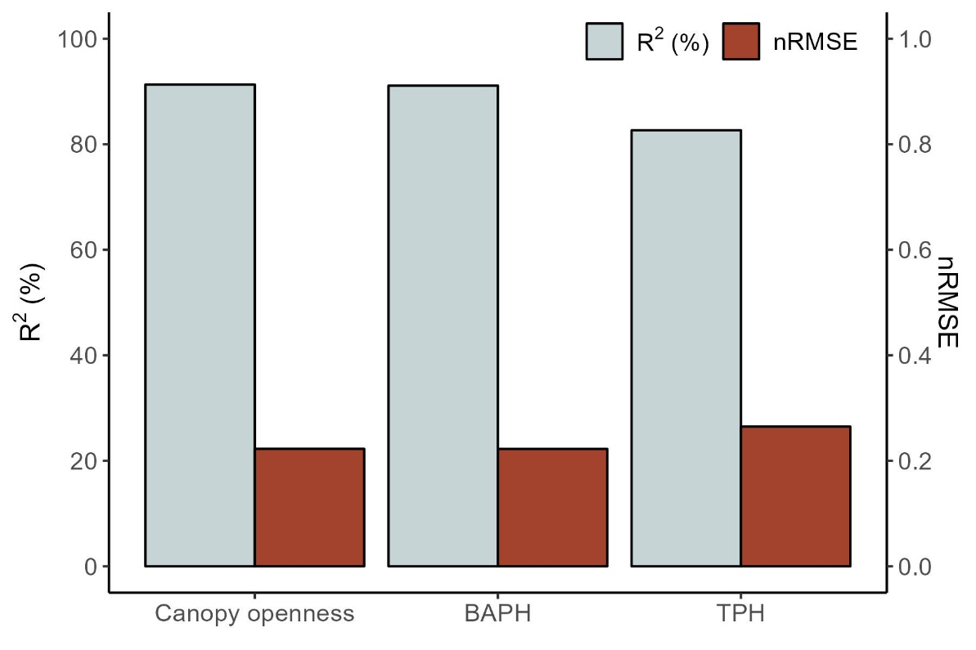
Figure S4. Performance from linear models predicting traditional forest inventory (TFI) variables from terrestrial laser scanning (TLS) derived variables. For each response variable, we conducted a variable selection process using random forests (VSURF) and identified the top two TLS-derived predictor variables to use for modelling. We used R² and nRMSE to assess performance. Normalized root mean square error (nRMSE) is a measure of model error that is standardized by the mean of the response variable.

