Supplemental material 1
Post-wildfire effects, fuel dynamics, and overstory structural changes create risks to forest carbon in future fires

Joseph D. Birch^{1,2ǂ*}, Matthew B. Dickinson³, Eric E. Knapp⁴, Carol Ewell^{5,} Jessica R. Miesel^{1,2*}
¹Department of Plant, Soil and Microbial Sciences, Michigan State University, East Lansing, Michigan, 48823, USA;
²Program in Ecology, Evolution and Behavior, Michigan State University, East Lansing, Michigan, 48823, USA;
³USDA Forest Service, Northern Research Station, Delaware, Ohio, 43015, USA;
⁴USDA Forest Service, Pacific Southwest Research Station, Redding, California, 96002, USA;
⁵USDA Forest Service, PSW Region, Vallejo, California, 95370, USA
*Current address: Department of Forest, Rangeland and Fire Sciences, University of Idaho, Moscow, ID, 83844, USA

^{ǂ}Corresponding author: Joseph D. Birch, jdcooper@uidaho.edu, (208) 298-6090

Methods
Adaptations for partial and missing data

Twelve plots were missing partial pre-fire or immediate post-fire measurements for one or more forest strata. As possible, we used alternative, co-occurring data to supplement missing measurements (or excluded the plots from analyses relating to the missing measurements; n=3). Nine plots were missing post-fire vegetation data and so we compared pre-fire and post-fire transect photos to estimate the percent change in seedling, shrub, grass, and forb cover (Birch et al., 2023). Three plots were missing all or some post-fire measurements and were excluded from any analyses relying on those missing measurements. Finally, four plots located in the ForestGEO Yosemite Forest Dynamics Plot had higher resolution co-occurring pre- and post-fire measurements of forest and fuel structure and so we used these alternative measurements (Cansler et al., 2019; Lutz et al., 2017)

Table S1 Allometric equations used to estimate living tree biomass for species present in our study sites, California, USA. Where biomass is calculated as: ln(biomass(kg)) = β₀ + β₁×ln(diameter at breast height [DBH], cm) (Chojnacky et al., 2013; Miles, 2009).
Species | β₀ | β₁ | Source(s)
Abies concolor | -3.1774 | 2.6426 | Chojnacky et al. 2014
Abies magnifica | -3.1774 | 2.6426 | Chojnacky et al. 2014
Calocedrus decurrens | -2.7765 | 2.4195 | Chojnacky et al. 2014
Cornus nuttallii | -2.2118 | 2.4133 | Chojnacky et al. 2014
Pinus contorta | -2.6177 | 2.4638 | Chojnacky et al. 2014
Pinus jeffreyi | -2.6177 | 2.4638 | Chojnacky et al. 2014
Pinus lambertiana | -2.6177 | 2.4638 | Chojnacky et al. 2014
Pinus monticola | -2.6177 | 2.4638 | Chojnacky et al. 2014
Pinus ponderosa | -2.6177 | 2.4638 | Chojnacky et al. 2014
Pinus sabiniana | -2.6177 | 2.4638 | Chojnacky et al. 2014; Miles 2009
Pseudotsuga menziesii var. menziesii | -2.4623 | 2.4852 | Chojnacky et al. 2014
Salix spp. | -2.4441 | 2.4561 | Chojnacky et al. 2014
Sequoiadendron giganteum | -2.7765 | 2.4195 | Chojnacky et al. 2014
Quercus chrysolepis | -2.2198 | 2.4410 | Chojnacky et al. 2014
Quercus kelloggii | -2.0705 | 2.4410 | Chojnacky et al. 2014
Quercus garryana var. breweri | -2.0705 | 2.4410 | Chojnacky et al. 2014; Miles 2009
We excluded six plots from calculations involving live overstory basal area, biomass, and total ecosystem biomass because they had Sequoia giganteum > 200 cm DBH and could not be accurately measured due to buttressing.
Table S2 Component parameters we used to estimate biomass (kg) for the live foliage, bark, stem wood, and coarse roots for all pole and overstory trees. Biomass components are calculated as: biomass(kg) = exp(β₀ + β₁×ln(diameter at breast height, cm) (Jenkins et al., 2003).
Species |  | Foliage |  |  | Bark |  | Stem |  | Roots
 |  | β₀ | β₁ | β₀ |  | β₁ | β₀ | β₁ | β₀ | β₁
Abies concolor |  | -2.9584 | 4.4766 | -2.098 |  | -1.1432 | -0.3737 | -1.8055 | -1.5619 | 0.6614
Abies magnifica |  | -2.9584 | 4.4766 | -2.098 |  | -1.1432 | -0.3737 | -1.8055 | -1.5619 | 0.6614
Acer macrophyllum |  | -4.0813 | 5.8816 | -2.0129 |  | -1.6805 | -0.3065 | -5.424 | -1.6911 | 0.816
Aesculus californica |  | -4.0813 | 5.8816 | -2.0129 |  | -1.6805 | -0.3065 | -5.424 | -1.6911 | 0.816
Arbutus menziesii |  | -4.0813 | 5.8816 | -2.0129 |  | -1.6805 | -0.3065 | -5.424 | -1.6911 | 0.816
Calocedrus decurrens |  | -2.9584 | 4.4766 | -2.098 |  | -1.1432 | -0.3737 | -1.8055 | -1.5619 | 0.6614
Cornus nuttallii |  | -4.0813 | 5.8816 | -2.0129 |  | -1.6805 | -0.3065 | -5.424 | -1.6911 | 0.816
Juniperus californica* |  | -2.9584 | 4.4766 | -2.098 |  | -1.1432 | -0.3737 | -1.8055 | -1.5619 | 0.6614
Notholithocarpus densiflorus |  | -4.0813 | 5.8816 | -2.0129 |  | -1.6805 | -0.3065 | -5.424 | -1.6911 | 0.816
Pinus attenuata |  | -2.9584 | 4.4766 | -2.098 |  | -1.1432 | -0.3737 | -1.8055 | -1.5619 | 0.6614
Pinus contorta |  | -2.9584 | 4.4766 | -2.098 |  | -1.1432 | -0.3737 | -1.8055 | -1.5619 | 0.6614
Pinus jeffreyi |  | -2.9584 | 4.4766 | -2.098 |  | -1.1432 | -0.3737 | -1.8055 | -1.5619 | 0.6614
Pinus lambertiana |  | -2.9584 | 4.4766 | -2.098 |  | -1.1432 | -0.3737 | -1.8055 | -1.5619 | 0.6614
Pinus ponderosa |  | -2.9584 | 4.4766 | -2.098 |  | -1.1432 | -0.3737 | -1.8055 | -1.5619 | 0.6614
Pinus sabiniana |  | -2.9584 | 4.4766 | -2.098 |  | -1.1432 | -0.3737 | -1.8055 | -1.5619 | 0.6614
Pseudotsuga menziesii var. menziesii |  | -2.9584 | 4.4766 | -2.098 |  | -1.1432 | -0.3737 | -1.8055 | -1.5619 | 0.6614
Quercus chrysolepis |  | -4.0813 | 5.8816 | -2.0129 |  | -1.6805 | -0.3065 | -5.424 | -1.6911 | 0.816
Quercus garryana var. breweri* |  | -4.0813 | 5.8816 | -2.0129 |  | -1.6805 | -0.3065 | -5.424 | -1.6911 | 0.816
Quercus kelloggii |  | -4.0813 | 5.8816 | -2.0129 |  | -1.6805 | -0.3065 | -5.424 | -1.6911 | 0.816
Sequoiadendron giganteum | -2.9584 |  | 4.4766 | -2.098 |  | -1.1432 | -0.3737 | -1.8055 | -1.5619 | 0.6614
*Wood specific gravity used to match species to genus-level allometric equations

Table S3 Species-specific density conversion factors used to convert live biomass to estimated biomass of standing snags, by decay classification (Harmon et al., 2008).
Species |  |  | Class 1  (%) |  | Class 2  (%) |  |  | Cass 3  (g cm³) | Class 4  (g cm³) | Class 5  (g cm³)
Abies concolor |  |  | 0.92 |  | 0.86 |  |  | 0.29 | 0.22 | 0.17
Abies magnifica |  |  | 1.00 |  | 0.93 |  |  | 0.15 | 0.14 | 0.08
Acer macrophyllum |  |  | 0.94 |  | 0.70 |  |  | 0.28 | 0.17 | 0.13
Aesculus californica |  |  | 0.94 |  | 0.73 |  |  | 0.32 | 0.21 | 0.15
Arbutus menziesii |  |  | 0.94 |  | 0.73 |  |  | 0.32 | 0.21 | 0.15
Calocedrus decurrens |  |  | 1.00 |  | 0.85 |  |  | 0.29 | 0.30 | 0.30
Cornus nuttallii |  |  | 0.94 |  | 0.73 |  |  | 0.32 | 0.21 | 0.15
Juniperus californica |  |  | 0.95 |  | 0.82 |  |  | 0.25 | 0.16 | 0.14
Notholithocarpus densiflorus |  |  | 0.94 |  | 0.73 |  |  | 0.32 | 0.21 | 0.15
Pinus attenuata |  |  | 0.91 |  | 0.82 |  |  | 0.27 | 0.16 | 0.17
Pinus contorta |  |  | 0.97 |  | 0.95 |  |  | 0.27 | 0.16 | 0.16
Pinus jeffreyi |  |  | 0.86 |  | 0.83 |  |  | 0.21 | 0.20 | 0.17
Pinus lambertiana |  |  | 0.99 |  | 0.76 |  |  | 0.26 | 0.26 | 0.19
Pinus ponderosa |  |  | 0.96 |  | 0.91 |  |  | 0.34 | 0.24 | 0.20
Pinus sabiniana |  |  | 0.91 |  | 0.82 |  |  | 0.27 | 0.16 | 0.17
Pseudotsuga menziesii var. menziesii |  |  | 0.85 |  | 0.72 |  |  | 0.21 | 0.26 | 0.19
Quercus chrysolepis |  |  | 0.98 |  | 0.77 |  |  | 0.38 | 0.24 | 0.24
Quercus kelloggii |  |  | 0.98 |  | 0.77 |  |  | 0.38 | 0.24 | 0.24
Quercus garryana var. breweri |  |  | 0.98 |  | 0.77 |  |  | 0.38 | 0.24 | t0.24
Sequoiadendron giganteum |  |  | 0.95 |  | 0.82 |  |  | 0.25 | 0.16 | 0.14

Table S4 The LANDFIRE Biophysical Setting (BPS) classification (LANDFIRE, 2020) and the number (N) of Fire Behavior Assessment Team (FBAT) and Wieslander Vegetation Type Mapping dataset (Kelly et al., 2005; Kelly et al., 2008) plots within each category in California, USA.
BPS classification | FBAT plots (N) | VTM plots (N)
Mediterranean California Dry-Mesic Mixed Conifer Forest and Woodland | 7 | 104
Mediterranean California Mesic Mixed Conifer Forest and Woodland | 5 | 17
Mediterranean California Dry-Mesic Mixed Conifer Forest and Woodland | 13 | 612
Mediterranean California Mesic Mixed Conifer Forest and Woodland | 30 | 939
California Montane Jeffrey Pine (-Ponderosa Pine) Woodland | 39 | 612
Mediterranean California Mixed Evergreen Forest-Interior | 5 | 70

Table S5 The proportion of decay classes (sensu Lutz et al., 2021) recorded for standing dead trees pre-fire, post-fire, and at remeasurement in California, USA.
Decay class | Pre-fire | Post-fire | Remeasurement
1* | 87.1 | 99.0 | 82.6
2 | 4.8 | 0.4 | 12.7
3 | 4.2 | 0.1 | 3.3
4 | 0.5 | 0.0 | 0.1
5 | 2.9 | 0.3 | 0.0
*Decay classes not recorded in the field are assumed to be of class 1.

Table S6 Estimates of mean and maximum C emissions (Mg ha⁻¹) under differing RdNBR severity classes (Miller and Thode, 2007) in California, USA. Percent consumption estimated using data from Birch et al. (2023, their table 4) and Becker and Lutz (2023) and consumed fuels multiplied by 0.5 to estimate C consumed (Martin et al., 2018).
Fuel class | Unchanged |  |  | Low |  |  | Moderate |  |  | High
 | Mean | Max | Mean |  | Max | Mean |  | Max | Mean |  | Max
Tree foliage* | 0.0 | 0.0 | 1.2 |  | 5.1 | 1.7 |  | 8.6 | 4.3 |  | 21.5
Snags* | 18.0 | 119.9 | 18.0 |  | 119.9 | 18.0 |  | 119.9 | 18.0 |  | 119.9
Seedling | 0.3 | 7.4 | 0.2 |  | 6.5 | 0.3 |  | 8.7 | 0.7 |  | 16.9
Shrubs | 1.7 | 40.0 | 1.6 |  | 36.6 | 1.8 |  | 42.3 | 2.3 |  | 53.8
Grass | 0.0 | 1.4 | 0.0 |  | 1.3 | 0.0 |  | 1.4 | 0.0 |  | 1.5
Forb | 0.1 | 7.6 | 0.1 |  | 7.7 | 0.1 |  | 9.0 | 0.0 |  | 6.0
1000-h | 12.3 | 154.7 | 12.5 |  | 157.2 | 14.3 |  | 179.7 | 18.1 |  | 227.1
100-h | 1.2 | 9.1 | 1.4 |  | 10.8 | 1.3 |  | 10.3 | 1.6 |  | 12.4
10-h | 1.6 | 8.9 | 1.6 |  | 9.1 | 1.8 |  | 10.0 | 2.1 |  | 12.0
1-h | 0.0 | 0.1 | 0.2 |  | 1.4 | 0.2 |  | 1.2 | 0.3 |  | 1.7
Litter | 4.5 | 19.5 | 6.0 |  | 26.2 | 6.2 |  | 27.2 | 5.6 |  | 24.5
Duff | 8.8 | 30.5 | 12.7 |  | 44.2 | 15.4 |  | 53.8 | 14.0 |  | 49.06
Total | 48.5 | NA | 55.5 |  | NA | 61.1 |  | NA | 67.0 |  | NA
*Plots with Sequoia giganteum excluded from estimations

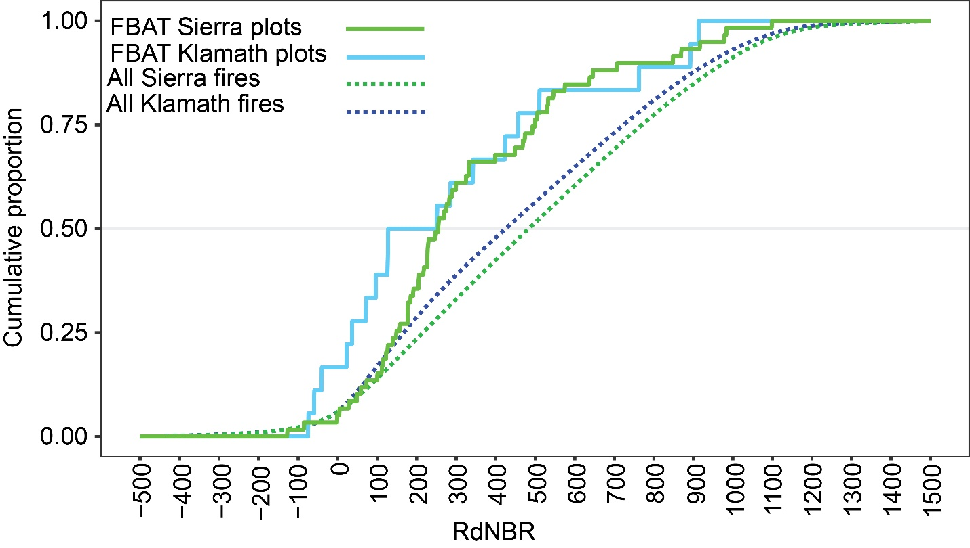
Figure S1 Cumulative distribution of relative delta normalized burn ratio (RdNBR) values for all Fire Behavior Assessment (FBAT) plots 2005 – 2020 and for in all fires (>400 ha) in the Sierra Nevada and Klamath Mountain ecoregions, California, USA (Miles and Goudey, 1997). Higher (lower) RdNBR values are associated with more (less) severe fire effects. All fire perimeters and RdNBR were sourced from the Monitoring Trends in Burn Severity (Monitoring Trends in Burn Severity, 2023) program for the period 2005 – 2020.
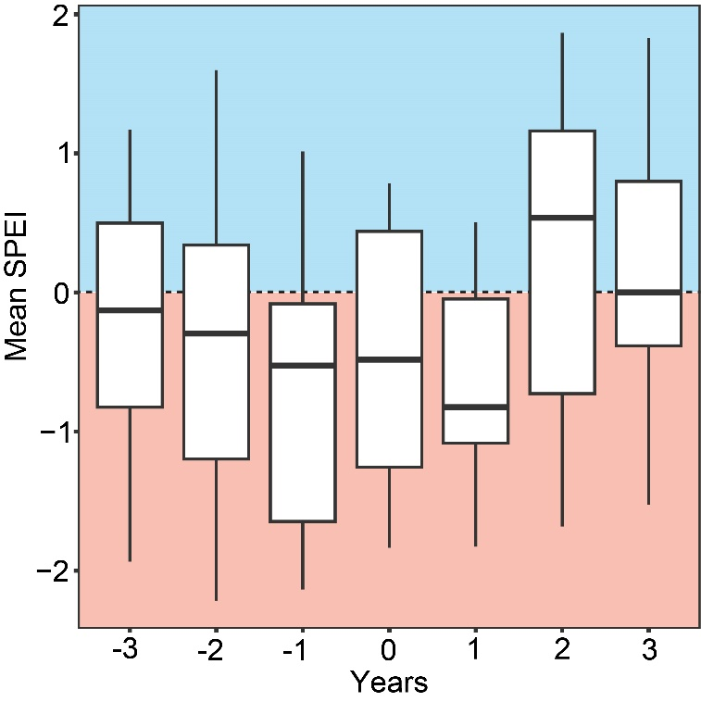
Figure S2 Standardized Precipitation-Evapotranspiration Index (SPEI) values averaged over the 12-month periods before (negative year values) and after (positive year values) the year of burn (‘Year 0’)in plots in California, USA. Values of SPEI <0 (>0) indicate drought (mesic) conditions.
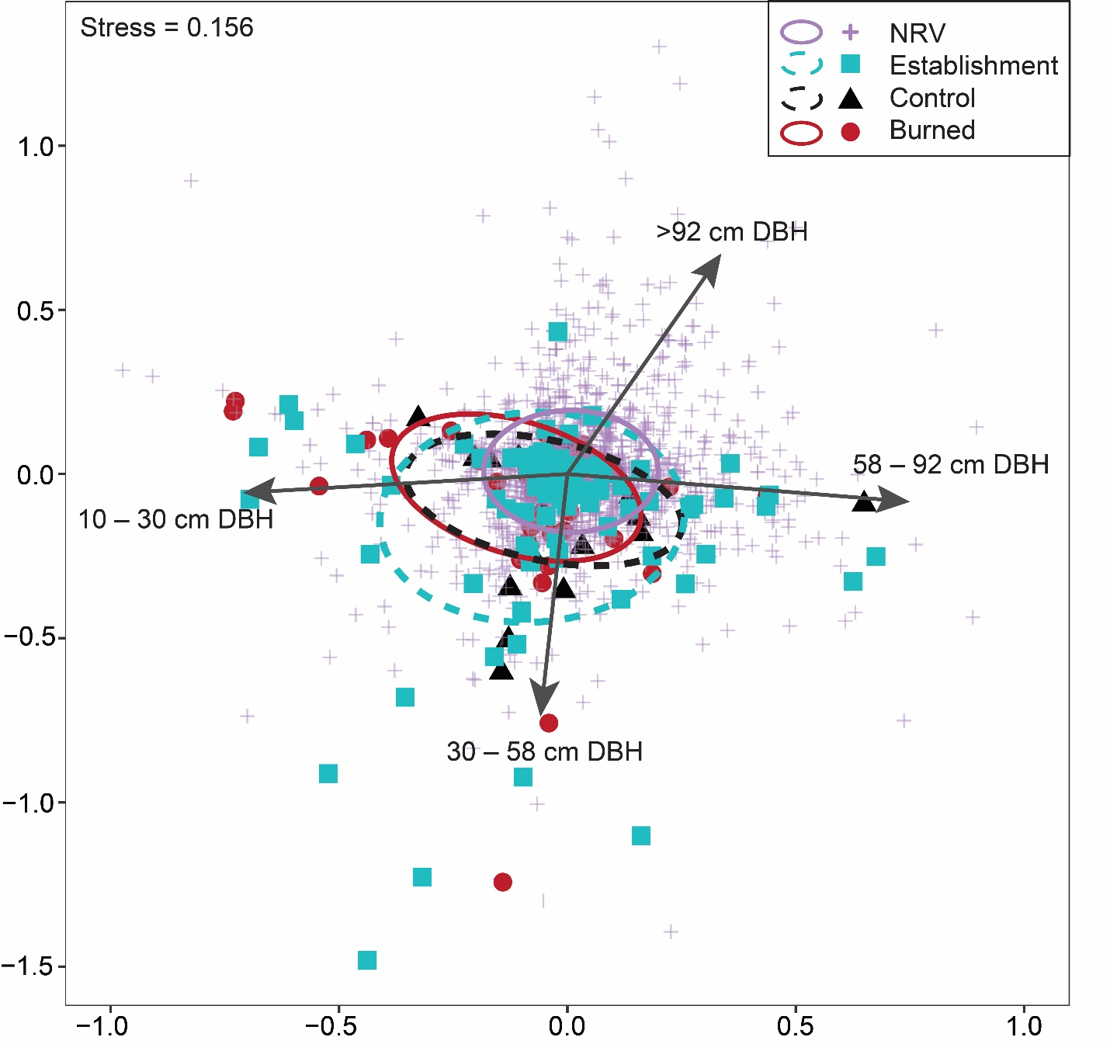
Figure S3 Nonmetric multidimensional scaling (NMDS) ordination representing community dissimilarity in trees per hectare, by size class, between the pre-fire establishment plots, the burned and control plots at the time of remeasurement, and the historical Wieslander plots from the 1920s – 1930s (Kelly et al., 2005; Kelly et al., 2008) which represent a condition more similar to but potentially still departed from the natural range of variability (NRV) in California mixed-conifer forests. Ellipses represent 95% confidence intervals for group centroids. Vectors indicate significant correlations (P < 0.001) between the size of trees and ordination space.

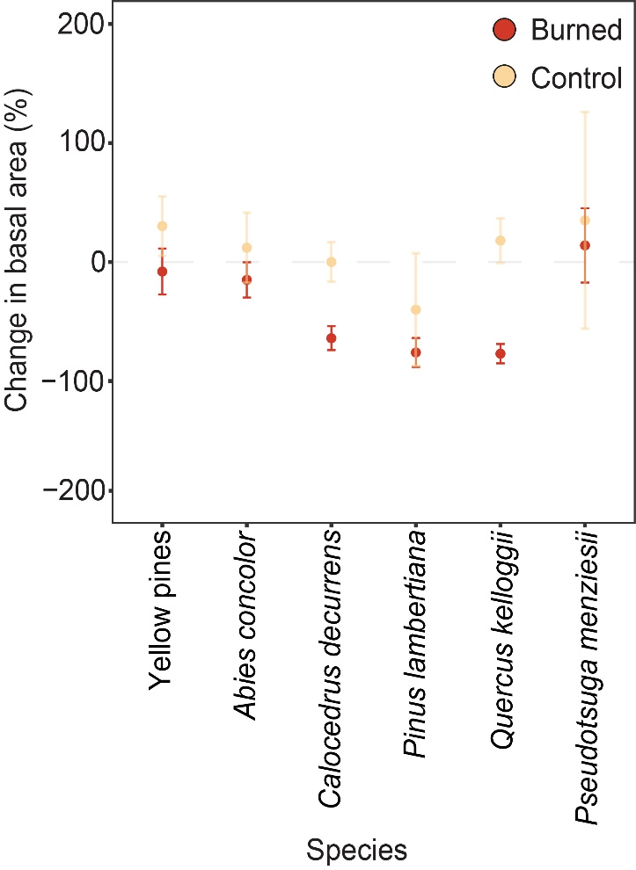
Figure S4 Mean ± 1 SE change in basal area (%) by tree species, between pre-fire and remeasurement for burned and unburned control forests in California, USA. Yellow pine grouping include both Pinus ponderosa and Pinus jeffreyii, due to hybridization.

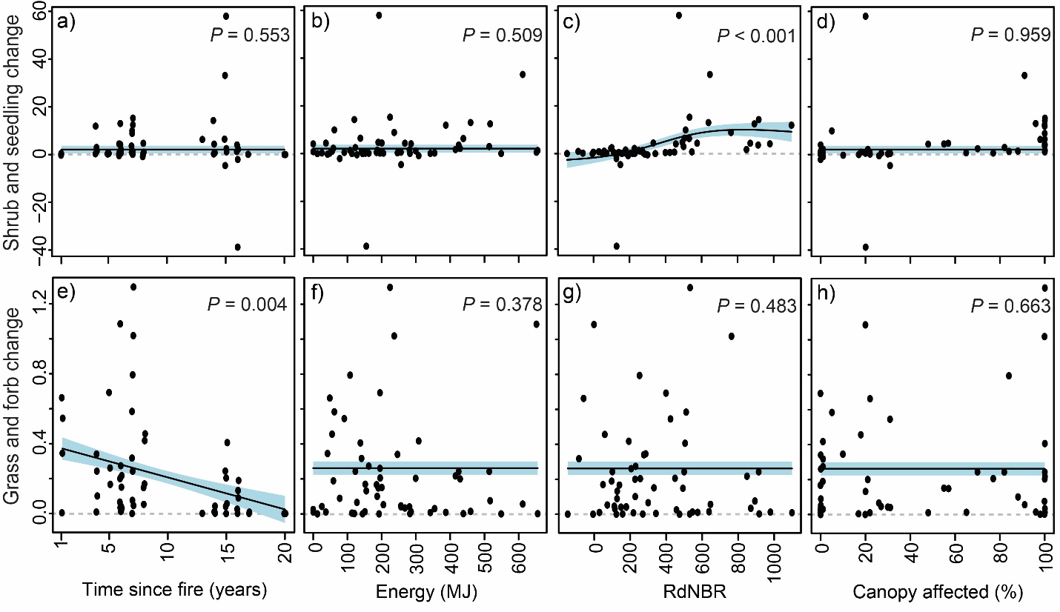
Figure S5 Partial effects plots with 95% confidence intervals (blue-shading) for change in shrub and seedling fuels (Mg ha⁻¹; a-d) and grass and forb fuels (Mg ha⁻¹; e-h) between postfire and remeasurement in California, USA. (a, e,) Time since fire. (b, f) Fire energy (MJ). (c, g) Relative delta normalized burn ratio (RdNBR). (d, h) Percent canopy affected (%). Values above (below) ‘0’ on the y-axis indicate greater (lower) fuel mass at the time of remeasurement, relative to relative to pre-fire.

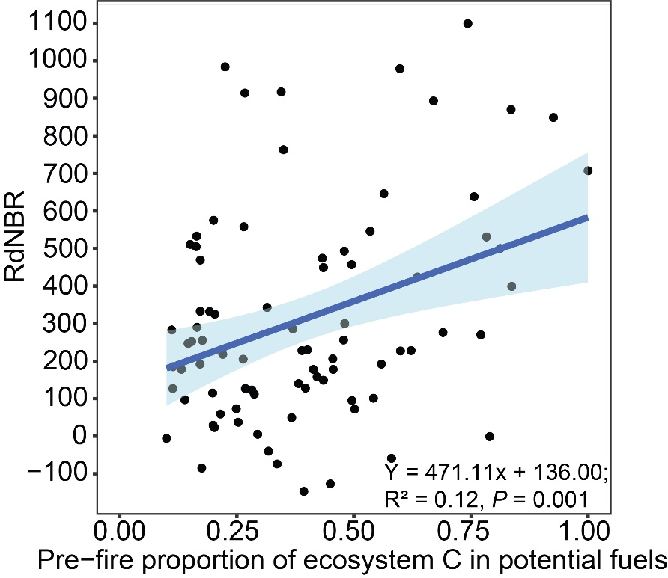
Figure S6 The positive, linear relationship with 95% confidence intervals (blue-shading) between the pre-fire proportion of aboveground ecosystem C in potential fuels and the relative delta normalized burn ratio (RdNBR) in California, USA.

References
Becker KML, Lutz JA. Predicting snag fall in an old-growth forest after fire. Fire Ecology 2023; 19: 71. https://doi.org/10.1186/s42408-023-00225-z
Birch JD, Dickinson MB, Reiner A, Knapp EE, Dailey SN, Ewell C, et al. Heading and backing fire behaviours mediate the influence of fuels on wildfire energy. International Journal of Wildland Fire 2023; 32: 1244-1261. https://doi.org/10.1071/WF22010
Cansler CA, Swanson ME, Furniss TJ, Larson AJ, Lutz JA. Fuel dynamics after reintroduced fire in an old-growth Sierra Nevada mixed-conifer forest. Fire Ecology 2019; 15: 16. https://doi.org/10.1186/s42408-019-0035-y
Chojnacky DC, Heath LS, Jenkins JC. Updated generalized biomass equations for North American tree species. Forestry: An International Journal of Forest Research 2013; 87: 129-151. https://doi.org/10.1093/forestry/cpt053
Harmon ME, Woodall CW, Fasth B, Sexton J. Woody detritus density and density reduction factors for tree species in the United States: a synthesis. USDA For. Serv. Gen. Tech. Rep. NRS-29 2008.
Jenkins JC, Chojnacky DC, Heath LS, Birdsey RA. National-scale biomass estimators for United States tree species. Forest Science 2003; 49: 12-35. https://doi.org/10.1093/forestscience/49.1.12
Kelly M, Allen-Diaz B, Kobzina N. Digitization of a historic dataset: the wieslander california vegetation type mapping project. Madroño 2005; 52: 191-201, 11. https://doi.org/10.3120/0024-9637(2005)52[191:DOAHDT]2.0.CO;2
Kelly M, Ueda K-i, Allen-Diaz B. Considerations for ecological reconstruction of historic vegetation: Analysis of the spatial uncertainties in the California Vegetation Type Map dataset. Plant Ecology 2008; 194: 37-49. https://doi.org/10.1007/s11258-007-9273-1
LANDFIRE. Biophysical Settings, LANDFIRE 2.0.0. U.S. Department of the Interior GS, and U.S. Department of Agriculture. 2020. https://landfire.gov/bps.php. .
Lutz JA, Furniss TJ, Germain SJ, Becker KML, Blomdahl EM, Jeronimo SMA, et al. Shrub communities, spatial patterns, and shrub-mediated tree mortality following reintroduced fire in Yosemite National Park, California, USA. Fire Ecology 2017; 13: 104-126. https://doi.org/10.4996/fireecology.1301104
Lutz JA, Struckman S, Furniss TJ, Birch JD, Yocom LL, McAvoy DJ. Large-diameter trees, snags, and deadwood in southern Utah, USA. Ecological Processes 2021; 10: 9. https://doi.org/10.1186/s13717-020-00275-0
Martin AR, Doraisami M, Thomas SC. Global patterns in wood carbon concentration across the world’s trees and forests. Nature Geoscience 2018; 11: 915-920. 10.1038/s41561-018-0246-x
Miles PD. Specific gravity and other properties of wood and bark for 156 tree species found in North America. Vol 38: US Department of Agriculture, Forest Service, Northern Research Station, 2009.
Miles SR, Goudey CB. Ecological subregions of California: section and subsection descriptions. San Francisco, California, USA.: USDA Forest Service, Pacific Southwest Region, 1997.
Miller JD, Thode AE. Quantifying burn severity in a heterogeneous landscape with a relative version of the delta Normalized Burn Ratio (dNBR). Remote Sensing of Environment 2007; 109: 66-80. https://doi.org/10.1016/j.rse.2006.12.006
Monitoring Trends in Burn Severity. Burn severity database. US Department of Agriculture UGS. 2023. https://www.mtbs.gov/.

