Table S1: Semi-structured interview guide
Introduction
Good morning/afternoon. My name is [interviewer’s name], and we are conducting this interview to better understand traditional practices, environmental changes, and the challenges faced by the community. The information will be used for research and cultural documentation purposes, and your anonymity will be fully respected. The interview is expected to last approximately [estimated time]. Do you feel comfortable to begin?

1. Traditional use of fire
- How did you learn to use fire in crop fields or other activities?
- In which situations is fire currently used in the community?
- Have there been changes in the timing, intensity, or frequency of burning? How and why?
- What precautions does the community usually take to prevent fire from spreading beyond the intended area?
- How do you perceive the differences between traditional fire use and the fires that occur today?
Probing question:
Can you describe a recent example in which the use of fire brought benefits or problems to the community?

2. Agricultural management and cropping systems
- What are the main steps involved in preparing and cultivating a crop field (roça)?
- How long is a field usually cultivated, and how long does it remain under fallow?
- What criteria determine when and where a new field is opened?
- Which crops are commonly planted together, and why?
- What techniques does the community use to maintain soil fertility?
Probing question:
Could you explain how the timing of burning is decided and what is done after the burn?

3. Cattle management
- How is cattle managed within the community?
- Which areas are used for grazing, and how are they maintained?
- Have there been changes in herd size or livestock practices in recent years?
- What are the main challenges related to cattle and pasture management?
- How do cattle interact with crop fields, forests, or palm swamps (veredas)?
Probing question:
Can you describe a case in which cattle had a positive or negative effect on a cultivated area or natural vegetation?

4. Water availability and rainfall regime
- What was the rainfall pattern like when you were a child?
- What changes have you noticed in the amount and distribution of rainfall?
- Have there been changes in the quality or quantity of water available for domestic use, agriculture, or livestock?
- What strategies does the community use to cope with periods of drought or excessive rainfall?
Probing question:
Could you give an example of how the community adapted to a recent change in rainfall patterns?

5. Infrastructure, public policies, and conflicts
- What improvements or changes in infrastructure have occurred in recent years (e.g., roads, electricity, communication)?
- How have these changes affected community life and work?
- Are there conflicts related to land, water, or the use of natural resources?
- How have public policies helped or hindered the community?
- Is there support from government agencies or NGOs to maintain traditional practices?
Probing question:
Can you describe an example of a policy or project that had a significant impact on the community?

6. Local environmental changes
- What changes in vegetation and the environment have you observed over recent decades?
- Have any plant or animal species appeared or disappeared?
- Are there areas that were previously productive and are no longer so?
- How does the community interpret these changes?
Probing question:
Can you share a striking example that illustrates these environmental changes?

7. Traditional knowledge and education
- How is knowledge about farming, fire, cattle, and water transmitted across generations?
- Do children and young people participate in productive activities?
- Have there been changes in how this knowledge is taught or shared?
- Does the local school address topics related to community culture and the local environment?
- Are young people interested in continuing traditional practices?
Probing question:
Can you give an example of a traditional practice or knowledge that you consider important to preserve?

Closing
Is there anything you would like to add that we did not ask about and that you consider important?
Thank you very much for your participation. Your contribution is extremely valuable to our research and to the preservation of the community’s memory.

Table S2: Summary of the interview sample
Sample characteristic | Description
Total number of interviewees | 51 Kalunga farmers
Gender composition | 32 men; 19 women
Communities included | Engenho II; Vão do Moleque; Vão de Almas; Prata
Data collection period | 2021–2022
Sampling strategy | Snowball sampling aimed at ensuring diversity in age and gender

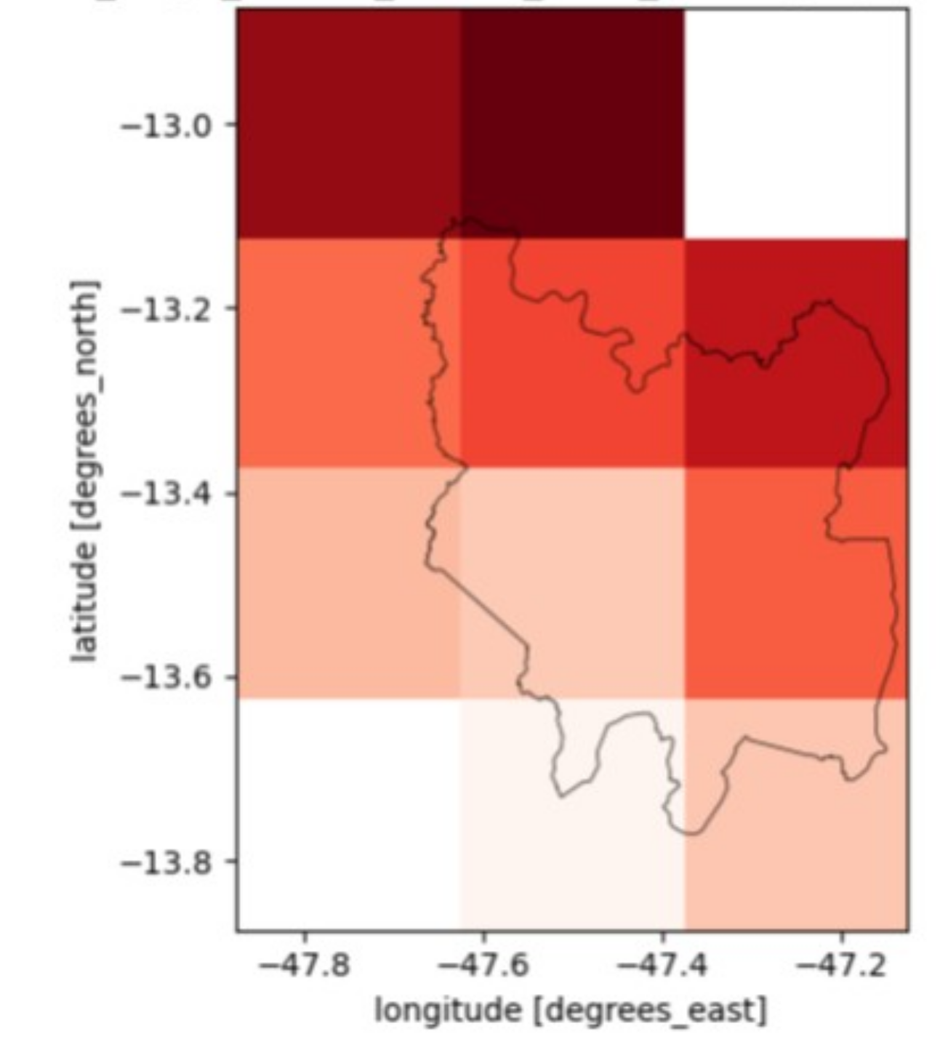
Figure S1: ERA5 grid cells retained for the climate analyses in the Kalunga Quilombola Territory, Brazilian Cerrado. The black polygon delineates the Kalunga Territory, and the highlighted 0.25° × 0.25° grid cells correspond to the ten ERA5 cells intersecting the territory and included in the spatial aggregation of climate variables. Coordinates are shown in degrees of latitude and longitude.

