Supplementary information

Impacts of Wildfires and Prescribed fires on Mercury Cycling and Exposure: A Global Bibliometric Analysis and Scientific Response-Lag Evaluation
Yener Ulus¹, Elif Yıldırım², Martin Tsz-Ki Tsui^{3,4,5}, Tyler Cameron Webber¹, Habibullah Uzun⁶
¹Biology and Environmental Science Department, College of Sciences, Auburn University at Montgomery, Montgomery, AL, United States
²Suleyman Demirel University, Department of Statistics, Faculty of Engineering and Natural Sciences, Isparta, Türkiye
³School of Life Sciences, The Chinese University of Hong Kong, Hong Kong SAR, China
⁴State Key Laboratory of Marine Environmental Health, City University of Hong Kong, Kowloon Tong, Kowloon, Hong Kong SAR, China
⁵Department of Earth and Environmental Sciences, Institute of Environment, Energy and Sustainability, The Chinese University of Hong Kong, Hong Kong SAR, China
⁶Department of Environmental Engineering, Istanbul Technical University, Istanbul, Türkiye

Correspondence to: Elif Yildirim (elif.yildirim@sdu.edu.tr)

S1. Descriptive Bibliometric Results
Table S1. PICOS criteria
PICOS | Description
Population | All published academic studies on the Hg pollution and exposure in various ecosystems related to wildfire and controlled fires. All studies on environmental pollution in different ecosystems after wildfires, the effects of Hg on human health, and policies related to the subject.
Intervention | Studies that theoretically address the issue of fire impact on Hg cycling. Examining studies on the effects of this pollution on human health, the environment, and ecosystems, and the measures/policies taken in this regard.
Comparison | A comparison of the levels of productivity and collaboration levels of studies in the field of research across years, authors, institutions, countries and thematic trends.
Outcomes | The analysis and visualization of the development trends, citation levels, keyword patterns, collaboration networks, trend topics, and scientific structures of the literature on fire-driven Hg cycling.
Study designs | Articles related to the subject, published in English and indexed in the WoS database, only in the “Research Article” and “Early Access” categories.

Table S2. The descriptive statistics of the dataset created for bibliometric analysis
Description | Results
Main Information About Data
Timespan | 1999:2025
Sources (Journals, Books, etc) | 43
Documents | 94
Annual Growth Rate % | 7.13
Document Average Age | 9.74
Average citations per doc | 31.66
References | 4145
Document Contents
Keywords Plus (ID) | 378
Author's Keywords (DE) | 253
Authors
Authors | 526
Authors of single-authored docs | 0
Authors Collaboratıon
Single-authored docs | 0
Co-Authors per Doc | 6.32
International co-authorships % | 32.63
Document Types
article | 94
article; early access | 1

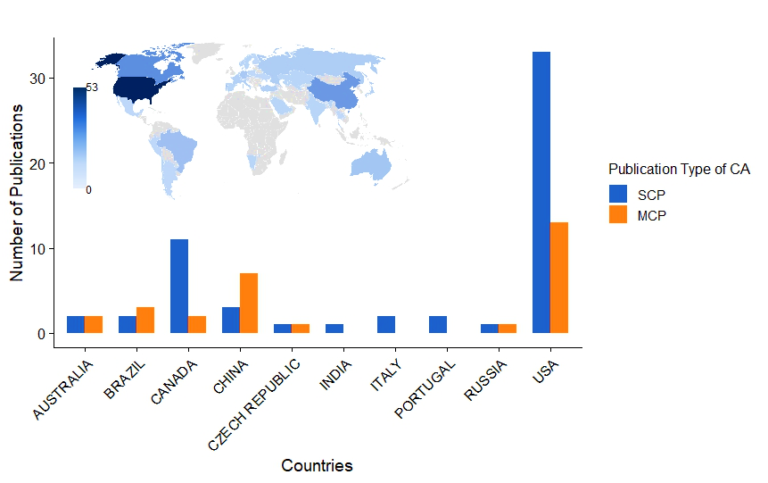
Figure S1. Top 10 countries based on corresponding author (CA) publications, showing single-country publications (SCP) and multi-country publications (MCP). The map illustrates the global distribution of publications based on all contributing authors’ affiliations (not limited to corresponding authors). Color intensity represents the total number of publications per country.
Figure S1 shows that the USA leads scientific production on fire and their impact on Hg cycling research, both in total output and corresponding author (CA)-based contributions. Accordingly, the USA was seen as a leader in the field in terms of country frequencies (f = 53) and distribution across CA countries (n = 46; 48.4%). It was followed by Canada (f = 19 and CA, n = 13; 13.7%) and China (f = 17 and CA, n = 11; 11.6%). While Brazil (f = 6 and CA, n = 5; 5.3%) and Australia (f = 5 and CA, n = 4; 4.2%) stand out as countries with medium-level contributions, countries such as the Czech Republic, Italy, Portugal, Russia, and India were observed to have recorded, but limited, production. The map further reflects the global distribution of publications based on all contributing authors, helping distinguish between total production (f) and corresponding author contributions (n).
Figure S1 highlights the leading role of certain countries in scientific production on fire-driven Hg research, with the USA clearly dominating both in total output and collaborative contributions. Based on corresponding author (CA) affiliations, the USA ranks first in publication frequency (f = 53) and CA-based contributions (n = 46; 48.4%). It is followed by Canada (f = 19; n = 13; 13.7%) and China (f = 17; n = 11; 11.6%). Brazil (f = 6; n = 5; 5.3%) and Australia (f = 5; n = 4; 4.2%) show moderate levels of contribution, while countries such as the Czech Republic, Italy, Portugal, Russia, and India exhibit relatively limited production. The map further illustrates the global distribution of publications based on all contributing authors, highlighting the broader geographic spread of research activity beyond corresponding author affiliations.
When international collaboration rates were examined, it was observed that approximately 28.3% of publications in the USA are of the MCP nature; thus, the collaboration rate remains relatively low, despite the USA's high volume of publications. However, the proportion of international collaborations was relatively higher in countries such as China (63.6%), Brazil (60%), Australia (50%), the Czech Republic (50%), and Russia (50%). In countries such as Italy, Portugal, and India, however, all publications were found to be SCP.
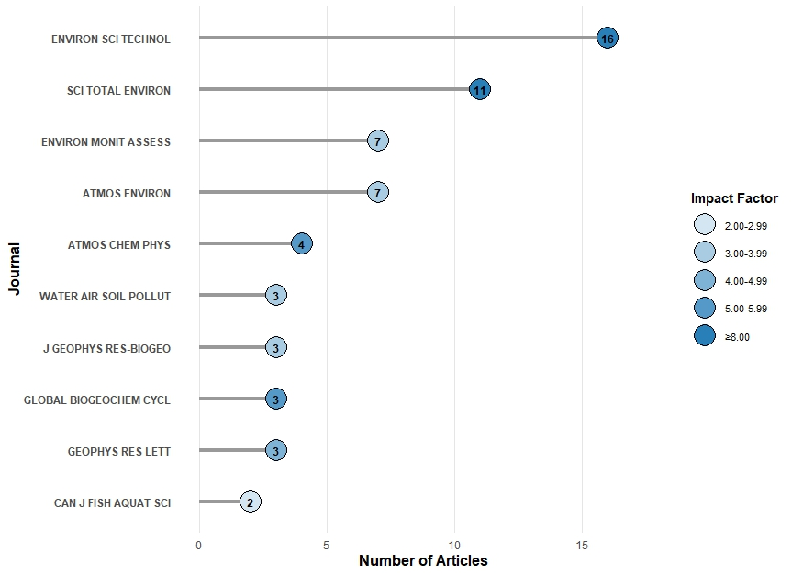
Figure S2. Top 10 journals with the greatest number of publications in the field. The horizontal axis shows the number of articles published in each journal, while bubble size and color indicate the journal impact factor (IF) categories.
Figure S2 shows that Environmental Science & Technology (n = 16; IF = 11.3) is the leading journal in terms of publication count, followed by Science of the Total Environment (n = 11; IF = 8.0), Environmental Monitoring and Assessment (n = 7; IF = 3.0), and Atmospheric Environment (n = 7; IF = 3.7). Other journals, including Atmospheric Chemistry and Physics (n = 4; IF = 5.1), Water, Air, and Soil Pollution (n = 3; IF = 3.0), Journal of Geophysical Research: Biogeosciences (n = 3; IF = 3.5), Global Biogeochemical Cycles (n = 3; IF = 5.5), Geophysical Research Letters (n = 3; IF = 4.0), and Canadian Journal of Fisheries and Aquatic Sciences (n = 2; IF = 2.2), also contribute to the field at varying levels.
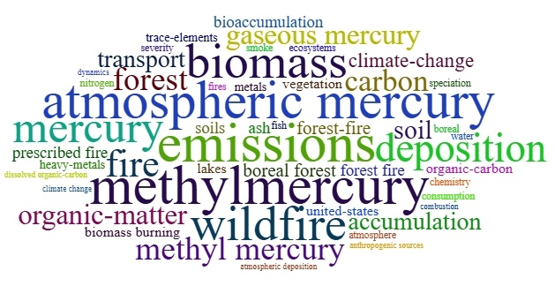
Figure S3. Word cloud of Keywords Plus (KP) in the literature on fire-driven Hg cycling. Keyword size reflects frequency, with larger words indicating higher occurrence across the dataset.

Figure S3 presents the relative frequency of Keywords Plus (KP) in the literature on fire-driven Hg cycling. Prominent terms include Hg, MeHg, biomass, emissions, atmospheric Hg, wildfires, and deposition. These terms reflect commonly used research topics and provide a general overview of dominant themes in the literature. Additional keywords such as bioaccumulation, organic matter, and soil indicate that studies also address biological exposure in terrestrial and aquatic ecosystems, while terms such as climate change, water and fish suggest links to broader environmental processes. Overall, the keyword distribution highlights the growing attention to interactions between wildfires and biogeochemical processes.

S2. Scientific Response and Cross-Correlation Function
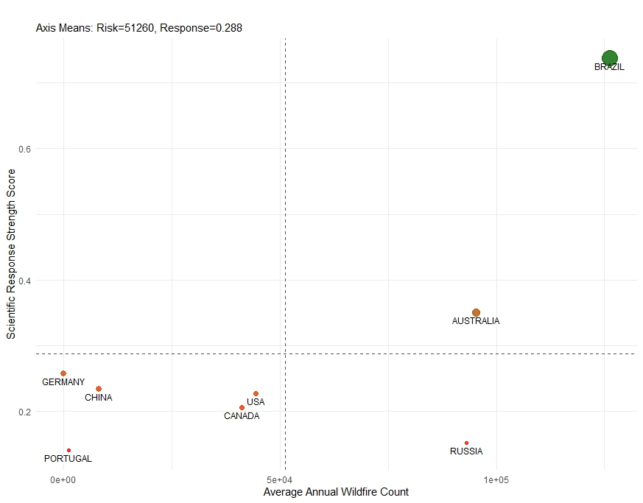
Figure S4. Scientific response matrix
These national results are synthesized in the scientific response matrix (Figure S4), which positions countries according to their average annual wildfire frequency and response speed ​​and Strength. Brazil is located in the upper right quadrant of the matrix, with the highest response scores, while high-risk countries such as Australia and Russia, and high-volume countries like the USA and Canada, are positioned in the lower quadrant, with lower response scores. This positioning suggests that scientific leadership should be defined not only by publication volume but also by the speed (Lag) and strength (r) of response to environmental risks.
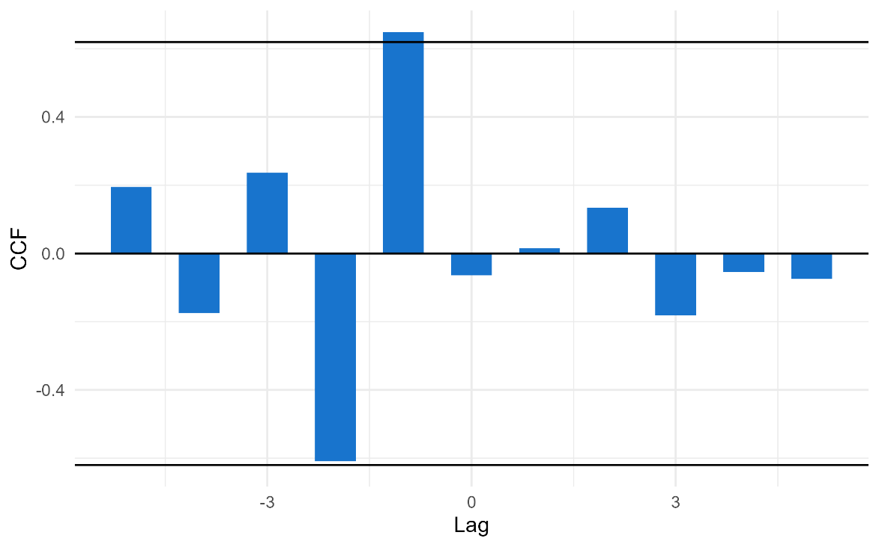
Figure S5. CCF between detrended annual global fire frequency and scientific publication output (2015–2024). Linear trends were removed from both time series prior to analysis. Horizontal lines represent approximate 95% confidence bounds (±2/√n).
The detrended global CCF results confirm that the lagged association at Lag = −1 persists after removing linear trends, suggesting that this relationship is not solely driven by shared temporal increases in both series. The absence of significant correlations at other lags indicates that the temporal coupling between fire activity and scientific output is limited and concentrated around a short-term response.
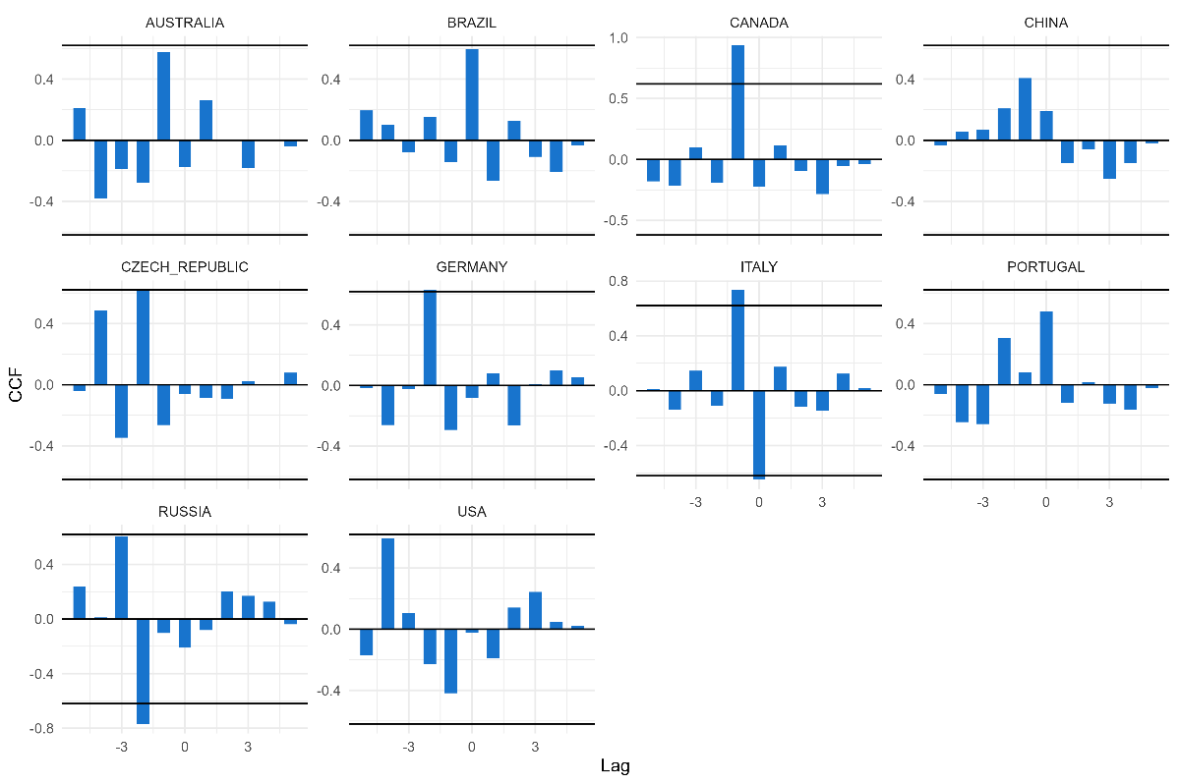
Figure S6. CCF between detrended annual fire frequency and scientific publication output at the country level (2015–2024). Linear trends were removed from each time series prior to analysis. Horizontal lines indicate approximate 95% confidence bounds (±2/√n).
The detrended country-level analyses reveal heterogeneous temporal patterns, with only a small number of lagged correlations exceeding the confidence bounds. Notably, significant positive associations are observed in Canada (Lag = −1) and Italy (Lag = +1), while the Czech Republic (Lag = −2) and Russia (Lag = +2) also exhibit notable deviations from the confidence limits. However, these associations differ in both direction and timing, and no systematic lag pattern emerges across countries.
Overall, the results suggest that country-specific responses of scientific output to wildfire activity are highly variable and not driven by a common temporal mechanism.

S3. Qualitative Synthesis of Influential Wildfire and Prescribed-Burning Studies
In this section, we concentrated on the ten most highly cited studies, as well as prominent controlled/ prescribed burning studies in the literature. These studies have made important contributions to understanding how wild, prescribed, and laboratory-controlled biomass or soil combustion experiments influence Hg mobilization and transformation within forest ecosystems. Together, these studies are acknowledged for their significant impact on our understanding of how fires, whether natural or laboratory-burning, evaluate the mobilization and transformation of Hg within forest ecosystems. Collectively, they have demonstrated that the fate of Hg is predominantly influenced by vegetation type, deposition history, fire severity and Hg speciation (Table S3). Furthermore, the literature focuses primarily on total Hg (THg) and Hg⁰, while MeHg, a toxic and biologically critical form, has been addressed in very limited studies (Figure S7). Similarly, an examination of environmental metrics reveals that studies on natural fires have primarily focused on soil, air, and plant components, whereas the controlled burning literature emphasizes the dynamics of soil, vegetation, and organic matter. In contrast, aquatic environments and biotic receptors are limitedly represented in both literature streams, indicating critical knowledge gaps regarding human health and ecosystem risks (Figure S8).
An initial experimental study by Friedli and colleagues, conducted in North American forests, focused on Hg volatilization during laboratory biomass burning and wildfires, including those that consumed vegetation, litter and agricultural waste (Friedli et al., 2001). Both laboratory burning and real-world (wildfires in Montana, Ontario, the Cascade Mountains, and Northeastern Oregon) smoke analysis have shown that more than 94% of the Hg present (reaching up to 75 ng/g) in vegetation is volatilized during combustion, primarily as Hg⁰, which is the most stable and atmospherically persistent form of Hg (Friedli et al., 2003a; Friedli et al., 2003b).
This is primarily attributed to atmospheric deposition, elevated combustion temperatures during the consumption of vegetation, and intense soil heating. This indicates that most of the Hg released from wildfires becomes part of the global atmospheric pool, while a portion may contribute to local depositions.
Dicosty and colleagues conducted a comprehensive assessment of low-intensity prescribed burns and their atmospheric emissions in southeastern USA pine forests (Dicosty et al., 2006). They further investigated Hg storage in soil horizons (i.e., O, A, E, and B). The study revealed that Hg concentrations were highest in the O horizon and declined with increasing fire frequency. Furthermore, the annual Hg losses were determined to be 0.18 g Hg ha⁻¹ yr⁻¹, which closely corresponds to the measured atmospheric deposition rates of 0.17 g Hg ha⁻¹ yr⁻¹. These results indicate that prescribed burns are net-neutral within the Hg cycle, acting primarily as a re-emission process rather than as new sources, and they contribute less than 1% to anthropogenic Hg emissions in the US. In addition, experiments with prescribed burns and controlled stove burns have further demonstrated that a variety of chemical tracers, particularly total-Hg and K⁺, are effective in pinpointing emission sources (Zhang et al., 2013).
Measurements taken in the field within the Canadian Boreal Forest fires reveal that Hg⁰ released during these wildfires can be transported over long distances through the atmosphere (Sigler et al., 2003). The researchers identified significant correlations between Hg⁰ and carbon monoxide (CO) in plumes from the Canadian boreal forest. The estimated release of 1.5 g Hg ha⁻¹, equivalent to 3.5 tonnes annually. Friedli and colleagues further reported that wildfire plumes in Washington and Oregon exhibited Hg concentrations six times higher than background levels, with emission factors of 113 ± 59 µg Hg/kg of fuel (Friedli et al., 2003b).
Turetsky and the research team showed that peat soils contained ten times more Hg than upland areas. It was estimated that climate-induced drought and wildfires could release up to 116.8 tonnes of Hg annually in western Canada, transforming peatlands from long-term Hg reservoirs into significant atmospheric sources (Turetsky et al., 2006). Similarly, Biswas and the research team found that both the severity of fires and the type of vegetation significantly affected Hg loss in conifer, aspen, and meadow ecosystems in the Rocky Mountains. High-severity fires could volatilize up to 86% of the Hg stored in the soil. Moreover, they noted that fire severity significantly affects Hg emissions, with USA wildfires potentially releasing 19–64 tonnes of Hg each year, which could account for up to 42% of anthropogenic flux (Biswas et al., 2007).
Fire-induced Hg emissions have environmental implications that extend beyond atmospheric effects. Research conducted by Kelly et al. (2006) has demonstrated that forest fires can substantially increase the bioaccumulation of MeHg in fish. In the aftermath of wildfires in Jasper National Park, Alberta, Hg concentrations in fish rose fivefold, attributed to altered food web dynamics and increased Hg inputs from runoff. This suggests that terrestrial fires indirectly augment the bioavailability of Hg in aquatic ecosystems.
In their 2016 study, Burton and colleagues expanded their understanding of hydrological fluxes by examining the 2009 Station Fire in California. They found that levels of soluble Fe, Mn, and Hg increased significantly in the burned catchments. Moreover, total Fe, Pb, Ni, and Zn occasionally exceeded the criteria for aquatic life. This suggests that the movement of ash and sediment is crucial in the mobilization of Hg and metals following a fire (Burton et al., 2016). In a study conducted by Abraham et al. (2018), the impact of prescribed burning in an old gold-mining region in Australia was investigated. The researchers discovered that during the fires, 8–97% of Hg was volatilized, which was subsequently re-accumulated in the topsoil after rainfall. The concentration of Hg in the soil doubled (from 2.2 to 4.9 mg/kg) following postfire rainfall, due to the leaching and redeposition of Hg-rich ash. The study highlights that prescribed burns can intensify Hg mobility and increase exposure risk to downstream ecosystems from historically contaminated sites. Huang et al. (2011) developed the first Hg emission inventory specifically for China, estimating emissions at 27 Mg yr⁻¹ from biomass burning. This is mainly attributed to the combustion of biofuels and crop residues, with forest fires contributing to a lesser extent. These regional investigations complement North American field studies, underscoring the significance of fires in the global Hg budget.
In a recent study, Taylor et al. (2025) explored prescribed burning in a wet sclerophyll Eucalyptus forest in Victoria, Australia. Their findings indicated that low intensity burning did not significantly lower soil Hg levels, although the combustion of litter led to measurable emissions. The litter showed the highest Hg concentrations (leaf: 71 ng g⁻¹; bark: 21 ng g⁻¹; twig: 8 ng g⁻¹), identifying it as the main source of emissions during fuel reduction burns. Mendez-Lopez et al. (2025) also explored Hg movement after fires by analyzing sediment transport in Portugal's Mediterranean region. Their findings showed Hg levels increased as particle size decreased, with fine sediments (<0.2 mm) containing up to 126 µg/kg of Hg. T-Hg mobilization ranged from 32 to 78 mg ha⁻¹, peaking after intense rainfall. The research revealed that low-intensity burns can increase Hg transfer to water systems through erosion and fine sediment runoff, particularly following fires.
Together, these ten most-cited studies, along with the key prescribed-burning studies discussed here, indicate that Hg⁰ is the dominant form of Hg released during fire, whereas MeHg production may increase after fire through subsequent biogeochemical processes.
Although prescribed fires are less intense, they can still impact short-term Hg re-emission and its movement through watersheds. The composition of vegetation, the organic matter in soil, and the severity of fires are identified as crucial factors influencing Hg fluxes. Moreover, as global fire frequency and intensity rise, long-term Hg reservoirs in peatlands, forest soils, and litter layers may shift from being sinks to becoming major atmospheric sources.
Figure S7. Hg Types by Fire Type

Figure S8. Environmental Metrics by Fire Type

Article | Objectives of the Study | Study Region (Country)
Friedli et al., 2003a | To measure Hg emissions from biomass burning using laboratory and airborne methods and estimate their contribution to atmospheric Hg. | United States and Canada — laboratory burns in Missoula, Montana, and wildfire measurements near Hearst, Ontario.
Kelly et al., 2006 | To determine how forest fire affects Hg accumulation in fishes through food web changes and increased Hg inputs. | Canada — Moab Lake, Jasper National Park, Alberta.
Sigler et al., 2003 | To measure Hg emissions from a large-scale Canadian boreal forest fire and evaluate their long-range atmospheric transport. | Canada — Northern Quebec boreal forest, with plume transport observed over the northeastern United States.
Zhang et al., 2013 | To characterize PM₂.₅ emissions and chemical tracers, including particulate Hg, from various biomass burning types to distinguish emission sources. | United States — Lake Tahoe Basin, California–Nevada region.
Friedli et al., 2001 | To quantify Hg emissions from burning vegetation and litter and assess their contribution to the atmospheric Hg budget. | United States — Vegetation samples collected from seven locations across MT, ID, CA, CT, SC, WA, and FL.
Turetsky et al., 2006 | To quantify Hg stocks in boreal soils and assess how wildfires and climate-driven drought increase Hg emissions to the atmosphere. | Western Canada — Boreal forests and peatlands across Alberta, Saskatchewan, Manitoba, and the Northwest Territories.
Table S3. Influential wildfire and prescribed-burning studies included in Supplementary Text S3
Table S3 - Continued
Article | Objectives of the Study | Study Region (Country)
Biswas et al., 2007 | To quantify Hg release from Rocky Mountain forest fires of varying severity and determine its dependence on vegetation type and soil organic matter. | United States — Northwestern Wyoming (Boulder Creek, Green Knoll, and East Table wildfire sites).
Burton et al., 2016 | To evaluate how the 2009 Station Fire in California affected trace element (including Hg) concentrations in streams and stormflow. | United States — Angeles National Forest, San Gabriel Mountains, Southern California.
Huang et al., 2011 | To develop a high-resolution inventory of Hg emissions from biomass burning in China using China-specific emission factors. | China — Covering mainland provinces, excluding small South China Sea islands.
Friedli et al., 2003b | To measure Hg emissions from August 2001 wildfires in Washington and an agricultural waste fire in Oregon, estimating their atmospheric contribution. | United States — Washington State (Cascade Mountains) and northeastern Oregon.
Melendez-Perez et al., 2014 | To quantify Hg emissions from soil and biomass during a prescribed fire in the Amazonian rainforest and compare these values to previous emission estimates from another Amazonian site (Alta Floresta). The study aimed to identify the main Hg sources (biomass vs. soil), estimate emission factors, and evaluate the relationship between soil temperature and Hg release. | Rio Branco, Acre State, southwestern Amazonia, Brazil.

S4. List of Included Studies in The Bibliometric Analysis
Table S4. List of all publications included in the bibliometric analysis (n = 94)
Number | Year publication year | Publication Title | doi
1 | 2013 | Mercury Toxicity in Wild land Firefighters | https://doi.org/10.1016/j.wem.2013.01.004
2 | 2010 | Impacts of the Canadian Forest Fires on Atmospheric Mercury and Carbonaceous Particles in Northern New York | https://doi.org/10.1021/es1024806
3 | 2008 | Ecogeochemical consequences of forest fires in belt pine forests of Altai krai | https://doi.org/10.1134/S1995425508040115
4 | 2003 | Emission and long-range transport of gaseous mercury from a large-scale Canadian boreal forest fire | https://doi.org/10.1021/es026401r
5 | 2006 | Forest fire increases mercury accumulation by fishes via food web restructuring and increased mercury inputs | https://doi.org/10.1073/pnas.0609798104
6 | 2025 | Impact of forest fire on the heavy metal content in the soil cover of the Amankaragay pine forest, Kostanay Region | https://doi.org/10.12911/22998993/199472
7 | 2002 | Forest fire indicators and mercury deposition in an intense land use change region in the Brazilian Amazon (Alta Floresta, MT) | https://doi.org/10.1016/S0048-9697(02)00045-1
8 | 2021 | Effects of forest fires on mercury accumulation in soil at the artisanal small-scale gold mining | https://doi.org/10.1007/s10661-021-09394-3
9 | 2007 | Release of mercury from Rocky Mountain forest fires | https://doi.org/10.1029/2006GB002696
10 | 2023 | Methylmercury content in soil and litter from the Amazonian rainforest and its potential fate during forest fires | https://doi.org/10.3389/fenvc.2023.1242915
11 | 2018 | Climate, Fire, and Vegetation Mediate Mercury Delivery to Midlatitude Lakes over the Holocene | https://doi.org/10.1021/acs.est.8b01523
12 | 2012 | Estimation of mercury emissions from forest fires, lakes, regional and local sources using measurements in Milwaukee and an inverse method | https://doi.org/10.5194/acp-12-8993-2012
13 | 2006 | Spatial and temporal distributions of mercury emissions from forest fires in Mediterranean region and Russian federation | https://doi.org/10.1016/j.atmosenv.2006.06.051
14 | 2017 | Yellow Perch (Perca flavescens) Mercury Unaffected by Wildland Fires in Northern Minnesota | https://doi.org/10.2134/jeq2016.10.0418
15 | 2010 | Mercury emissions from forest burning in southern Amazon | https://doi.org/10.1029/2009GL042220
16 | 2024 | Local and landscape factors influencing mercury distribution in water, bottom sediment, and biota from lakes of the Araguaia River floodplain, Central Brazil | https://doi.org/10.1016/j.scitotenv.2023.168336
17 | 2024 | Biomonitoring of firefighters' exposure to priority pollutant metal(loid)s during wildland fire combat missions: Impact on urinary levels and health risks | https://doi.org/10.1016/j.scitotenv.2024.176105
18 | 2009 | Effect of Fire on Pools of Mercury in Forest Soil, Central Europe | https://doi.org/10.1007/s00128-009-9705-9
19 | 2025 | Heavy metal(loid) contamination in forest fire affected soil and surface water: pollution indices and human health risk assessment | https://doi.org/10.1007/s10661-025-13796-y
20 | 2019 | High-resolution inventory of mercury emissions from biomass burning in tropical continents during 2001-2017 | https://doi.org/10.1016/j.scitotenv.2018.10.420
21 | 2008 | Modeling mercury emissions from forest fires in the Mediterranean region | https://doi.org/10.1007/s10652-007-9048-1
22 | 2001 | Mercury in smoke from biomass fires | https://doi.org/10.1029/2000GL012704
23 | 2000 | Potential effects of forest fire and storm flow on total mercury and methylmercury in sediments of an arid-lands reservoir | https://doi.org/10.1016/S0048-9697(00)00554-4
24 | 2005 | Methyl mercury concentrations in macroinvertebrates and fish from burned and undisturbed lakes on the Boreal Plain | https://doi.org/10.1139/F05-103
25 | 2009 | Forest Fire Effects on Mercury Deposition in the Boreal Forest | https://doi.org/10.1021/es802634y
26 | 2019 | Soil Nitrogen and Mercury Dynamics Seven Decades After a Fire Disturbance: a Case Study at Acadia National Park | https://doi.org/10.1007/s11270-019-4085-1
27 | 2016 | Mercury in terrestrial forested systems with highly elevated mercury deposition in southwestern China: The risk to insects and potential release from wildfires | https://doi.org/10.1016/j.envpol.2016.01.003
28 | 2025 | Post-fire forest management effects on soil metal dynamics in Mediterranean forests | https://doi.org/10.3389/fenvs.2025.1661652
29 | 2018 | Effects of prescribed fire and post-fire rainfall on mercury mobilization and subsequent contamination assessment in a legacy mine site in Victoria, Australia | https://doi.org/10.1016/j.chemosphere.2017.09.117
30 | 2024 | The non-selective Antarctic filter feeder Salpa thompsoni as a bioindicator of mercury origin | https://doi.org/10.1038/s41598-024-52770-5
31 | 2007 | Mercury in vegetation and organic soil at an upland boreal forest site in Prince Albert National Park, Saskatchewan, Canada | https://doi.org/10.1029/2005JG000061
32 | 2017 | Emissions of forest floor and mineral soil carbon, nitrogen and mercury pools and relationships with fire severity for the Pagami Creek Fire in the Boreal Forest of northern Minnesota | https://doi.org/10.1071/WF16128
33 | 2014 | Post-Fire Comparisons of Forest Floor and Soil Carbon, Nitrogen, and Mercury Pools with Fire Severity Indices | https://doi.org/10.2136/sssaj2013.08.0351nafsc
34 | 2022 | Impacts of Forest Fire Ash on Aquatic Mercury Cycling | https://doi.org/10.1021/acs.est.2c01591
35 | 2024 | Cumulative Effects of Watershed Disturbances and Run-of-river Dams on Mercury Cycling: Case Study and Recommendations for Environmental Managers | https://doi.org/10.1007/s00267-024-01990-6
36 | 2013 | High-resolution inventory of mercury emissions from biomass burning in China for 2000-2010 and a projection for 2020 | https://doi.org/10.1002/2013JD019734
37 | 2009 | Particulate mercury emissions in regional wildfire plumes observed at the Mount Bachelor Observatory | https://doi.org/10.1016/j.atmosenv.2009.08.046
38 | 2025 | Mercury in an Australian sclerophyll Eucalyptus forest and emissions from fuel reduction prescribed burning | https://doi.org/10.1071/EN24087
39 | 2024 | Wildfire burn severity and stream chemistry influence aquatic invertebrate and riparian avian mercury exposure in forested ecosystems | https://doi.org/10.1007/s10646-024-02730-6
40 | 2003 | Mercury emissions from the August 2001 wildfires in Washington State and an agricultural waste fire in Oregon and atmospheric mercury budget estimates - art. no. 1039 | https://doi.org/10.1029/2002GB001972
41 | 2008 | Particulate-phase and gaseous elemental mercury emissions during biomass combustion: Controlling factors and correlation with particulate matter emissions | https://doi.org/10.1021/es071279n
42 | 2010 | Immediate and Long-Term Fire Effects on Total Mercury in Forests Soils of Northeastern Minnesota | https://doi.org/10.1021/es100544d
43 | 2024 | Wildfires Influence Mercury Transport, Methylation, and Bioaccumulation in Headwater Streams of the Pacific Northwest | https://doi.org/10.1021/acs.est.4c00789
44 | 2011 | Wildfire induced changes in aquatic invertebrate communities and mercury bioaccumulation in the Okefenokee Swamp | https://doi.org/10.1007/s10750-011-0694-4
45 | 2018 | How important is biomass burning in Canada to mercury contamination? | https://doi.org/10.5194/acp-18-7263-2018
46 | 2019 | Investigation of mercury emissions from burning of Australian eucalypt forest surface fuels using a combustion wind tunnel and field observations | https://doi.org/10.1016/j.atmosenv.2018.12.015
47 | 2016 | The effects of wildfire on mercury and stable isotopes (δ15N, δ13C) in water and biota of small boreal, acidic lakes in southern Norway | https://doi.org/10.1007/s10661-016-5148-z
48 | 2024 | Dominance of Particulate Mercury in Stream Transport and Rapid Watershed Recovery from Wildfires in Northern California, USA | https://doi.org/10.1021/acs.est.4c09364
49 | 2010 | The Effect of Wildfire on Soil Mercury Concentrations in Southern California Watersheds | https://doi.org/10.1007/s11270-010-0351-y
50 | 2024 | Influence of barrens restoration treatments on soil carbon, nitrogen, and mercury pools and emissions | https://doi.org/10.1002/saj2.20657
51 | 2006 | Atmospheric deposition and re-emission of mercury estimated in a prescribed forest-fire experiment in Florida, USA | https://doi.org/10.1007/s11270-006-9149-3
52 | 2007 | Seasonal and inter-annual variations in methyl mercury concentrations in zooplankton from boreal lakes impacted by deforestation or natural forest fires | https://doi.org/10.1007/s10661-006-9442-z
53 | 2022 | Estimation of mercury emissions from the forest floor of a pine plantation during a wildfire in central Portugal | https://doi.org/10.1007/s10661-022-10436-7
54 | 1999 | Impact of wildfire and clear-cutting in the boreal forest on methyl mercury in zooplankton | https://doi.org/10.1139/cjfas-56-2-339
55 | 2025 | Mobilization of mercury by sediment transport after a prescribed fire in NE Portugal: Insight into size classes and temporal variation | https://doi.org/10.1016/j.jhazmat.2024.136657
56 | 2014 | Soil and biomass mercury emissions during a prescribed fire in the Amazonian rain forest | https://doi.org/10.1016/j.atmosenv.2014.06.032
57 | 2018 | Origin, Reactivity, and Bioavailability of Mercury in Wildfire Ash | https://doi.org/10.1021/acs.est.8b03729
58 | 2024 | Substantial Mercury Releases and Local Deposition from Permafrost Peatland Wildfires in Southwestern Alaska | https://doi.org/10.1021/acs.est.4c08765
59 | 2015 | Forest Structure Affects Soil Mercury Losses in the Presence and Absence of Wildfire | https://doi.org/10.1021/acs.est.5b03355
60 | 2024 | Wildfire effects on mercury fate in soils of North-Western Siberia | https://doi.org/10.1016/j.scitotenv.2024.175572
61 | 2013 | Particulate emissions from different types of biomass burning | https://doi.org/10.1016/j.atmosenv.2013.02.026
62 | 2022 | Wildfires trigger multi-decadal increases in sedimentation rate and metal loading to subarctic montane lakes | https://doi.org/10.1016/j.scitotenv.2022.153738
63 | 2017 | Mercury concentrations and pools in four adjacent coniferous and deciduous upland forests in Beijing, China | https://doi.org/10.1002/2017JG003776
64 | 2016 | Trace Elements in Stormflow, Ash, and Burned Soil following the 2009 Station Fire in Southern California | https://doi.org/10.1371/journal.pone.0153372
65 | 2021 | Geochemical Features of Post-Pyrogenic Changes of Polissya Soils (low fıre) | https://doi.org/10.15407/mineraljournal.43.03.091
66 | 2010 | The impact of over 100 years of wildfires on mercury levels and accumulation rates in two lakes in southern California, USA | https://doi.org/10.1007/s12665-009-0238-7
67 | 2019 | Mercury Pollution in the Arctic from Wildfires: Source Attribution for the 2000s | https://doi.org/10.1021/acs.est.9b01773
68 | 2012 | Singular and Combined Effects of Blowdown, Salvage Logging, and Wildfire on Forest Floor and Soil Mercury Pools | https://doi.org/10.1021/es300133h
69 | 2008 | Mercury storage in surface soils in a central Washington forest and estimated release during the 2001 Rex Creek Fire | https://doi.org/10.1016/j.scitotenv.2008.05.043
70 | 2016 | Estimating mercury emissions resulting from wildfire in forests of the Western United States | https://doi.org/10.1016/j.scitotenv.2016.01.166
71 | 2017 | Boreal Forests Sequester Large Amounts of Mercury over Millennial Time Scales in the Absence of Wildfire | https://doi.org/10.1021/acs.est.6b06369
72 | 2006 | Mercury distribution in two Sierran forest and one desert sagebrush steppe ecosystems and the effects of fire | https://doi.org/10.1016/j.scitotenv.2005.11.025
73 | 2015 | Effects of wildfire on mercury mobilisation in eucalypt and pine forests | https://doi.org/10.1016/j.catena.2015.02.024
74 | 2025 | Natural surface emissions dominate anthropogenic emissions contributions to total gaseous mercury at Canadian rural sites | https://doi.org/10.5194/acp-25-8591-2025
75 | 2018 | Mercury from wildfires: Global emission inventories and sensitivity to 2000-2050 global change | https://doi.org/10.1016/j.atmosenv.2017.10.061
76 | 2007 | Mass balances of mercury and nitrogen in burned and unburned forested watersheds at Acadia National Park, Maine, USA | https://doi.org/10.1007/s10661-006-9332-4
77 | 2021 | Where there is smoke there is mercury: Assessing boreal forest fire mercury emissions using aircraft and highlighting uncertainties associated with upscaling emissions estimates | https://doi.org/10.5194/acp-21-5635-2021
78 | 2017 | Emerging investigator series: the effect of wildfire on streamwater mercury and organic carbon in a forested watershed in the southeastern United States | https://doi.org/10.1039/c7em00419b
79 | 2011 | Mercury Emissions from Biomass Burning in China | https://doi.org/10.1021/es202224e
80 | 2004 | Chemistry of burning the forest floor during the FROSTFIRE experimental burn, interior Alaska, 1999 - art. no | https://doi.org/10.1029/2003GB002194
81 | 2020 | Paleolimnological Assessment of Wildfire-Derived Atmospheric Deposition of Trace Metal(loid)s and Major Ions to Subarctic Lakes (Northwest Territories, Canada) | https://doi.org/10.1029/2020JG005720
82 | 2024 | Fine particle pollution during megafires contains potentially toxic elements | https://doi.org/10.1016/j.envpol.2024.123306
83 | 2021 | Chemical composition of soil-associated ash from the southern California Thomas Fire and its potential inhalation risks to farmworkers | https://doi.org/10.1016/j.jenvman.2020.111570
84 | 2003 | Mercury emissions from burning of biomass from temperate North American forests: laboratory and airborne measurements | https://doi.org/10.1016/S1352-2310(02)00819-1
85 | 2015 | Responses of riparian tetragnathid spiders to wildfire in forested ecosystems of the California Mediterranean climate region, USA | https://doi.org/10.1086/683682
86 | 2024 | Fire-Induced Changes in Geochemical Elements of Forest Floor in Southern Siberia | https://doi.org/10.3390/fire7070243
87 | 2024 | The impact of frequent wildfires during the Permian-Triassic transition: Floral change and terrestrial crisis in southwestern China | https://doi.org/10.1016/j.palaeo.2024.112129
88 | 2024 | Wildland-urban interface wildfire increases metal contributions to stormwater runoff in Paradise, California | https://doi.org/10.1039/d3em00298e
89 | 2024 | A genome catalogue of mercury-methylating bacteria and archaea from sediments of a boreal river facing human disturbances | https://doi.org/10.1111/1462-2920.16669
90 | 2022 | Grazing lambs on pastures regrown after wildfires did not significantly alter metal content in meat and wool | https://doi.org/10.3733/ca.2022a0016
91 | 2022 | Record of Middle Jurassic wildfire and its incidental mercury emissions in northern Qaidam Basin, China: Evidence from the inertinite and mercury anomalies in coal | https://doi.org/10.1016/j.coal.2022.104078
92 | 2021 | Coupled hydrological and geochemical impacts of wildfire in peatland-dominated regions of discontinuous permafrost | https://doi.org/10.1016/j.scitotenv.2021.146841
93 | 2007 | Watershed nitrogen and mercury geochemical fluxes integrate landscape factors in long-term research watersheds at Acadia National Park, Maine, USA | https://doi.org/10.1007/s10661-006-9328-0
94 | 2006 | Wildfires threaten mercury stocks in northern soils | https://doi.org/10.1029/2005GL025595

References

Biswas, A., Blum, J. D., Klaue, B., & Keeler, G. J. (2007). Release of mercury from Rocky Mountain forest fires. Global Biogeochemical Cycles, 21(1).
Biswas, A., Blum, J. D., Klaue, B., & Keeler, G. J. (2007). Release of mercury from Rocky Mountain forest fires. Global Biogeochemical Cycles, 21(1).
Burke, M. P., Hogue, T. S., Ferreira, M., Mendez, C. B., Navarro, B., Lopez, S., & Jay, J. A. (2010). The effect of wildfire on soil mercury concentrations in southern California watersheds. Water, Air, & Soil Pollution, 212(1), 369–385.
Burton, C. A., Hoefen, T. M., Plumlee, G. S., Baumberger, K. L., Backlin, A. R., Gallegos, E., & Fisher, R. N. (2016). Trace elements in stormflow, ash, and burned soil following the 2009 Station Fire in southern California. PLoS ONE, 11(5).
Dicosty, R. J., Callaham, M. A., & Stanturf, J. A. (2006). Atmospheric deposition and re-emission of mercury estimated in a prescribed forest-fire experiment in Florida, USA. Water, Air, & Soil Pollution, 176(1–4), 77–91.
Friedli, H. R., Radke, L. F., & Lu, J. Y. (2001). Mercury in smoke from biomass fires. Geophysical Research Letters, 28(17), 3223–3226.
Friedli, H. R., Radke, L. F., Lu, J. Y., Banic, C. M., Leaitch, W. R., & MacPherson, J. I. (2003a). Mercury emissions from burning of biomass from temperate North American forests: Laboratory and airborne measurements. Atmospheric Environment, 37(2), 253–267.
Friedli, H. R., Radke, L. F., Prescott, R., Hobbs, P. V., & Sinha, P. (2003b). Mercury emissions from the August 2001 wildfires in Washington State and an agricultural waste fire in Oregon and atmospheric mercury budget estimates. Global Biogeochemical Cycles, 17(2), 1039.
Huang, X., Li, M., Friedli, H. R., Song, Y., Chang, D., & Zhu, L. (2011). Mercury emissions from biomass burning in China. Environmental Science & Technology, 45(21), 9442–9448.
Kelly, E. N., Schindler, D. W., St. Louis, V. L., Donald, D. B., & Vladicka, K. E. (2006). Forest fire increases mercury accumulation by fishes via food web restructuring and increased mercury inputs. Proceedings of the National Academy of Sciences, 103(51), 19380-19385.
Melendez-Perez, J. J., Fostier, A. H., Carvalho Jr, J. A., Windmöller, C. C., Santos, J. C., & Carpi, A. (2014). Soil and biomass mercury emissions during a prescribed fire in the Amazonian rain forest. Atmospheric Environment, 96, 415-422.
Méndez-López, M., Parente-Sendín, A., Acemel-Míguez, L., Fonseca, F., Santos, I., de Figueiredo, T., ... & Nóvoa-Munoz, J. C. (2025). Mobilization of mercury by sediment transport after a prescribed fire in NE Portugal: Insight into size classes and temporal variation. Journal of Hazardous Materials, 484, 136657.
Sigler, J. M., Lee, X., & Munger, W. (2003). Emission and long-range transport of gaseous mercury from a large-scale Canadian boreal forest fire. Environmental Science & Technology, 37(19), 4343–4347.
Taylor, J. R., Schneider, L., Fostier, A. H., Keith, H., Cao, F., Davies, P., Cary, G. J., Haberle, S. G., & Lawrence, S. (2025). Mercury in an Australian sclerophyll eucalyptus forest and emissions from fuel reduction prescribed burning. Environmental Chemistry, 22(1).
Turetsky, M. R., Harden, J. W., Friedli, H. R., Flannigan, M., Payne, N., Crock, J., & Radke, L. (2006). Wildfires threaten mercury stocks in northern soils. Geophysical Research Letters, 33(16).
Zhang, Y., Obrist, D., Zielinska, B., & Gertler, A. (2013). Particulate emissions from different types of biomass burning. Atmospheric Environment, 72, 27–35.

