Long-term forest understory recovery and tradeoffs in response to prescribed fire return interval

Appendix 2: Overstory Variables and Relationships

Becky K. Kerns^{1*}, Gregg Riegel², Nathan M. Wade^{3,1}, Deborah G. Nemens⁵, Claire M. Tortorelli^{1,6}, Danielle H. Berger^{3,7}, Maureen C. Kennedy⁸, G. L. Williams³, Susan Prichard⁵

¹ USDA Forest Service, Pacific Northwest Research Station, Corvallis, OR, USA
² USDA Forest Service, Pacific Northwest Region, Bend, OR, USA
³ USDA Forest Service, Pacific Northwest Research Station and Oak Ridge Institute for Science and Education, Oak Ridge, TN, USA
⁴ Current affiliation: Department of Forest Ecosystems and Society, Oregon State University, Corvallis, OR, USA
⁵ University of Washington, School of Environmental and Forest Sciences, Seattle, WA, USA
⁶ USDA Forest Service, Pacific Northwest Research Station, Corvallis, OR, USA and Oregon State University, Corvallis, OR
⁷ Current affiliation: University of Minnesota, St. Paul, MN, USA
⁸ University of Washington Tacoma, Department of Sciences and Mathematics, Tacoma WA, USA
*Correspondence
Becky K. Kerns
Becky.Kerns@usda.gov
Overstory Methods
Tree density data from the beginning (1998) and end of the experiment (2016) was used to reconstruct initial conditions, fire effects, and interpret understory responses. All live and dead trees above 15 cm in height in each 1-ha plot were tagged for long-term monitoring. The initial data collection was completed by 1998 after the first and one of the second reburns. However, the burns were low intensity, resulting largely in sapling mortality but little bole consumption with all stems standing before the burns still recognizable, allowing a reconstruction of pre-burn tree structure (Youngblood and Riegel, 1999). Initial tree density was reconstructed using live and dead tree counts (trees >1.37 m: large live, large dead, suppressed trees, small dead) published in Table 2, Youngblood and Riegel 1999. Live tree (>6.5 cm dbh) density in 2016 was calculated from the 2016 remeasurement at the end of the experiment.
Fisheye images were used to determine the overstory influence on light conditions along each transect in 2001-2003 and 2007 (detailed in Appendix 2). Sky visibility is the proportion of visible sky from the photo point. Sky visibility was estimated using fish-eye photos taken at 3 points along each transect (20, 50, 80 m) with an 180-degree lens. The resulting circular image was analyzed by Hemiview (Delta-T Devices Ltd., Cambridge, UK) to determine the proportion of sky visible through the canopy. Imagery was collected from different plots in 2001, 2002, and 2003 (hereafter 2001-03) and combined to create a single light sample after the second 5-year burn. Images were also collected in 2007 after the third 5-yr and first 10-yr burns.
In 2023, overstory canopy cover data was collected using a 25-point grid densiometer. Cover was collected every 10 m along each transect, resulting in 30 points per plot.
Statistical models used for testing treatment differences for overstory variables are described in the manuscript. We elucidated relationships between the overstory and four key understory components at the plot scale (total herbaceous, brackenfern, bitterbrush, snowbrush) using a separate regression analysis for years with an available light or overstory metric. Regressions and graphing were conducted using the tidyverse and ggpmisc packages, R statistical software version 4.4.1 (Aphalo, 2016; R Core Team, 2024)
Results
The pre-treatment forest structure reconstruction of tree density documented initial differences among all treatments except for the 10- and 20-yr, with lower tree density noted for the control and 5-yr treatments compared to the 10- and 20-yr. Differences were driven by patches of saplings and small trees; large tree density did not differ among treatments. Sky visibility results in 2001/03 also reflected more open conditions in the 5-yr treatment compared to the control and 20-yr; by 2007 the 10-yr also had more visibility compared to the 20-yr. No patterns were detected among treatments for overstory cover in 2023. Understory and overstory relationships were weakly apparent later in the study (Appendix 2 Figure 1). In 2023 snowbrush cover was more strongly correlated to the overstory canopy (r² = 0.71); however, this pattern was driven by only two plots with very low little overstory canopy cover and high snowbrush cover.

Appendix 2 Table 1. Raw data means for overstory response variables across years and treatment.
Treatment | 1998  TDen | 1998  Live | 2016  TDen | 2001/03  SkyVis | 2007  SkyVis | 2023  CanCvr
Control | 1326.00 | 44.33 | 611.33 | 0.33 | 0.31 | 37.47
5-yr | 641.67 | 50.00 | 191.33 | 0.42 | 0.38 | 30.04
10-yr | 2066.33 | 62.00 | 233.67 | 0.36 | 0.37 | 25.29
20-yr | 2736.67 | 60.33 | 429.00 | 0.34 | 0.29 | 28.93

Appendix 2 Figure 1. Back-transformed estimated marginal model means and standard error for overstory variables by treatment and year.
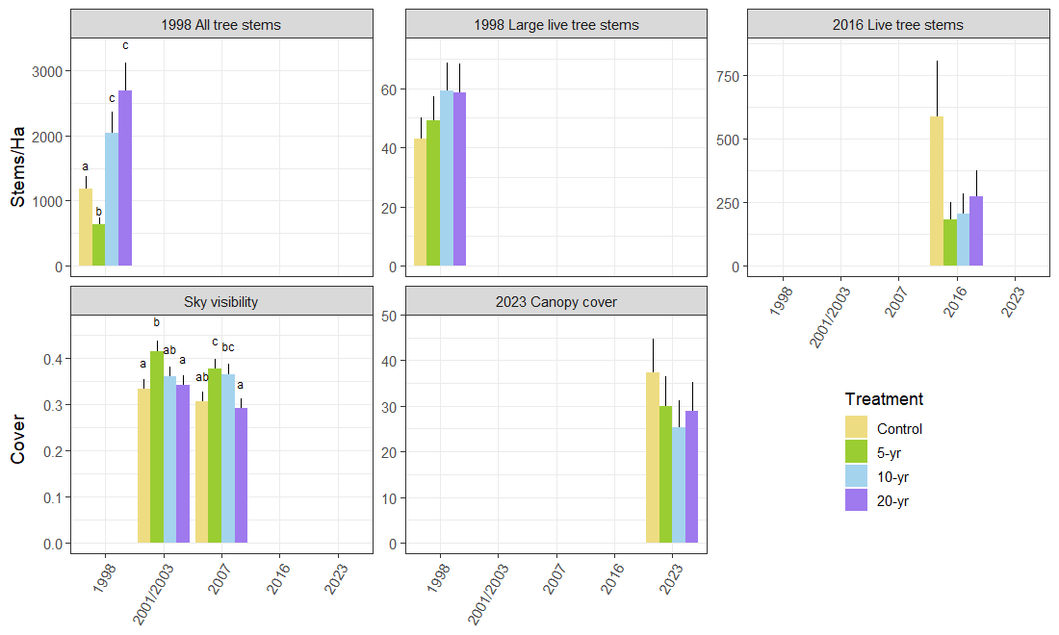

Appendix 2 Table 2. Effect size, and treatment contrasts by year for tree density, sky visibility, and overstory canopy cover.
Contrast | Ratio | Standard error | DF | P-value
1998 tree stem density
Control - 5 yr | 1.88 | 0.43 | Inf | 0.03
Control - 10 yr | 0.58 | 0.13 | Inf | 0.08
Control - 20 yr | 0.44 | 0.10 | Inf | < 0.01
5 yr - 10 yr | 0.31 | 0.07 | Inf | 0.01
5 yr - 20 yr | 0.24 | 0.05 | Inf | 0.01
10 yr - 20 yr | 0.76 | 0.17 | Inf | 0.61
1998 large live tree stem density
Control - 5 yr | 0.88 | 0.21 | Inf | 0.94
Control - 10 yr | 0.73 | 0.17 | Inf | 0.53
Control - 20 yr | 0.73 | 0.17 | Inf | 0.54
5 yr - 10 yr | 0.83 | 0.19 | Inf | 0.86
5 yr - 20 yr | 0.84 | 0.19 | Inf | 0.87
10 yr - 20 yr | 1.01 | 0.23 | Inf | 1.00
2016 live tree stem density
Control - 5 yr | 3.21 | 1.71 | Inf | 0.13
Control - 10 yr | 2.86 | 1.52 | Inf | 0.20
Control - 20 yr | 2.17 | 1.15 | Inf | 0.47
5 yr - 10 yr | 0.89 | 0.48 | Inf | 1.00
5 yr - 20 yr | 0.67 | 0.36 | Inf | 0.88
10 yr - 20 yr | 0.76 | 0.40 | Inf | 0.95
2001/03 SkyVis | Odds Ratio
Control - 5 yr | 0.70 | 0.09 | Inf | 0.03
Control - 10 yr | 0.89 | 0.12 | Inf | 0.80
Control - 20 yr | 0.96 | 0.13 | Inf | 0.99
5 yr - 10 yr | 1.26 | 0.16 | Inf | 0.27
5 yr - 20 yr | 1.37 | 0.18 | Inf | 0.07
10 yr - 20 yr | 1.09 | 0.14 | Inf | 0.92
2007SkyVis
Control - 5 yr | 0.73 | 0.10 | Inf | 0.07
Control - 10 yr | 0.77 | 0.10 | Inf | 0.18
Control - 20 yr | 1.07 | 0.14 | Inf | 0.96
5 yr - 10 yr | 1.05 | 0.14 | Inf | 0.98
5 yr - 20 yr | 1.47 | 0.19 | Inf | 0.02
10 yr - 20 yr | 1.39 | 0.18 | Inf | 0.06
CanCvr% | Estimate
Control - 5 yr | 1.25 | 0.36 | Inf | 0.87
Control - 10 yr | 1.48 | 0.45 | Inf | 0.56
Control - 20 yr | 1.30 | 0.37 | Inf | 0.81
5 yr - 10 yr | 1.19 | 0.37 | Inf | 0.95
5 yr - 20 yr | 1.04 | 0.32 | Inf | 1.00
10 yr - 20 yr | 0.87 | 0.28 | Inf | 0.97

Appendix 2 Figure 2. Relationships between overstory variables and four key understory components. Data are r² values and sign. The graph shows the 2023 relationship between snowbrush cover and overstory canopy cover. The strong negative relationship is driven by two plots with low canopy cover and high snowbrush cover. Kerns and Poopy{Citation}

Understory Group | 2001-03 sky visibility | 2007 sky visibility | 2016 tree density | 2023 canopy cover
Total herb | 0.07 | 0.21 | -0.38 | 0.01
Brackenfern | 0.07 | 0.20 | -0.30 | -0.16
Bitterbrush | -0.24 | -0.23 | 0.35 | 0.04
Snowbrush | 0.02 | 0.01 | -0.20 | -0.72

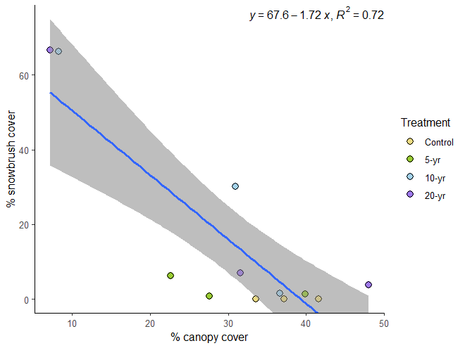

Literature Cited
Aphalo, P.J., 2016. ggpmisc: Miscellaneous Extensions to “ggplot2.” https://doi.org/10.32614/CRAN.package.ggpmisc
R Core Team, 2024. R, A language and environment for statistical computing, R Foundation for Statistical Computing.
Youngblood, A., Riegel, G., 1999. Reintroducing fire in eastside ponderosa pine forests: a long-term test of fuel treatments, in: Proceedings of the Joint Fire Science Conference and Workshop, Boise, ID. pp. 15–17.

