Supplementary material

Variables in the soil and climate datasets
Table 1: List of variables included in the used climate dataset, the Bioclimatic variables dataset based on WorldClim data for the reference period 1970 to 2000 (Hijmans and Graham 2006; Fick and Hijmans 2017)
Variable name | Description
BIO1 | Annual Mean Temperature
BIO2 | Mean Diurnal Range (Mean of monthly (max temp - min temp))
BIO3 | Isothermality (BIO2/BIO7) (×100)
BIO4 | Temperature Seasonality (standard deviation ×100)
BIO5 | Max Temperature of Warmest Month
BIO6 | Min Temperature of Coldest Month
BIO7 | Temperature Annual Range (BIO5-BIO6)
BIO8 | Mean Temperature of Wettest Quarter
BIO9 | Mean Temperature of Driest Quarter
BIO10 | Mean Temperature of Warmest Quarter
BIO11 | Mean Temperature of Coldest Quarter
BIO12 | Annual Precipitation
BIO13 | Precipitation of Wettest Month
BIO14 | Precipitation of Driest Month
BIO15 | Precipitation Seasonality (Coefficient of Variation)
BIO16 | Precipitation of Wettest Quarter
BIO17 | Precipitation of Driest Quarter
BIO18 | Precipitation of Warmest Quarter
BIO19 | Precipitation of Coldest Quarter

Table 2: List of variables included in the used soil dataset, the topsoil physical properties map based on the LUCAS database (Ballabio et al. 2016)
Variable name | Description
Clay | Topsoil (0–20 cm) clay content (%)
Silt | Topsoil (0–20 cm) silt content (%)
Sand | Topsoil (0–20 cm) sand content (%)
Coarse fragments | Topsoil (0–20 cm) coarse fragments (%)
Bulk density | Bulk density derived from soil texture datasets
AWC | Available Water Capacity for the topsoil fine earth fraction

Normalized Mean Absolute Error (nMAE) for the calculated models using all plots
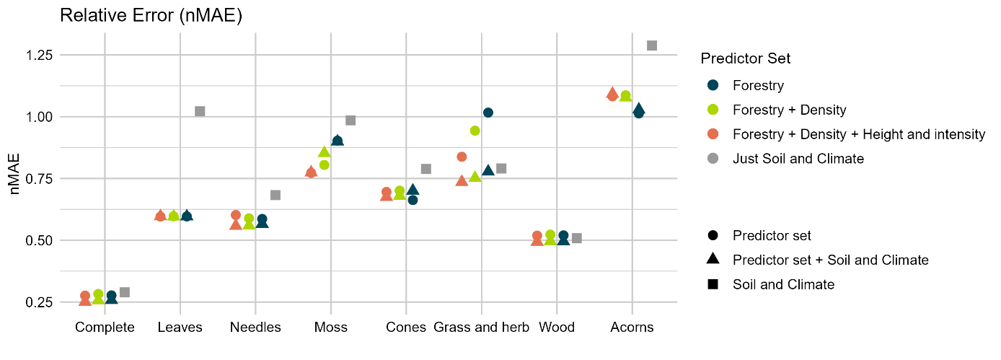
Figure 1: nMAE for all calculated models, figure analogous to the shown R² and nRMSE in Figure 6 of the original Paper. The nMAE is used for evaluating model performance.

Partial dependence plots

For models using all plots (53 plots)
Complete fuel load
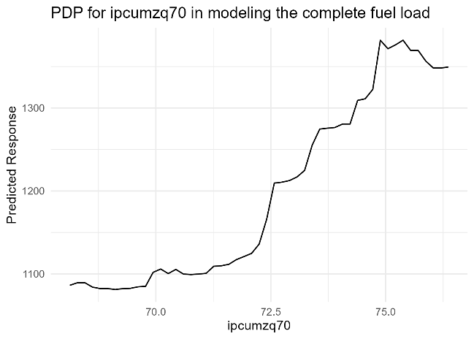 | 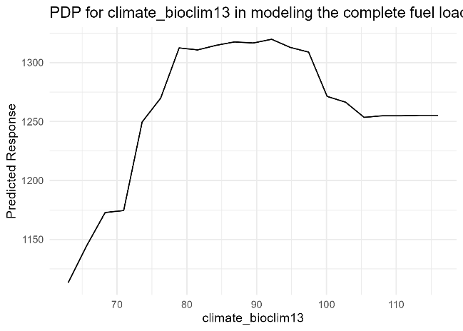
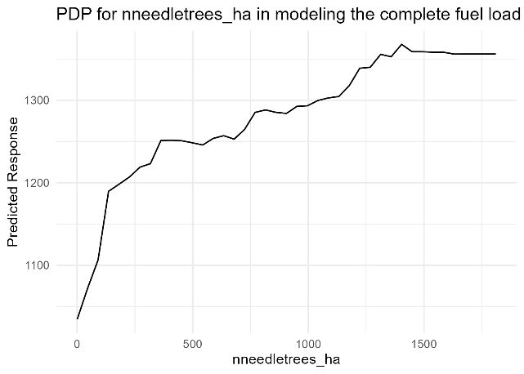 | 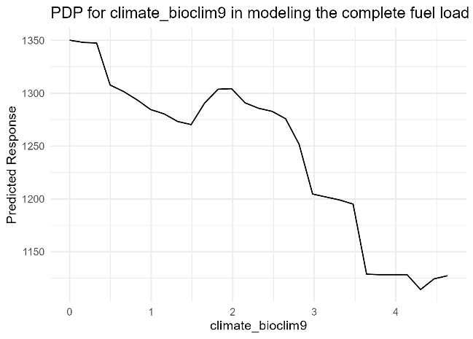
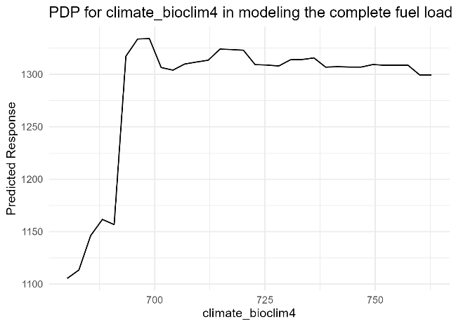
Leaves
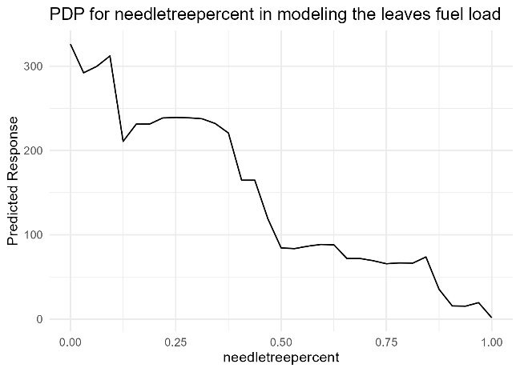
Needles
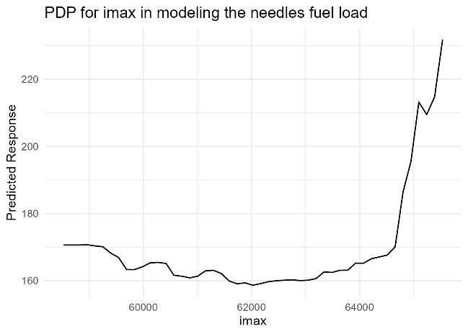 | 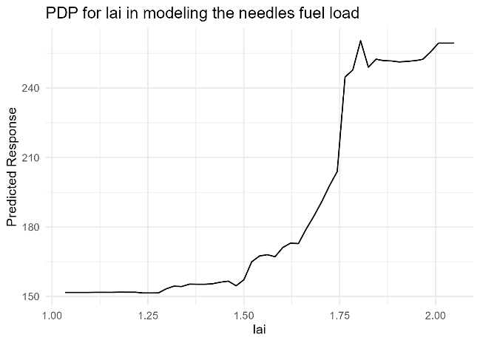
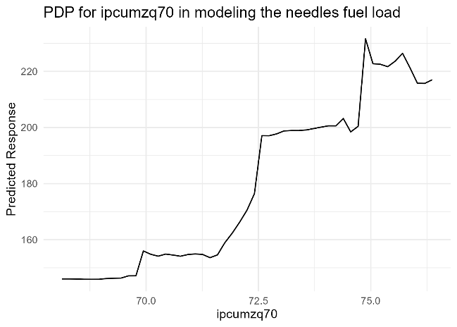 | 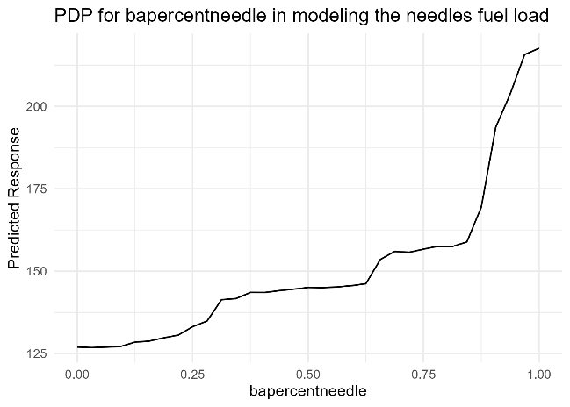
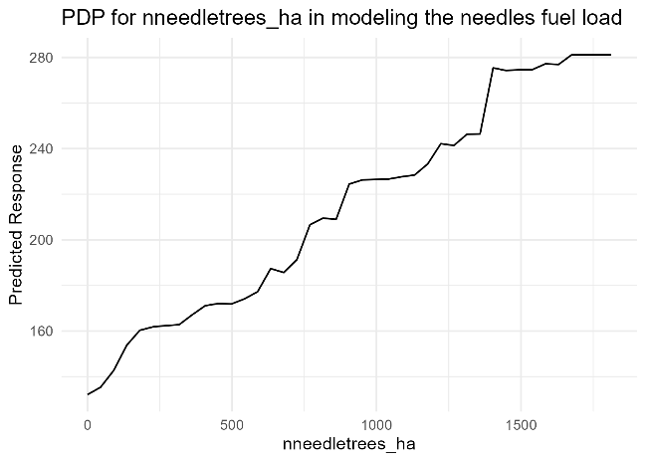
Moss
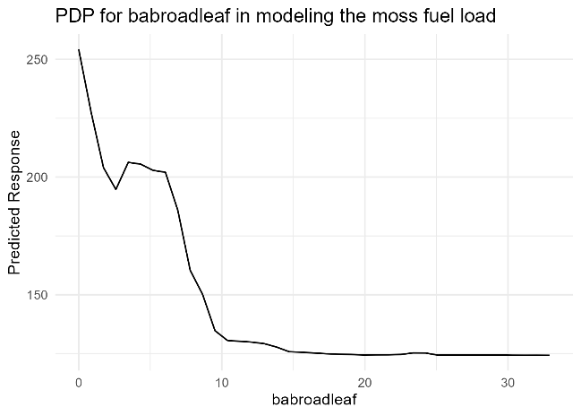 | 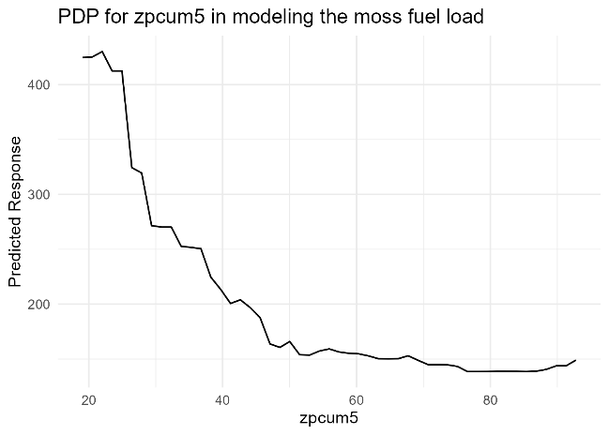
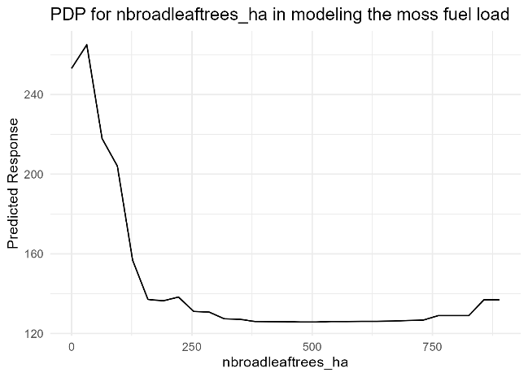
Cones
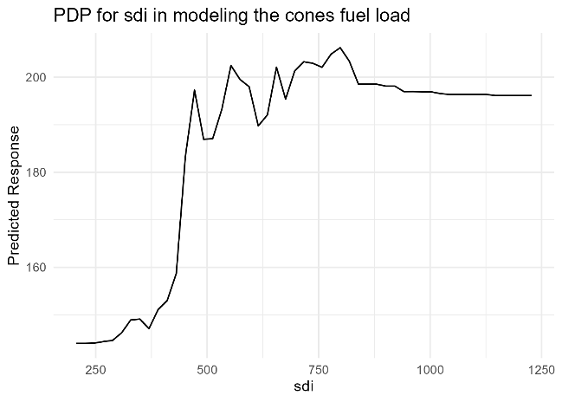 | 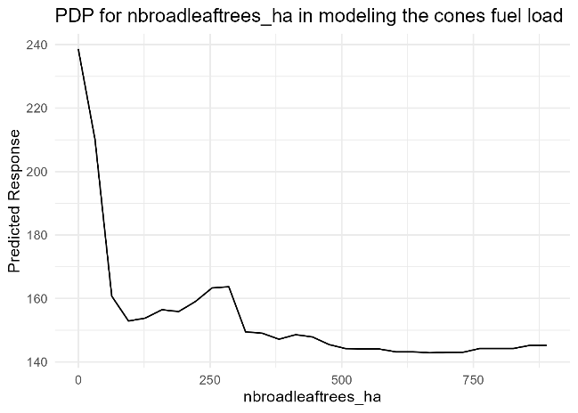
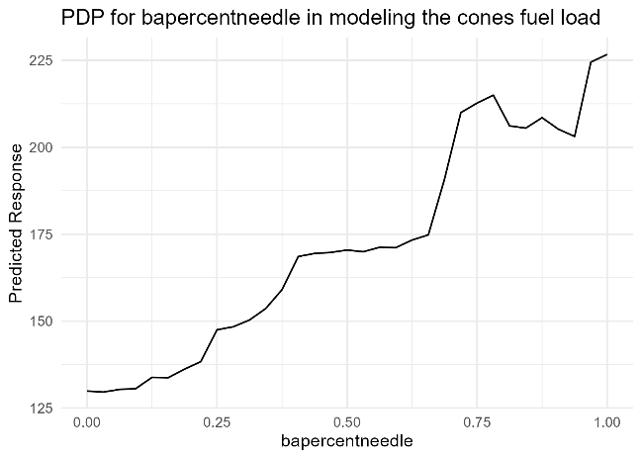 | 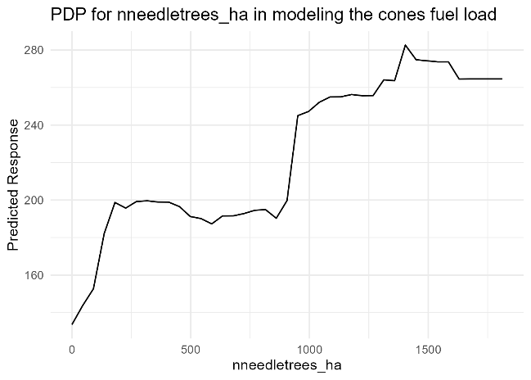
Grass and Herb
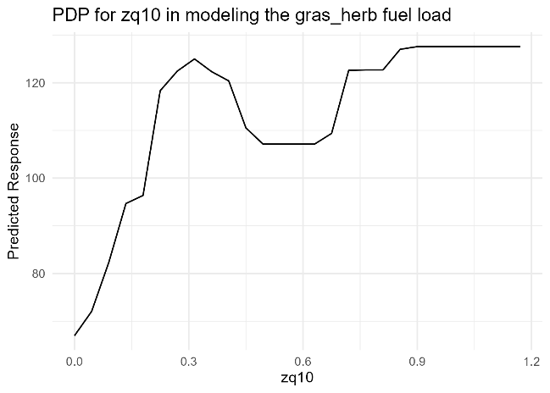 | 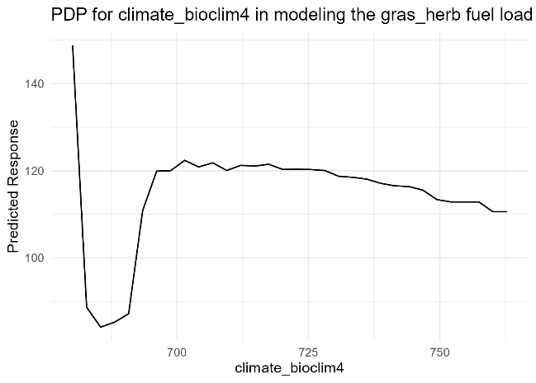
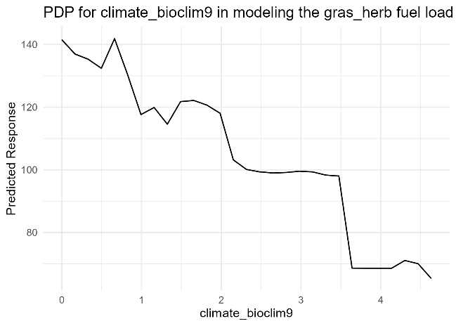 | 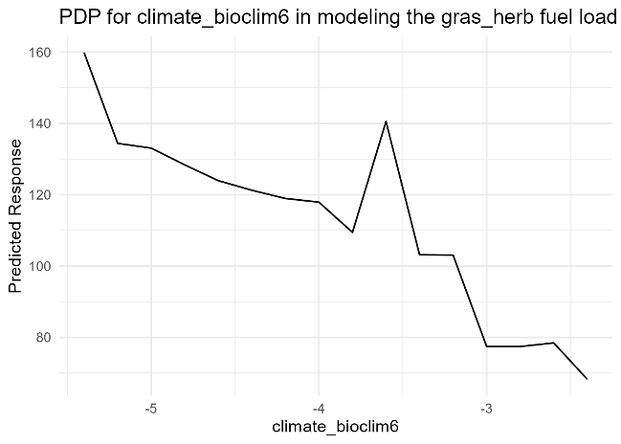
Wood
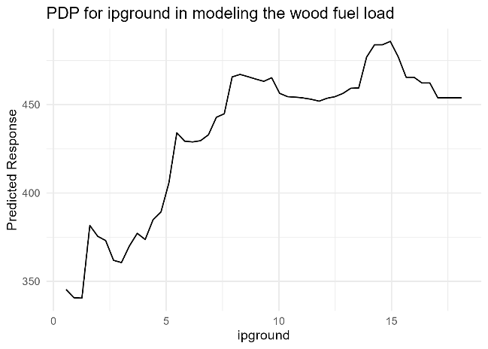 | 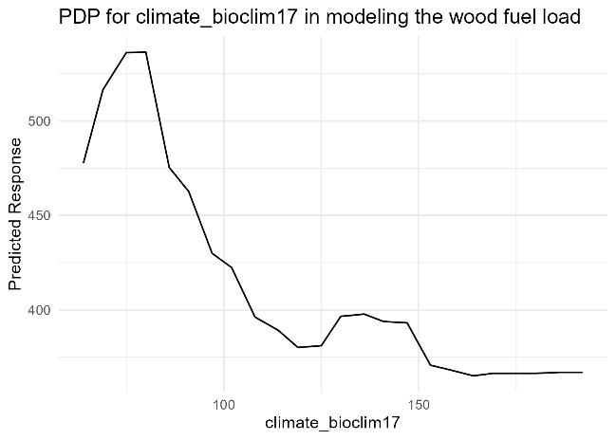
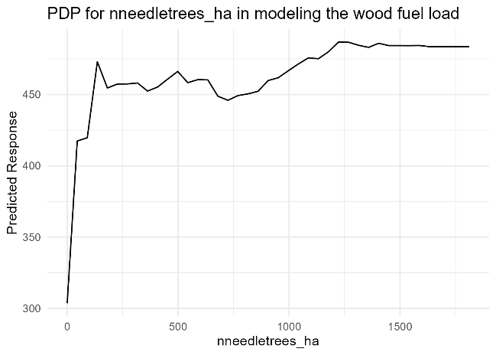 | 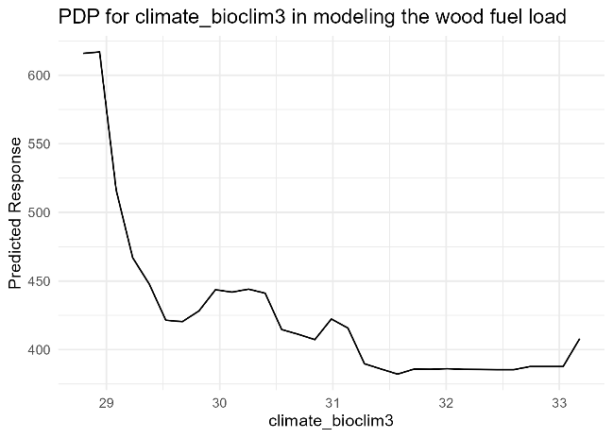
Acorns
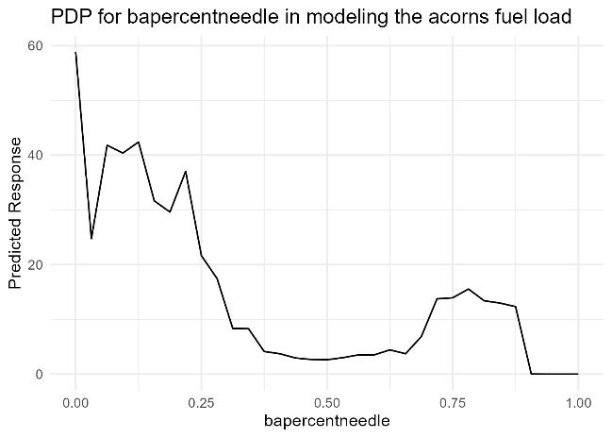

For models of pure pine plots (22 plots)
Complete fuel load
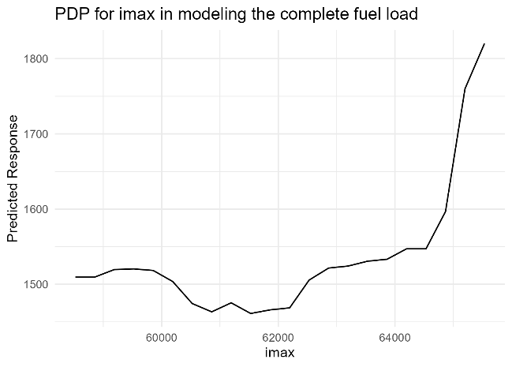 | 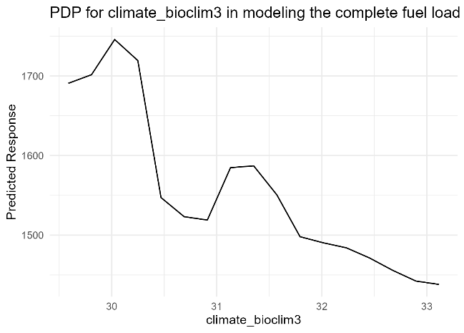
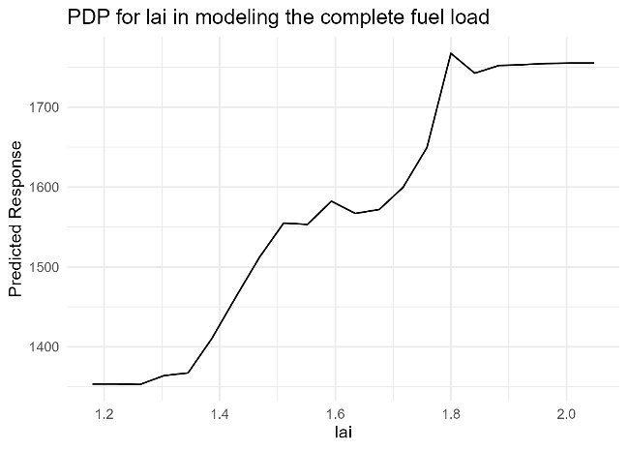
Leaves – No model created
Needles
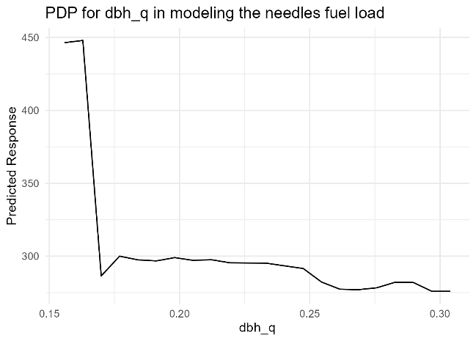 | 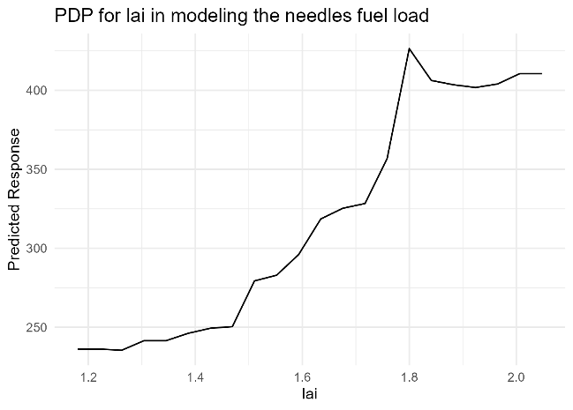
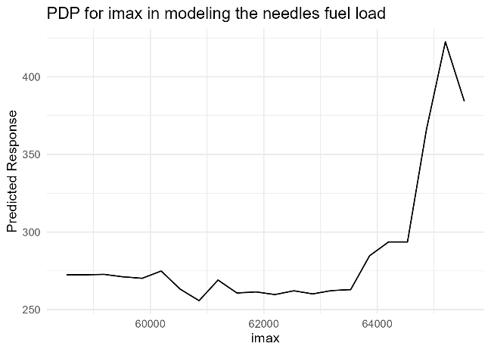
Moss
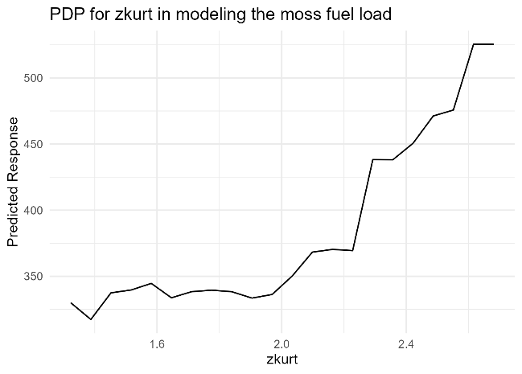 | 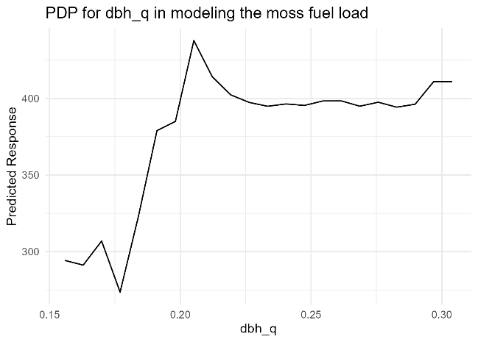
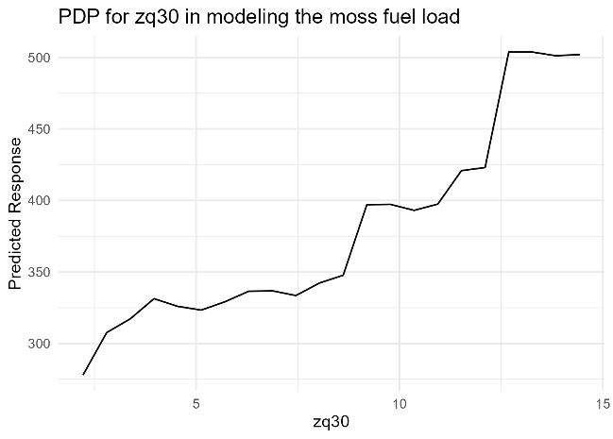
Cones
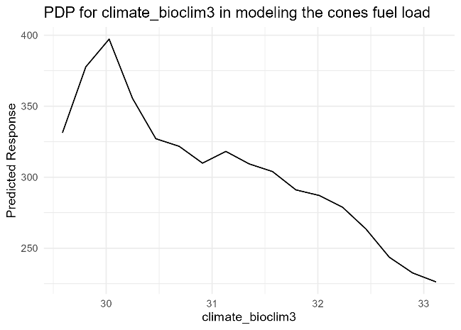 | 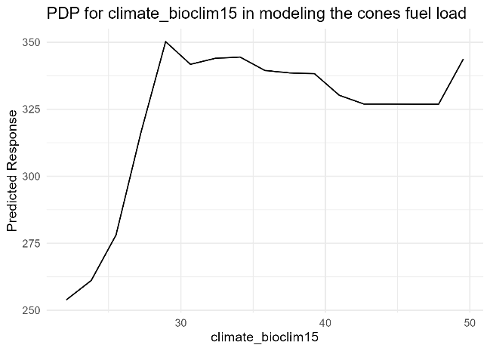
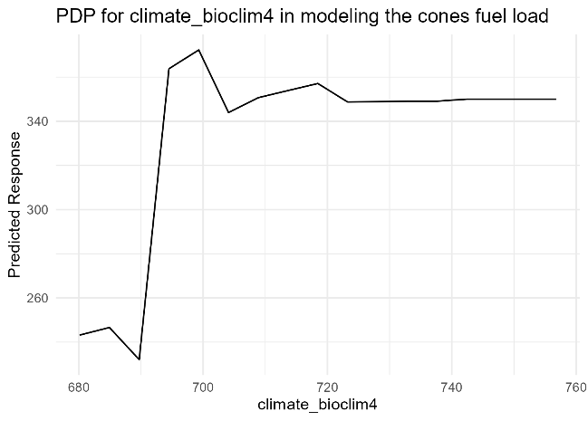
Grass and Herb
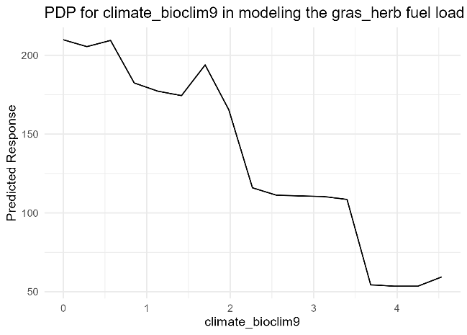 | 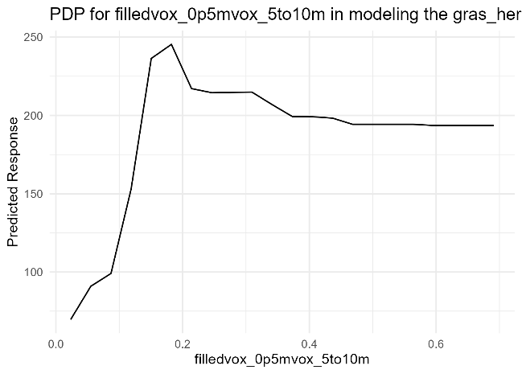

Wood
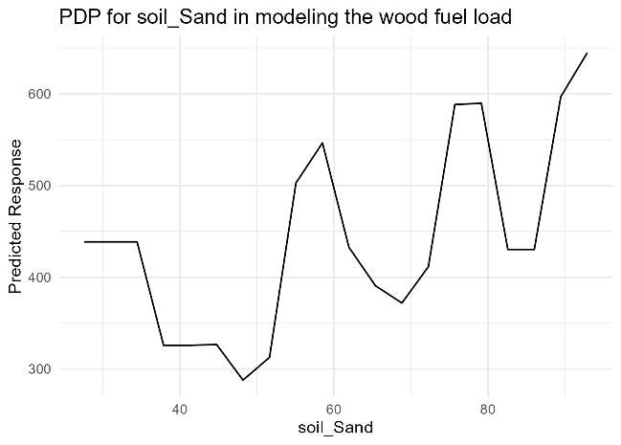
Acorns – no model created

For models using pure oak plots (10 plots)
Complete fuel load
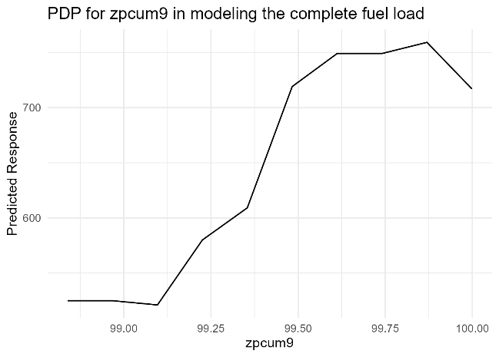
Leaves
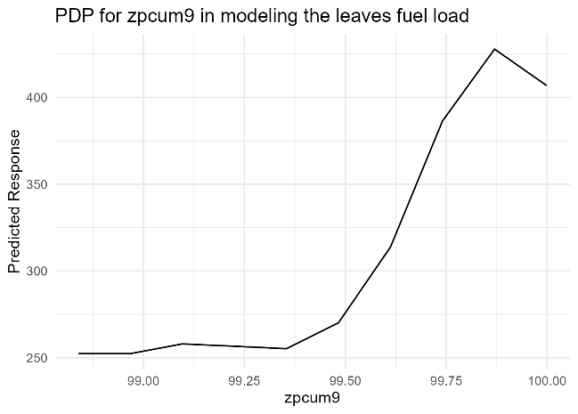
Needles – no model created
Moss
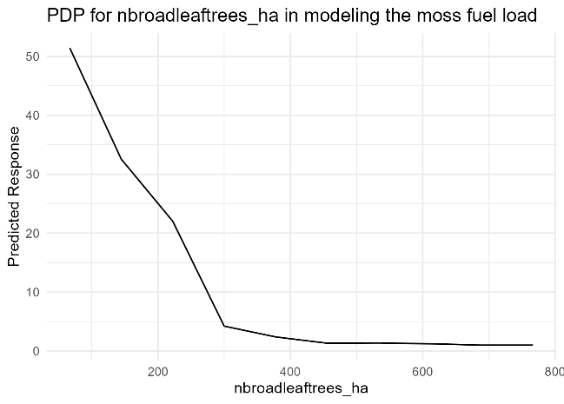
Cones – no model created
Grass and Herb
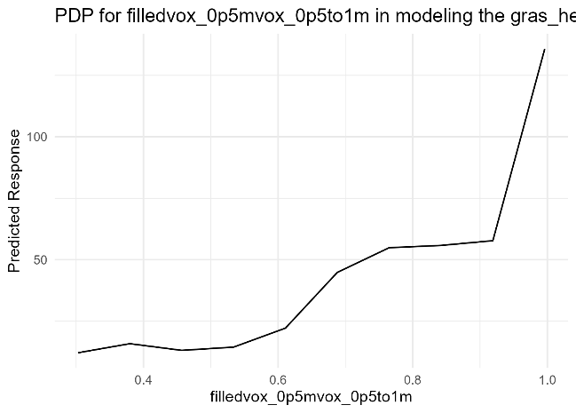
Wood
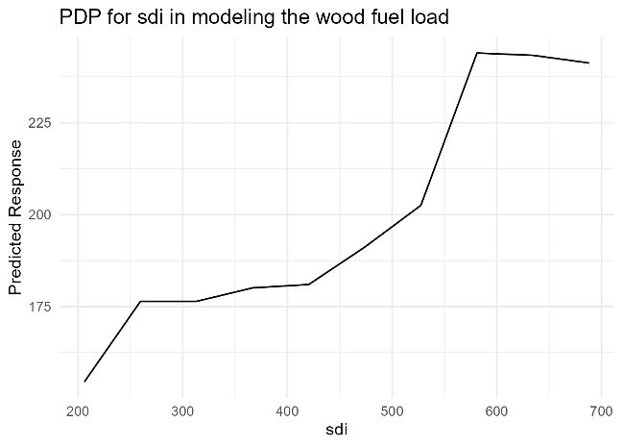 | 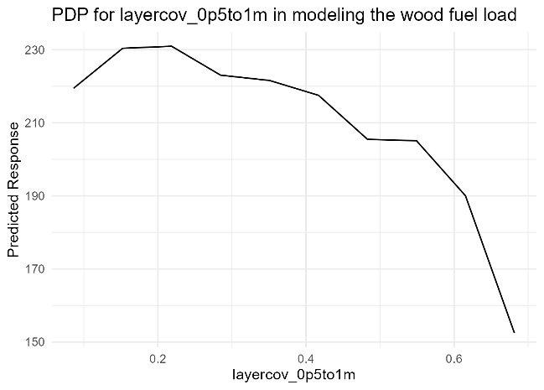
Acorns
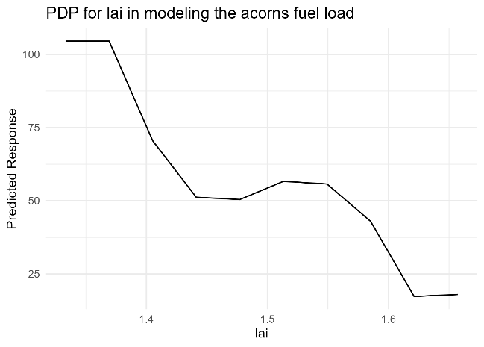

Using single microplot samples and small areas around sample locations for predictions

Methods
We calculated all of the described predictor metrics (Table 2 in the original paper) for 0.5 m and 1 m buffers around the sample locations. Using these metrics, we performed the same modeling as described in the original paper, but for the 212 single samples, using buffer metrics around each sample rather than plot-wise sums of litter weights and metrics calculated for the whole plot area.

Results
Model performance is consistently lower for models using small buffers only in comparison to models using the four combined samples and the whole plot area for the calculation of predictor metrics (Figure 5; max. R²: 0.29, nRMSE: 1.10 for the same model). The overlap between predictors of analogous models is small (Table 4, predictors marked in green). At the same time, they have a high number of predictors and are thus complex, but performance remains low (Table 4). This suggests that no good modeling solution can be found.
Moreover, models often include predictors for climate and soil (Table 4, 17/31 predictors in comparison to 8/27 predictors for whole plots). Predictors for climate and soil are of coarser resolution due to the input data set. This suggests that information on the broader surroundings is crucial, and data on the direct sampling location alone are not sufficient for a robust prediction of fuel weights. Or in other words, the link between structural data is weak at the ultra-local scale: random effects may dominate, while, at the plot level, noise is sufficiently low to let structure explain some signal in a combined litter sample.
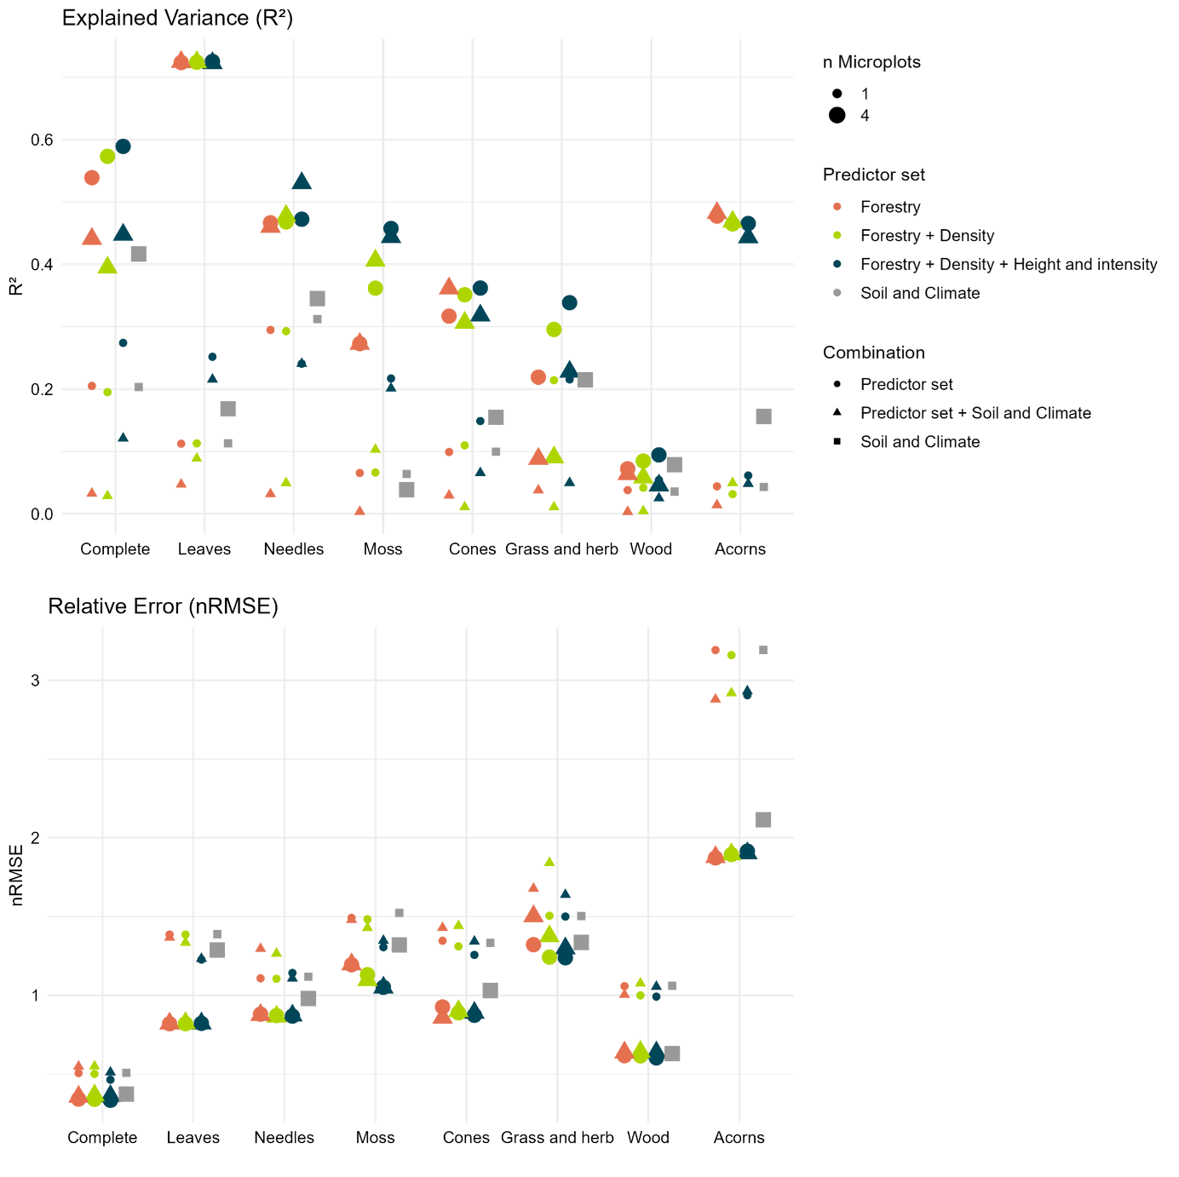
Figure 2: Comparison of model performances for models of single samples using small buffers around the sample location (0.5 and 1 m) for the calculation of predictors (smaller symbols) and models using a combination of the 4 samples in one plot and the whole plot area for the calculation of predictors (bigger symbols). Models using bigger areas and more samples consistently outperform the more detailed models for small areas and single samples (higher R² and lower nRMSE).

Table 4: Selected best model per class for single samples and small areas for predictor calculation in comparison to the combination of four samples in one plot. Predictors marked in green: Predictors are present in models for the combined samples using the whole plot area as well as the analogous model for single samples using small buffers around the sample location.
Class | Samples | Selected predictors | R² | nRMSE
Complete | 4 combined | ipcumzq70 + nneedletrees_ha + climate_bioclim13 + climate_bioclim4 + climate_bioclim9 | 0.59 | 0.33
Complete | Single samples | climate_bioclim13 + ipcumzq70_1 + soil_Coarsefragments | 0.27 | 0.46
Leaves | 4 combined | needletreepercent | 0.72 | 0.82
Leaves | Single samples | ipcumzq70_1 + climate_bioclim18 + layercov_5to10m_1 + iskew_0p5 + soil_Silt + soil_Bulk_density + climate_bioclim19 | 0.25 | 1.23
Needles | 4 combined | nneedletrees_ha + bapercentneedle + ipcumzq70 + lai + imax | 0.53 | 0.87
Needles | Single samples | climate_bioclim18 + soil_Bulk_density | 0.29 | 1.1
Moss | 4 combined | nbroadleaftrees_ha + zpcum5 + babroadleaf | 0.46 | 1.05
Moss | Single samples | ipcumzq70_1 + zq45_0p5 + climate_bioclim2 + zpcum6_1 | 0.22 | 1.31
Cones | 4 combined | nneedletrees_ha + bapercentneedle + nbroadleaftrees_ha + sdi | 0.36 | 0.86
Cones | Single samples | ipcumzq90_1 + soil_Coarsefragments + climate_bioclim15 + climate_bioclim4 + zq25_0p5 | 0.15 | 1.26
Gras and herb | 4 combined | climate_bioclim6 + climate_bioclim9 + climate_bioclim4 + zq10 | 0.34 | 1.24
Gras and herb | Single samples | climate_bioclim6 + climate_bioclim4 | 0.22 | 1.5
Wood | 4 combined | climate_bioclim3 + nneedletrees_ha + climate_bioclim17 + ipground | 0.09 | 0.6
Wood | Single samples | ipcumzq90_1 + soil_Silt + ipcumzq70_0p5 + imax_1 | 0.05 | 0.99
Acorns | 4 combined | bapercentneedle | 0.48 | 1.88
Acorns | Single samples | layercov_2to5m_0p5 + soil_Bulk_density + zskew_1 + climate_bioclim9 | 0.06 | 2.9

Predicted vs. observed values for all fuel classes

For models using all plots (53 plots)
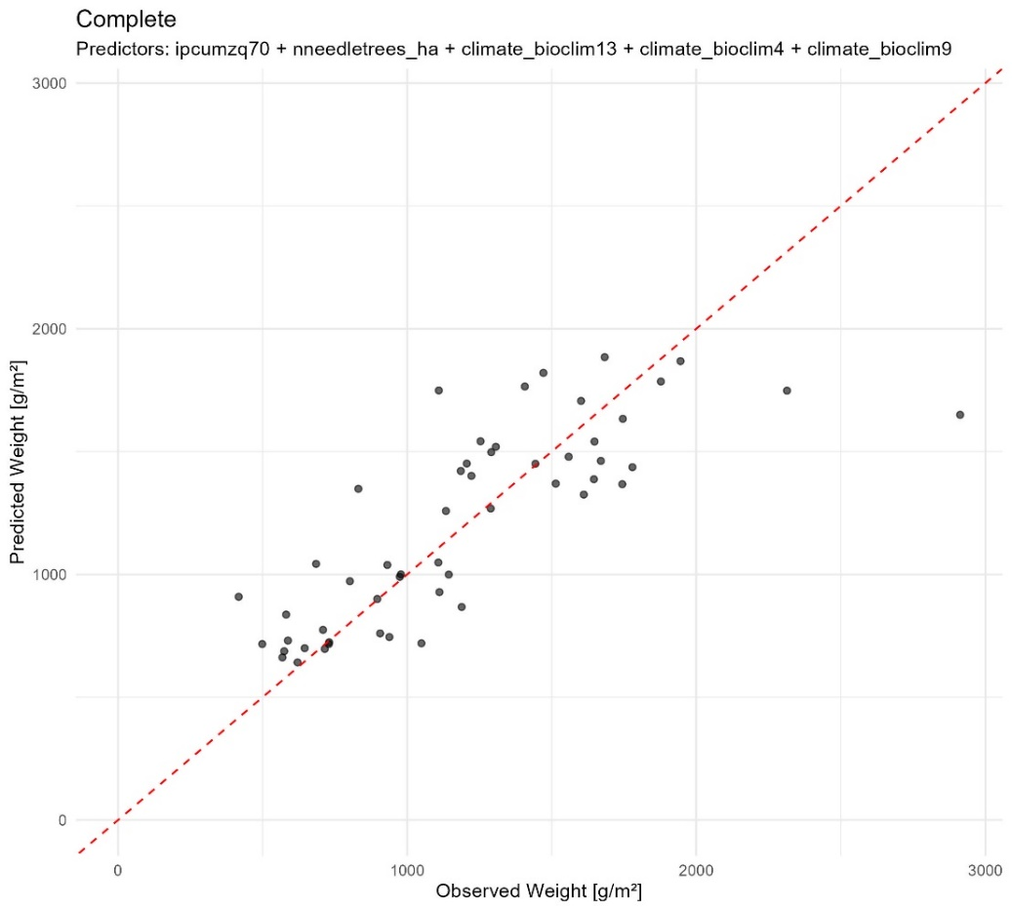
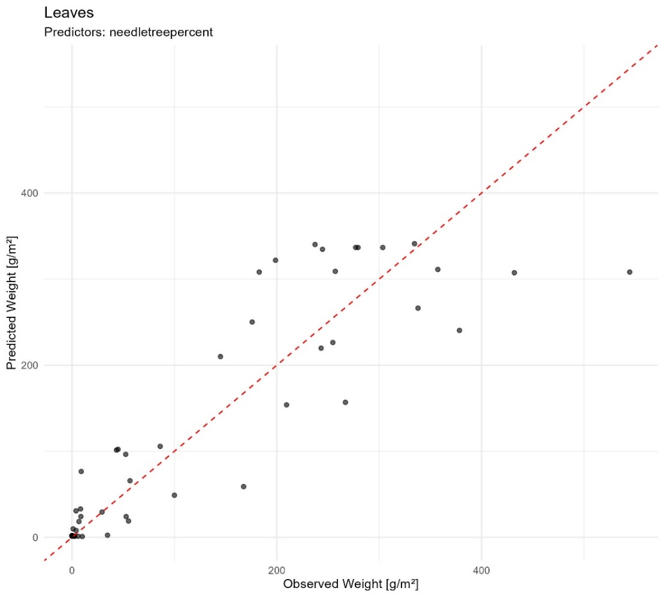
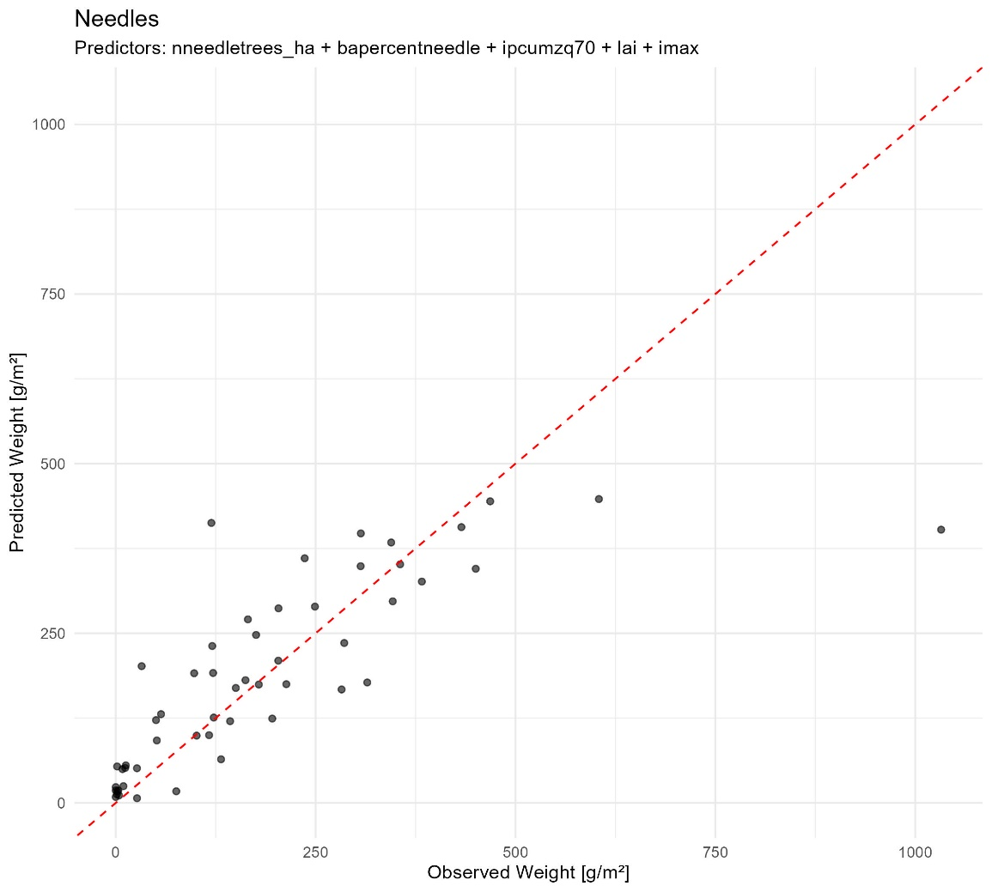
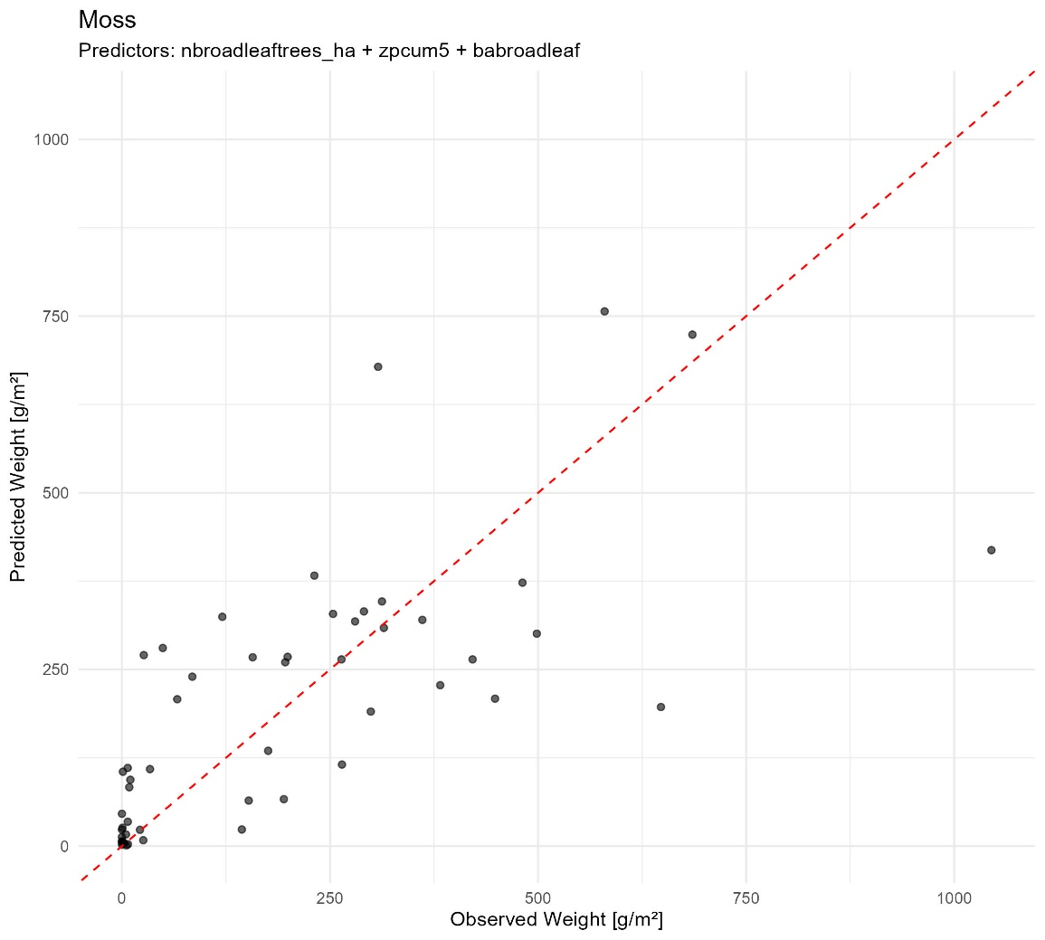
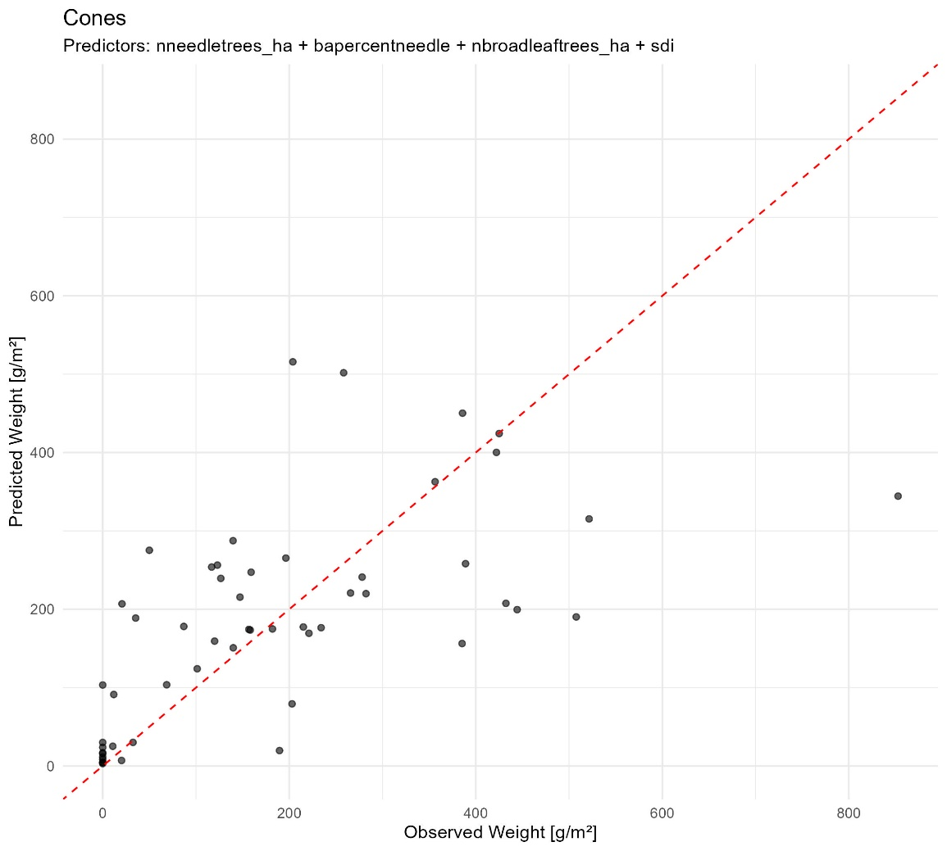
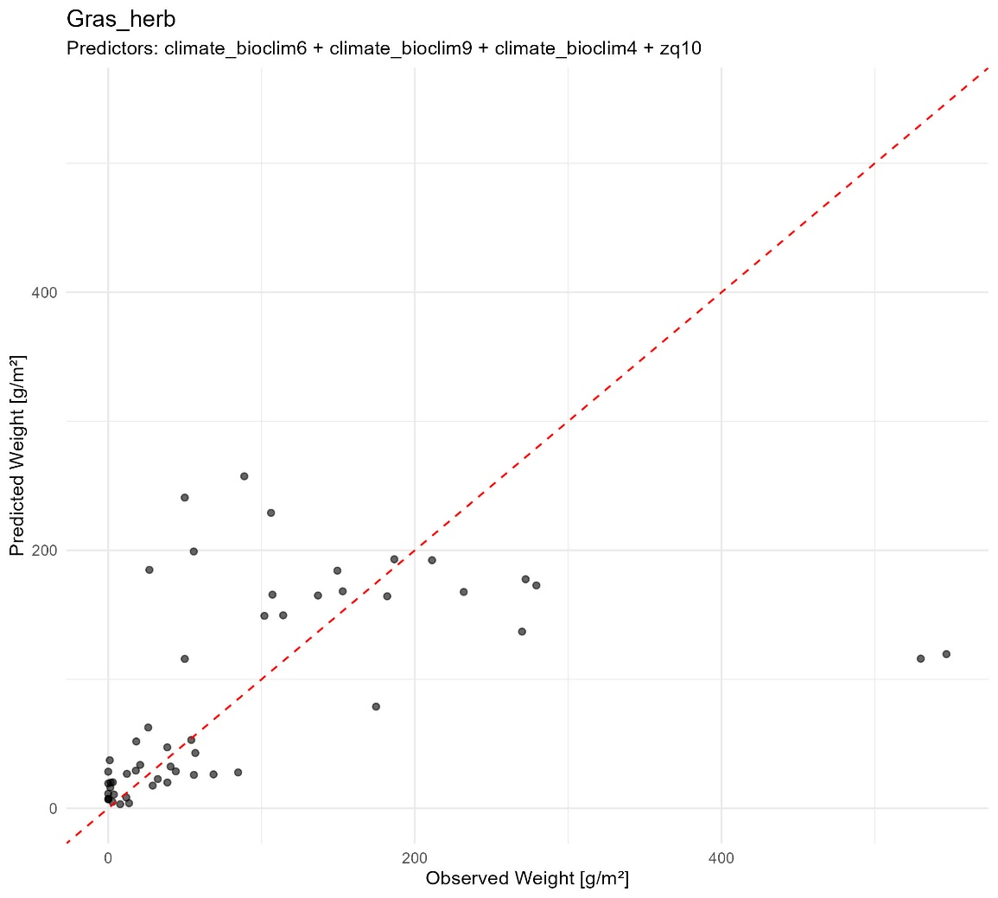
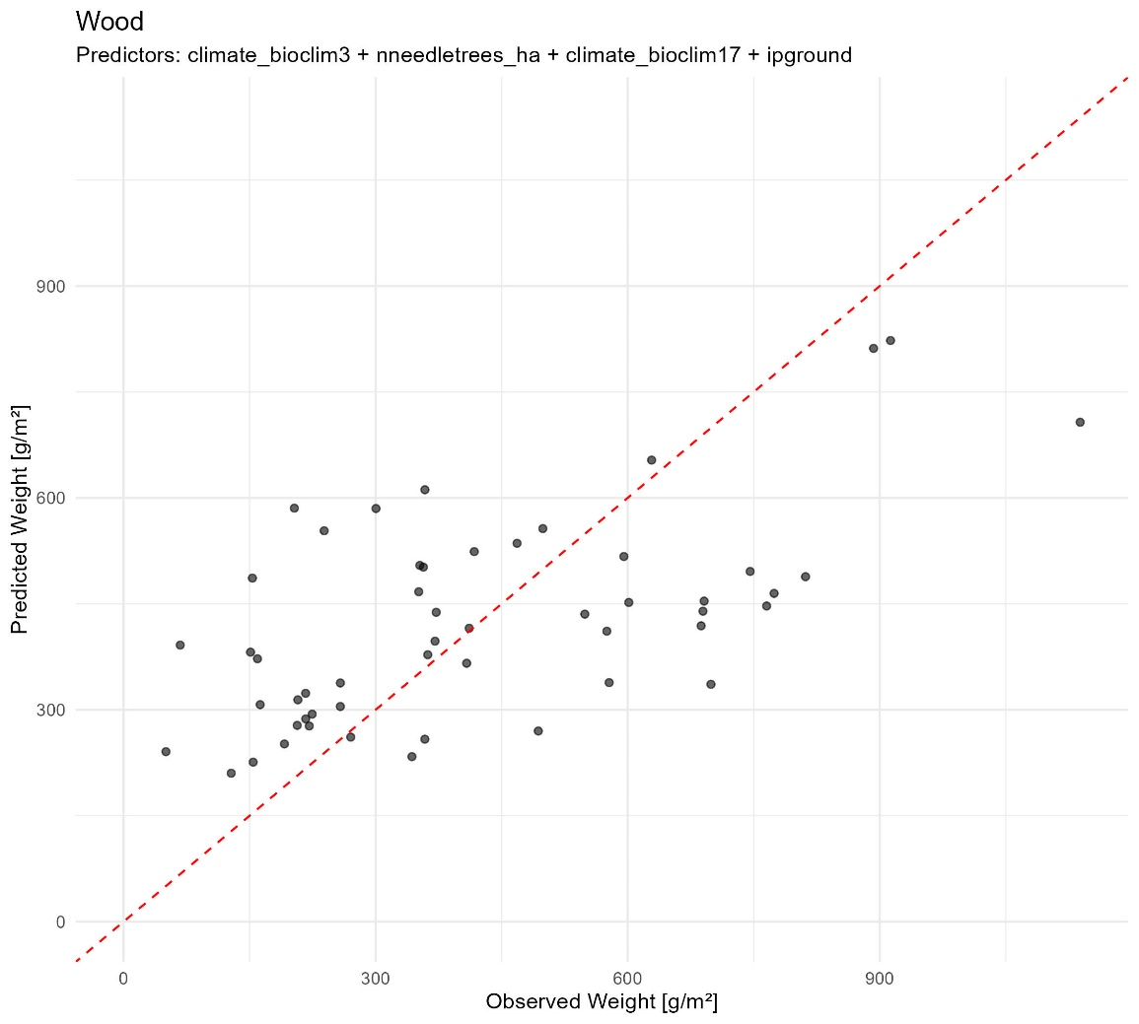
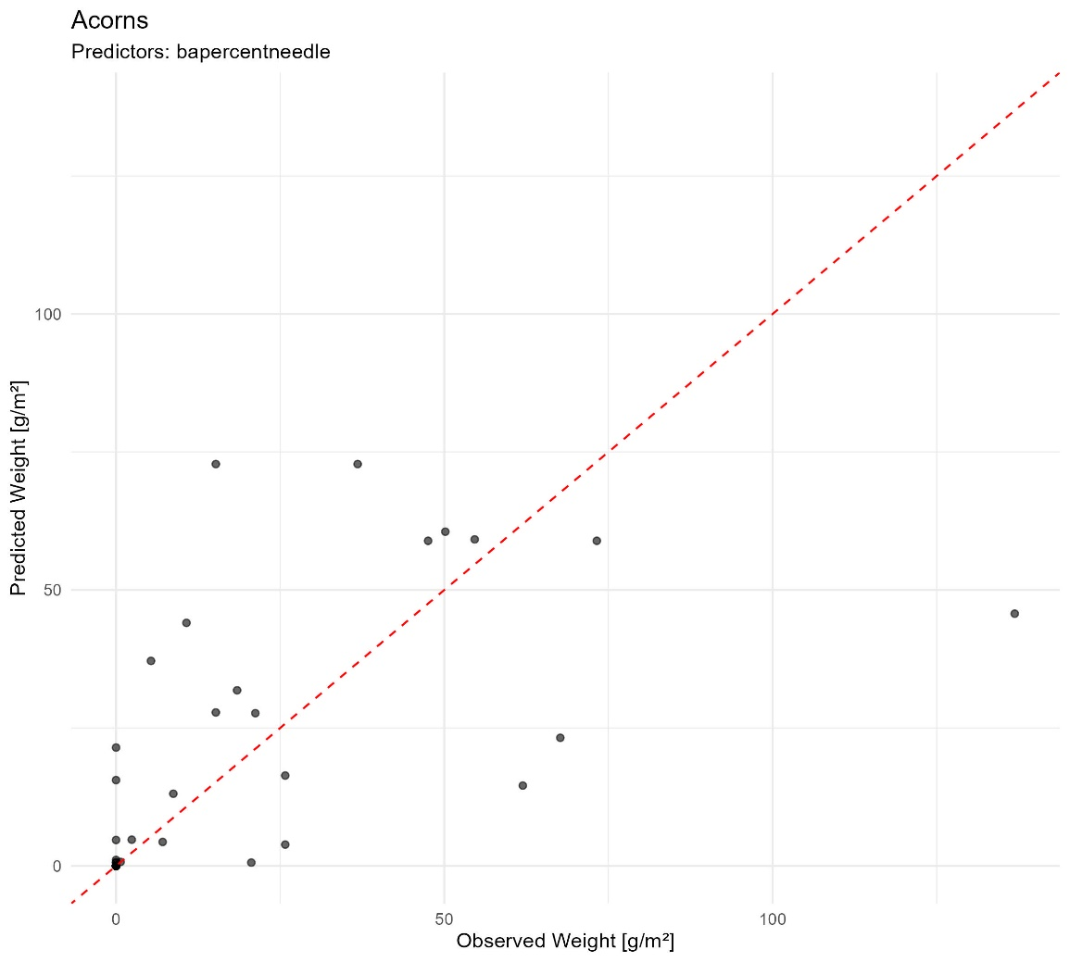

For models using pure pine plots (22 plots)
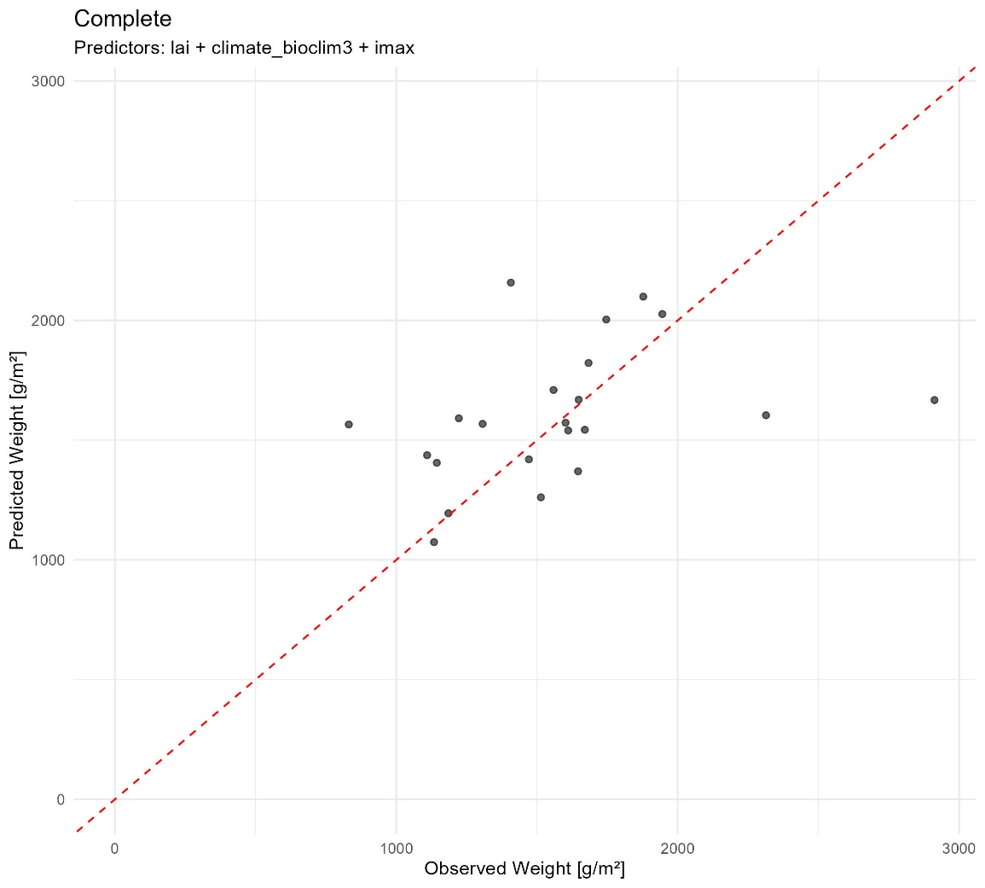
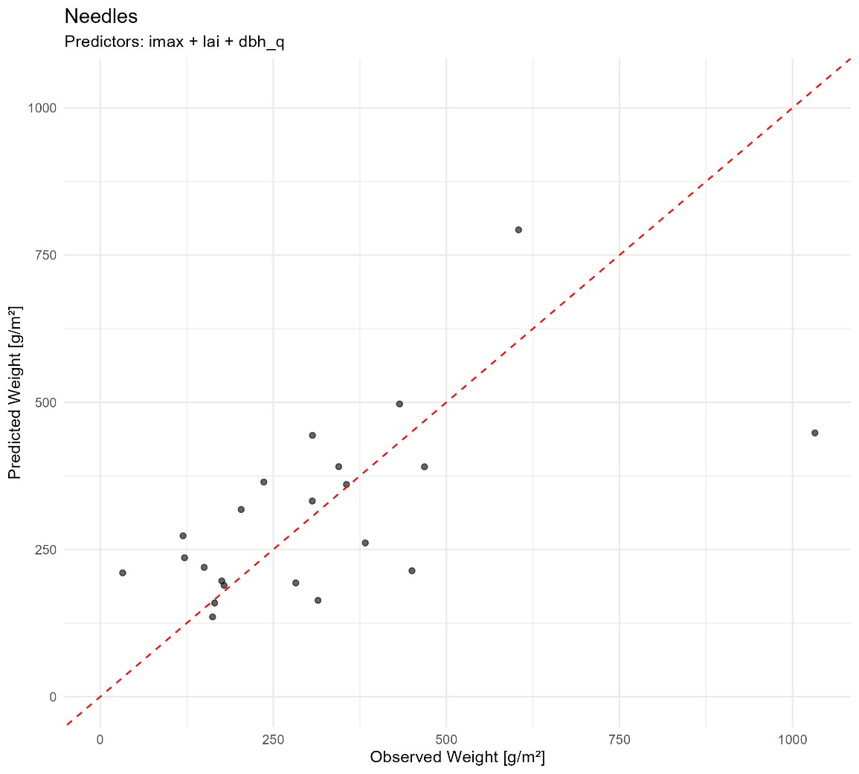
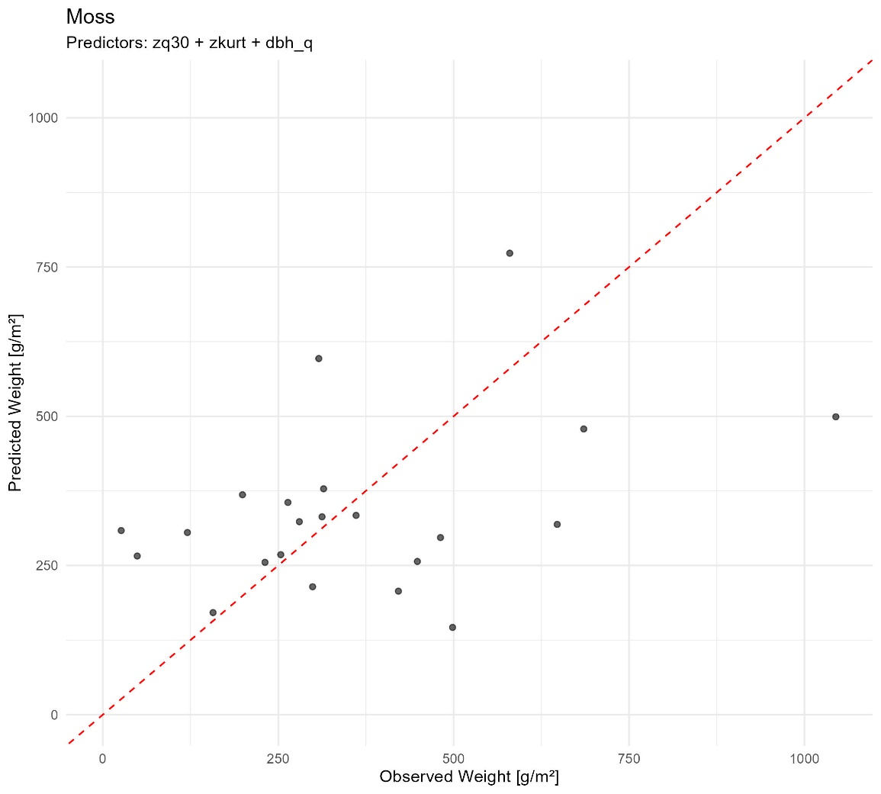
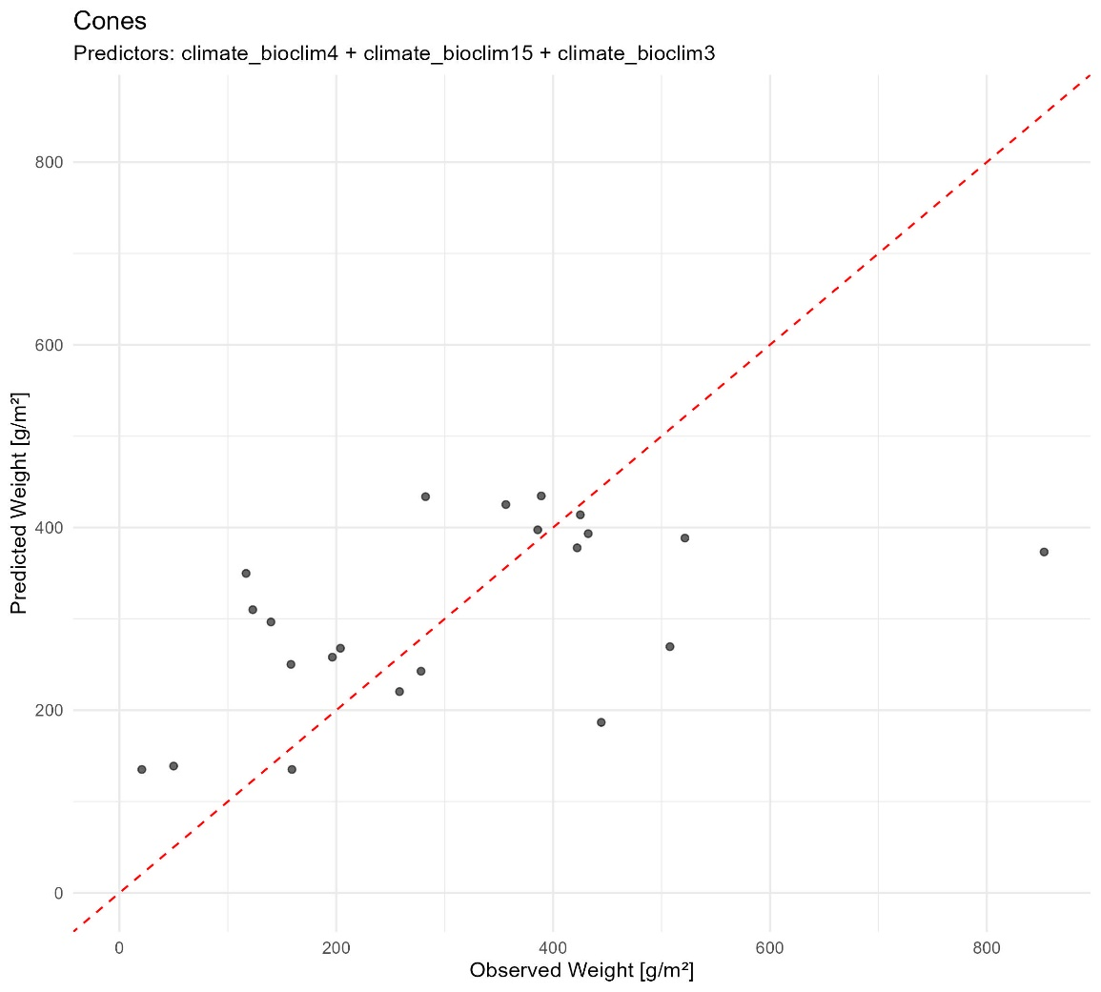
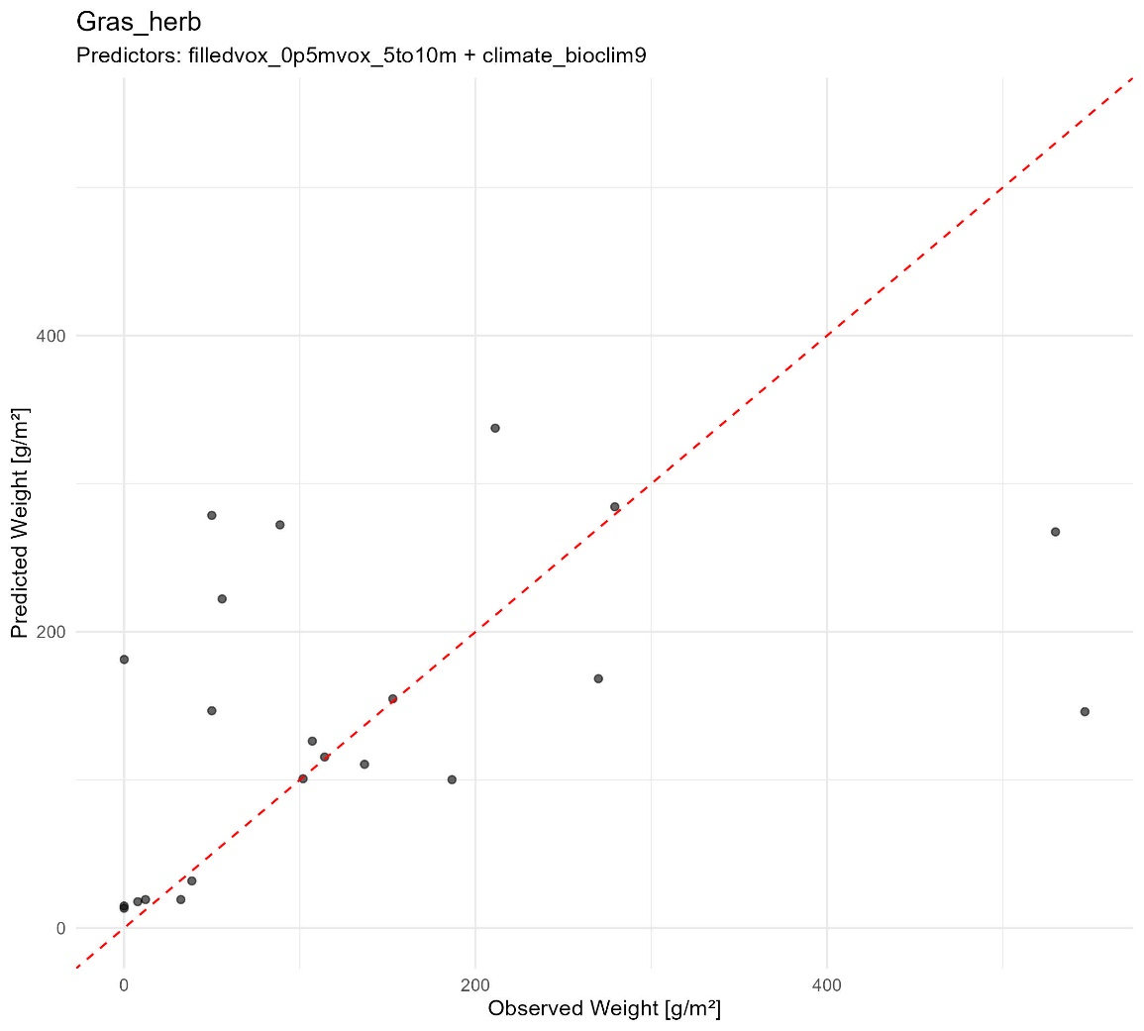
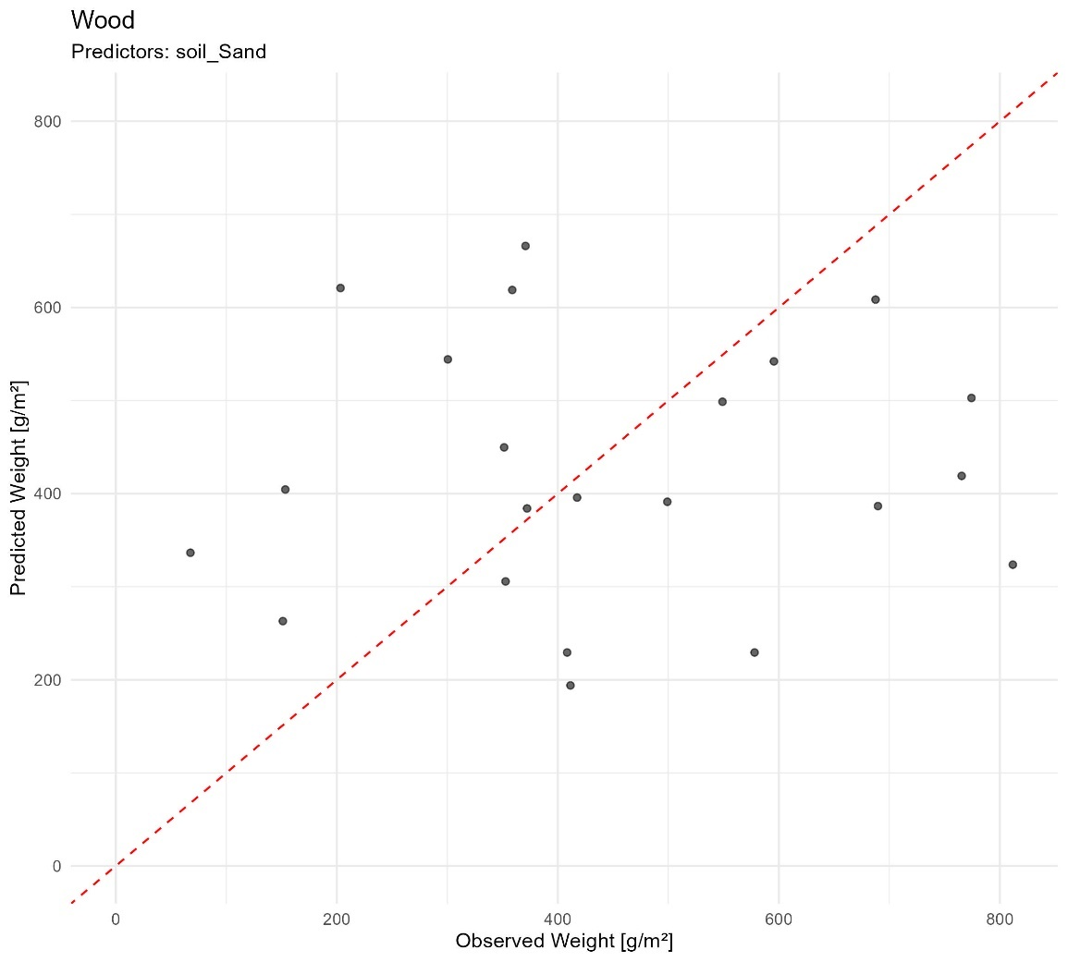

For models using pure oak plots (10 plots)
