Supplementary material

Table S1: Preliminary model comparison used to assess whether mapped fire severity classes improved model fit relative to a broader burnt/unburnt classification.
Fire classification | WAIC | WAIC SE | ELPD difference | Difference SE
Burnt/unburnt | 406.3292902 | 6.32401718 | 0 | 0
Fire severity | 406.5018625 | 6.425215726 | -0.08628616 | 0.316123631

Table S2: Posterior contrasts from posterior predictions of the Bayesian Poisson mixed-effects model of common wombat (Vombatus ursinus) relative abundance (30-minute independent detection events). These contrasts compare burnt and unburnt areas within burrow and non-burrow sites, differences between burrow and non-burrow sites within each fire category, and the difference in the fire effect between site types. Predictions were generated with continuous covariates held at their mean values, and random effects excluded. Estimates are on the response scale and represent differences in expected relative abundance per trap-day.
Contrast | Estimate | l-89% CI | u-89% CI
Non-burrow: Burnt vs Unburnt | -0.030815419 | -0.11647 | 0.050484275
Burrow: Burnt vs Unburnt | -0.142152845 | -0.27649 | -0.026718574
Unburnt: Burrow vs Non-burrow | 0.111216682 | 0.011106 | 0.229521271
Burnt: Burrow vs Non-burrow | -0.000120744 | -0.05846 | 0.058473013
Difference in fire effect (Burrow vs Non-burrow) | -0.111337426 | -0.24629 | 0.006517695

Table S3: Posterior summaries of the raw fixed effects from the Bayesian Poisson mixed-effects model of common wombat (Vombatus ursinus) relative abundance (30-minute independent detection events). Estimates are on the log scale, with unburnt non-burrow sites as the reference category. The model included site type, fire category, their interaction, and scaled environmental covariates.
Parameter | Estimate | Est.Error | l-89% CI | u-89% CI | Rhat | Bulk_ESS | Tail_ESS
Intercept | -2.018981642 | 0.283168043 | -2.469273994 | -1.569729165 | 1.002291042 | 4972.991808 | 5210.875889
Site type: burrow | 0.5929497 | 0.336353198 | 0.06053441 | 1.128636432 | 1.000317095 | 4396.209309 | 5004.548513
Fire category: burnt | -0.249059737 | 0.414397508 | -0.916659781 | 0.414456524 | 1.001296107 | 4603.869753 | 5161.538742
NDVI | -0.147964283 | 0.159309684 | -0.403343097 | 0.110816349 | 1.001593242 | 5515.117815 | 5999.236005
Terrain ruggedness | 0.116778177 | 0.162176874 | -0.140979106 | 0.379047715 | 1.00065535 | 5664.002362 | 5601.958287
Elevation | 0.243500397 | 0.162005015 | -0.012564483 | 0.500792596 | 1.000546174 | 6311.0036 | 5564.240566
Site type x fire category: burrow x burnt | -0.598087996 | 0.47853764 | -1.369770797 | 0.158443592 | 1.000392527 | 3731.322504 | 4863.42954

Table S4: Posterior contrasts derived from predicted hourly detection probabilities from the Bayesian generalised additive mixed models (GAMMs) of common wombat (Vombatus ursinus). These contrasts compare burnt and unburnt areas within burrow and non-burrow sites, differences between burrow and non-burrow sites within each fire category, and the difference in the fire effect between site types. Contrasts were calculated from posterior predictions and are on the response scale, representing average differences in predicted hourly detection probability across the diel cycle.
Contrast | Estimate | l-89% CI | u-89% CI
Non-burrow: Burnt vs Unburnt | -0.000946415 | -0.006856275 | 0.004924427
Burrow: Burnt vs Unburnt | -0.00937814 | -0.015609643 | -0.00274215
Unburnt: Burrow vs Non-burrow | 0.011419973 | 0.006235992 | 0.016413784
Burnt: Burrow vs Non-burrow | 0.002988248 | -0.001751122 | 0.007744279
Difference in fire effect (Burrow vs Non-burrow) | -0.008431725 | -0.015458375 | -0.001238483

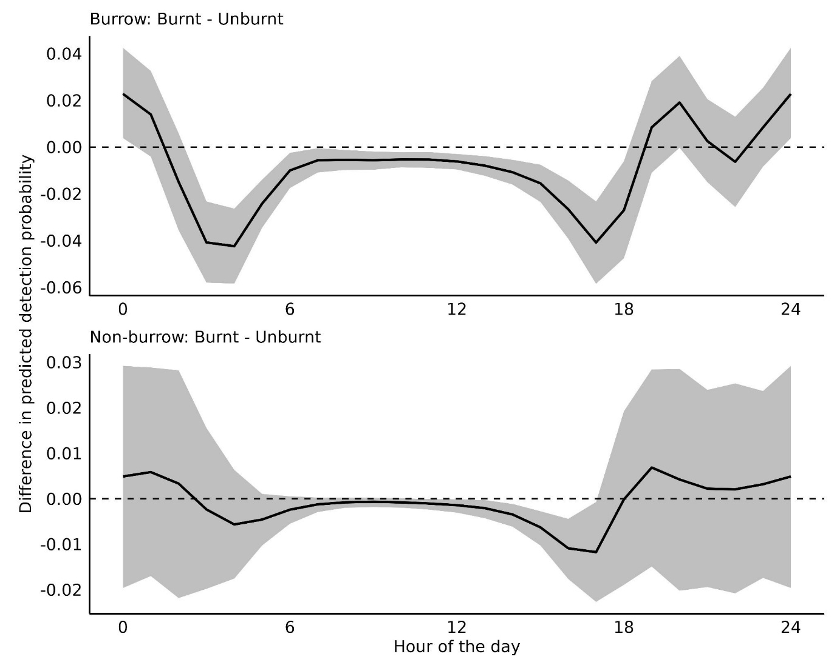Fig. S1: Differences in predicted hourly detection probability from the Bayesian generalised additive mixed models (GAMMs) for common wombat (Vombatus ursinus), comparing burnt and unburnt areas at burrow and non-burrow sites during the 2019–2020 wildfires in south-eastern Australia. Smooth curves show the estimated difference in predicted hourly detection probability across solar time, and shaded regions denote 89% credible intervals. Positive values indicate higher predicted hourly detection probability in burnt areas, whereas negative values indicate higher predicted hourly detection probability in unburnt areas.

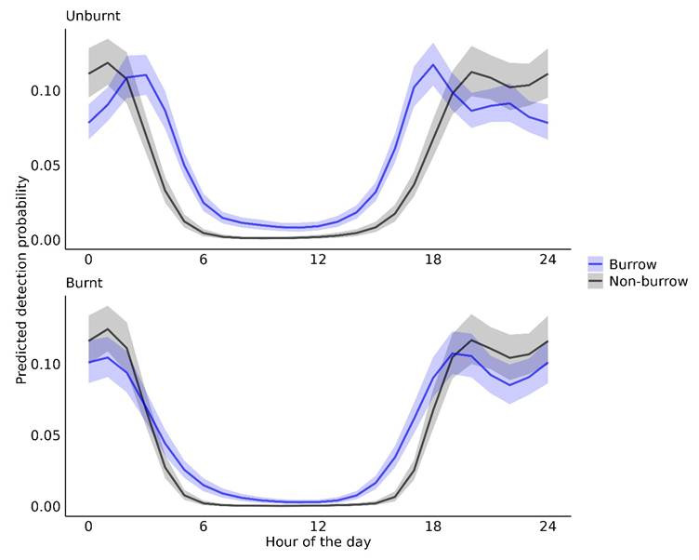
Fig. S2: Predicted diel activity curves from the Bayesian generalised additive mixed models (GAMMs) for common wombat (Vombatus ursinus), comparing burrow and non-burrow sites within burnt and unburnt areas during the 2019–2020 wildfires in south-eastern Australia. Smooth curves show predicted hourly detection probability across solar time, and shaded regions denote 89% credible intervals.
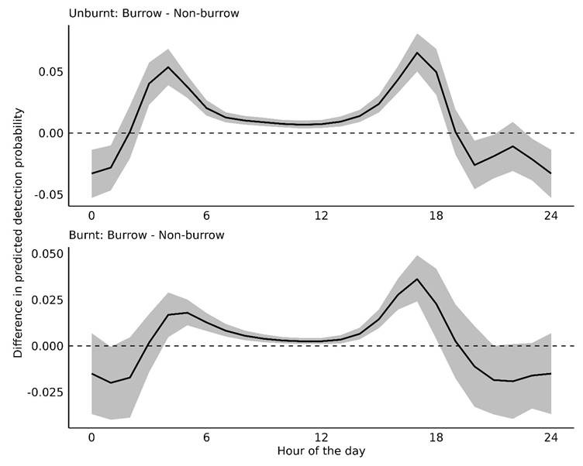
Fig. S3: Differences in predicted hourly detection probability from the Bayesian generalised additive mixed models (GAMMs) for common wombat (Vombatus ursinus), comparing burrow and non-burrow sites within burnt and unburnt areas during the 2019–2020 wildfires in south-eastern Australia. Smooth curves show the estimated difference in predicted hourly detection probability across solar time, and shaded regions denote 89% credible intervals. Positive values indicate higher predicted hourly detection probability at burrow sites, whereas negative values indicate higher predicted hourly detection probability at non-burrow sites.

Table S5: Posterior summaries of the raw fixed effects from the Bayesian generalised additive mixed model of common wombat (Vombatus ursinus) diel activity. The model allowed separate diel activity curves for each site category. Estimates are on the logit scale, with unburnt non-burrow sites as the reference category.
Parameter | Estimate | Est.Error | l-89% CI | u-89% CI | Rhat | Bulk_ESS | Tail_ESS
Intercept | -4.125624234 | 0.140058537 | -4.360575119 | -3.915443355 | 1.000529865 | 5091.793485 | 4825.816277
Site type: burrow | 0.960261097 | 0.14773614 | 0.739368554 | 1.205638655 | 1.000534881 | 5158.347492 | 4751.773299
Fire category: burnt | -0.622608939 | 0.26222765 | -1.054961577 | -0.221592675 | 1.00095117 | 3649.613414 | 4273.78702
Elevation | 0.057579924 | 0.030578552 | 0.00987749 | 0.106027624 | 1.000156463 | 5883.717431 | 5789.595989
NDVI | -0.009799401 | 0.032796698 | -0.062221738 | 0.04160024 | 0.99997029 | 5293.654409 | 5694.362787
Terrain ruggedness | 0.06201447 | 0.030522253 | 0.013633579 | 0.110808619 | 1.000132363 | 7877.767937 | 6481.738733
Site type x fire category: burrow x burnt | 0.154331648 | 0.274801136 | -0.274793469 | 0.60191585 | 1.000623801 | 3853.887751 | 4731.460503

