Peatland fire occurrence across Sweden from 2001 to 2023 along drainage, land-cover, and hydroclimatic gradientss
Daniel Escobar*^{1,2}, Clara Hübinger¹
¹ Department of Physical Geography and Bolin Centre for Climate Research, Stockholm University, SE-106 91 Stockholm, Sweden.
² Climate Action, Alliance of Bioversity International and the International Centre for Tropical Agriculture (CIAT), Palmira 763537, Colombia.
* Correspondence: daniel.escobar@natgeo.su.se
Supplementary Information

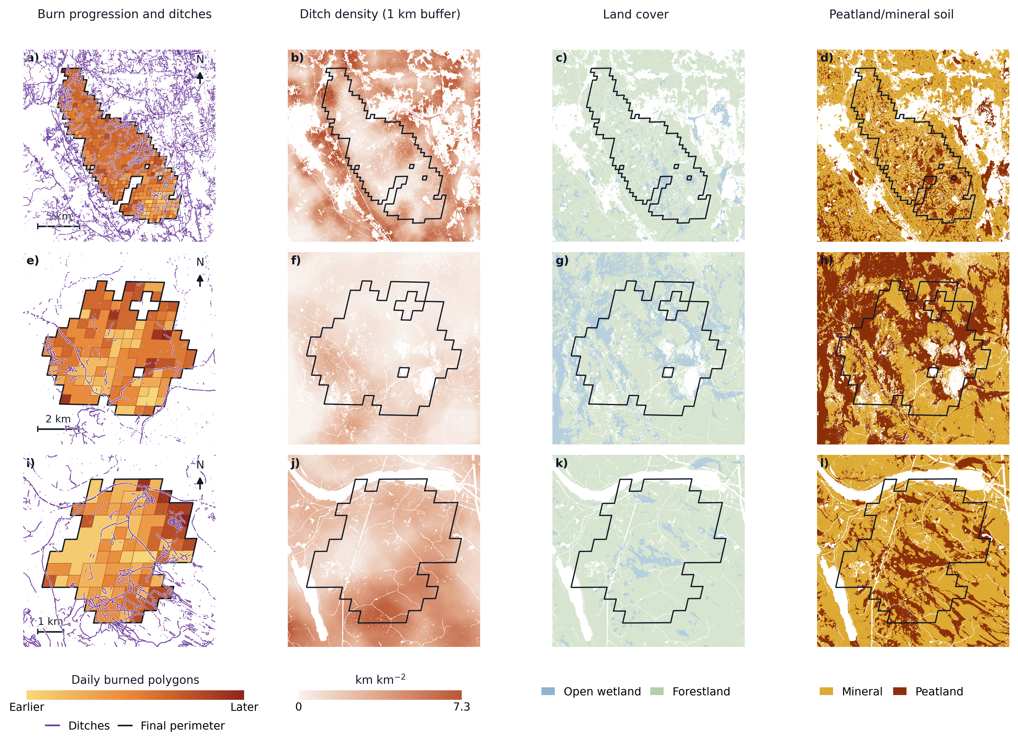
Supplementary Figure S1. Examples of multi-day burned-area (BA) event progression and landscape context. Rows show three selected BA events, and columns show daily burned polygons with mapped ditches, 1 km ditch-density context, NMD2023 land cover, and peatlands and mineral soil. Burn-progression colors run from earlier to later daily burned polygons; purple lines show mapped ditches; black outlines show final event perimeters; and soil colors distinguish mineral and peat. The figure illustrates how first-day BA polygons were interpreted as apparent fire-start proxies rather than exact ignition locations.

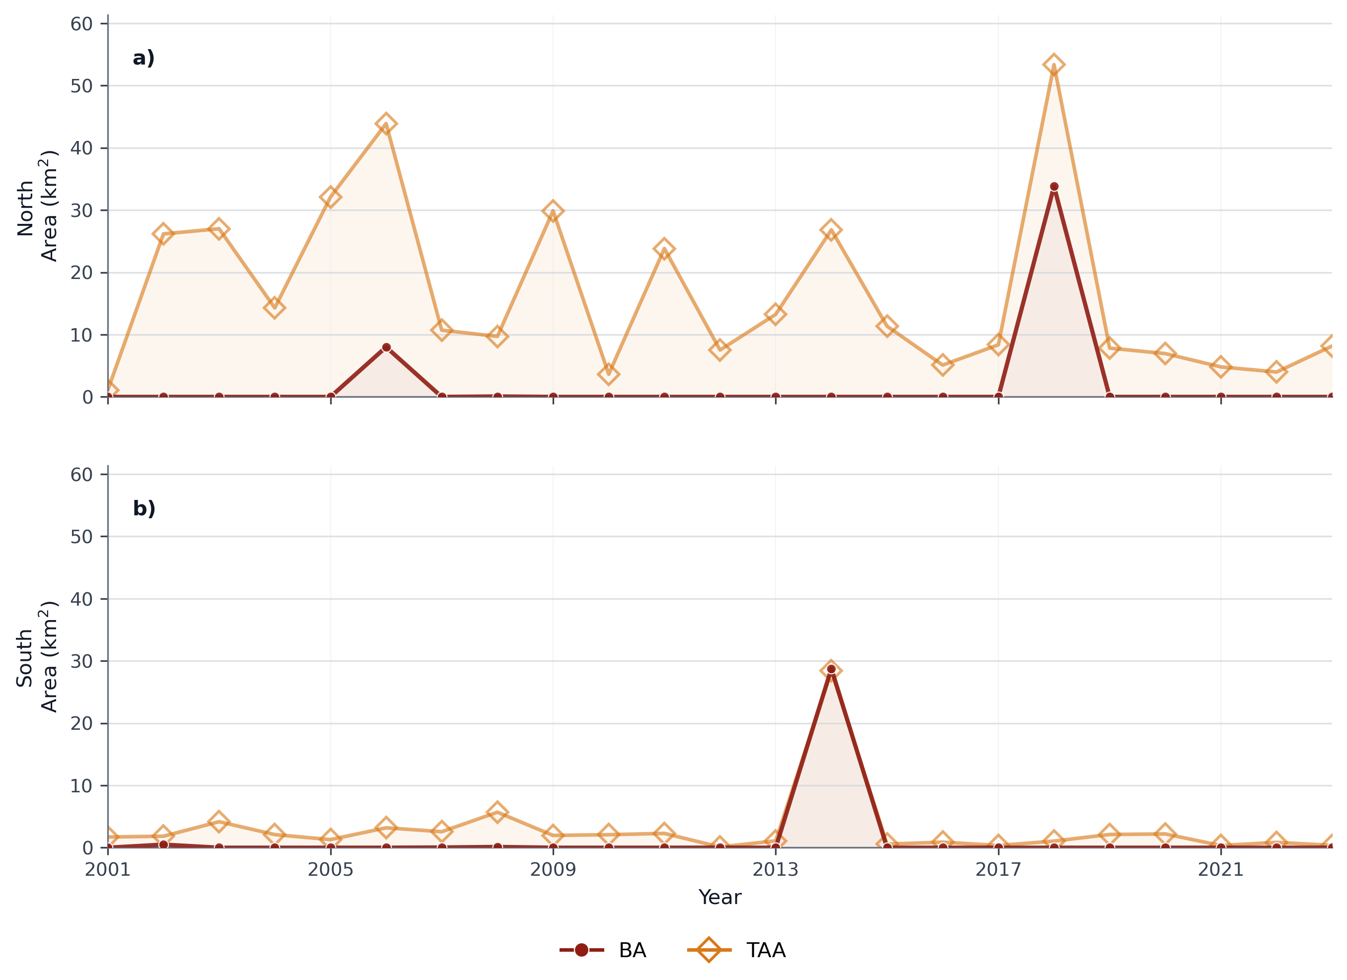
Supplementary Figure S2. Annual peatland fire-affected area in northern and southern Sweden, 2001-2023. Panels show (a) northern and (b) southern Sweden. Values are shown separately for FIRED burned-area perimeters (BA; dark red circles) and thermal-anomaly footprint areas (TAA; orange diamonds). Peatland fire-affected area is expressed in km² and was calculated within the NMD2023 forest-and-open-wetland analysis domain using Ågren et al. (2022) peatland map, corresponding to predicted organic-layer thickness ≥ 30 cm.

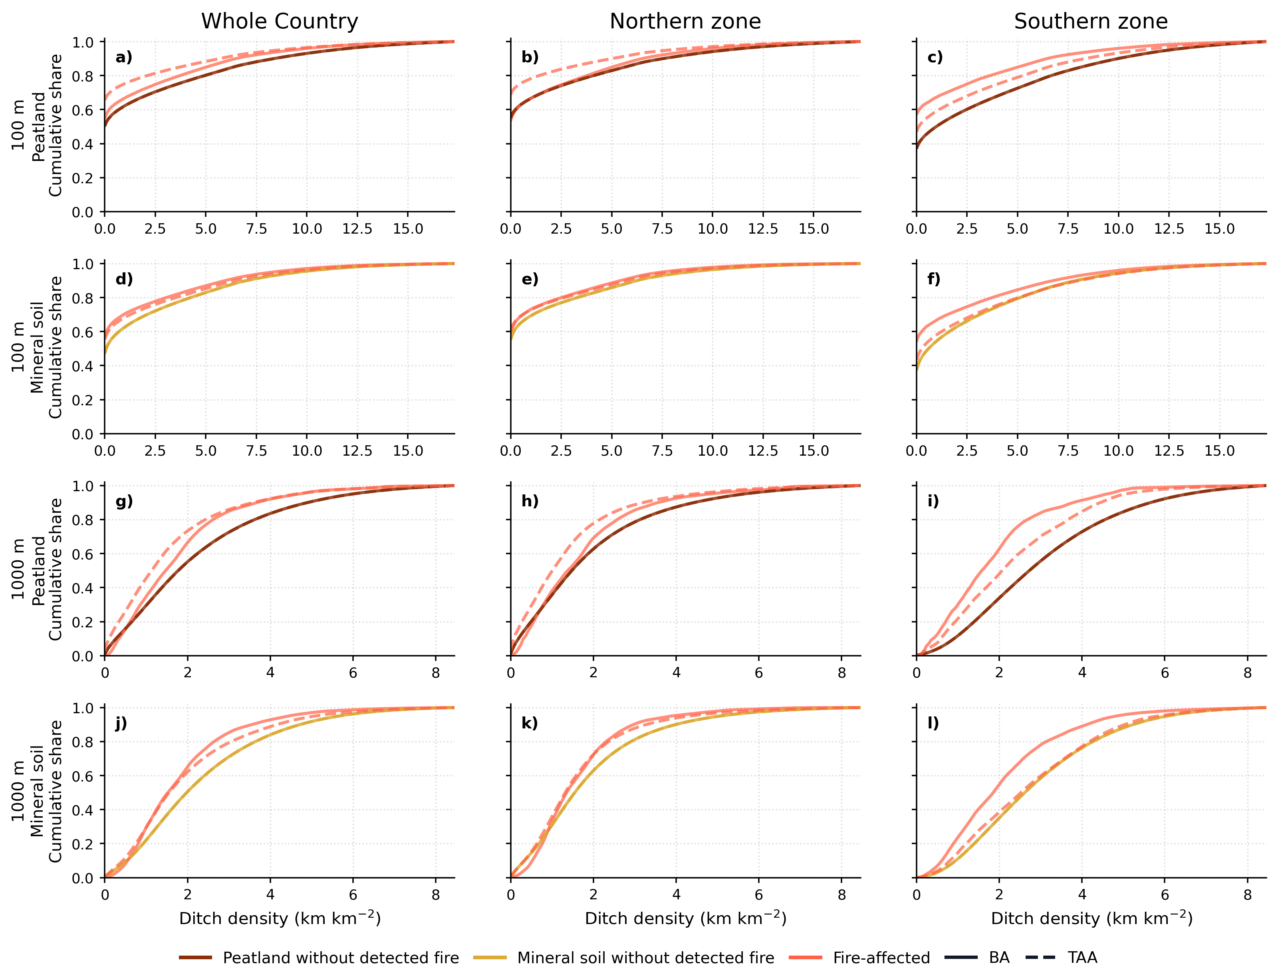
Supplementary Figure S3. Cumulative distributions of mapped ditch density by soil type, reporting zone, neighborhood radius, and fire dataset. Columns show reporting zones: whole country, northern zone, and southern zone. Rows combine the ditch-density neighborhood radius and soil type: 100 m peatlands, 100 m mineral soils, 1,000 m peatlands, and 1,000 m mineral soils, from top to bottom. Brown and yellow curves show areas without detected fire for peatlands and mineral soils, respectively; orange curves show fire-affected areas within the soil class shown in each row. Solid and dashed lines distinguish BA and TAA. Ditch density is expressed as km km⁻².
Supplementary Table S1. Fire-affected minus areas without detected fire ditch-density statistics by soil type. Differences are in km km-2; negative values indicate lower ditch density in fire-affected pixels. KS-D is the Kolmogorov-Smirnov distance; delta is Cliff's delta.
Dataset | Region | Buffer (m) | Soil | Mean diff. | Median diff. | P75 diff. | KS-D | Delta | Effect
BA | Whole country | 100 | Peatland | -0.52 | 0.00 | -1.04 | 0.049 | -0.063 | negligible
BA | North | 100 | Peatland | -0.20 | 0.00 | -0.13 | 0.023 | 0.003 | negligible
BA | South | 100 | Peatland | -1.41 | -0.97 | -3.04 | 0.200 | -0.229 | small
BA | Whole country | 100 | Mineral | -0.48 | -0.07 | -1.24 | 0.098 | -0.105 | negligible
BA | North | 100 | Mineral | -0.30 | 0.00 | -0.68 | 0.042 | -0.048 | negligible
BA | South | 100 | Mineral | -0.66 | -0.59 | -1.49 | 0.168 | -0.166 | small
BA | Whole country | 1000 | Peatland | -0.46 | -0.30 | -0.84 | 0.133 | -0.122 | negligible
BA | North | 1000 | Peatland | -0.22 | -0.10 | -0.44 | 0.071 | -0.040 | negligible
BA | South | 1000 | Peatland | -1.19 | -1.15 | -1.75 | 0.321 | -0.406 | medium
BA | Whole country | 1000 | Mineral | -0.52 | -0.46 | -0.87 | 0.155 | -0.178 | small
BA | North | 1000 | Mineral | -0.29 | -0.20 | -0.49 | 0.101 | -0.076 | negligible
BA | South | 1000 | Mineral | -0.76 | -0.76 | -1.08 | 0.208 | -0.284 | small
TAA | Whole country | 100 | Peatland | -0.94 | 0.00 | -2.66 | 0.152 | -0.166 | small
TAA | North | 100 | Peatland | -0.82 | 0.00 | -2.29 | 0.138 | -0.149 | small
TAA | South | 100 | Peatland | -0.74 | -0.86 | -1.52 | 0.099 | -0.117 | negligible
TAA | Whole country | 100 | Mineral | -0.30 | -0.07 | -0.82 | 0.080 | -0.079 | negligible
TAA | North | 100 | Mineral | -0.22 | 0.00 | -0.62 | 0.053 | -0.053 | negligible
TAA | South | 100 | Mineral | -0.10 | -0.33 | -0.20 | 0.058 | -0.047 | negligible
TAA | Whole country | 1000 | Peatland | -0.70 | -0.64 | -1.09 | 0.190 | -0.247 | small
TAA | North | 1000 | Peatland | -0.56 | -0.47 | -0.87 | 0.162 | -0.208 | small
TAA | South | 1000 | Peatland | -0.70 | -0.66 | -0.83 | 0.155 | -0.223 | small
TAA | Whole country | 1000 | Mineral | -0.37 | -0.43 | -0.59 | 0.117 | -0.143 | negligible
TAA | North | 1000 | Mineral | -0.28 | -0.23 | -0.47 | 0.095 | -0.105 | negligible
TAA | South | 1000 | Mineral | -0.12 | -0.09 | -0.04 | 0.051 | -0.044 | negligible

Supplementary Table S2. Fire minus no-fire ditch-density statistics for peatlands stratified by mapped land-cover context. Differences are in km km-2; KS-D and delta use the binned cumulative distributions.
Dataset | Region | Buffer (m) | Peat land cover | Mean diff. | Median diff. | P75 diff. | KS-D | Delta | Effect
BA | Whole country | 100 | Open peatland | 0.16 | 0.00 | 0.50 | 0.049 | 0.050 | negligible
BA | North | 100 | Open peatland | 0.17 | 0.00 | 0.42 | 0.062 | 0.061 | negligible
BA | South | 100 | Open peatland | -0.25 | 0.00 | -0.39 | 0.047 | -0.046 | negligible
BA | Whole country | 100 | Forested peatland | -0.73 | -0.54 | -1.40 | 0.076 | -0.097 | negligible
BA | North | 100 | Forested peatland | -0.40 | -0.08 | -0.65 | 0.039 | -0.029 | negligible
BA | South | 100 | Forested peatland | -1.44 | -1.77 | -2.73 | 0.212 | -0.235 | small
BA | Whole country | 1000 | Open peatland | -0.14 | 0.03 | -0.25 | 0.079 | 0.014 | negligible
BA | North | 1000 | Open peatland | -0.01 | 0.07 | -0.02 | 0.094 | 0.058 | negligible
BA | South | 1000 | Open peatland | -1.06 | -0.94 | -1.58 | 0.298 | -0.370 | medium
BA | Whole country | 1000 | Forested peatland | -0.56 | -0.43 | -1.01 | 0.157 | -0.170 | small
BA | North | 1000 | Forested peatland | -0.34 | -0.20 | -0.64 | 0.101 | -0.095 | negligible
BA | South | 1000 | Forested peatland | -1.08 | -1.02 | -1.60 | 0.293 | -0.367 | medium
TAA | Whole country | 100 | Open peatland | -0.39 | 0.00 | -0.38 | 0.098 | -0.100 | negligible
TAA | North | 100 | Open peatland | -0.37 | 0.00 | -0.21 | 0.098 | -0.101 | negligible
TAA | South | 100 | Open peatland | -0.15 | 0.00 | -0.18 | 0.023 | -0.024 | negligible
TAA | Whole country | 100 | Forested peatland | -0.96 | -0.57 | -2.28 | 0.135 | -0.155 | small
TAA | North | 100 | Forested peatland | -0.88 | -0.20 | -2.31 | 0.124 | -0.142 | negligible
TAA | South | 100 | Forested peatland | -0.67 | -1.07 | -1.10 | 0.091 | -0.106 | negligible
TAA | Whole country | 1000 | Open peatland | -0.47 | -0.36 | -0.69 | 0.133 | -0.180 | small
TAA | North | 1000 | Open peatland | -0.35 | -0.26 | -0.48 | 0.107 | -0.148 | small
TAA | South | 1000 | Open peatland | -0.80 | -0.72 | -1.15 | 0.203 | -0.268 | small
TAA | Whole country | 1000 | Forested peatland | -0.69 | -0.72 | -1.05 | 0.188 | -0.240 | small
TAA | North | 1000 | Forested peatland | -0.59 | -0.55 | -0.94 | 0.172 | -0.213 | small
TAA | South | 1000 | Forested peatland | -0.56 | -0.50 | -0.63 | 0.112 | -0.172 | small

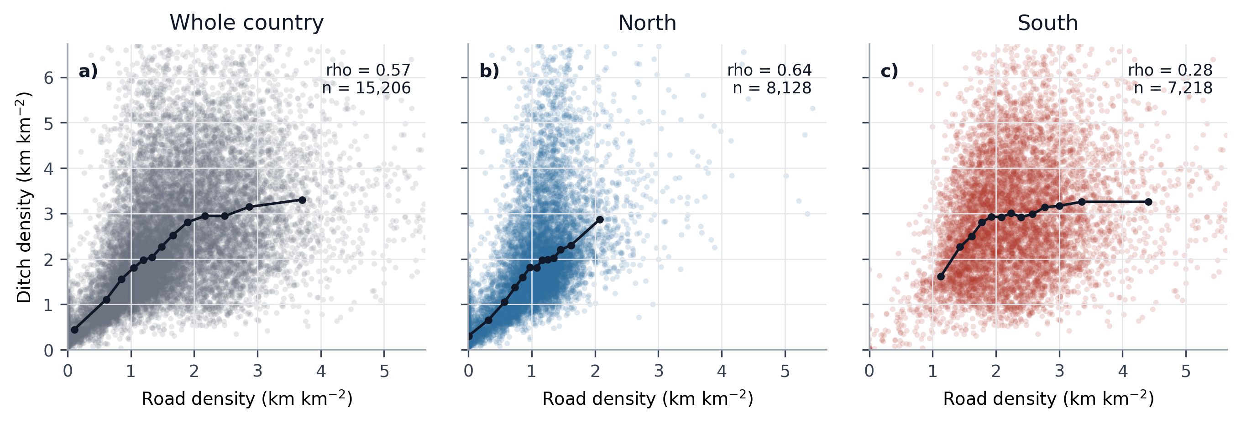
Supplementary Figure S4. Road and ditch density covariation across 5 km grid cells in the NMD2023 analysis domain. Panels show whole-country, northern, and southern grid cells for 1,000 m road density and 1,000 m mapped ditch density. Points are grid-cell means; black lines show binned medians rather than fitted models. Spearman rho values were calculated from all grid cells in each region; axes are truncated at the 99th percentile for readability.

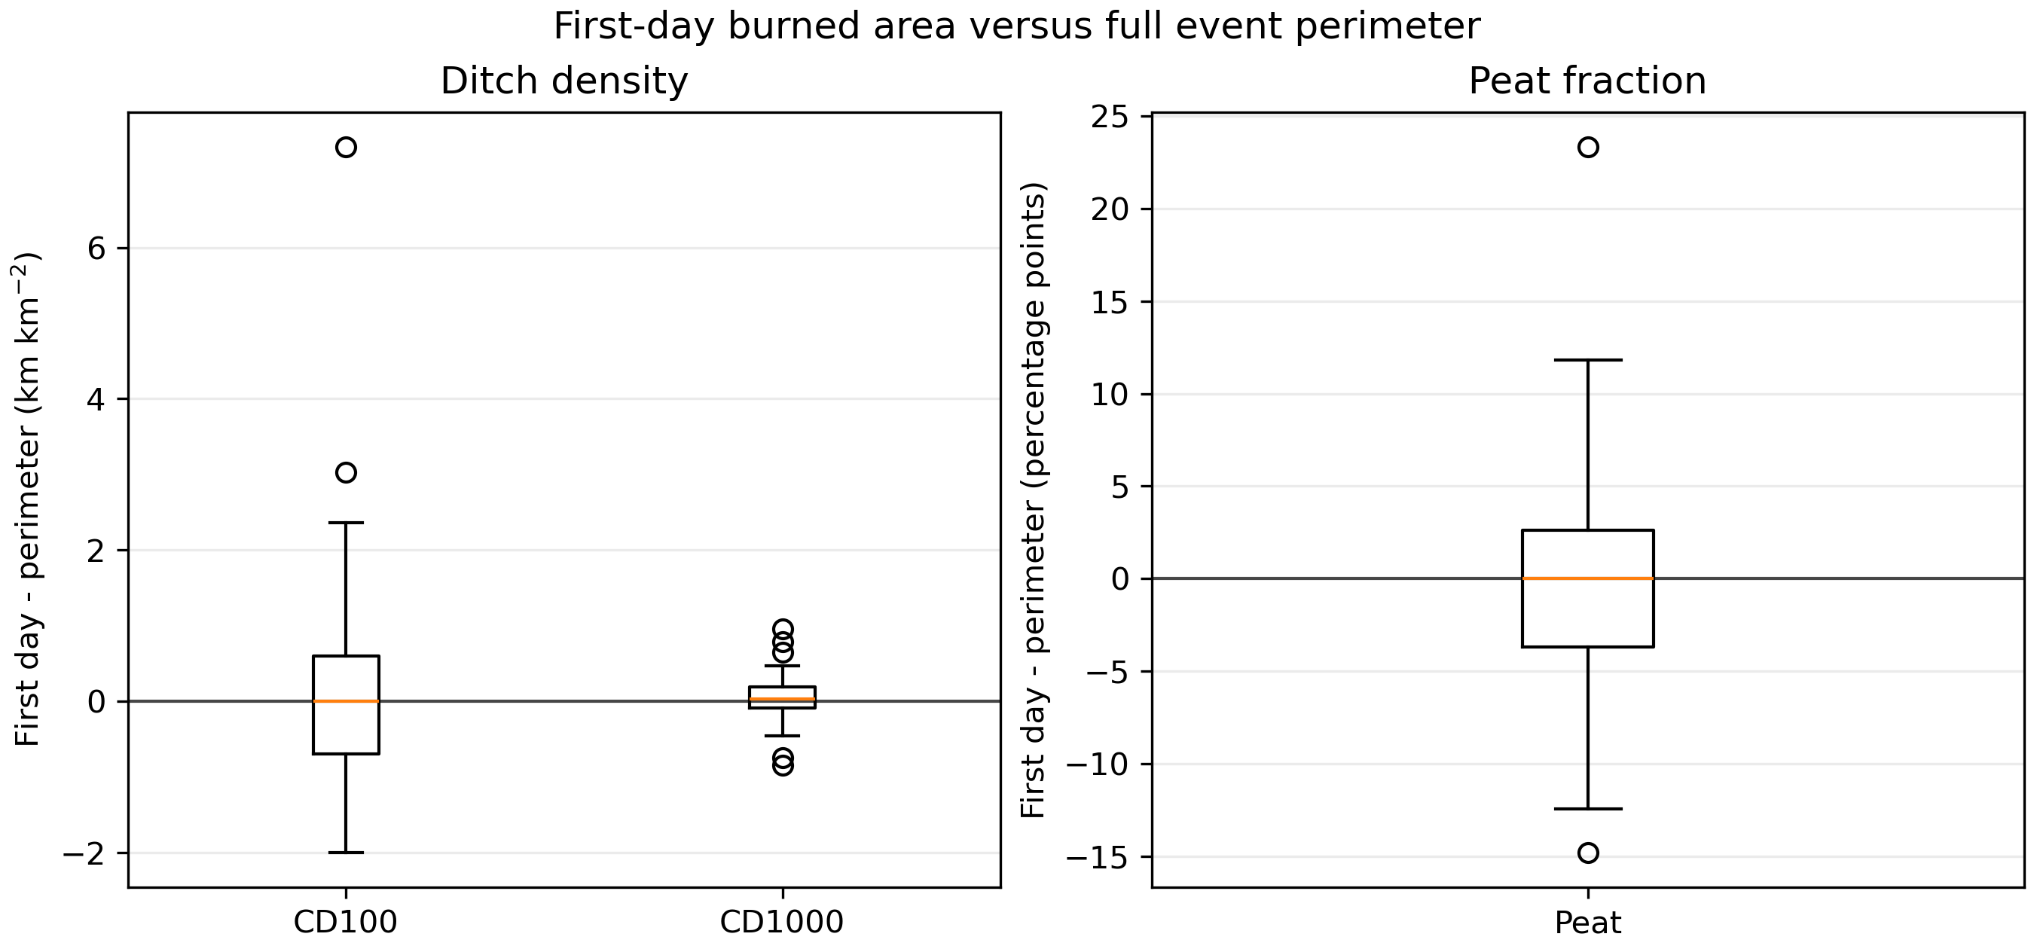
Supplementary Figure S5. First-day burned area versus full BA event perimeter in multi-day BA events. Boxplots show paired first-day minus final-perimeter differences for 100 m and 1,000 m ditch-density means and peatland area fraction. First-day burned area is an apparent fire-start proxy, not an exact ignition location.

Supplementary Table S3. Event-level paired comparison of first-day burned areas and full BA event perimeters. Higher/lower/equal gives the number of events where the first-day value was greater than, less than, or equal to the full-perimeter value. Differences are first day minus perimeter.
Group | Metric | Unit | n | Higher/lower/equal | First-day median | Perimeter median | Median diff. | IQR diff. | Sign-test p
All events | 100 m mean ditch density | km km⁻² | 35 | 17/18/0 | 1.55 | 1.74 | -0.00 | -0.70 to 0.60 | 1.000
All events | 100 m median ditch density | km km⁻² | 35 | 16/17/2 | 0.20 | 0.08 | 0.00 | -0.11 to 0.31 | 1.000
All events | 1,000 m mean ditch density | km km⁻² | 35 | 20/15/0 | 1.95 | 2.08 | 0.04 | -0.09 to 0.19 | 0.500
All events | 1,000 m median ditch density | km km⁻² | 35 | 20/15/0 | 1.88 | 1.93 | 0.01 | -0.09 to 0.27 | 0.500
All events | Peat fraction | percentage points | 35 | 15/15/5 | 16.97 | 14.78 | 0.00 | -3.71 to 2.64 | 1.000
North | 100 m mean ditch density | km km⁻² | 22 | 10/12/0 | 1.42 | 1.64 | -0.01 | -0.86 to 0.38 | 0.832
North | 100 m median ditch density | km km⁻² | 22 | 9/11/2 | 0.00 | 0.00 | -0.00 | -0.00 to 0.09 | 0.824
North | 1,000 m mean ditch density | km km⁻² | 22 | 12/10/0 | 1.85 | 1.88 | 0.04 | -0.09 to 0.17 | 0.832
North | 1,000 m median ditch density | km km⁻² | 22 | 11/11/0 | 1.84 | 1.91 | 0.02 | -0.08 to 0.28 | 1.000
North | Peat fraction | percentage points | 22 | 11/10/1 | 20.20 | 20.69 | 0.25 | -4.21 to 3.10 | 1.000
South | 100 m mean ditch density | km km⁻² | 13 | 7/6/0 | 2.53 | 1.98 | 0.11 | -0.43 to 1.56 | 1.000
South | 100 m median ditch density | km km⁻² | 13 | 7/6/0 | 0.84 | 0.79 | 0.00 | -0.18 to 1.34 | 1.000
South | 1,000 m mean ditch density | km km⁻² | 13 | 8/5/0 | 2.11 | 2.12 | 0.02 | -0.08 to 0.21 | 0.581
South | 1,000 m median ditch density | km km⁻² | 13 | 9/4/0 | 2.08 | 2.03 | 0.01 | -0.10 to 0.24 | 0.267
South | Peat fraction | percentage points | 13 | 4/5/4 | 0.00 | 0.95 | 0.00 | -0.52 to 0.25 | 1.000

Supplementary drainage summaries use the NMD2023 analysis domain. The fire/no-fire ditch-density comparisons (Supplementary Figure S3 and Supplementary Tables S1 and S2) use the p99 ditch-density selection used for the main drainage figures. The road/ditch covariation figure (Supplementary Figure S4) uses 5 km grid-cell means of the 1,000 m road- and ditch-density products, and the event-level first-day/perimeter summaries (Supplementary Figure S5 and Supplementary Table S3) use the 100 m and 1,000 m ditch-density products.

