Supplementary Materials

Fire Ecology
Original Research Article
Fueling the Fire: Predicting Cogongrass (Imperata cylindrica) Impacts on Fire Behavior Across Environmental and Seasonal Gradients
Alan A. Ivory II^{1*}, Carissa L. Wonkka¹, Devan A. McGranahan², Paul Akpejeluh³, Sarah Kincy¹, Noah C. Weidig¹, Caleb P. Roberts³, Kody M. Brock⁴, Carlos A. Silva⁴, Victoria M. Donovan¹

1University of Florida, School of Forest, Fisheries, and Geomatics Sciences, West Florida Research and Education Center, Institute of Food and Agricultural Sciences, Milton, FL, USA; 2USDA Agricultural Research Service, Livestock & Range Research Laboratory, Miles City, MT, USA; 3U.S. Geological Survey, Arkansas Cooperative Fish & Wildlife Research Unit, University of Arkansas, Fayetteville, AR, USA; 4University of Florida, School of Forest, Fisheries, and Geomatic Sciences, Institute of Food and Agriculture Sciences, Gainesville, FL, USA
*Corresponding author: Alan Ivory (alanivory34428@ufl.edu)

Table S1: Fuel and Moisture Quantiles by Invasion Status and Season. Biomass values are in tonnes/ hectare, moisture is denoted as a percentage, and height is in meters.
Variable | Invaded - Spring | Invaded - Summer | Invaded - Winter | Non Invaded - Spring | Non Invaded - Summer | Non Invaded - Winter
Live Biomass (25%) | 1.16 | 1.77 | 0.95 | 0.37 | 0.28 | 0.21
Live Biomass (50%) | 2.16 | 2.45 | 1.50 | 0.51 | 0.59 | 0.27
Live Biomass (75%) | 3.47 | 3.72 | 2.49 | 0.75 | 1.02 | 0.51
Dead Biomass (25%) | 1.89 | 1.26 | 1.95 | 0.34 | 0.14 | 0.32
Dead Biomass (50%) | 2.42 | 2.40 | 3.41 | 0.75 | 0.32 | 0.72
Dead Biomass (75%) | 3.11 | 4.48 | 6.20 | 1.36 | 0.90 | 1.81
Litter Biomass (25%) | 3.49 | 2.33 | 3.02 | 3.92 | 3.99 | 4.61
Litter Biomass (50%) | 4.97 | 4.09 | 5.62 | 6.19 | 6.06 | 6.60
Litter Biomass (75%) | 9.22 | 6.75 | 7.92 | 8.34 | 7.31 | 9.26
Live Moisture Content (25%) | 54.67 | 133.22 | 95.77 | 51.68 | 133.27 | 30.65
Live Moisture Content (50%) | 117.06 | 147.42 | 119.49 | 80.33 | 163.92 | 85.19
Live Moisture Content (75%) | 133.05 | 168.25 | 151.14 | 146.20 | 191.77 | 184.43
Dead Moisture Content (25%) | 9.20 | 13.45 | 13.79 | 9.75 | 8.80 | 11.68
Dead Moisture Content (50%) | 10.40 | 18.01 | 19.72 | 15.47 | 15.42 | 16.25
Dead Moisture Content (75%) | 16.58 | 27.30 | 36.74 | 17.59 | 29.73 | 49.33
Litter Moisture Content (25%) | 9.49 | 11.68 | 15.98 | 7.29 | 10.01 | 15.91
Litter Moisture Content (50%) | 11.45 | 21.21 | 27.86 | 12.30 | 21.21 | 42.65
Litter Moisture Content (75%) | 14.92 | 35.50 | 47.96 | 17.28 | 47.67 | 56.81
Soil Moisture (25%) | 4.83 | 6.32 | 5.93 | 3.07 | 3.74 | 6.23
Soil Moisture (50%) | 5.77 | 10.90 | 10.92 | 4.03 | 5.50 | 9.57
Soil Moisture (75%) | 7.10 | 12.96 | 13.89 | 9.30 | 11.66 | 12.38
Height (25%) | 0.56 | 0.66 | 0.71 | 0.23 | 0.15 | 0.11
Height (50%) | 0.75 | 0.80 | 0.85 | 0.33 | 0.24 | 0.24
Height (75%) | 0.95 | 1.01 | 0.97 | 0.44 | 0.34 | 0.36

Table S2: Posterior estimates of live biomass, based on a Bayesian regression model including latitude, season, invasion status, and their interactions. Values represent posterior means with 95% HPDI (highest posterior density interval), posterior probability of direction (Pd), effective sample sizes (ESS), and r̂ convergence diagnostics. Bolded rows indicate credible variables.
 | Estimate | Est. Error | 95% HPDI (Lower) | 95% HPDI (Upper) | Pd | Bulk ESS | Tail ESS | r̂
(Intercept) | -9.97 | 17.75 | -88.91 | 19.08 | 0.783 | 3,074 | 3,618 | 1.000
Latitude | 0.35 | 0.59 | -0.61 | 2.98 | 0.808 | 3,070 | 3,710 | 1.000
Season-Spring | -0.11 | 0.17 | -0.44 | 0.24 | 0.744 | 8,056 | 8,134 | 1.000
Season-Winter | -0.23 | 0.16 | -0.53 | 0.09 | 0.928 | 8,941 | 7,759 | 1.000
Status-Invaded | 18.94 | 3.71 | 11.86 | 26.15 | 1.000 | 5,974 | 6,228 | 1.000
Status-Invaded x Latitude | -0.57 | 0.12 | -0.81 | -0.34 | 1.000 | 6,034 | 6,384 | 1.000
Status-Invaded x Season-Spring | -0.70 | 0.30 | -1.30 | -0.12 | 0.984 | 8,934 | 7,893 | 1.000
Status-Invaded x Season-Winter | -0.99 | 0.28 | -1.55 | -0.43 | 1.000 | 9,360 | 8,232 | 1.000

Table S3: Pairwise comparisons of live biomass between invaded and non-invaded sites within each season, based on estimated marginal means. Values represent posterior mean differences with 95% highest posterior density intervals (HPDI) and posterior probability of direction (Pd). Bolded rows indicate credible variables.
Season | Contrast | Estimate | 95% HPD Lower | 95% HPD Upper |  | Pd
Summer | Invaded - Non_Invaded | 1.96 | 1.62 | 2.30 |  | 1.000
Spring | Invaded - Non_Invaded | 1.26 | 0.76 | 1.78 |  | 1.000
Winter | Invaded - Non_Invaded | 0.96 | 0.51 | 1.43 |  | 1.000

Table S4: Posterior estimates of dead biomass, based on a Bayesian regression model including latitude, season, and invasion status. Values represent posterior means with 95% HPDI (highest posterior density interval), Pd, ESS, and r̂. Bolded rows indicate credible variables.
 | Estimate | Est. Error | 95% HPDI (Lower) | 95% HPDI (Upper) | Pd | Bulk ESS | Tail ESS | r̂
(Intercept) | 2.17 | 8.15 | -55.41 | 29.11 | 0.608 | 568 | 219 | 1.000
Latitude | -0.06 | 0.27 | -0.97 | 1.83 | 0.593 | 561 | 219 | 1.000
Season-Spring | 0.32 | 0.21 | -0.07 | 0.73 | 0.947 | 1,811 | 2,851 | 1.000
Season-Winter | 0.43 | 0.23 | 0.01 | 0.93 | 0.971 | 796 | 237 | 1.001
Status-Invaded | 1.88 | 0.18 | 1.53 | 2.25 | 1.000 | 1,542 | 1,405 | 1.000

Table S5: Posterior estimates of litter biomass, based on a Bayesian regression model including latitude, season, and invasion status. Values represent posterior means with 95% HPDI (highest posterior density interval), Pd, ESS, and r̂. Bolded rows indicate credible variables.
 | Estimate | Est. Error | 95% HPDI (Lower) | 95% HPDI (Upper) | Pd | Bulk ESS | Tail ESS | r̂
(Intercept) | 22.24 | 45.23 | -65.65 | 234.50 | 0.725 | 655 | 146 | 1.003
Latitude | -0.56 | 1.50 | -7.78 | 2.27 | 0.662 | 667 | 145 | 1.003
Season-Spring | 1.40 | 0.66 | 0.10 | 2.79 | 0.981 | 9,619 | 7,695 | 1.001
Season-Winter | 1.16 | 0.57 | 0.08 | 2.37 | 0.975 | 9,033 | 8,316 | 1.000
Status-Invaded | -0.94 | 0.49 | -1.88 | 0.06 | 0.968 | 10,528 | 7,760 | 1.000

Table S6: Posterior estimates of live fuel moisture, based on a Bayesian regression model including latitude, season, and invasion status. Values represent posterior means with 95% HPDI (highest posterior density interval), Pd, ESS, and r̂. Bolded rows indicate credible variables.
 | Estimate | Est. Error | 95% HPDI (Lower) | 95% HPDI (Upper) | Pd | Bulk ESS | Tail ESS | r̂
(Intercept) | 240.62 | 246.12 | -544.09 | 1,204.92 | 0.834 | 3,499 | 2,908 | 1.000
Latitude | -2.69 | 8.19 | -34.28 | 24.16 | 0.637 | 3,514 | 2,956 | 1.000
Season-Spring | -56.15 | 10.59 | -77.49 | -34.86 | 1.000 | 10,297 | 8,120 | 1.000
Season-Winter | -37.98 | 11.55 | -61.03 | -15.22 | 1.000 | 8,900 | 8,455 | 1.000
Status-Invaded | -5.20 | 9.34 | -23.61 | 12.29 | 0.715 | 10,050 | 7,819 | 1.000

Table S7: Posterior estimates of dead fuel moisture, based on a Bayesian regression model including latitude, season, and invasion status. Values represent posterior means with 95% HPDI (highest posterior density interval), Pd, ESS, and r̂. Bolded rows indicate credible variables.
 | Estimate | Est. Error | 95% HPDI (Lower) | 95% HPDI (Upper) | Pd | Bulk ESS | Tail ESS | r̂
(Intercept) | 11.98 | 76.46 | -214.32 | 254.30 | 0.568 | 3,736 | 3,215 | 1.000
Latitude | 0.06 | 2.55 | -8.28 | 7.30 | 0.511 | 3,749 | 3,177 | 1.000
Season-Spring | -2.36 | 1.70 | -5.70 | 1.04 | 0.913 | 8,036 | 7,565 | 1.000
Season-Winter | 1.30 | 1.90 | -2.36 | 5.25 | 0.763 | 7,955 | 7,420 | 1.000
Status-Invaded | 1.61 | 1.51 | -1.40 | 4.49 | 0.854 | 10,234 | 8,348 | 1.000

Table S8: Posterior estimates of litter fuel moisture, based on a Bayesian regression model including latitude, season, and invasion status. Values represent posterior means with 95% HPDI (highest posterior density interval), Pd, ESS, and r̂. Bolded rows indicate credible variables.
 | Estimate | Est. Error | 95% HPDI (Lower) | 95% HPDI (Upper) | Pd | Bulk ESS | Tail ESS | r̂
(Intercept) | -25.14 | 95.84 | -350.03 | 381.47 | 0.611 | 2,035 | 1,840 | 1.001
Latitude | 1.59 | 3.20 | -11.90 | 12.47 | 0.686 | 2,058 | 1,848 | 1.001
Season-Spring | -8.89 | 3.55 | -15.67 | -2.19 | 0.997 | 6,855 | 7,019 | 1.000
Season-Winter | 10.30 | 3.98 | 2.46 | 17.76 | 0.997 | 9,996 | 8,155 | 1.000
Status-Invaded | -1.91 | 2.83 | -7.49 | 3.48 | 0.755 | 8,698 | 7,075 | 1.000

Table S9: Posterior estimates of soil moisture, based on a Bayesian regression model including latitude, season, and invasion status. Values represent posterior means with 95% HPDI (highest posterior density interval), Pd, ESS, and r̂. Bolded rows indicate credible variables.
 | Estimate | Est. Error | 95% HPDI (Lower) | 95% HPDI (Upper) | Pd | Bulk ESS | Tail ESS | r̂
(Intercept) | -60.48 | 32.13 | -156.97 | 90.07 | 0.865 | 2,025 | 753 | 1.001
Latitude | 2.26 | 1.07 | -2.45 | 5.83 | 0.880 | 2,044 | 741 | 1.001
Season-Spring | -1.98 | 0.88 | -3.68 | -0.36 | 0.989 | 5,122 | 4,828 | 1.001
Season-Winter | 1.30 | 0.74 | -0.10 | 2.78 | 0.960 | 5,583 | 7,074 | 1.000
Status-Invaded | 1.04 | 0.63 | -0.20 | 2.31 | 0.948 | 7,846 | 6,866 | 1.000

Table S10: Pairwise comparisons of vegetation height between invaded and non-invaded sites within each season, based on estimated marginal means. Values represent posterior mean differences with 95% highest posterior density intervals (HPDI) and posterior probability of direction (Pd). Bolded rows indicate credible variables.
Season |  |  |  | Contrast | Estimate | 95% HPD Lower | 95% HPD Upper |  |  | Pd
Summer |  |  |  | Invaded - Non_Invaded | 0.59 | 0.52 | 0.65 |  |  | 1.000
Spring |  |  |  | Invaded - Non_Invaded | 0.43 | 0.33 | 0.52 |  |  | 1.000
Winter |  |  |  | Invaded - Non_Invaded | 0.59 | 0.51 | 0.69 |  |  | 1.000

Table S11: Posterior estimates of vegetation height, based on a Bayesian regression model including latitude, season, invasion status, and their interactions. Values represent posterior means with 95% HPDI (highest posterior density interval), Pd, ESS, and r̂. Bolded rows indicate credible variables.
 | Estimate | Est. Error | 95% HPDI (Lower) | 95% HPDI (Upper) | Pd | Bulk ESS | Tail ESS | r̂
(Intercept) | 0.50 | 1.76 | -11.12 | 7.64 | 0.615 | 4,520 | 3,355 | 1.001
Latitude | -0.01 | 0.06 | -0.24 | 0.38 | 0.564 | 4,530 | 3,323 | 1.001
Season-Spring | 0.09 | 0.04 | 0.01 | 0.18 | 0.985 | 8,065 | 7,907 | 1.000
Season-Winter | -0.02 | 0.04 | -0.10 | 0.06 | 0.695 | 7,039 | 7,562 | 1.000
Status-Invaded | 3.79 | 0.70 | 2.34 | 5.09 | 1.000 | 6,755 | 7,136 | 1.000
Status-Invaded x Latitude | -0.11 | 0.02 | -0.15 | -0.06 | 1.000 | 6,816 | 7,195 | 1.000
Status-Invaded x Season-Spring | -0.16 | 0.06 | -0.27 | -0.04 | 0.997 | 8,076 | 8,534 | 1.000
Status-Invaded x Season-Winter | 0.01 | 0.06 | -0.11 | 0.12 | 0.550 | 7,115 | 7,681 | 1.000

Table S12: Posterior estimates of surface fire rate of spread, based on a Bayesian regression model including invasion status. Values represent posterior means with 95% HPDI (highest posterior density interval), Pd, ESS, and r̂. Bolded rows indicate credible variables.
 | Estimate | Est. Error | 95% HPDI (Lower) | 95% HPDI (Upper) | Pd | Bulk ESS | Tail ESS | r̂
Intercept | 2.48 | 0.04 | 2.40 | 2.56 | 1.000 | 15,255 | 9,107 | 1.000
Status-Invaded | 0.75 | 0.06 | 0.63 | 0.87 | 1.000 | 15,436 | 9,251 | 1.000

Table S13: Posterior estimates of surface flame length, based on a Bayesian regression model including invasion status. Values represent posterior means with 95% HPDI (highest posterior density interval), Pd, ESS, and r̂. Bolded rows indicate credible variables.
 | Estimate | Est. Error | 95% HPDI (Lower) | 95% HPDI (Upper) | Pd | Bulk ESS | Tail ESS | r̂
Intercept | 1.51 | 0.02 | 1.47 | 1.55 | 1.000 | 14,730 | 8,582 | 1.000
Status-Invaded | 0.16 | 0.03 | 0.10 | 0.22 | 1.000 | 15,596 | 8,927 | 1.000

Table S14: Posterior estimates of surface fireline intensity, based on a Bayesian regression model including invasion status. Values represent posterior means with 95% HPDI (highest posterior density interval), Pd, ESS, and r̂. Bolded rows indicate credible variables.
 | Estimate | Est. Error | 95% HPDI (Lower) | 95% HPDI (Upper) | Pd | Bulk ESS | Tail ESS | r̂
Intercept | 810.81 | 14.84 | 782.29 | 839.90 | 1.000 | 9,978 | 7,859 | 1.002
Status-Invaded | 0.33 | 0.99 | -1.66 | 2.23 | 0.625 | 12,309 | 7,772 | 1.000

Table S15: Posterior estimates of crown transition ratio, based on a Bayesian regression model including invasion status. Values represent posterior means with 95% HPDI (highest posterior density interval), Pd, ESS, and r̂. Bolded rows indicate credible variables.
 | Estimate | Est. Error | 95% HPDI (Lower) | 95% HPDI (Upper) | Pd | Bulk ESS | Tail ESS | r̂
Intercept | 0.20 | 0.01 | 0.19 | 0.21 | 1.000 | 9,100 | 7,753 | 1.000
Status-Invaded | 0.03 | 0.01 | 0.01 | 0.05 | 0.996 | 7,538 | 7,574 | 1.000

Table S16: Posterior estimates from a secondary Bayesian regression of surface fire rate of spread at invaded sites. Values represent posterior means with 95% credible intervals (CI), Pd, ESS, and r̂. Bolded rows indicate credible variables.
 | Estimate | Est. Error | 95% CI (Lower) | 95% CI (Upper) | Pd | Bulk ESS | Tail ESS | r̂
Intercept | 3.19 | 0.03 | 3.12 | 3.26 | 1.000 | 18,480 | 9,267 | 1.000
Dead_Fuel_Moisture | -0.70 | 0.02 | -0.74 | -0.67 | 1.000 | 16,673 | 9,856 | 1.000
Dead_Biomass | 0.72 | 0.02 | 0.68 | 0.75 | 1.000 | 16,183 | 9,449 | 1.000
Litter_Biomass | 0.91 | 0.02 | 0.88 | 0.94 | 1.000 | 17,310 | 9,880 | 1.001
Live_Fuel_Moisture | -0.64 | 0.03 | -0.69 | -0.59 | 1.000 | 15,778 | 8,941 | 1.000
Live_Biomass | 0.03 | 0.03 | -0.02 | 0.08 | 0.864 | 18,519 | 8,770 | 1.000

Table S17: Posterior estimates from a secondary Bayesian regression of surface fire rate of spread at non-invaded sites. Values represent posterior means with 95% CI, Pd, ESS, and r̂. Bolded rows indicate credible variables.
 | Estimate | Est. Error | 95% CI (Lower) | 95% CI (Upper) | Pd | Bulk ESS | Tail ESS | r̂
Intercept | 1.84 | 0.03 | 1.78 | 1.90 | 1.000 | 9,531 | 8,567 | 1.000
Dead_Fuel_Moisture | -0.38 | 0.01 | -0.39 | -0.36 | 1.000 | 8,588 | 9,093 | 1.001
Dead_Biomass | 0.36 | 0.03 | 0.31 | 0.42 | 1.000 | 9,329 | 8,063 | 1.001
Litter_Biomass | 0.49 | 0.01 | 0.48 | 0.51 | 1.000 | 8,014 | 8,661 | 1.000
Live_Fuel_Moisture | -0.40 | 0.00 | -0.41 | -0.39 | 1.000 | 10,782 | 9,326 | 1.000
Live_Biomass | -0.72 | 0.02 | -0.76 | -0.67 | 1.000 | 10,260 | 8,418 | 1.000

Table S18: Posterior estimates from a secondary Bayesian regression of surface flame length at invaded sites. Values represent posterior means with 95% credible intervals (CI), Pd, ESS, and r̂. Bolded rows indicate credible variables.
 | Estimate | Est. Error | 95% CI (Lower) | 95% CI (Upper) | Pd | Bulk ESS | Tail ESS | r̂
Intercept | 1.67 | 0.02 | 1.64 | 1.70 | 1.000 | 17,214 | 8,939 | 1.001
Dead_Fuel_Moisture | -0.31 | 0.01 | -0.32 | -0.29 | 1.000 | 16,767 | 9,297 | 1.000
Dead_Biomass | 0.36 | 0.01 | 0.35 | 0.38 | 1.000 | 16,693 | 9,166 | 1.000
Litter_Biomass | 0.46 | 0.01 | 0.45 | 0.48 | 1.000 | 22,010 | 9,729 | 1.000
Live_Fuel_Moisture | -0.23 | 0.01 | -0.25 | -0.20 | 1.000 | 16,909 | 9,116 | 1.001
Live_Biomass | -0.04 | 0.01 | -0.07 | -0.02 | 1.000 | 15,344 | 8,538 | 1.000

Table S19: Posterior estimates from a secondary Bayesian regression of surface flame length at non-invaded sites. Values represent posterior means with 95% CI, Pd, ESS, and r̂. Bolded rows indicate credible variables.
 | Estimate | Est. Error | 95% CI (Lower) | 95% CI (Upper) | Pd | Bulk ESS | Tail ESS | r̂
Intercept | 1.42 | 0.01 | 1.39 | 1.44 | 1.000 | 8,641 | 7,961 | 1.000
Dead_Fuel_Moisture | -0.17 | 0.00 | -0.17 | -0.16 | 1.000 | 8,879 | 8,383 | 1.001
Dead_Biomass | 0.20 | 0.01 | 0.18 | 0.23 | 1.000 | 8,082 | 7,916 | 1.001
Litter_Biomass | 0.28 | 0.00 | 0.27 | 0.29 | 1.000 | 7,213 | 7,482 | 1.000
Live_Fuel_Moisture | -0.14 | 0.00 | -0.14 | -0.13 | 1.000 | 10,275 | 9,264 | 1.000
Live_Biomass | -0.16 | 0.01 | -0.18 | -0.14 | 1.000 | 8,663 | 8,372 | 1.000

Table S20: Posterior estimates from a secondary Bayesian regression of surface fireline intensity at invaded sites. Values represent posterior means with 95% credible intervals (CI), Pd, ESS, and r̂. Bolded rows indicate credible variables.
 | Estimate | Est. Error | 95% CI (Lower) | 95% CI (Upper) | Pd | Bulk ESS | Tail ESS | r̂
Intercept | 946.40 | 24.60 | 898.46 | 994.17 | 1.000 | 16,744 | 9,027 | 1.000
Dead_Fuel_Moisture | -0.47 | 0.99 | -2.39 | 1.50 | 0.680 | 14,850 | 9,102 | 1.000
Dead_Biomass | 0.37 | 1.01 | -1.55 | 2.32 | 0.647 | 17,457 | 9,221 | 1.000
Litter_Biomass | 0.79 | 0.99 | -1.20 | 2.79 | 0.788 | 16,384 | 9,715 | 1.001
Live_Fuel_Moisture | -0.15 | 1.02 | -2.12 | 1.82 | 0.554 | 17,530 | 9,375 | 1.001
Live_Biomass | 0.02 | 1.02 | -1.94 | 1.97 | 0.506 | 17,098 | 8,997 | 1.001

Table S21: Posterior estimates from a secondary Bayesian regression of surface fireline intensity at non-invaded sites. Values represent posterior means with 95% CI, Pd, ESS, and r̂. Bolded rows indicate credible variables.
 | Estimate | Est. Error | 95% CI (Lower) | 95% CI (Upper) | Pd | Bulk ESS | Tail ESS | r̂
Intercept | 691.54 | 12.39 | 667.58 | 716.26 | 1.000 | 14,777 | 9,444 | 1.000
Dead_Fuel_Moisture | -1.13 | 1.02 | -3.12 | 0.85 | 0.868 | 14,849 | 9,490 | 1.000
Dead_Biomass | 0.07 | 0.98 | -1.90 | 2.05 | 0.527 | 14,583 | 9,229 | 1.001
Litter_Biomass | 1.22 | 1.00 | -0.75 | 3.25 | 0.888 | 13,458 | 8,599 | 1.000
Live_Fuel_Moisture | -1.29 | 0.98 | -3.23 | 0.62 | 0.908 | 13,754 | 8,969 | 1.000
Live_Biomass | -0.06 | 1.02 | -2.02 | 1.92 | 0.527 | 14,292 | 9,011 | 1.002

Table S22: Posterior estimates from a secondary Bayesian regression of crown transition ratio at invaded sites. Values represent posterior means with 95% credible intervals (CI), Pd, ESS, and r̂. Bolded rows indicate credible variables.
 | Estimate | Est. Error | 95% CI (Lower) | 95% CI (Upper) | Pd | Bulk ESS | Tail ESS | r̂
Intercept | 0.26 | 0.01 | 0.25 | 0.27 | 1.000 | 11,010 | 8,213 | 1.001
Dead_Fuel_Moisture | -0.08 | 0.00 | -0.08 | -0.07 | 1.000 | 12,532 | 9,169 | 1.001
Dead_Biomass | 0.09 | 0.00 | 0.08 | 0.09 | 1.000 | 13,333 | 9,022 | 1.001
Litter_Biomass | 0.11 | 0.00 | 0.11 | 0.12 | 1.000 | 13,661 | 8,986 | 1.000
Live_Fuel_Moisture | -0.06 | 0.00 | -0.07 | -0.05 | 1.000 | 12,232 | 8,618 | 1.000
Live_Biomass | -0.01 | 0.00 | -0.01 | 0.00 | 0.901 | 10,334 | 8,646 | 1.000
Canopy_Base_Height | -0.08 | 0.01 | -0.10 | -0.07 | 1.000 | 5,732 | 6,859 | 1.001

Table S23: Posterior estimates from a secondary Bayesian regression of crown transition ratio at non-invaded sites. Values represent posterior means with 95% CI, Pd, ESS, and r̂. Bolded rows indicate credible variables.
 | Estimate | Est. Error | 95% CI (Lower) | 95% CI (Upper) | Pd | Bulk ESS | Tail ESS | r̂
Intercept | 0.21 | 0.01 | 0.18 | 0.23 | 1.000 | 7,973 | 7,712 | 1.000
Dead_Fuel_Moisture | -0.04 | 0.00 | -0.05 | -0.04 | 1.000 | 10,781 | 9,227 | 1.000
Dead_Biomass | 0.06 | 0.01 | 0.04 | 0.08 | 1.000 | 7,379 | 7,548 | 1.001
Litter_Biomass | 0.08 | 0.00 | 0.07 | 0.08 | 1.000 | 8,833 | 9,584 | 1.000
Live_Fuel_Moisture | -0.04 | 0.00 | -0.04 | -0.03 | 1.000 | 12,255 | 9,562 | 1.001
Live_Biomass | -0.04 | 0.01 | -0.06 | -0.02 | 1.000 | 8,138 | 7,567 | 1.001
Canopy_Base_Height | -0.12 | 0.00 | -0.13 | -0.12 | 1.000 | 7,767 | 8,107 | 1.000

Table S24: Posterior estimates of surface fire rate of spread from a seasonal Bayesian regression model including season, invasion status, and their interaction. Values represent posterior means with 95% HPDI (highest posterior density interval), Pd, ESS, and r̂. Bolded rows indicate credible variables.
 | Estimate | Est. Error | 95% HPDI (Lower) | 95% HPDI (Upper) | Pd | Bulk ESS | Tail ESS | r̂
Intercept | 1.97 | 0.06 | 1.86 | 2.09 | 1.000 | 6,612 | 7,658 | 1.000
Season-Winter | 0.91 | 0.09 | 0.73 | 1.09 | 1.000 | 6,084 | 7,635 | 1.000
Season-Spring | 2.24 | 0.09 | 2.07 | 2.41 | 1.000 | 6,981 | 8,028 | 1.000
Status-Invaded | 1.14 | 0.09 | 0.97 | 1.32 | 1.000 | 5,742 | 7,103 | 1.000
Status-Invaded x Season-Winter | 0.67 | 0.13 | 0.41 | 0.93 | 1.000 | 5,632 | 6,865 | 1.000
Status-Invaded x Season-Spring | 1.45 | 0.14 | 1.16 | 1.73 | 1.000 | 5,988 | 6,748 | 1.000

Table S25: Posterior estimates of surface flame length from a seasonal Bayesian regression model including season, invasion status, and their interaction. Values represent posterior means with 95% HPDI (highest posterior density interval), Pd, ESS, and r̂. Bolded rows indicate credible variables.
 | Estimate | Est. Error | 95% HPDI (Lower) | 95% HPDI (Upper) | Pd | Bulk ESS | Tail ESS | r̂
Intercept | 1.26 | 0.02 | 1.21 | 1.31 | 1.000 | 7,312 | 8,794 | 1.000
Season-Winter | 0.33 | 0.04 | 0.26 | 0.40 | 1.000 | 7,457 | 8,219 | 1.000
Season-Spring | 0.86 | 0.04 | 0.79 | 0.93 | 1.000 | 7,312 | 8,129 | 1.000
Status-Invaded | 0.34 | 0.04 | 0.27 | 0.41 | 1.000 | 6,209 | 7,509 | 1.000
Status-Invaded x Season-Winter | 0.22 | 0.05 | 0.12 | 0.32 | 1.000 | 6,827 | 8,416 | 1.000
Status-Invaded x Season-Spring | 0.45 | 0.05 | 0.36 | 0.55 | 1.000 | 6,530 | 8,173 | 1.000

Table S26: Posterior estimates of surface fireline intensity from a seasonal Bayesian regression model including season and invasion status. Values represent posterior means with 95% HPDI (highest posterior density interval), Pd, ESS, and r̂. Bolded rows indicate credible variables.
 | Estimate | Est. Error | 95% HPDI (Lower) | 95% HPDI (Upper) | Pd | Bulk ESS | Tail ESS | r̂
Intercept | 1,146.22 | 15.89 | 1,115.74 | 1,177.55 | 1.000 | 10,705 | 8,796 | 1.000
Season-Winter | -0.01 | 1.02 | -1.98 | 1.93 | 0.502 | 14,489 | 8,694 | 1.000
SeasonSpring | 0.92 | 1.01 | -0.98 | 2.90 | 0.823 | 13,729 | 8,296 | 1.000
Status-Invaded | 0.74 | 0.98 | -1.22 | 2.69 | 0.774 | 12,422 | 9,103 | 1.000

Table S27: Posterior estimates of crown transition ratio from a seasonal Bayesian regression model including season, invasion status, and their interaction. Values represent posterior means with 95% HPDI (highest posterior density interval), Pd, ESS, and r̂. Bolded rows indicate credible variables.
 | Estimate | Est. Error | 95% HPDI (Lower) | 95% HPDI (Upper) | Pd | Bulk ESS | Tail ESS | r̂
Intercept | 0.14 | 0.01 | 0.13 | 0.16 | 1.000 | 8,128 | 8,175 | 1.000
Season-Winter | 0.06 | 0.01 | 0.04 | 0.09 | 1.000 | 6,603 | 8,079 | 1.000
SeasonSpring | 0.22 | 0.01 | 0.20 | 0.25 | 1.000 | 7,051 | 7,978 | 1.000
Status-Invaded | 0.07 | 0.01 | 0.04 | 0.09 | 1.000 | 6,204 | 8,036 | 1.001
Status-Invaded x Season-Winter | 0.10 | 0.02 | 0.07 | 0.14 | 1.000 | 5,994 | 7,315 | 1.000
Status-Invaded x SeasonSpring | 0.23 | 0.02 | 0.18 | 0.27 | 1.000 | 6,681 | 8,963 | 1.000

Table S28: Pairwise comparisons of surface fire rate of spread between invaded and non-invaded sites within each season, based on estimated marginal means. Values represent posterior mean differences with 95% highest posterior density intervals (HPD) and posterior probability of direction (Pd). Bolded rows indicate credible variables.
Season | Contrast | Estimated Diff | Lower 95% HPD | Upper 95% HPD | Pd
Summer | Invaded - Non_Invaded | 1.14 | 0.97 | 1.32 | 1.000
Spring | Invaded - Non_Invaded | 2.60 | 2.38 | 2.82 | 1.000
Winter | Invaded - Non_Invaded | 1.81 | 1.63 | 2.02 | 1.000

Table S29: Pairwise comparisons of surface flame length between invaded and non-invaded sites within each season, based on estimated marginal means. Values represent posterior mean differences with 95% highest posterior density intervals (HPD) and posterior probability of direction (Pd). Bolded rows indicate credible variables.
Season | Contrast | Estimated Diff | Lower 95% HPD | Upper 95% HPD | Pd
Summer | Invaded - Non_Invaded | 0.34 | 0.27 | 0.41 | 1.000
Spring | Invaded - Non_Invaded | 0.80 | 0.73 | 0.86 | 1.000
Winter | Invaded - Non_Invaded | 0.56 | 0.49 | 0.63 | 1.000

Table S30: Pairwise comparisons of surface fireline intensity between invaded and non-invaded sites within each season, based on estimated marginal means. Values represent posterior mean differences with 95% highest posterior density intervals (HPDI) and posterior probability of direction (Pd). Bolded rows indicate credible variables.
Season | Contrast | Estimated Diff | Lower 95% HPD | Upper 95% HPD | Pd
Summer | Invaded - Non_Invaded | 0.75 | -1.21 | 2.73 | 0.77
Spring | Invaded - Non_Invaded | 1.44 | -1.31 | 4.30 | 0.84
Winter | Invaded - Non_Invaded | 1.02 | -1.81 | 3.75 | 0.76

Table S31: Pairwise comparisons of crown transition ratio between invaded and non-invaded sites within each season, based on estimated marginal means. Values represent posterior mean differences with 95% highest posterior density intervals (HPDI) and posterior probability of direction (Pd). Bolded rows indicate credible variables.
Season | Contrast | Estimated Diff | Lower 95% HPD | Upper 95% HPD | Pd
Summer | Invaded - Non_Invaded | 0.07 | 0.05 | 0.09 | 1.000
Spring | Invaded - Non_Invaded | 0.29 | 0.26 | 0.33 | 1.000
Winter | Invaded - Non_Invaded | 0.17 | 0.14 | 0.20 | 1.000

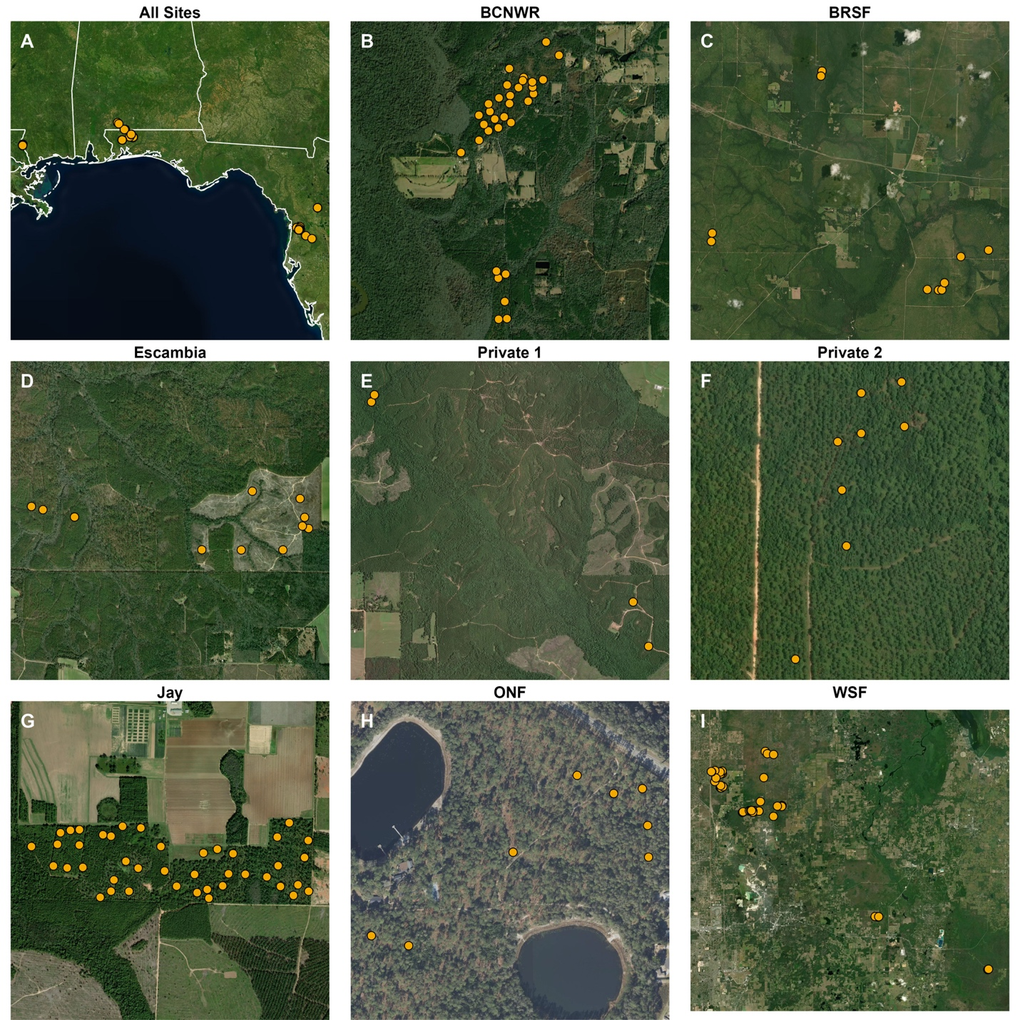
Figure S1. Distribution of sampling locations across each study forest. Panel A: All sampling sites; Panel B: Bogue Chitto National Wildlife Refuge; Panel C: Blackwater River State Forest; Panel D: Escambia Experimental Forest; Panel E: Private property 1; Panel F: Private property 2; Panel G: Jay Research Forest; Panel H: Ocala National Forest; Panel I: Withlacoochee State Forest.

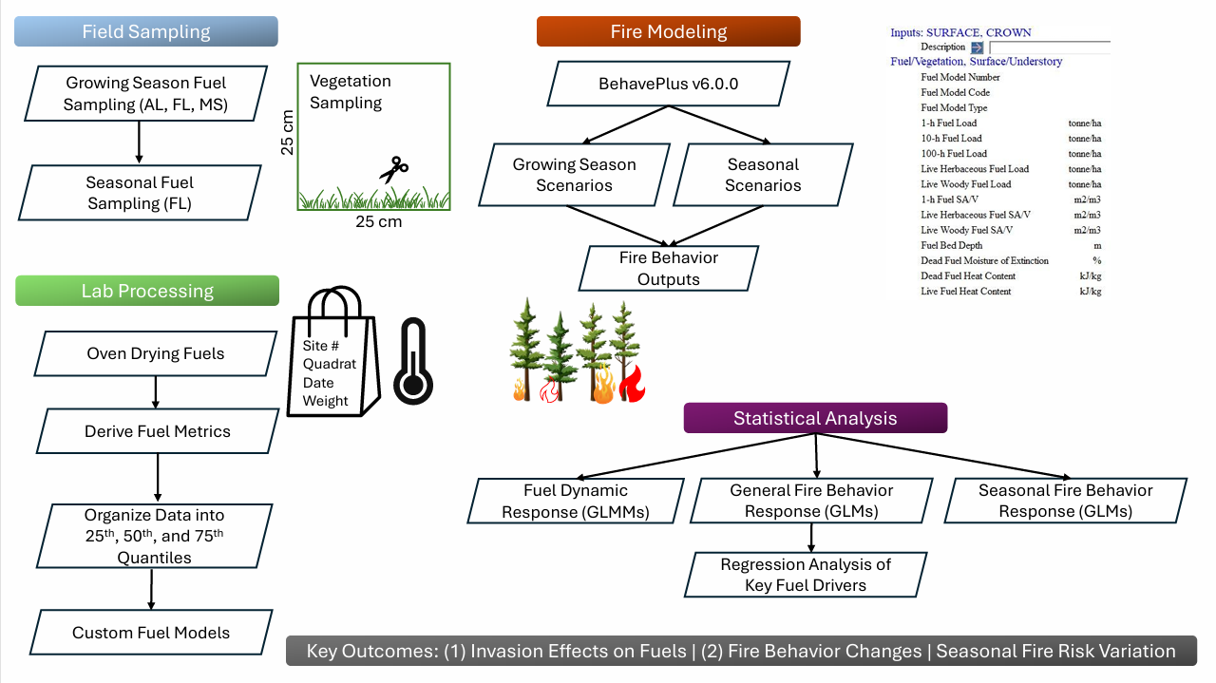
Figure S2. Methodological framework for fuel and fire behavior analysis. The diagram outlines the progression from regional field sampling, fuel and fire modeling, and statistical synthesis used to determine key outcomes of cogongrass invasion on fuel dynamics and fire behavior.

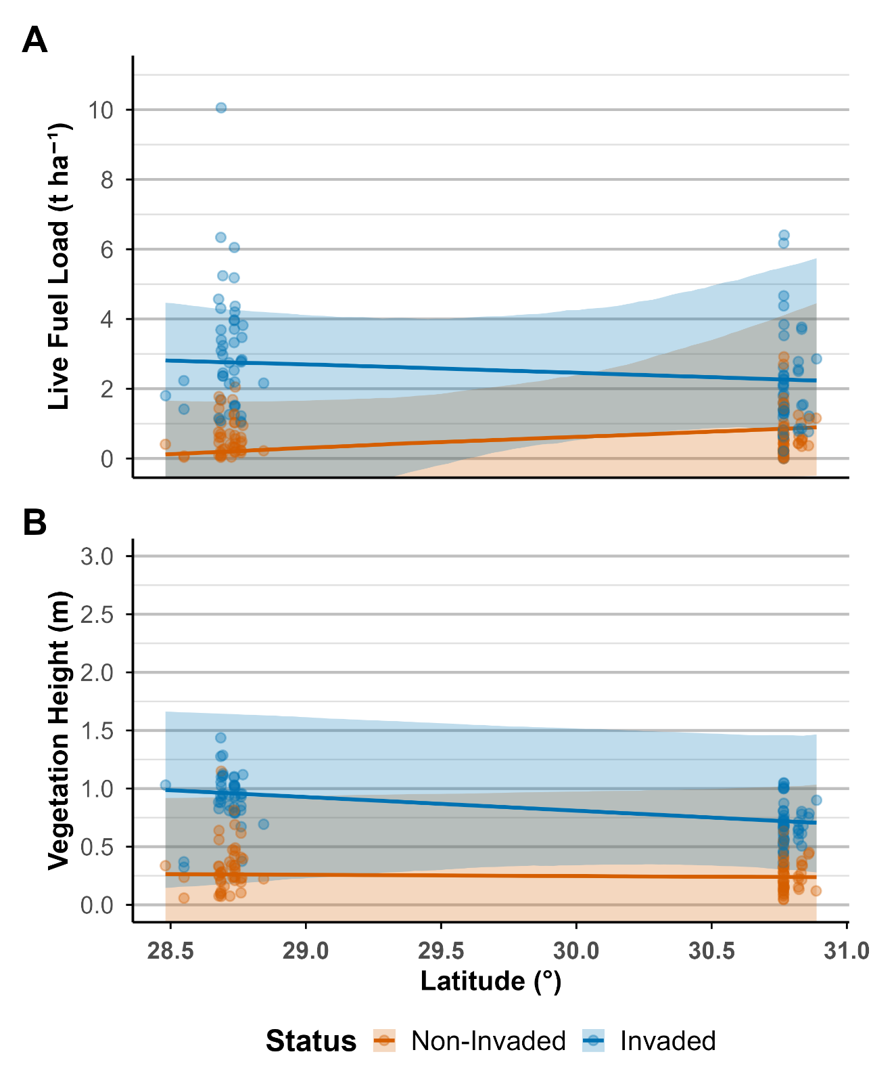
Figure S3. Latitudinal comparisons of live fuel load (A) and vegetation height (B) for non‑invaded and invaded sites. The lines show the medians and interquartile ranges of invaded and non-invaded sites. Points are individual observations, colored by invasion status.

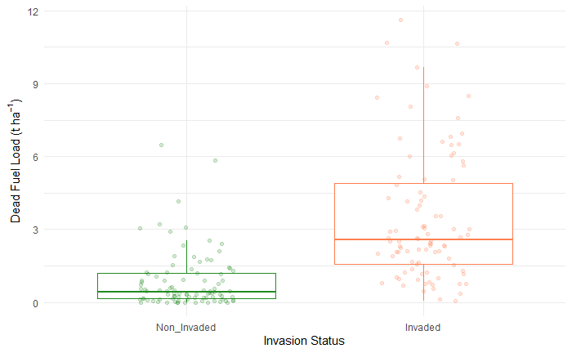
Figure S4. Boxplot showing dead fuel load differences by invasion status; x-axes contrast non-invaded vs invaded plots; points are individual observations overlaid on boxplots (median, IQR, whiskers).

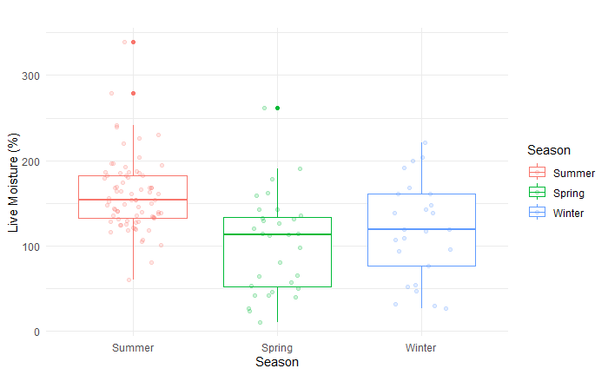
Figure S5. Boxplot showing live fuel moisture differences by season; x-axes contrast summer (red), spring (green), and winter (blue) seasons; points are individual observations overlaid on boxplots (median, IQR, whiskers).

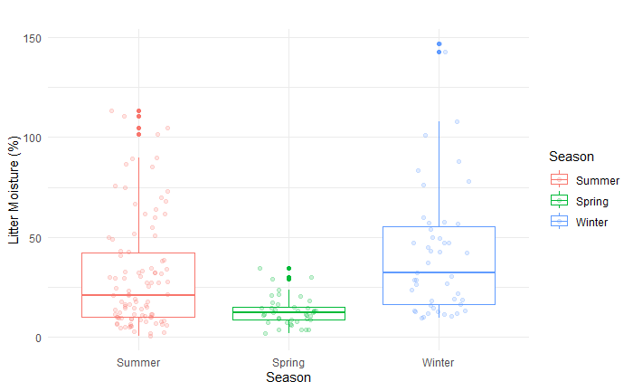
Figure S6. Boxplot showing litter fuel moisture differences by season; x-axes contrast summer (red), spring (green), and winter (blue) seasons; points are individual observations overlaid on boxplots (median, IQR, whiskers).

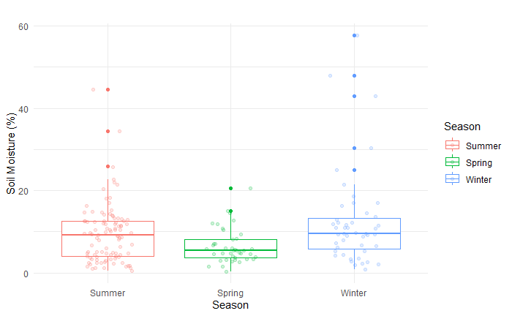
Figure S7. Boxplot showing soil moisture differences by season; x-axes contrast summer (red), spring (green), and winter (blue) seasons; points are individual observations overlaid on boxplots (median, IQR, whiskers).

