Supplementary table
Table S1. Model-selection results for tree density, basal area, and juvenile plant responses. Candidate models were compared using Akaike’s Information Criterion (AIC). ΔAIC values are reported relative to the best-supported model for each response and taxon.
Response | Taxon | Model | df | AIC | ΔAIC
Tree density | All trees | Poisson | 13 | 24244.92 | 19959.82
Tree density | All trees | NegBin | 14 | 4421.85 | 136.74
Tree density | All trees | ZINB | 15 | 4285.11 | 0.00
Tree density | Junipers | Poisson | 13 | 9919.23 | 6471.09
Tree density | Junipers | NegBin | 14 | 3728.89 | 280.74
Tree density | Junipers | ZINB | 15 | 3448.14 | 0.00
Tree density | Oaks | Poisson | 13 | 6430.28 | 4328.42
Tree density | Oaks | NegBin | 14 | 2264.10 | 162.25
Tree density | Oaks | ZINB | 15 | 2101.86 | 0.00
Tree density | Piñons | Poisson | 13 | 16770.39 | 13276.99
Tree density | Piñons | NegBin | 14 | 3697.00 | 203.61
Tree density | Piñons | ZINB | 15 | 3493.39 | 0.00
Basal area | All trees | log-Gaussian GLMM | 14 | 788.17 | 0.00
Basal area | All trees | Tweedie GLMM | 15 | 2083.60 | 1295.43
Basal area | All trees | Gamma positive-only | 14 | 2073.35 | 1285.19
Basal area | Junipers | log-Gaussian GLMM | 14 | 957.30 | 0.00
Basal area | Junipers | Tweedie GLMM | 15 | 1592.82 | 635.52
Basal area | Junipers | Gamma positive-only | 14 | 1447.54 | 490.25
Basal area | Oaks | log-Gaussian GLMM | 14 | 817.67 | 0.00
Basal area | Oaks | Tweedie GLMM | 15 | 1510.28 | 692.61
Basal area | Oaks | Gamma positive-only | 14 | 1350.68 | 533.01
Basal area | Piñons | log-Gaussian GLMM | 14 | 1041.09 | 0.00
Basal area | Piñons | Tweedie GLMM | 15 | 1599.95 | 558.85
Basal area | Piñons | Gamma positive-only | 14 | 1437.88 | 396.79
Juvenile plants | All juveniles | NegBin | 14 | 4441.79 | 0.00
Juvenile plants | Junipers | NegBin | 14 | 3161.27 | 0.00
Juvenile plants | Oaks | NegBin | 14 | 2936.40 | 0.00
Juvenile plants | Piñons | NegBin | 14 | 3286.03 | 0.00

Supplementary figure captions
Figure S1. Estimated marginal means (± 95% confidence intervals) of tree density (trees ha⁻¹) across timesteps (pre-disturbance, post-drought, post-fire) and fire severity classes (unburned, low, moderate, high). Panels show responses for all trees combined, junipers, oaks, and piñons. Values are model-based predictions from negative binomial mixed-effects models with plot included as a random intercept.
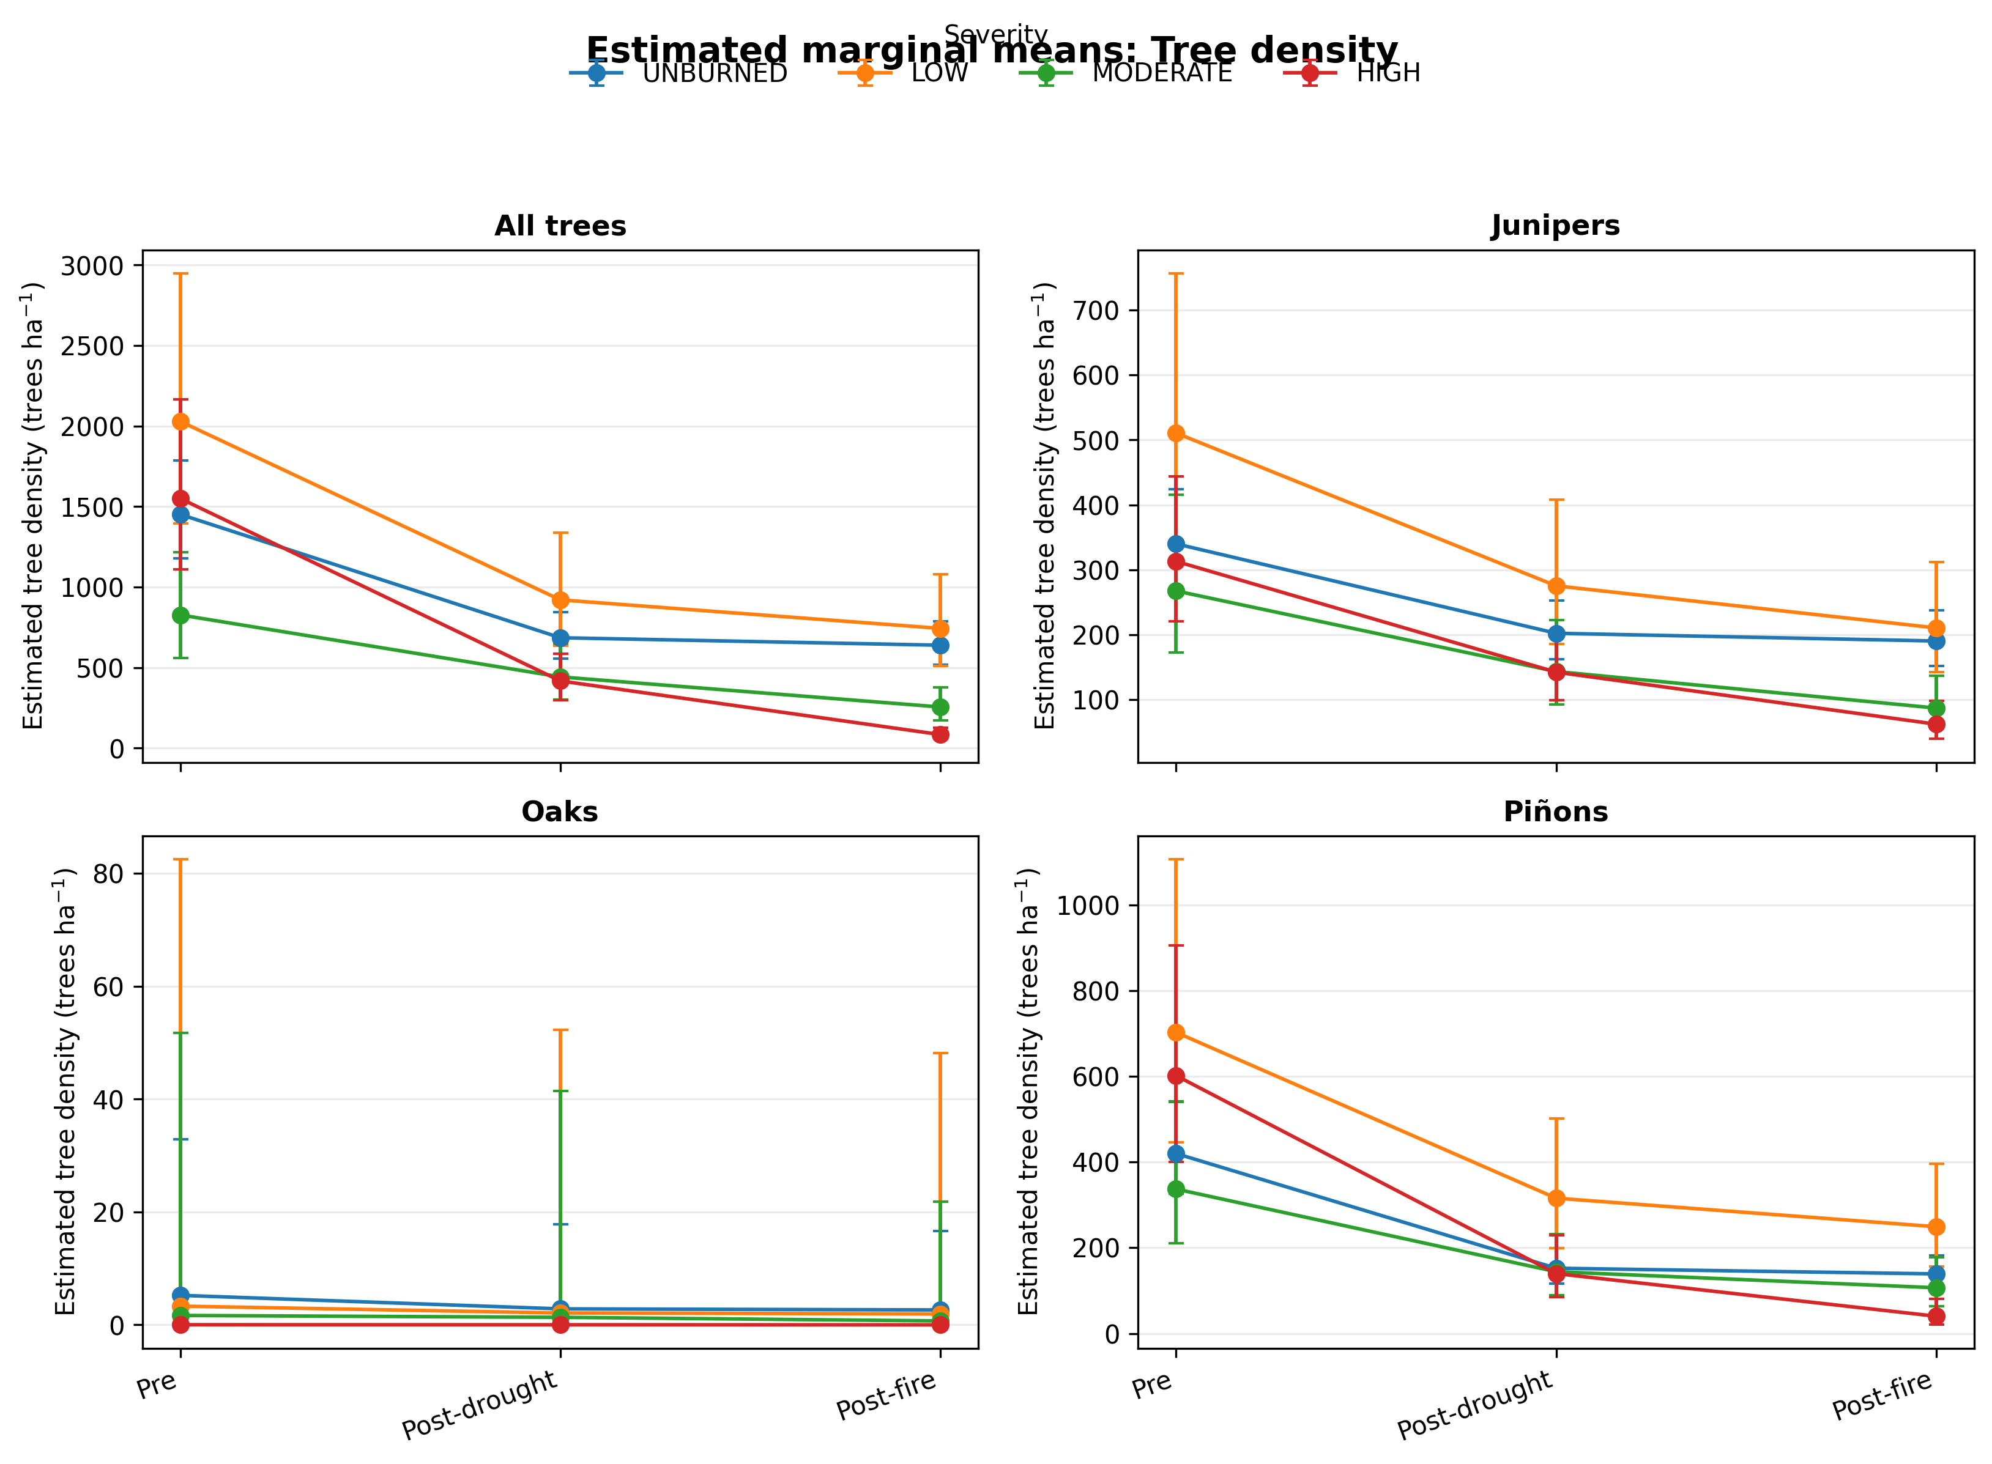

Figure S2. Estimated marginal means (± 95% confidence intervals) of basal area (m² ha⁻¹) across timesteps (pre-disturbance, post-drought, post-fire) and fire severity classes (unburned, low, moderate, high). Panels show responses for all trees combined, junipers, oaks, and piñons. Values are model-based predictions from log-Gaussian mixed-effects models selected by AIC, with plot included as a random intercept.
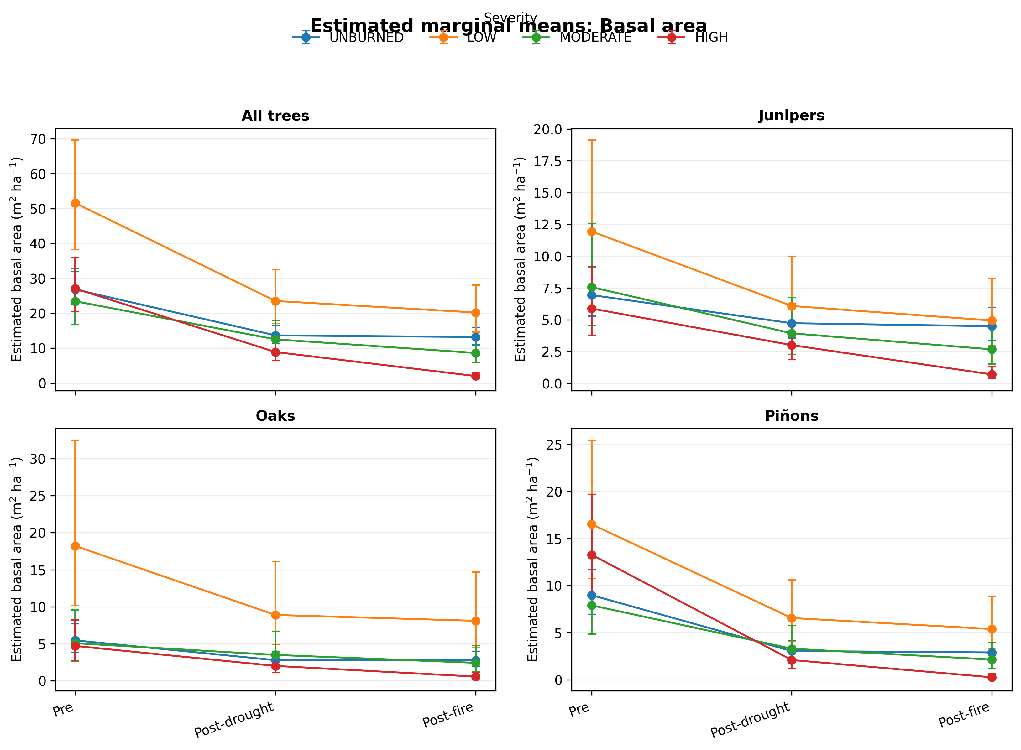

Figure S3. Estimated marginal means (± 95% confidence intervals) of juvenile plant density (trees ha⁻¹) across timesteps (pre-disturbance, post-drought, post-fire) and fire severity classes (unburned, low, moderate, high). Panels show responses for all juveniles combined, junipers, oaks, and piñons. Values are model-based predictions from negative binomial mixed-effects models with plot included as a random intercept.
