SUPPLEMENTAL Information
Table S1. Full set of Sentinel-2-derived candidate model input features to predict surface fuels.
Variable | Equation | Description
Normalized Difference Vegetation Index (NDVI) | $$NDVI = \frac{NIR - Red}{NIR + Red}$$ | Captures photosynthetically active ‘green’ vegetation
Dead Fuel Index (DFI) | $$DFI =100*(1-\frac{SWIR2}{SWIR1})*(\frac{Red}{NIR})$$ | Captures standing senesced or ‘brown’ vegetation
Normalized Difference Tillage Index (NDTI) | $$NDTI = \frac{SWIR1-SWIR2}{SWIR1+SWIR2}$$ | Captures vegetation residue or litter
Soil-Adjusted Total Vegetation Index (SATVI) | $$SATVI=\frac{SWIR1 - Red}{SWIR1 + Red + 0.5}*(1+0.5)-(\frac{SWIR2}{2})$$ | Relates to standing vegetation, especially where vegetation cover is low
Normalized Difference Infrared Index (NDII7) | $$NDII7=\frac{NIR-SWIR2}{NIR+SWIR2}$$ | Relates to standing vegetation without strong sensitivity to its photosynthetic state
Ratio Vegetation Index (RVI) | $$RVI = \frac{NIR}{Red}$$ | Indicates amount of vegetation and reduces noise from topography and atmospheric condition
Enhanced Vegetation Index (EVI) | $$EVI = 2.5*\frac{NIR-Red}{NIR+6*Red-7.5*Blue+1}$$ | Estimates vegetation greenness, especially in high biomass areas
Broadband spectral angle indices (BAIs) | $$BAI126=180-tan(\frac{{BAI126}_{y1}}{{BAI126}_{x1}})(\frac{180}{π})+tan(\frac{{BAI126}_{y2}}{{BAI126}_{x2}})(\frac{180}{π})$$ | Estimate fractional cover of vegetation, litter, and bareground, but less sensitive to surface moisture than other vegetation indices
Broadband spectral angle indices (BAIs) | $$BAI136=180-tan(\frac{{BAI136}_{y1}}{{BAI136}_{x1}})(\frac{180}{π})+tan(\frac{{BAI136}_{y2}}{{BAI136}_{x2}})(\frac{180}{π})$$
Broadband spectral angle indices (BAIs) | $$BAI236=180-tan(\frac{{BAI236}_{y1}}{{BAI236}_{x1}})(\frac{180}{π})+tan(\frac{{BAI236}_{y2}}{{BAI236}_{x2}})(\frac{180}{π})$$
Broadband spectral angle indices (BAIs) | $$BAI246=180-tan(\frac{{BAI246}_{y1}}{{BAI246}_{x1}})(\frac{180}{π})+tan(\frac{{BAI246}_{y2}}{{BAI246}_{x2}})(\frac{180}{π})$$
Near-infrared (NIR) | NA | Single band 0.85-0.88 μm
Shortwave infrared 1 (SWIR1) | NA | Single band 1.57-1.65 μm
Shortwave infrared 2 (SWIR2) | NA | Single band 2.11-2.29 μm
Table S2. Best hyperparameters of random forest models for predicting each fuel component.
Response variable | Number of trees (ntree) | Number of variables tried at each split (mtry)
Litter load | 300 | 4
Dead 1hr load | 1000 | 4
Live herbaceous load | 1000 | 4
Fuelbed depth | 300 | 4
Table S3. ANOVA results for fire behavior metrics across plant communities and months.
Rate of spread |  | Df | Sum sq | Mean sq | F | p-value
Rate of spread | Plant community | 4 | 3467 | 866.7 | 46.21 | <0.0001
Rate of spread | Month | 3 | 6398 | 2132.8 | 113.71 | <0.0001
Rate of spread | Plant community:month | 12 | 892 | 74.4 | 3.96 | <0.0001
Fireline intensity | Plant community | 4 | 3593755 | 8986439 | 46.082 | <0.0001
Fireline intensity | Month | 3 | 6517232 | 2172411 | 111.426 | <0.0001
Fireline intensity | Plant community:month | 12 | 885629 | 73802 | 3.785 | <0.0001
Flame length | Plant community | 4 | 12.830 | 3.208 | 49.745 | <0.0001
Flame length | Month | 3 | 16.927 | 5.642 | 87.507 | <0.0001
Flame length | Plant community:month | 12 | 2.156 | 0.180 | 2.786 | <0.0001

Table S4. Post-hoc Tukey HSD results for fire behavior metrics across plant communities.
 | Comparisons | Mean diff | Standard error | Adj p-value
Rate of spread | Xeric tall – mesic tall | -1.650 | 2.210 | 0.246
Rate of spread | Mixedgrass – mesic tall | -3.852 | 1.896 | <0.001
Rate of spread | Smooth brome – mesic tall | 0.142 | 2.146 | 0.999
Rate of spread | Prairie dog – mesic tall | -8.855 | 2.333 | <0.001
Rate of spread | Mixedgrass – xeric tall | -2.202 | 1.617 | 0.002
Rate of spread | Smooth brome – xeric tall | 1.793 | 1.904 | 0.076
Rate of spread | Prairie dog – xeric tall | -7.205 | 2.113 | <0.001
Rate of spread | Smooth brome - mixedgrass | 3.995 | 1.529 | <0.001
Rate of spread | Prairie dog – mixedgrass | -5.002 | 1.782 | <0.001
Rate of spread | Prairie dog – smooth brome | -8.998 | 2.046 | <0.001
Fireline intensity | Xeric tall – mesic tall | -71.341 | 71.260 | 0.049
Fireline intensity | Mixedgrass – mesic tall | -149.581 | 61.128 | <0.001
Fireline intensity | Smooth brome – mesic tall | -3.469 | 69.194 | 0.999
Fireline intensity | Prairie dog – mesic tall | -280.171 | 75.222 | <0.001
Fireline intensity | Mixedgrass – xeric tall | -78.239 | 52.164 | <0.001
Fireline intensity | Smooth brome – xeric tall | 67.872 | 61.418 | 0.021
Fireline intensity | Prairie dog – xeric tall | -280.829 | 68.138 | <0.001
Fireline intensity | Smooth brome - mixedgrass | 146.112 | 49.304 | <0.001
Fireline intensity | Prairie dog – mixedgrass | -130.589 | 57.458 | <0.001
Fireline intensity | Prairie dog – smooth brome | -276.702 | 65.974 | <0.001
Flame length | Xeric tall – mesic tall | -1.09 | 0.130 | 0.141
Flame length | Mixedgrass – mesic tall | -0.246 | 0.111 | <0.001
Flame length | Smooth brome – mesic tall | 0.014 | 0.097 | 0.997
Flame length | Prairie dog – mesic tall | -0.529 | 0.137 | <0.001
Flame length | Mixedgrass – xeric tall | -0.136 | 0.095 | <0.001
Flame length | Smooth brome – xeric tall | 0.124 | 0.112 | 0.020
Flame length | Prairie dog – xeric tall | -0.419 | 0.124 | <0.001
Flame length | Smooth brome - mixedgrass | 0.260 | 0.090 | <0.001
Flame length | Prairie dog – mixedgrass | -0.282 | 0.105 | <0.001
Flame length | Prairie dog – smooth brome | -0.543 | 0.120 | <0.001

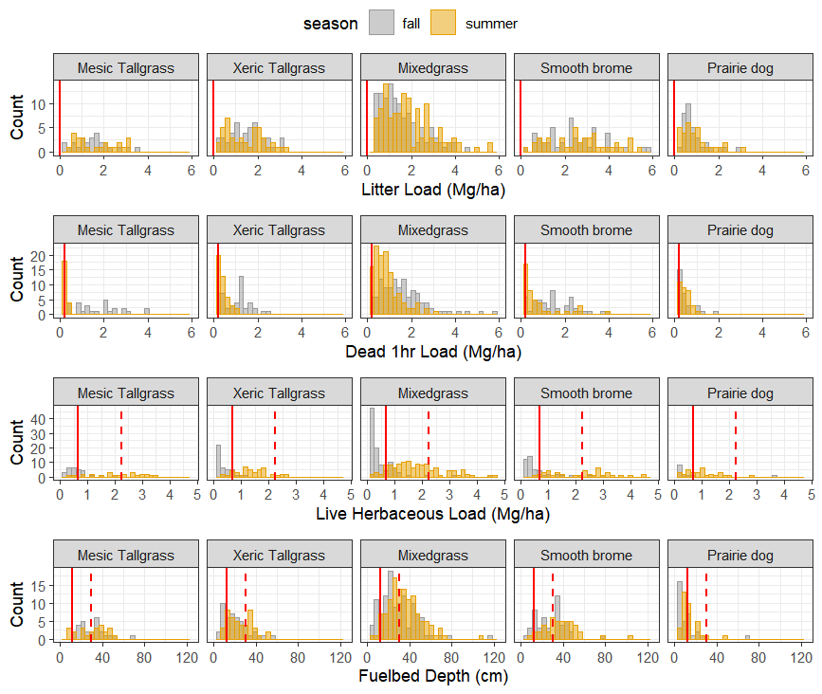
S1. The spatial variation (histograms) in observed fine fuel characteristics in August (gray) and October (orange) across the three years of sampling (2023-2025) across the five grassland communities: litter load, dead 1hr load, live herbaceous load, and fuelbed depth (top to bottom). Red lines indicate the fuel model parameters in the Scott and Burgan’s (2005) standard fuel models, GR1 (solid) and GR2 (dashed).
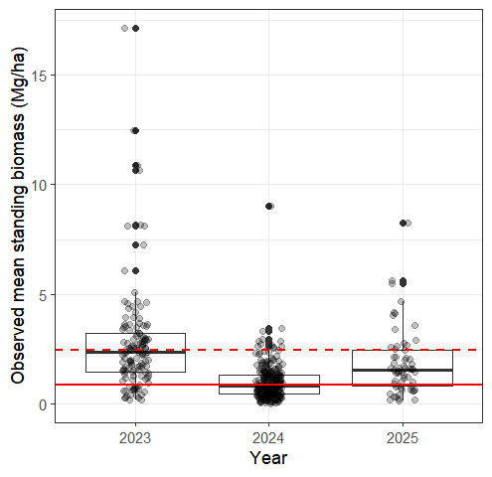
S2. Observed mean standing biomass (sum of dead 1hr and live herbaceous load) in October of 2023-2025. Points in solid black are outliers. Red lines indicate the sum of dead 1hr and live herbaceous load values in the Scott and Burgan’s (2005) standard fuel models, GR1 (solid) and GR2 (dashed).
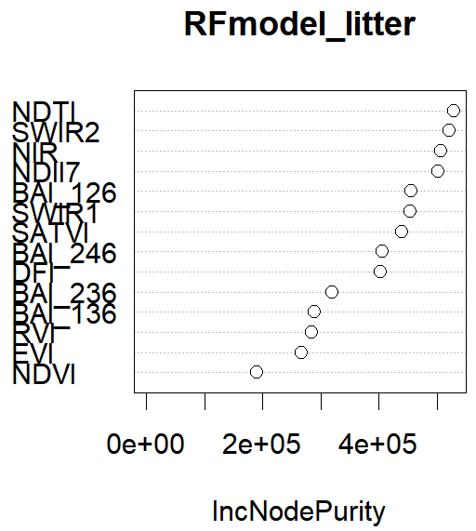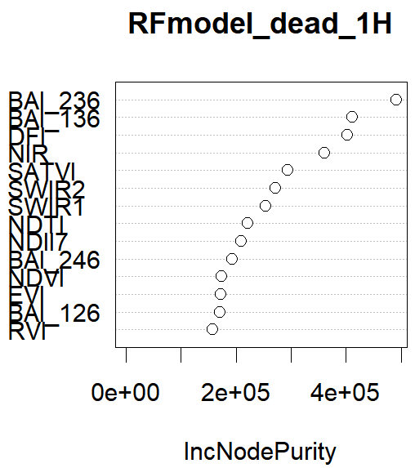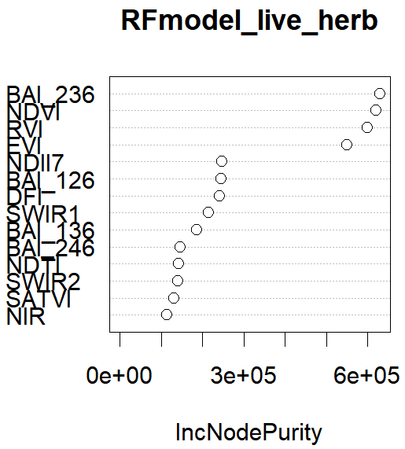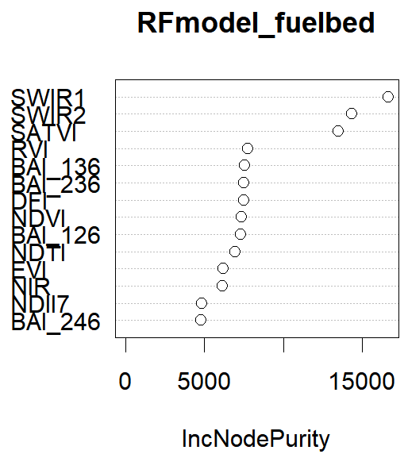
S3. Importance of predictors in random forest models of fuel loads and fuelbed depth.
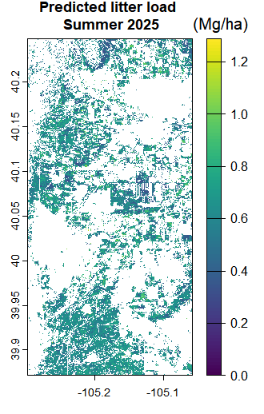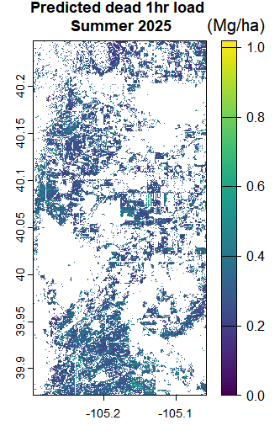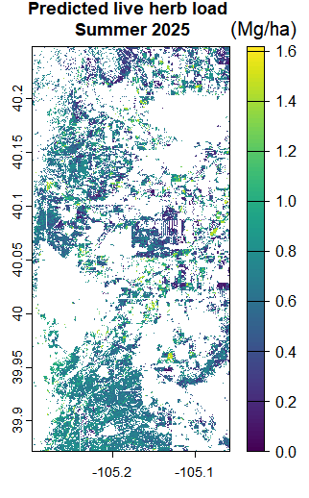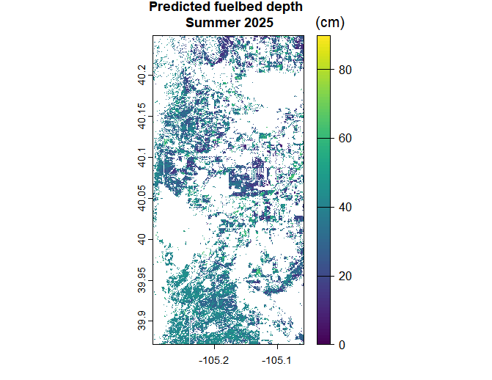
S4. Predicted litter load (Mg/ha), dead 1 hour load (Mg/ha), live herbaceous load (Mg/ha), and fuelbed depth (cm) across the landscape (10-m resolution) in August of 2025.
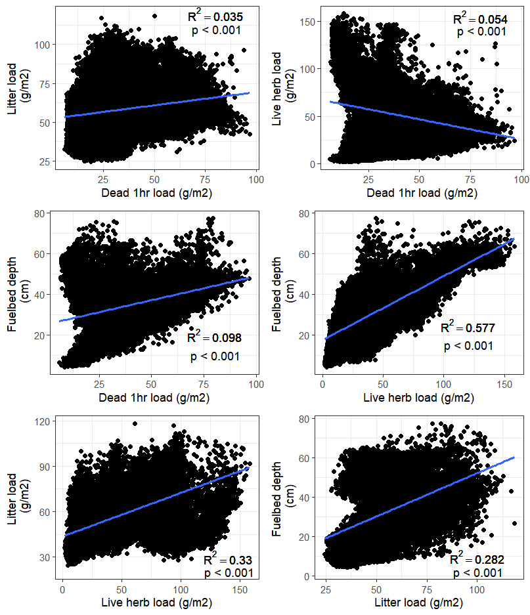
S5. Bivariate correlations of remotely predicted litter load, dead 1 hour load, live herbaceous load, and fuelbed depth in October of 2025.
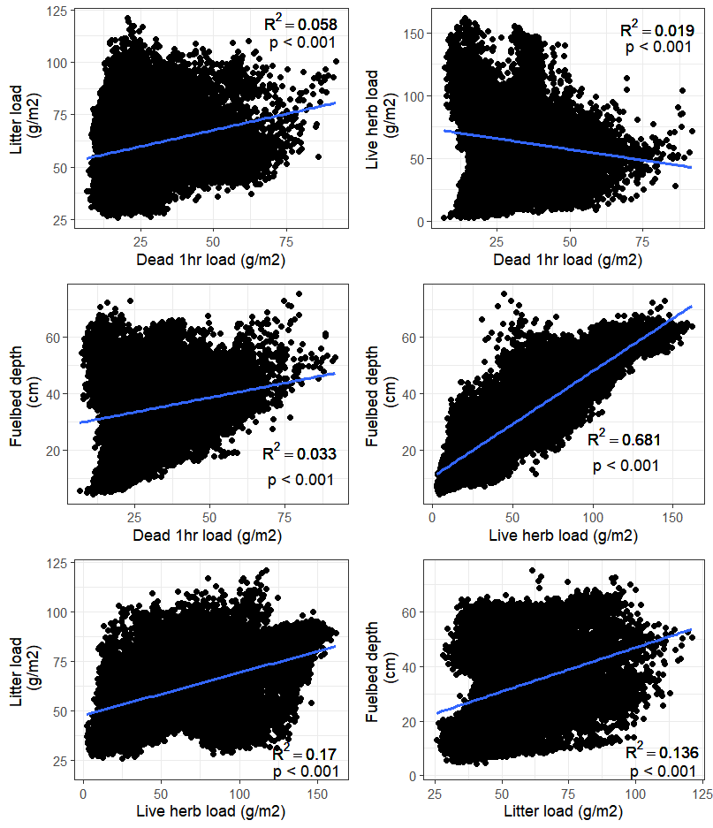
S6. Bivariate correlations of remotely predicted litter load, dead 1 hour load, live herbaceous load, and fuelbed depth in August of 2025.
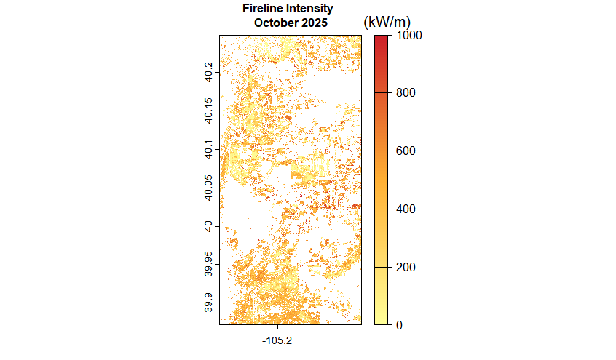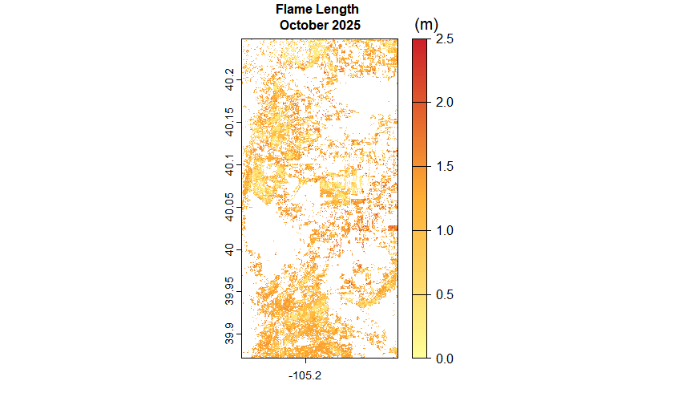
S7. Estimated fireline intensity (kW/m) and flame length (m) across the landscape using predicted surface fuel maps from October 2025. Models are run under the Scott & Burgan’s (2005) very dry fuel moisture D1L2 scenario and wind speed of 50 km/hr.
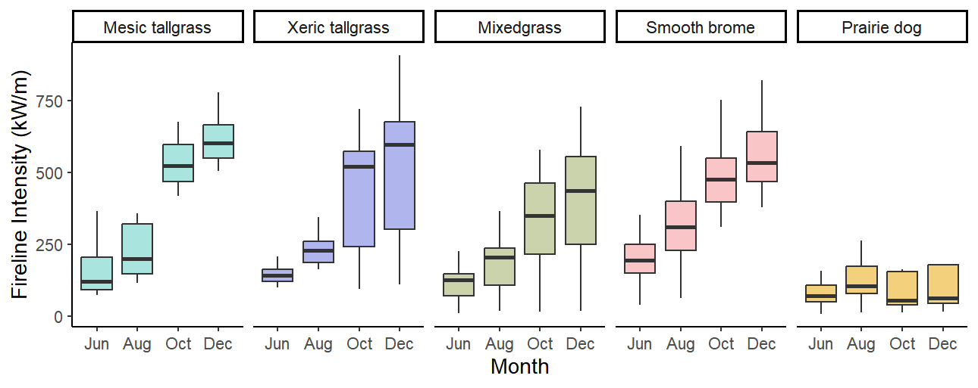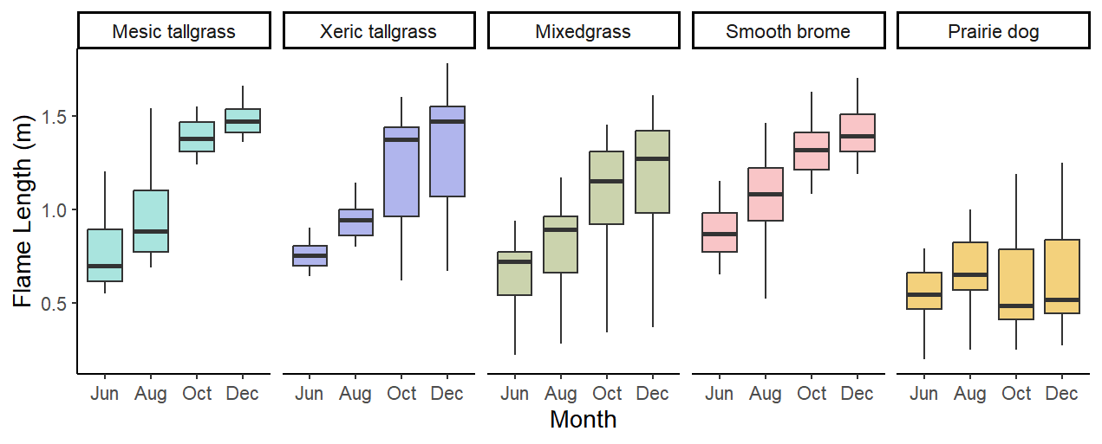
S8. Boxplots show seasonal variation in flameline intensity (kW/m) and flame length (m) in 2025 by grassland types: mesic tallgrass prairie (n = 12), xeric tallgrass prairie (n = 18), mixedgrass (n = 62), smooth brome-dominated grassland (n = 27), and prairie dog-dominated grassland (n = 14).
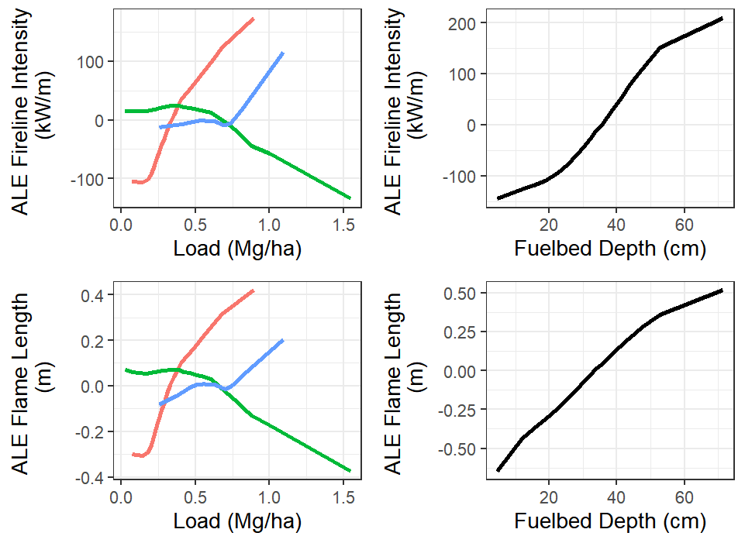
S9. Sensitivity analysis of remotely sensed predictors (litter, dead 1hr, live herb, fuelbed depth) on fireline intensity and flame length. Accumulated local effect (ALE) on rate of spread is the relative effect of changing a fuel characteristic (colored lines) on the prediction compared to the mean (the average effect is zero). Colored lines depict litter (blue), live herb (green), and dead 1hr (red) fuel loads. Black line depicts fuelbed depth.

