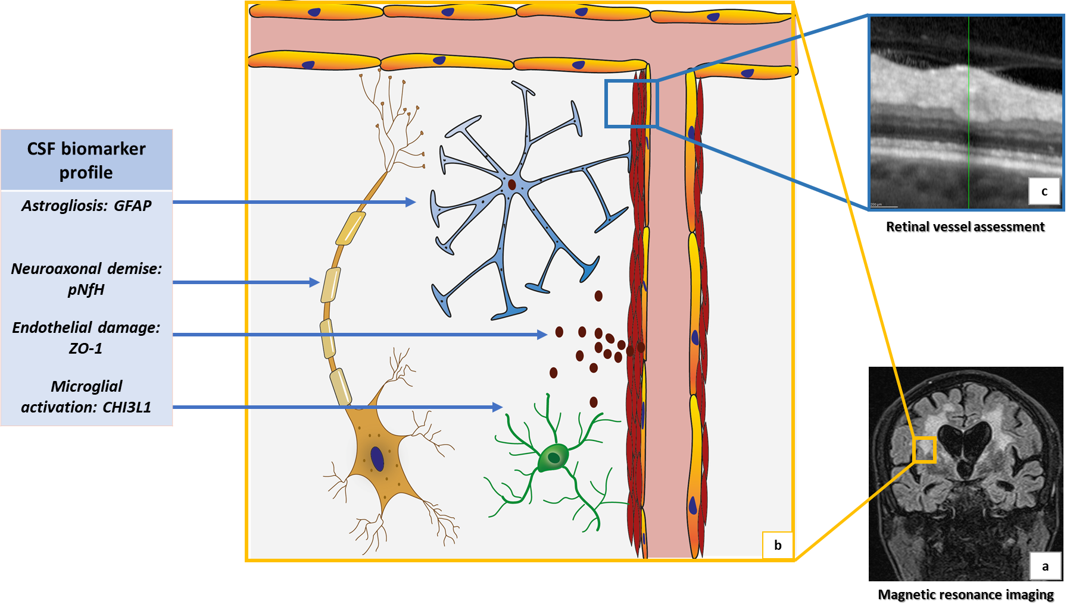
Supplementary figure 1: The pathophysiology of sporadic cerebral small vessel disease (CSVD) includes vessel wall thickening, endothelial damage with disturbance of blood-brain barrier, microglial activation, astrogliosis and neuroaxonal demise (b). Magnetic resonance imaging (MRI) shows characteristic changes in the subcortical white matter, specifically extended white matter hyperintensities on fluid-attenuated inversion recovery (FLAIR) sequences (a). Combining the MRI, OCT-based assessment of the retinal arterioles (c), and a detailed CSF biomarker profile might help to reflect the CSVD pathology in-vivo, which is the main aim of this exploratory work.

Supplementary table 1: Correlation between retinal vessel parameters, MRT findings, and CSF-biomarker parameters in n=24 CSVD patients (Spearman's r with p-value in brackets).
Retinal vessel parameters | White matter hyperintensities | Lacunar infarctions | Microbleeds | GFAP | pNfH | ZO-1 | CHI3L1
Mean arterial wall thickness (MWT) | - 0.4 (0.09) | 0.4 (0.09) | 0.4 (0.06) | - 0.4 (0.03) | - 0.3 (0.2) | - 0.3 (0.1) | - 0.4 (0.06)
Lumen diameter (LD) | 0.4 (0.09) | 0.2 (0.2) | -0.1(0.8) | 0.2 (0.5) | 0.3 (0.2) | 0.4 (0.07) | 0.4 (0.05)
Wall to lumen ration (WLR) | - 0,5 (0.009) | 0.1 (0.6) | 0.3 (0.2) | - 0.4 (0.04) | - 0.4 (0.06) | - 0.5 (0.02) | - 0.6 (0.003)
Total vessel diameter | 0.1 (0.001) | 0.4 (0.07) | 0.1 (0.6) | -0.1 (0.6) | 0.04 (0.9) | 0.1 (0.5) | 0.1 (0.6)
GFAP: glial fibrillary acidic protein, pNfH: phosphorylated neurofilament heavy chain protein, ZO-1: zona occludens-1, CHI3L1: chitinase 3 like 1

