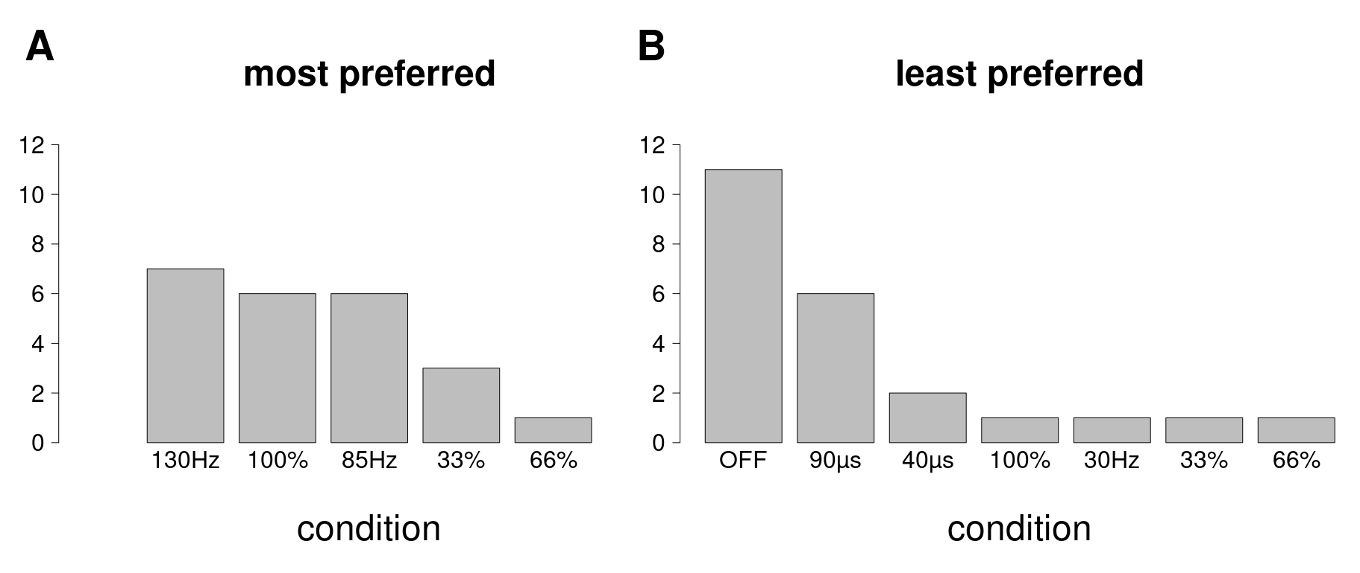

Supplementary figure 1: Histograms (absolute counts) of most and least preferred DBS conditions.

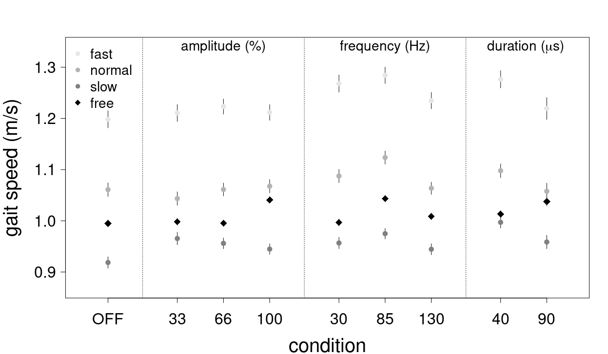
Supplementary figure 2: Gait speed estimates in the individual gait tasks (slow, fast, normal and free gait). Depicted are all measured stimulation conditions. OFF is no DBS stimulation, 33, 66 and 100 refer to the percentage in amplitude of the original stimulation settings of the patient. 30, 85 and 130 denote the stimulation frequency (Hz) whereas 40 and 90 refer to the stimulation pulse widths (µs). Error bars are two standard errors of the estimated difference between each condition and the reference condition (OFF). The error for the reference condition is estimated from the average of all other errors.

