Supplementary Material
Sekita et al. Switch to Tenecteplase for intravenous thrombolysis in stroke patients: Experience from a German High-volume Stroke Center

Content:
sFigure 1: Median Procedure times comparing TNK vs. rt-PA in
(A) any AIS and
(B) AIS within a time window of 4.5 hours and NIHSS>4 on presentation.
sFigure 2: Bleeding events comparing TNK vs. rt-PA treated patients.
sTable 1: Survey results on TNK perceptions among health care providers

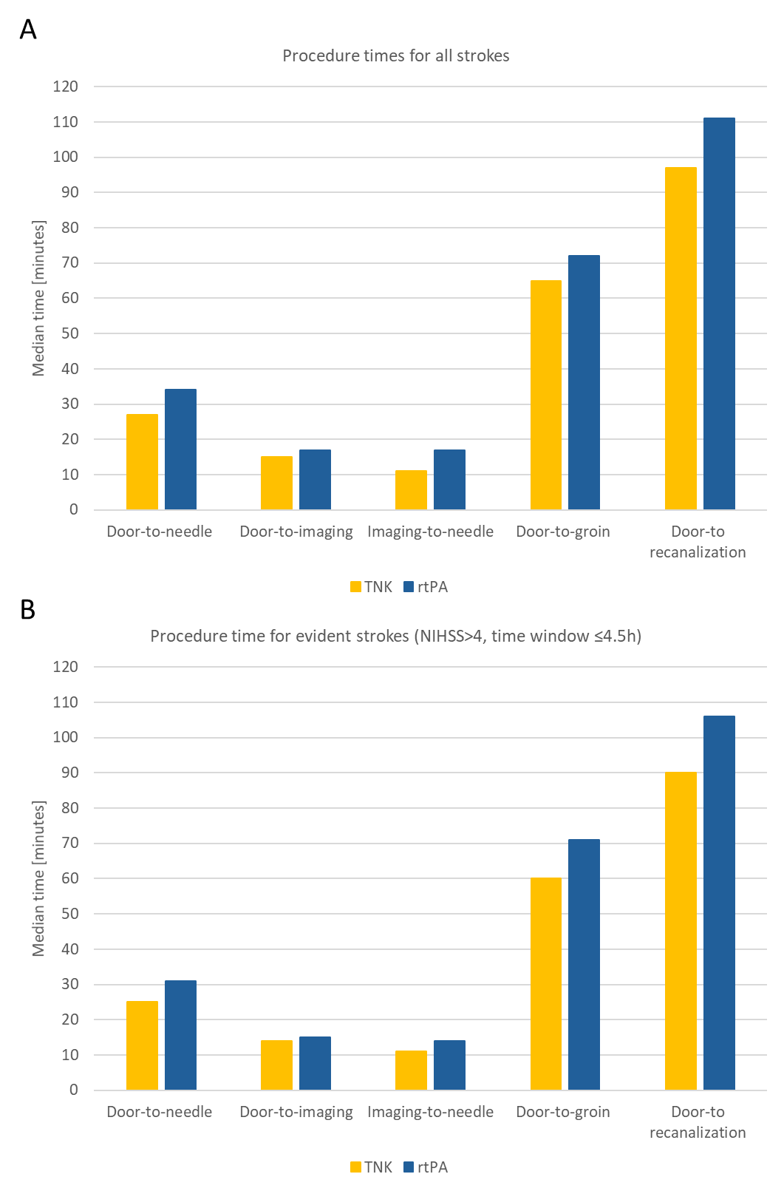
Supplementary Figure 1: Median procedure times comparing TNK vs. rt-PA in (A) any AIS and (B) AIS within a time window of 4.5-hours and NIHSS>4 on presentation. Abbreviations: NIHSS, National Institutes of Health Stroke Scale

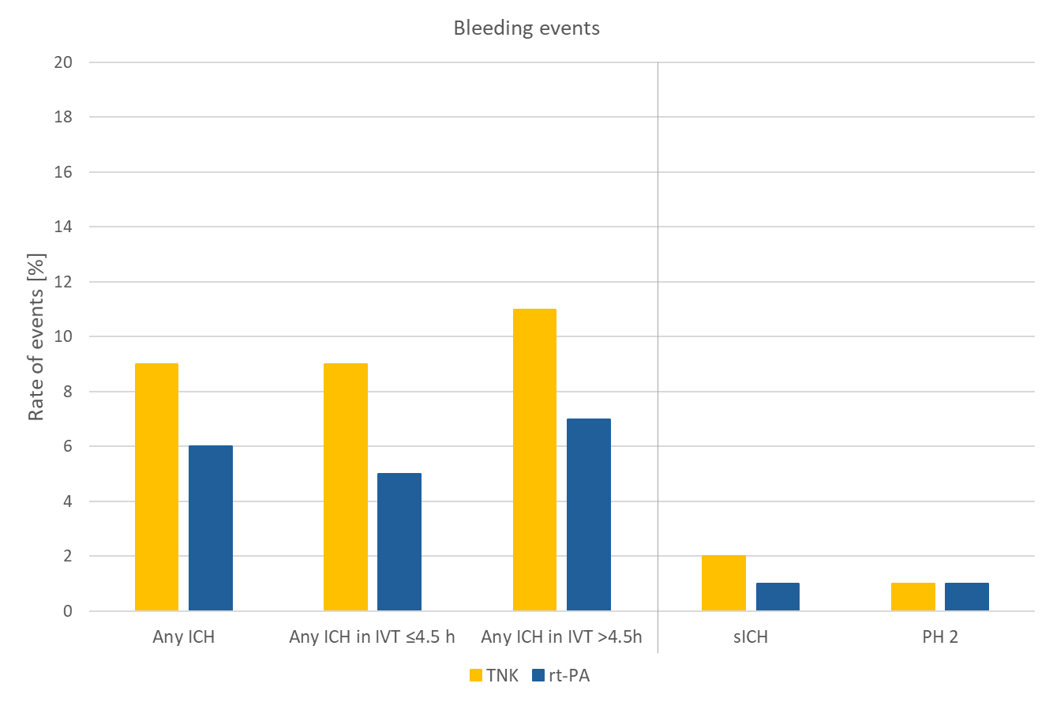
Supplementary Figure 2: Bleeding events comparing TNK vs. rt-PA treated patients. Bleeding events were categorized into any ICH, symptomatic ICH according to SITS-MOST criteria, and parenchymatous hematoma (PH2; Heidelberg Bleeding Classification). Further subanalysis was performed for IVT performed within 4.5-hours and beyond 4.5-hours time from symptom onset. Abbreviations: ICH indicates intracranial hemorrhage; IVT, intravenous thrombolysis; sICH, symptomatic intracranial hemorrhage; PH, parenchymatous hematoma.

Supplementary Table 1: Survey results on TNK perceptions among health care providers
Question | Response Options | Results
Professional Group; n (%) | Physician  Nursing staff | 29 (73%)  11 (27%)
Clinical experience of physicians; n (%) | Assistant doctor (IMC/ICU)  Assistant doctor (post-acute care unit)  Specialist doctor  Senior physician | 13 (46%)  5 (18%)  4 (14%)  6 (21%)
Lysis behavior changed after transition; n (%) | No  Yes | 10 (100%)  0 (0%)
Level of education for nursing staff; n (%) | Apprentice  Health care professional  Specialized training ICU  Specialized training IMC | 0 (0%)  6 (60%)  0 (0%)  4 (40%)
Clinical work experience, years; n (%) | <3  3-6  7-10  ≥10 | 0 (0%)  3 (27%)  1 (9%)  7 (64%)
Frequency of TNK use; n (%) | Never  Once  Repeatedly  Regularly | 3 (8%)  2 (6%)  25 (70%)  6 (17%)
Assessment of following aspects; n (%)
Overall satisfaction | Much worse than rt-PA  Worse than rt-PA  Like rt-PA  Better than rt-PA  Much better than rt-PA | 0 (0%)  1 (3%)  9 (29%)  13 (42%)  8 (26%)
Efficacy | Much worse than rt-PA  Worse than rt-PA  Like rt-PA  Better than rt-PA  Much better than rt-PA | 0 (0%)  0 (0%)  24 (71%)  8 (24%)  2 (6%)
Safety | Much worse than rt-PA  Worse than rt-PA  Like rt-PA  Better than rt-PA  Much better than rt-PA | 0 (0%)  8 (22%)  19 (53%)  5 (14%)  4 (11%)
Drug preparation | Much worse than rt-PA  Worse than rt-PA  Like rt-PA  Better than rt-PA  Much better than rt-PA | 0 (0%)  0 (0%)  5 (14%)  16 (44%)  15 (42%)
Dosing | Much worse than rt-PA  Worse than rt-PA  Like rt-PA  Better than rt-PA  Much better than rt-PA | 0 (0%)  2 (6%)  10 (28%)  15 (42%)  9 (25%)
Application | Much worse than rt-PA  Worse than rt-PA  Like rt-PA  Better than rt-PA  Much better than rt-PA | 0 (0%)  0 (0%)  1 (3%)  18 (50%)  17 (47%)
Time expenditure | Much worse than rt-PA  Worse than rt-PA  Like rt-PA  Better than rt-PA  Much better than rt-PA | 0 (0%)  0 (0%)  2 (6%)  13 (36%)  21 (58%)
Estimated time saving in DTN by TNK, min; mean |  | 5
Preference of thrombolytic therapy; n (%) | TNK  rt-PA  No preference | 15 (42%)  4 (1%)  17 (47%)
Abbreviations: IMC, intermediate care; ICU, intensive care unit

