Supplementary Material

Title: Consensus on the Clinical Utility of Digital Mobility Outcomes for Personalized Clinical Decision Support in Parkinson’s Disease.

Authors: Alan CASTRO MEJIA^{1†}, Stefano SAPIENZA^{1*†}, Ivana PACCOUD¹, Lisa ALCOCK^{3,6}, Philip BROWN⁴, Heiko GAßNER^{5,12}, Heather HUNTER⁴, Walter MAETZLER⁸, Anat MIRELMAN^{9,10,11}, Alice NIEUWBOER^{13,14}, Martin REGENSBURGER⁵, Lynn ROCHESTER^{3,4,6}, Sabine STALLFORTH⁵, Beatrix VEREIJKEN⁷, Alison YARNALL^{3,4}, and Jochen KLUCKEN^{1,2}

1. Luxembourg Centre for Systems Biomedicine, University of Luxembourg, Esch-sur-Alzette, Luxembourg
2. Centre Hospitalier de Luxembourg, Luxembourg, Luxembourg
3. NIHR Newcastle Biomedical Research Centre, Newcastle University, Campus for Ageing and Vitality, Newcastle upon Tyne, United Kingdom
4. The Newcastle upon Tyne Hospitals NHS Foundation Trust, Newcastle upon Tyne, United Kingdom
5. Department of Molecular Neurology, Friedrich-Alexander-Universität Erlangen-Nürnberg, Erlangen, Germany
6. Translational and Clinical Research Institute, Faculty of Medical Sciences, Newcastle University, Newcastle upon Tyne, United Kingdom
7. Department of Neuromedicine and Movement Science, Norwegian University of Science and Technology, Trondheim, Norway
8. Department of Neurology, University Hospital Schleswig-Holstein and Kiel University, Kiel, Germany
9. Laboratory for Early Markers of Neurodegeneration (LEMON), Tel Aviv Sourasky Medical Center, Tel Aviv, Israel
10. School of Medicine & Health Sciences, Tel Aviv University, Tel Aviv, Israel
11. Sagol School of Neuroscience, Tel Aviv University, Tel Aviv, Israel
12. Fraunhofer Institute for Integrated Circuits IIS, Erlangen, Germany
13. Neurorehabilitation Research Group (eNRGy), Department of Rehabilitation Sciences, KU Leuven, Leuven, Vlaams-Brabant, Belgium
14. Leuven Brain Institute (LBI), Leuven, Belgium
* Corresponding author
† Co-primary authors

Correspondence:
Name: Stefano Sapienza PhD
Affiliation: Luxembourg Center for Systems Biomedicine, Digital Medicine Group
Email: stefano.sapienza@uni.lu

SUPPLEMENTARY MATERIALS - TABLE OF CONTENTS

S1. Round 1 Voting Results for Framework Evaluation 3
S2. Round 1 Voting Results for Domain Clinical Contexts 4
S3. Round 1 Voting Results for Domain Clinical Values 5
S4. Round 2 New Domain (a) and Updated (b) Framework Structures 6
S5. Secondary: Results for Domain Time to Applicability 7
S6. Secondary: Results for Foreseen Challenges in Clinical Applicability 8
S7. Secondary: Main obstacle to the implementation of the DMOs within clinical practice. 9
S8. Secondary: Expert opinion on the main role of DMOs for clinical decisions. 10

S1. Round 1 Voting Results for Framework Evaluation

Framework | Strongly agree | Agree | Neither agree or disagree | Disagree | Strongly disagree | Average Agreement
Risk Pattern Forecast | 54.55 | 27.27 | 9.09 | 9.09 | 0.00 | 4.27
Timely Diagnosis | 54.55 | 45.45 | 0.00 | 0.00 | 0.00 | 4.55
Enhancing Diagnostic Power | 54.55 | 27.27 | 9.09 | 9.09 | 0.00 | 4.27
Individualized Intervention | 63.64 | 36.36 | 0.00 | 0.00 | 0.00 | 4.64
Treatment Monitoring | 63.64 | 27.27 | 0.00 | 9.09 | 0.00 | 4.45

S2. Round 1 Voting Results for Domain Clinical Contexts

Clinical Contexts | Strongly agree | Agree | Neither agree or disagree | Disagree | Strongly disagree | Average Agreement
Risk Pattern Forecast | 54.55 | 27.27 | 18.18 | 0.00 | 0.00 | 4.36
Timely Diagnosis | 81.82 | 18.18 | 0.00 | 0.00 | 0.00 | 4.82
Enhancing Diagnostic Power | 54.55 | 27.27 | 27.27 | 0.00 | 0.00 | 4.36
Individualized Intervention | 45.45 | 27.27 | 9.09 | 18.18 | 0.00 | 4.00
Treatment Monitoring | 45.45 | 45.45 | 0.00 | 9.09 | 0.00 | 4.27

S3. Round 1 Voting Results for Domain Clinical Values

Clinical  Value | Strongly agree | Agree | Neither agree or disagree | Disagree | Strongly disagree | Average Agreement
Risk Pattern Forecast | 36.36 | 36.36 | 27.27 | 0.00 | 0.00 | 4.09
Timely Diagnosis | 54.55 | 36.36 | 9.09 | 0.00 | 0.00 | 4.45
Enhancing Diagnostic Power | 45.45 | 27.27 | 18.18 | 9.09 | 0.00 | 4.09
Individualized Intervention | 27.27 | 45.45 | 9.09 | 9.09 | 9.09 | 3.73
Treatment Monitoring | 45.45 | 36.36 | 9.09 | 9.09 | 0.00 | 4.18

S4. Round 2 New Domain (a) and Updated (b) Framework Structures

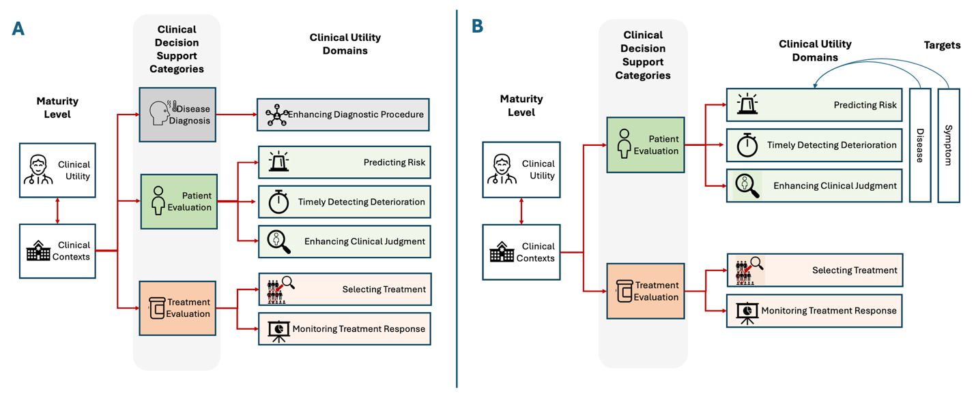
Notes: .

S5. Secondary: Results for Domain Time to Applicability

Timeline to Applicability | Don’t know | Now | 1-5 years | 5-10 years | >10 years | Not Clinically Relevant Applicable | Most Selected Option
Risk Patterns Forecast | 0.00 | 9.09 | 54.55 | 27.27 | 9.09 | 0.00 | In 1 to 5 years
Timely Diagnosis | 0.00 | 9.09 | 81.82 | 0.00 | 9.09 | 0.00 | In 1 to 5 years
Enhancing Diagnostic Procedure | 4.55 | 4.55 | 59.10 | 22.73 | 9.09 | 0.00 | In 1 to 5 years
Individualized Intervention | 3.03 | 9.09 | 39.39 | 36.36 | 9.09 | 3.03 | In 1 to 5 years
Treatment Monitoring | 4.55 | 13.64 | 50 | 18.18 | 13.64 | 0.00 | In 1 to 5 years
Note: Table denotes relative distribution and average agreement of expert feedback responses on the different example applicability timeline

S6. Secondary: Results for Foreseen Challenges in Clinical Applicability
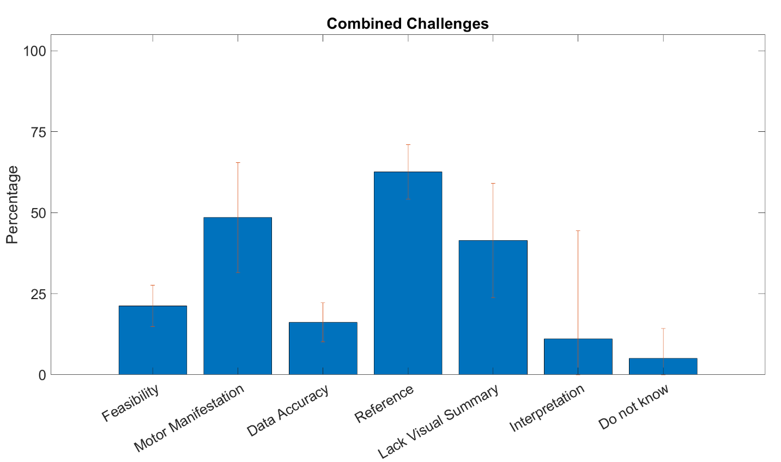
Note: Aggregated results from the challenges foreseen. Error bars represent the standard deviation of the occurrence of the item across different examples.

S7. Secondary: Main obstacle to the implementation of the DMOs within clinical practice.

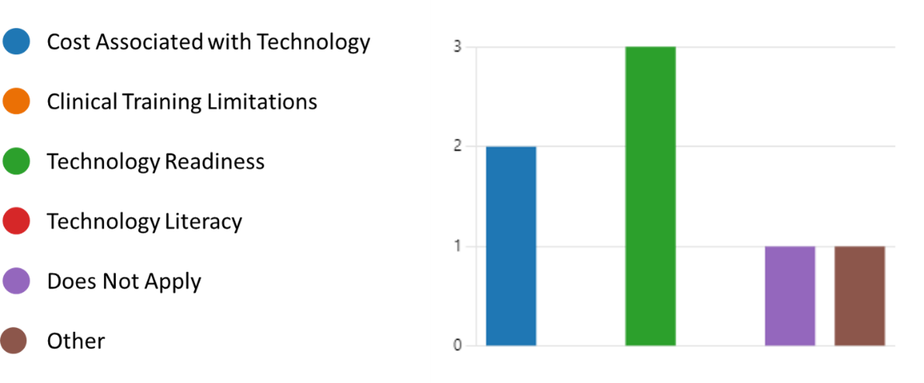

S8. Secondary: Expert opinion on the main role of DMOs for clinical decisions.

