Supplementary Fig. 1 Electrode position
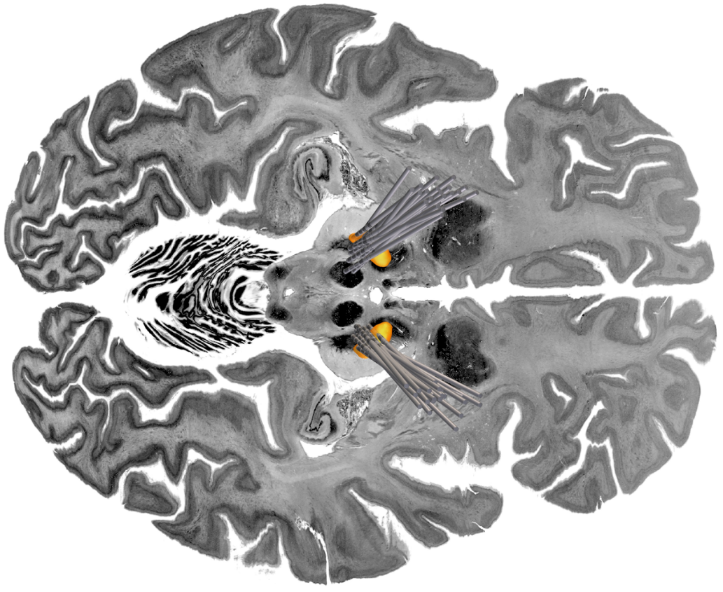
To localize the DBS electrodes with Lead-DBS v3.0 [1, 2], preoperative MRI and postoperative CT were co-registered and non-linearly warped to ICBM 2009b Nonlinear Asymmetric ('MNI') space using Advanced Normalization Tools. A brain shift correction was applied, and electrode trajectories were reconstructed using PaCER [3, 4]. For the purposes of electrode visualization, the DISTAL and Big Brain atlases were used [5, 6].

Supplementary Table 1 Bonferroni correction of p-values in multiple comparisons
Statistical test | Variables | Uncorrected p-value | Corrected p-value (Bonferroni)
Wilcoxon signed-rank test | - Beta power (ON medication) at the Frequency of the highest beta peak in OFF medication state  - Beta power (OFF medication) at the Frequency of the highest beta peak in OFF medication state | 1.184E-9 | <.001
Wilcoxon signed-rank test | - Mean beta power (entire beta band) OFF medication  - Mean beta power (entire beta band) ON medication | 1.076E-37 | <.001
Wilcoxon signed-rank test | - Mean beta power  (low beta band)  OFF medication  - Mean beta power  (low beta band)  ON medication | 1.8025E-26 | <.001
Wilcoxon signed-rank test | - Mean beta power (high beta band)  OFF medication  - Mean beta power  (high beta band)  ON medication | 1.8336E-38 | <.001
Binary logistic regression | - Dependent variable: BCC  - Independent variable: amplitude, frequency, standard deviation of the highest beta peak ON and OFF medication | .342 | >.999
Binary logistic regression | - Dependent variable: BCC  - Independent variable: PPR_{LBB+HBB} | .01 | .03
Binary logistic regression | - Dependent variable: BCC  - Independent variable: PPR_{LBB} | .021 | .063
Linear regression | - Dependent variable: TW  - Independent variable: amplitude, frequency, standard deviation of the highest beta peak ON and OFF medication | .171 | .513
Linear regression | - Dependent variable: TW  - Independent variable: PPR_{LBB+HBB} | .018 | .054
Linear regression | - Dependent variable: TW  - Independent variable: PPR_{LBB} | .000187185014138 | <.001
Pearson correlation | - MDS-UPDRS-III improvement  - PPR_{LBB+HBB} | .000137118444692 | .001
Pearson correlation | - MDS-UPDRS-III improvement  - PPR_{LBB} | .00000034145 | <.001
Pearson correlation | - MDS-UPDRS-III improvement  - Highest beta peak frequency OFF medication | .015 | .135
Pearson correlation | - MDS-UPDRS-III improvement  - Highest beta peak frequency ON medication | .389 | >.999
Pearson correlation | - MDS-UPDRS-III improvement  - Highest beta peak amplitude OFF medication | .721 | >.999
Pearson correlation | - MDS-UPDRS-III improvement  - Highest beta peak amplitude ON medication | .747 | >.999
Pearson correlation | - MDS-UPDRS-III improvement  - Highest beta peak standard deviation OFF medication | .038 | .342
Pearson correlation | - MDS-UPDRS-III improvement  - Highest beta peak standard deviation  ON medication | .915 | >.999
Linear regression | - Dependent variable: MDS-UPDRS-III improvement  - Independent variable: PPR_{LBB+HBB} | 3.4145E-7 | <.001
Linear regression | - Dependent variable: MDS-UPDRS-III improvement  - Independent variable: PPR_{LBB} | .000137118444692 | <.001

References
1. Neudorfer, C., et al., Lead-DBS v3.0: Mapping deep brain stimulation effects to local anatomy and global networks. Neuroimage, 2023. 268: p. 119862.
2. Hollunder, B., et al., Mapping dysfunctional circuits in the frontal cortex using deep brain stimulation. Nat Neurosci, 2024. 27(3): p. 573-586.
3. Horn, A., et al., Lead-DBS v2: Towards a comprehensive pipeline for deep brain stimulation imaging. Neuroimage, 2019. 184: p. 293-316.
4. Husch, A., et al., PaCER - A fully automated method for electrode trajectory and contact reconstruction in deep brain stimulation. Neuroimage Clin, 2018. 17: p. 80-89.
5. Ewert, S., et al., Toward defining deep brain stimulation targets in MNI space: A subcortical atlas based on multimodal MRI, histology and structural connectivity. Neuroimage, 2018. 170: p. 271-282.
6. Amunts, K., et al., BigBrain: an ultrahigh-resolution 3D human brain model. Science, 2013. 340(6139): p. 1472-5.

