Supplementary material
Tables

Supplement Table 1 Functional assessment outcomes at baseline for patients with non-SCLC-pLEMS, SCLC-pLEMS and aiLEMS enrolled in the European LEMS registry

Limited/reduced function at baseline, n (%) | Total | SCLC-pLEMS | non-SCLC-pLEMS | aiLEMS
Walk upstairs | 46/57 (81) | 7/7 (100) | 2/5 (40) | 37/45 (82)
Cycle | 37/50 (74) | 6/6 (100) | 2/5 (40) | 29/39 (74)
Getting up from a low chair with arm support | 31/58 (53) | 7/8 (88) | 2/5 (40) | 22/45 (49)
Getting up from a low chair without arm support | 39/55 (71) | 5/6 (83) | 2/5 (40) | 32/44 (73)
Getting up from sitting on one knee | 38/50 (76) | 5/6 (83) | 2/4 (50) | 31/40 (78)
Getting up from squatting | 40/54 (74) | 5/6 (83) | 2/4 (50) | 33/44 (75)
Climb stairs with arm support | 33/57 (58) | 6/8 (75) | 2/5 (40) | 23/43 (54)
Climb stairs without arm support | 39/56 (70) | 6/7 (86) | 2/5 (40) | 31/44 (71)
Walking on toes | 30/55 (55) | 6/9 (67) | 2/5 (40) | 21/41 (51)
Walking on heels | 30/56 (54) | 6/9 (67) | 2/4 (50) | 22/43 (51)
Getting up from highchair with arm support | 29/55 (53) | 5/7 (71) | 4/5 (40) | 20/43 (47)
Getting up from a high chair without any arm support | 31/54 (57) | 5/6 (83) | 2/5 (40) | 24/43 (56)

Supplement Table 2 Cancers found in LEMS in registry and systematic literature search.
 | Total | non-SCLC-pLEMS  in registry | non-SCLC-pLEMS in literature
Number of all tumors ^{a)} | 137 | 13 | 124
Cancer types  Non-small cell lung cancer  Merkel cell carcinoma  Lymphoproliferative disorders  Prostate cancer  Thymoma  Breast cancer  Colon cancer  Unknown primary origin  Mediastinal cancer  Ovarial cancer  Bladder cancer  Renal cancer  Pancreas cancer  Laryngeal carcinoma  Endometrial cancer  Leiomyosacroma (uterus)  Basalioma  Oropharyngeal cancer  Oesophagus cancer  Appendiceal carcinoma  Carcinoma of the seminal vesicles  Rectum cancer  Gall bladder cancer  Aggressive fibromatosis  Cervix carcinoma  Melanoma  Thyroid cancer  Tonsil cancer  Ameloblastoma  Pelvic tumor  Neuroblastoma  Kaposi sarcoma | 25  18  15  10  10  8  6  5  3  3  3  3  3  3  2  2  2  2  1  1  1  1  1  1  1  1  1  1  1  1  1  1 | 0  2  2  0  2  1  2  0  0  0  0  0  1  1  0  0  0  0  1  0  0  1  0  0  0  0  0  0  0  0  0  0 | 25  16  13  10  8  7  4  5  3  3  3  3  2  2  2  2  2  2  0  1  1  0  1  1  1  1  1  1  1  1  1  1
Geographic origin  Europe  North America/Canada  Asia  Middle East  Australia/New Zealand | 63  42  24  6  2 | 12  0  0  0  0 | 51  42  24  6  2
- In three patients two neoplasms occurred, in one patient two respectively three neoplasms

Supplement Table 3 Clinical, laboratory, treatment, and outcome profiles of non-SCLC-pLEMS patients grouped for neuroendocrine and non-neuroendocrine tumor with patient-level data identified in systematic review

 | Neuroendocrine tumor | Non-neuroendocrine tumor
N° | 40 | 41
Male  Age (years) | 26/37 (70)  61 (3-78) | 22/40 (55)  64 (2-77)
Smoking before cancer | 13/19 (68) | 10/19 (53)
Clinical symptoms  Muscle weakness  Fatigue  Reduced reflexes  Autonomic dysfunction  Muscle pain  Ocular symptoms  Bulbar symptoms  Weight lost  Ataxia | 36/37 (97)  10/37 (27)  18/35 (51)  24/37 (65)  2/37 (5)  14/37 (38)  16/37 (43)  5/37 (14)  9/37 (24) | 36/38 (95)  18/38 (47)  26/35 (74)  21/38 (55)  5/38 (13)  19/38 (50)  14/38 (37)  13/38 (43)  12/38 (32)
Further PNS  RPCS  Myasthenia gravis  Neuropathy  Scleroderma  Dermatomyositis  Limbic encephalitis | 9/40 (23)  4/40 (10)  1/40 (3)  2/40 (6)  1/40 (3)  0 (0)  1/40 (3) | 6/41 (15)  0 (0)  3/41 (7)  2/41 (5)  0 (0)  1/41 (2)  0 (0)
Diagnostic of LEMS  Electrophysiology positive  P/Q VGCC Abs positive  P/Q-VGCC Abs titer (median in pmol/L [range]) | 36/36 (100)  23/25 (92)  13/25 (52), (120 [44-23.000] | 40/41 (98)  20/26 (77)  11/26 (42), (220 [32-777]
FDG/PET-CT | 11/37 (30) | 4/35 (11)
LEMS treatment^{a)}  Symptomatic treatment  Steroids  Long-term IST  IVIG  Plasmapheresis  Rituximab  Cyclophosphamide | 15/36 (42)  6/36 (17)  4/36 (11)  10/36 (28)  6/36 (17)  2/36 (6)  2/36 (6) | 23/39 (59)  17/39 (44)  5/39 (13)  7/39 (18)  4/39 (10)  1/39 (3)  0 (0)
Tumor therapy^{a)}  Surgery  Chemotherapy  Radiotherapy  ICI  Hormone therapy  No treatment | 25/39 (64)  23/39 (59)  23/39 (59)  5/39 (13)  2/39 (5)  0 (0) | 25/41 (61)  10/41 (24)  8/41 (20)  0 (0)  1/41 (2)  8/41 (20)
Outcome after tumor treatment  Full recovery  Partial recovery  No change  Deterioration | 15/33 (45)  14/33 (42)  3/33 (9)  1/33 (3) | 7/18 (39)  9/18 (50)  2/18 (11)  0 (0)

Data are presented as median [range] or frequency (%) as appropriate. No significant differences were found between LEMS patients associated with neuroendocrine and non-neuroendocrine tumors (Chi square test, Mann Whitney U test).
Abbreviations: FDG PET = Fluorodeoxyglucose Positron Emission Tomography, ICI = immune checkpoint inhibitor; IVIG = intravenous immunoglobulin; Long-term IST = long-termin immunosuppressive treatment, RPCS = rapid progressive cerebellar syndrome
- Patient can me in more than one group

Figures

Supplemental Figure 1
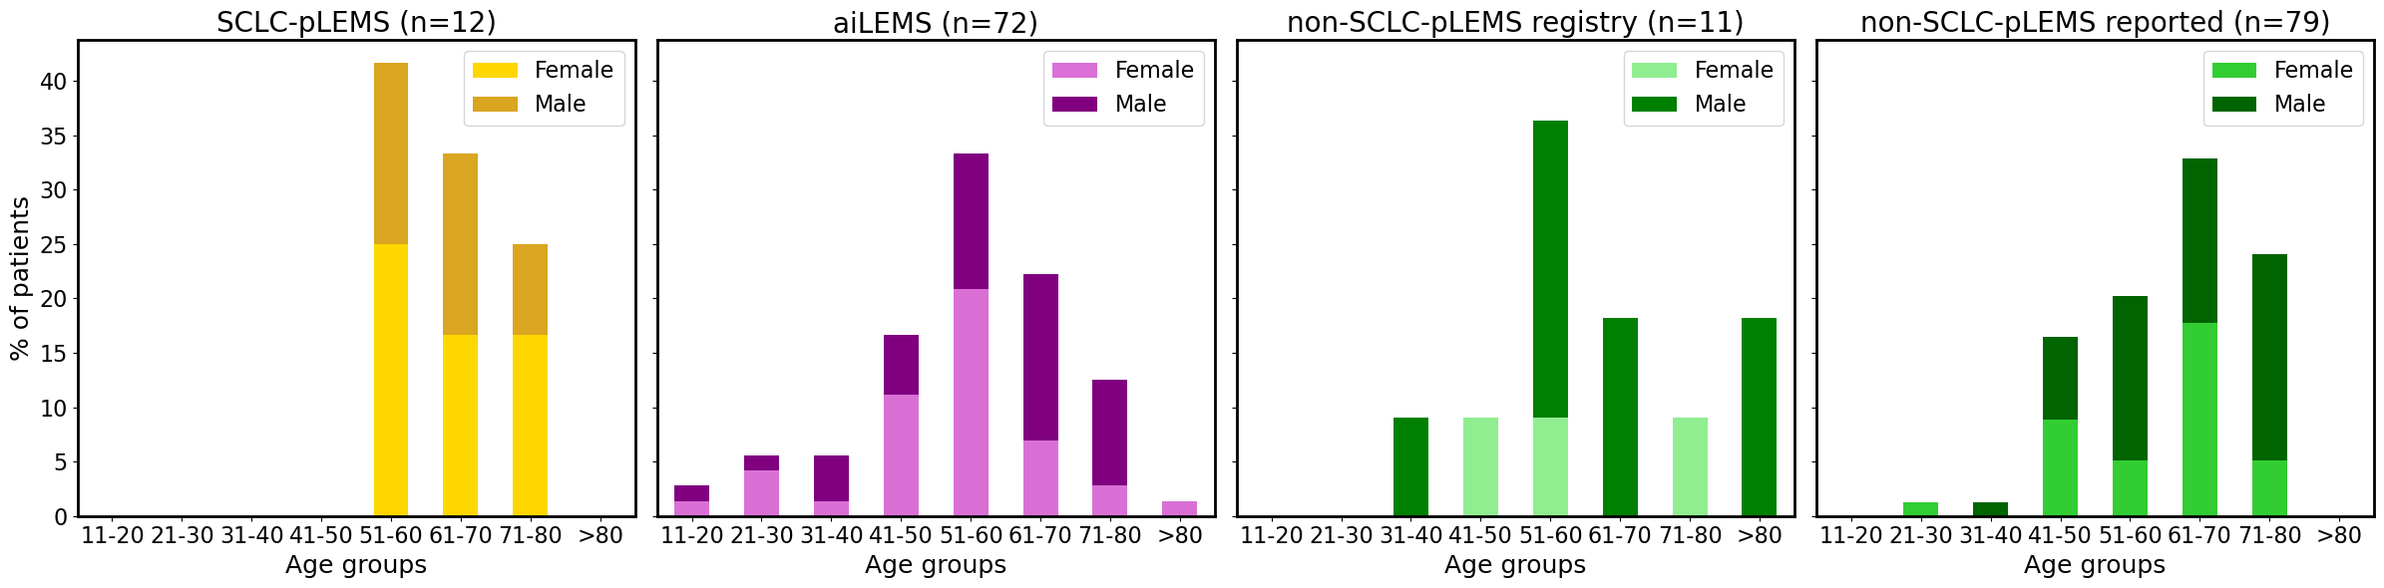
Demographic profiles
Stacked bar plots show the proportion of male and female patients across age groups for SCLC-pLEMS, aiLEMS and non-SCLC-pLEMS (registry-based and literature-reported). Tests applied: Chi-Square Test and Mann-Whitney U test

Supplemental Figure 2
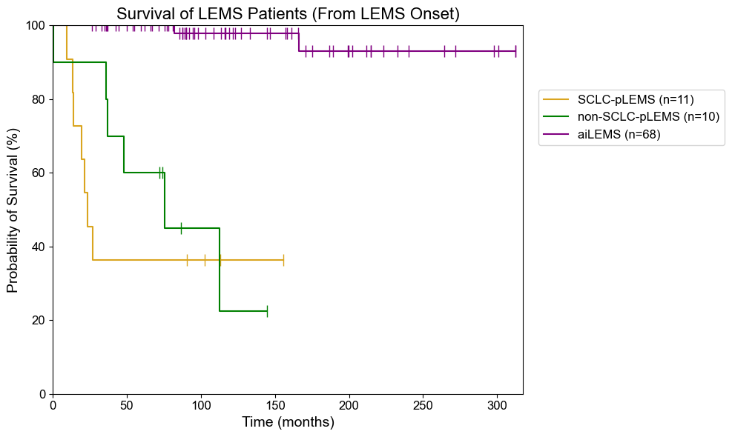

Survival rate of patients with SCLC-pLEMS, non-SCLC-pLEMS, and aiLEMS in the European LEMS registry
Kaplan-Meier curves show time from LEMS onset to death or last follow-up in patients with SCLC-pLEMS, non-SCLC-pLEMS, and aiLEMS.

