Figure S1
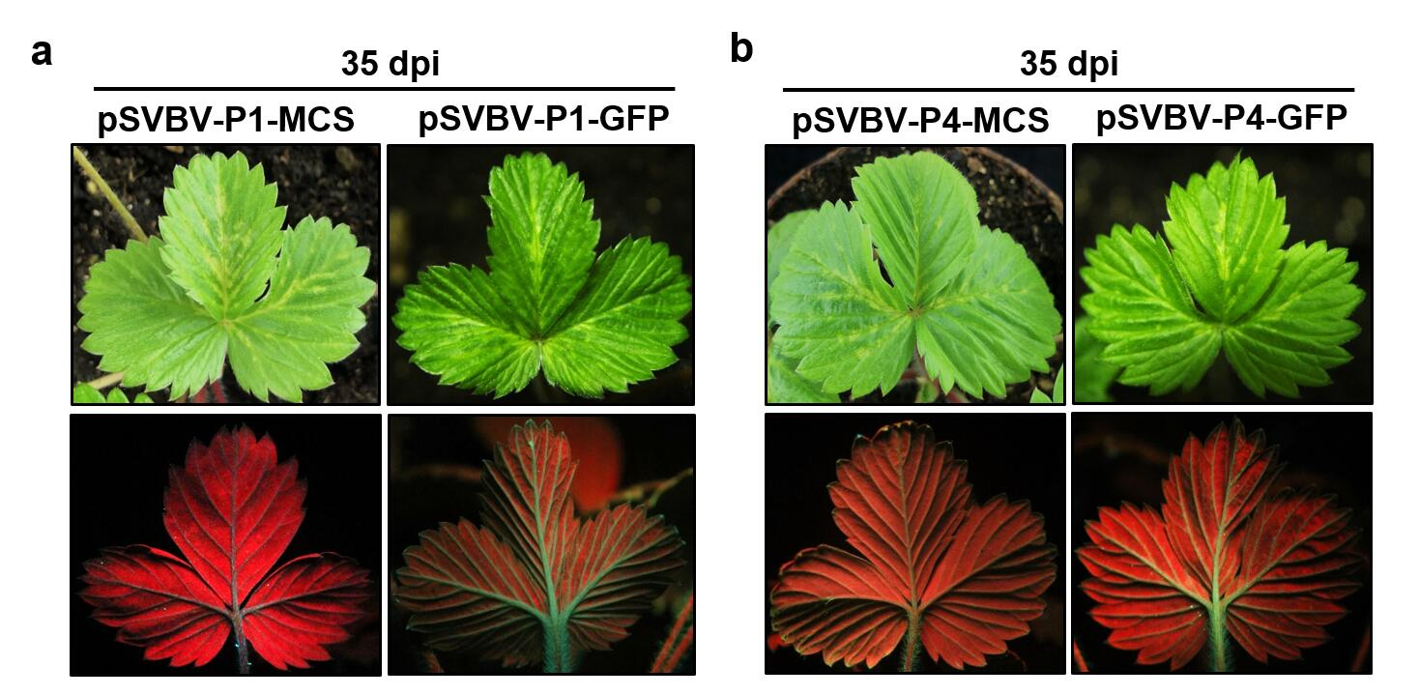
Fig. S1 Symptoms in strawberry plants agroinfiltrated with SVBV-based vectors. a Light-green vein banding symptoms in strawberry plants agroinfiltrated with pSVBV-P1-MCS or pSVBV-P1-GFP and (b) pSVBV-P4-MCS or pSVBV-P4-GFP at 35 dpi, backs of the strawberry plant leaves were illuminated under UV-B light to detection of fluorescence signals

