Additional file 1
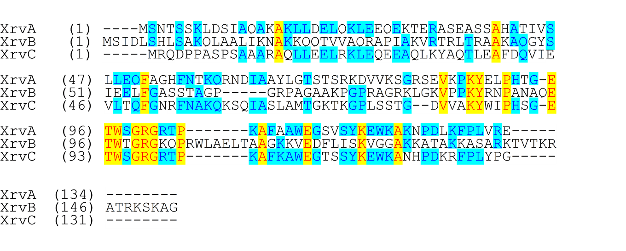
Figure S1 Comparison of the predicted amino acid sequences of XrvA, XrvB, and XrvC in Xoc strain GX01. The sequences of these proteins were acquired from NCBI website and the alignment was proceeded with the software NTI Vector. Residues that are identical in three sequences and two sequences are colored yellow- and cyan-backgrounds respectively.

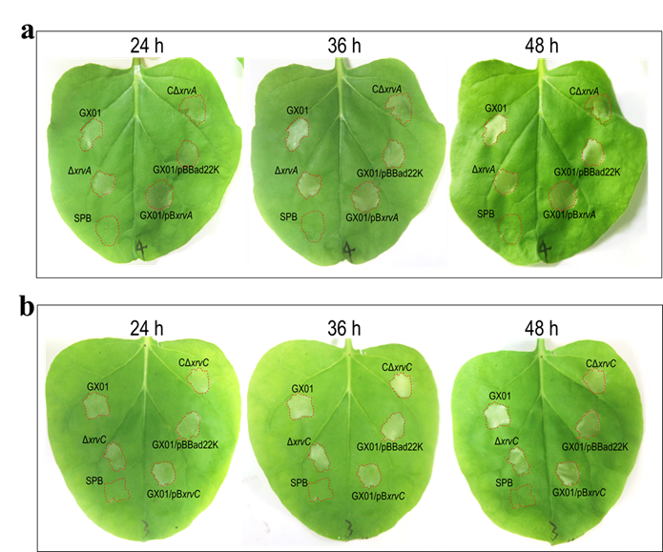
Figure S2 The XrvA and XrvC in Xoc do not impact HR induction on nonhost plant. Xoc strains were cultured in NB medium to a concentration of OD₆₀₀ of 0.5, and cells were collected and resuspended in SPB. The bacterial resuspensions were infiltrated into the leaves of non-host plant N. benthamiana. HR symptoms observed at 24, 36, and 48 hpi. a xrvA deletion mutant or overexpressing strain induced similar HR symptoms as wild type. b xrvC deletion mutant or overexpressing strain induced similar HR symptoms as wild type.

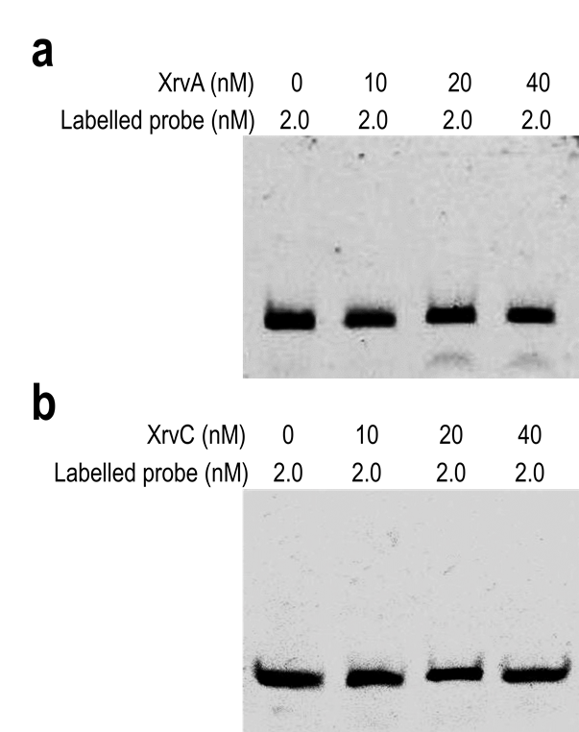
Figure S3 XrvA and XrvC do not bind the hrpG promoter region. The EMSA assay was carried out using the 6-carboxyfluorescein-labelled DNA probe of the hrpG promoter and His-XrvA (a) or His-XrvC (b) proteins. DNA and protein were incubated at 30ºC for 20 min before electrophoresis. No shifted band was observed under the tested conditions.

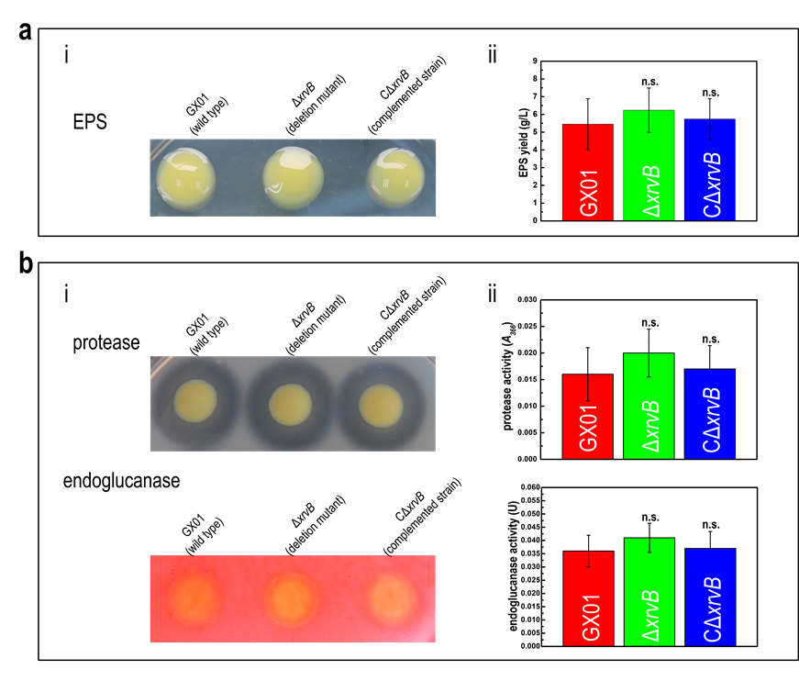
Figure S4 The level of EPS and extracellular enzymes produced by the xrvB deletion mutant was similar to that of the wild type in Xoc. a The effect of xrvB mutation on EPS production. Values given are the means ± SD (n=3). Significance was determined by ANOVA and Dunnett's post hoc test for comparison to the wild type. n.s., not significant at P ≤ 0.05. b The effect of xrvB mutation on the activities of protease and endoglucanase. Data are the mean ± SD (n=3). Significance was determined by ANOVA and Dunnett's post hoc test for comparison to the wild type. n.s., not significant at P ≤ 0.05.

