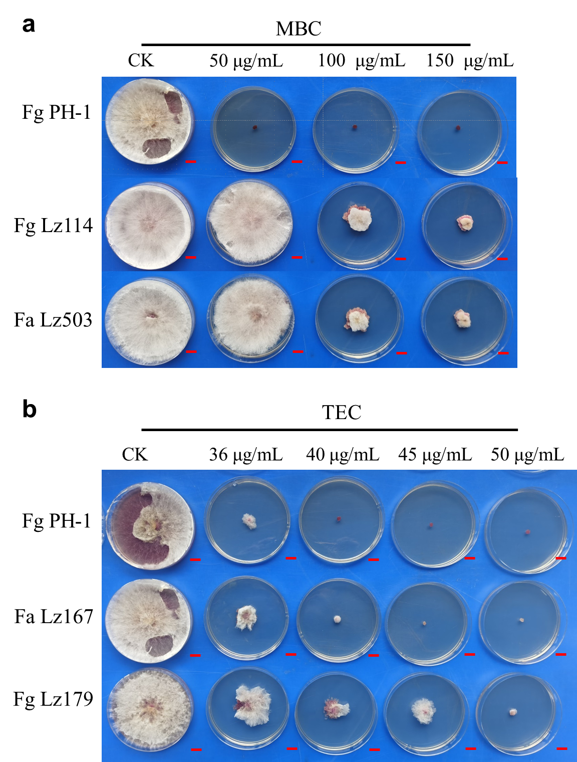
Figure S1 Mycelial growth of Fg Lz114, Fa Lz503, Fa Lz167, and Fg Lz179 on PDA plates was observed under different concentrations of MBC (a) and TEC (b) at the 7th day after inoculation, Scale bars = 1 cm.

