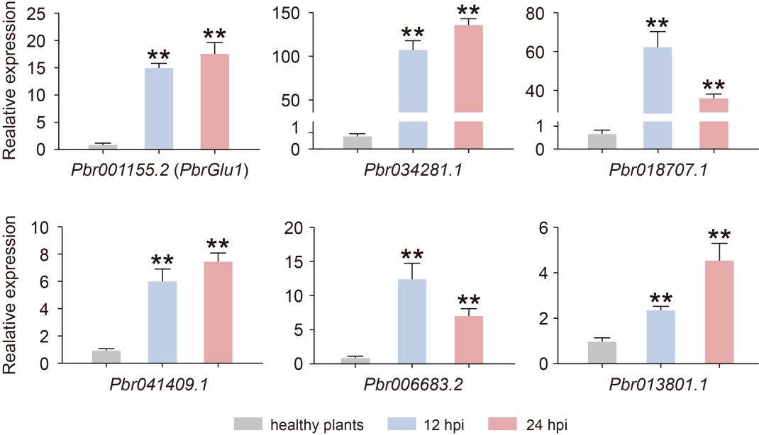
Figure S1 The relative expression levels of several apoplast proteins genes in C. fructicola infected plants and healthy plants. Bar values represent the means SEM of three biological replicates with three technical replicates. * indicate significant differences, * p<0.05, ** p<0.01.
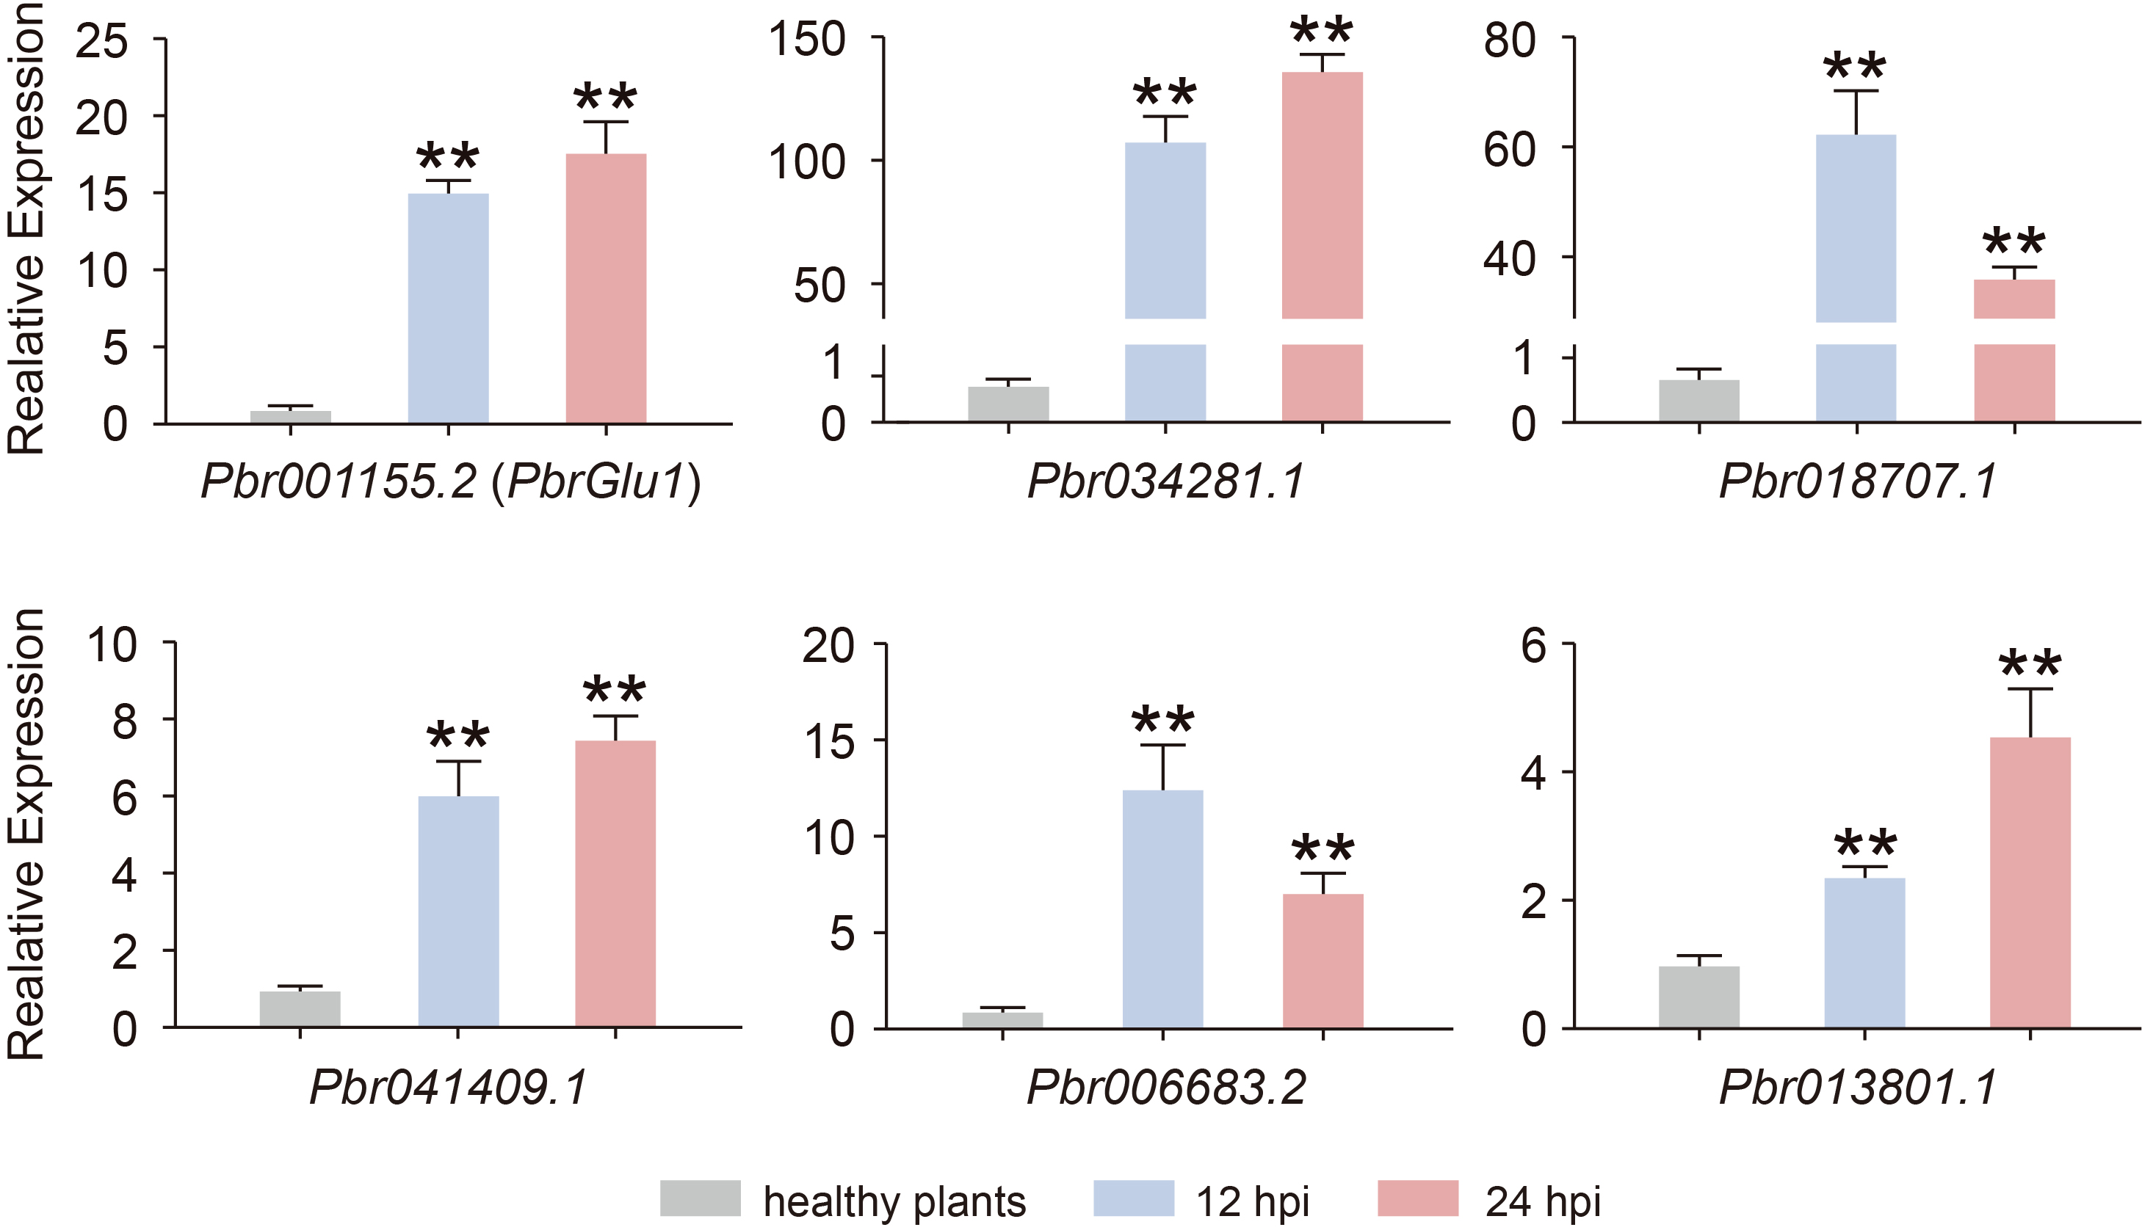
Figure S2 Phylogeny and conserved motifs of GH17 gene family genes in pear. The conserved motifs were analyzed by the MEME tool (http://memesuite.org/) using the default settings.
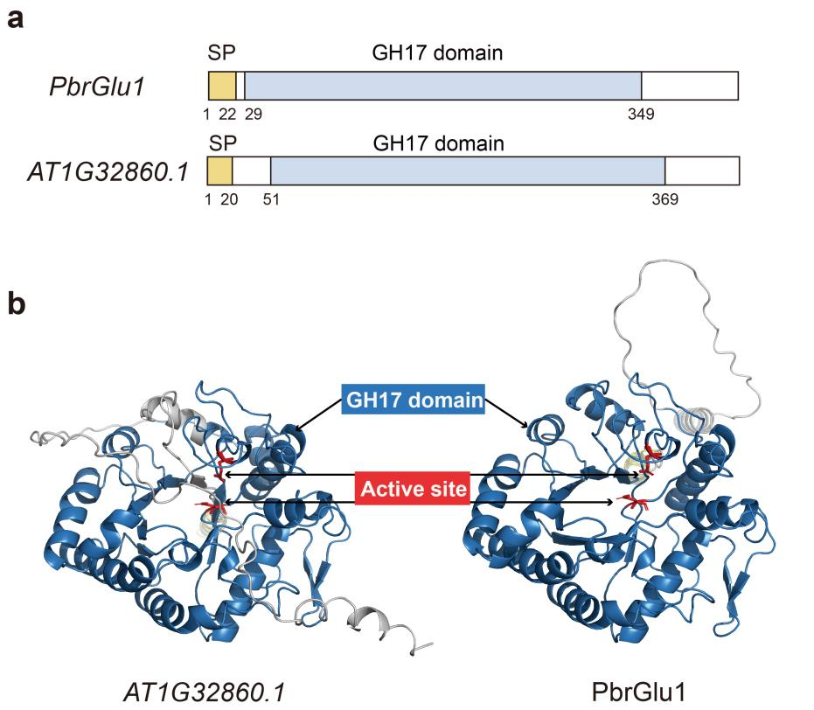
Figure S3 Predicted protein structures of PbrGlu1 and AT1G32860.1. a The predicted Pfam domain of PbrGlu1 and AT1G32860.1. b Schematic representation of PbrGlu1 and AT1G32860.1 model based on the predicted protein structure from UniProt (https://www.uniprot.org/).

