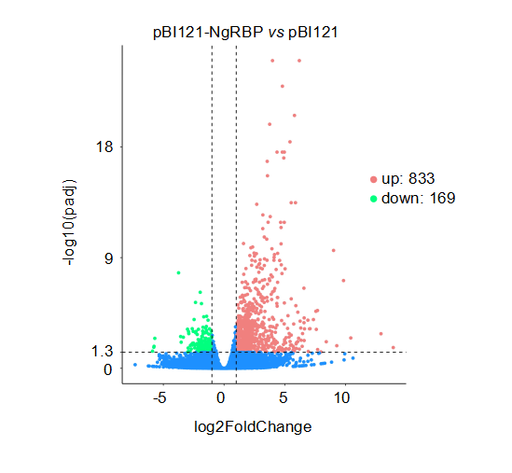
Figure S1 Volcano maps of differentially expressed genes. The dashed blue line represents the threshold for the screening criteria for differentially expressed genes.

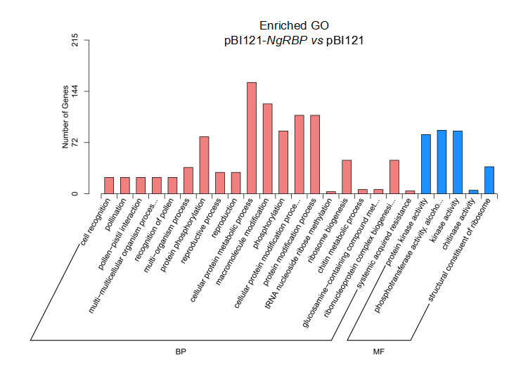
Figure S2 Gene ontology (GO) enrichment histogram of differential genes. The abscissa represents the GO term at the next level of the major GO categories, and the ordinate represents the number of differentially annotated genes. Two different classifications represent the two basic classifications of GO terms. From left to right are the biological processes (BP) and molecular functions (MF).

