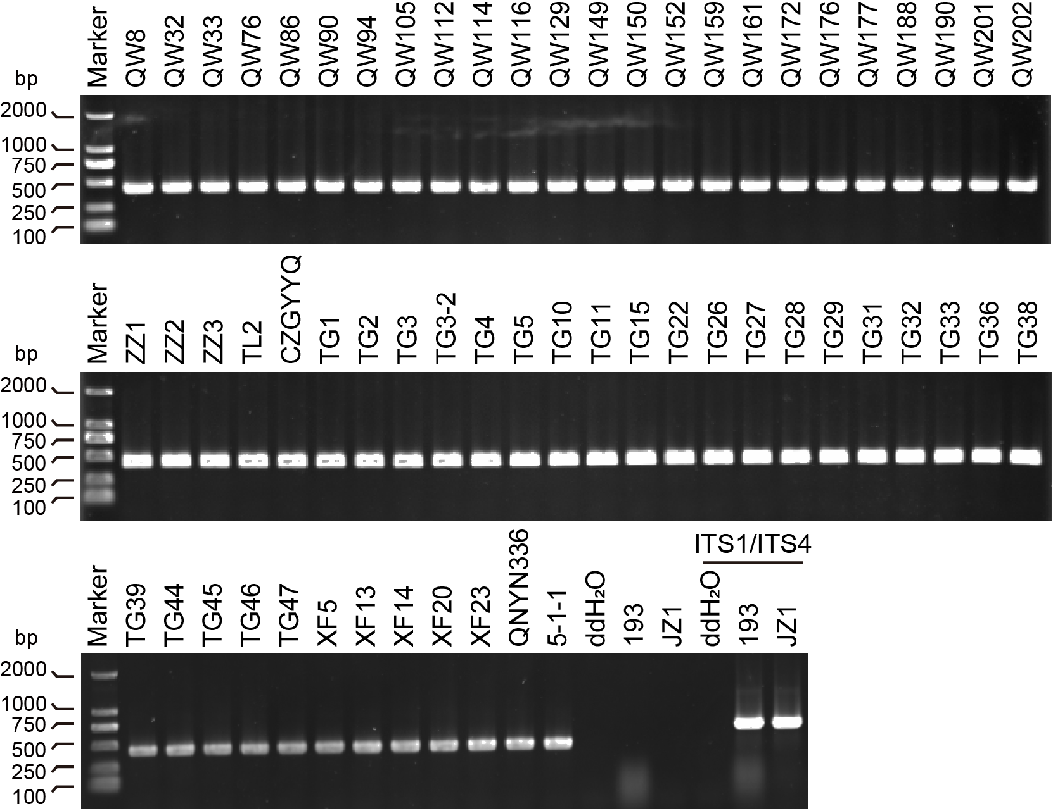
Figure S1. PCR detection of 60 isolates of E. turcicum using species primers. DNA from two E. rostratum strains, which are closely related to E. turcicum, were used as negative controls.
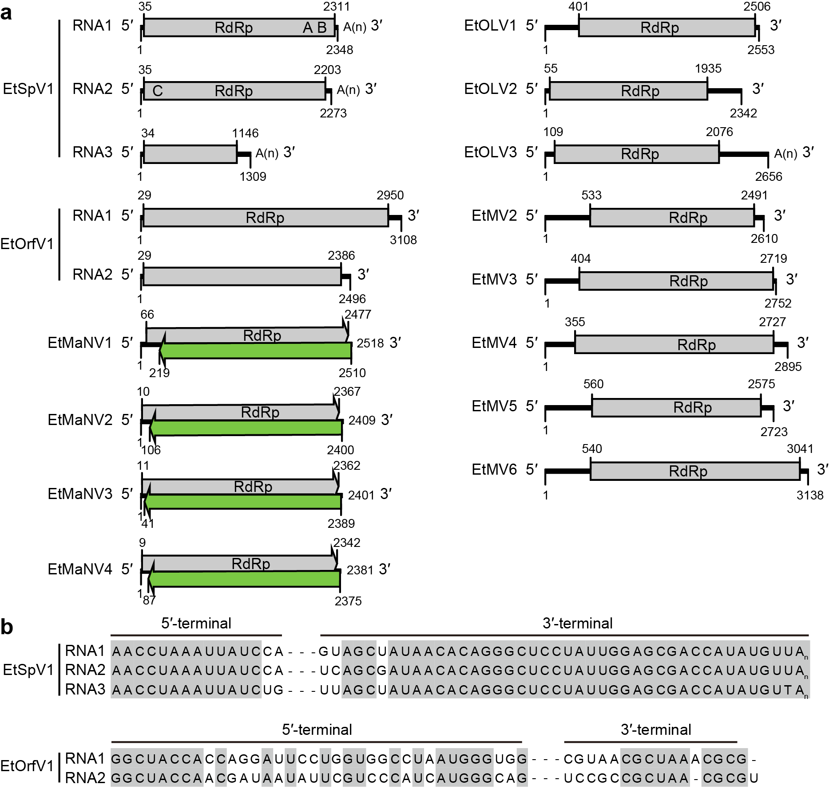
Figure S2. Genome structures and terminal sequence alignment of 14 viruses belonging to the phylum Lenarviricota. a Illustrations showing the genome organization of the 14 identified viruses. b Comparison of the 5' and 3' terminal sequences of EtSpV1 and EtOrfV1.
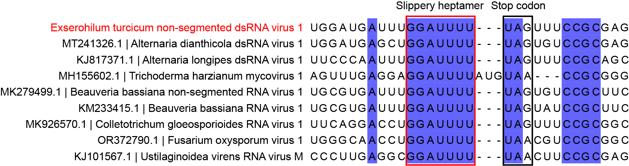
Figure S3. Predicted sites of ribosomal frameshifting in the genomes of all unirnaviruses. The termination codons of ORF1 and the heptanucleotide tandem shift sites are marked with black and red boxes, respectively.
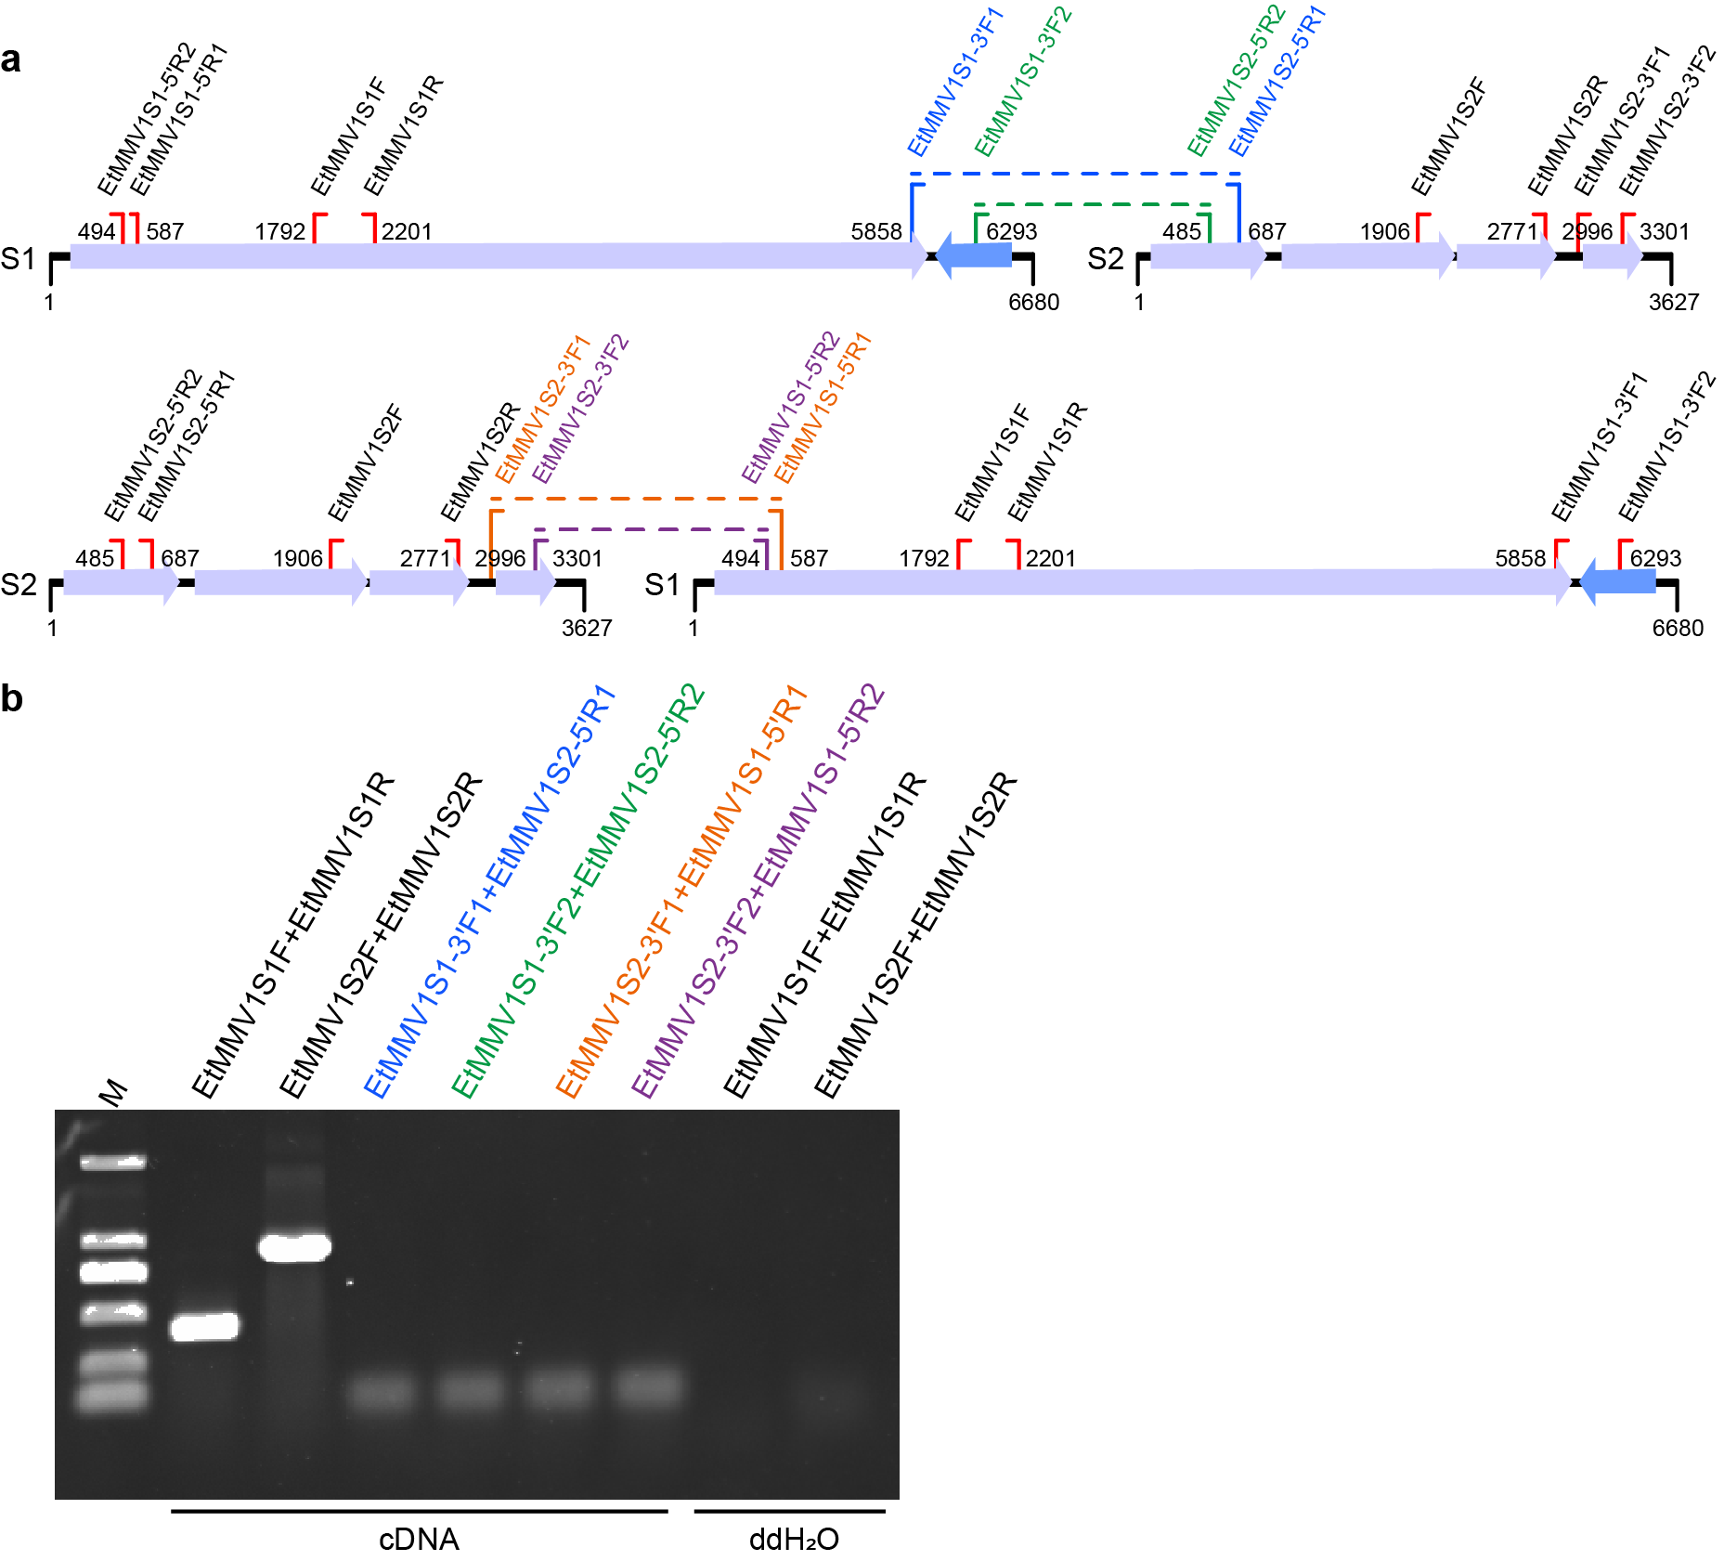
Figure S4. RT-PCR detection and validation of the bi-segmented genome of EtMMV1. a Schematic representation of primer positions, with dashed lines indicating possible PCR products. b Gel electrophoresis results showing PCR detection outcomes.
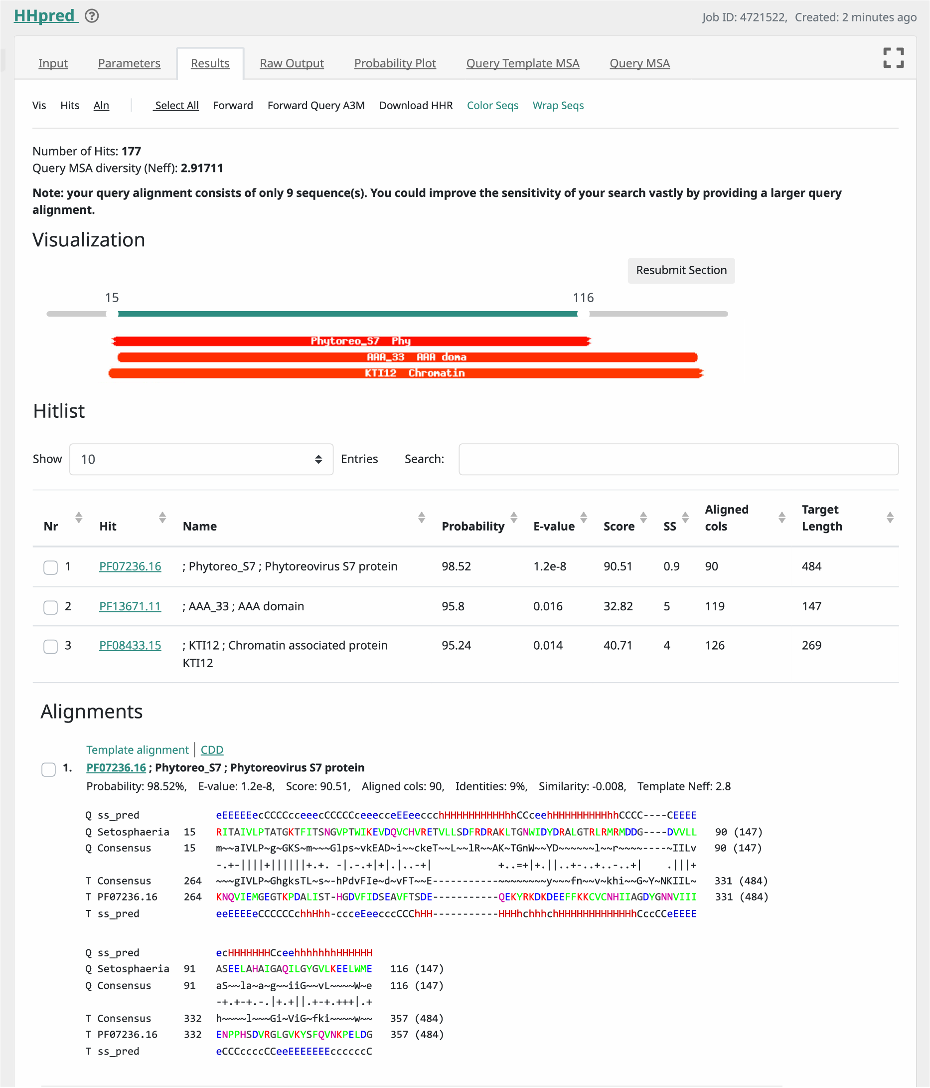
Figure S5. HHpred search results for the protein (P2) encoded by ORF2 of EtMMV1 RNA1 and homologous proteins from mymonaviruses. The search was performed using the HHpred website (https://toolkit.tuebingen.mpg.de/tools/hhpred) with default parameters and the Pfam-A_v37 database.
Figure S6. Multiple sequence alignment of Phytoreo_S7 domain sequences sourced from viruses and fungi. The alignment was generated using MAFFT and visualized in Jalview with default coloring parameters.

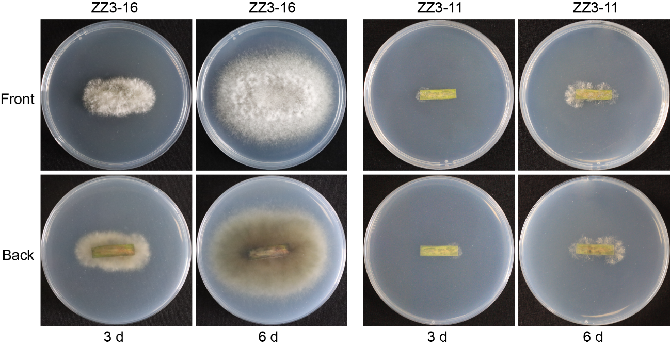
Figure S7. Morphology of E. turcicum re-isolated from lesions formed after artificial inoculation. Lesions were excised, surface-sterilized with 75% ethanol for 1 minute, rinsed with sterile water, and then inoculated onto PDA plates. Photographs were taken after 3 and 6 days of incubation at 25°C.
Figure 1e (uncropped gel image)
Figure 1f (uncropped gel image)
Figure 7a (EtG) (uncropped gel image) Figure 7a (EtMV2) (uncropped gel image)
Figure 7a (EtMV3) (uncropped gel image) Figure 7a (EtOLV1) (uncropped gel image)
Figure 7a (EtAV2) (uncropped gel image) Figure 7a (EtHV1) (uncropped gel image)
Figure 7a (EtPV1) (uncropped gel image)
Figure 7a (EtMaNV3)(uncropped gel image) Figure 7a (EtFV1) (uncropped gel image)
Figure 7a (EtOLV2)(uncropped gel image) Figure 7a (EtMMV1)(uncropped gel image)
Figure 7a (EtAV1) (uncropped gel image)
Figure S1 (uncropped gel image)
Figure S8. The full uncropped gels images from this study.

