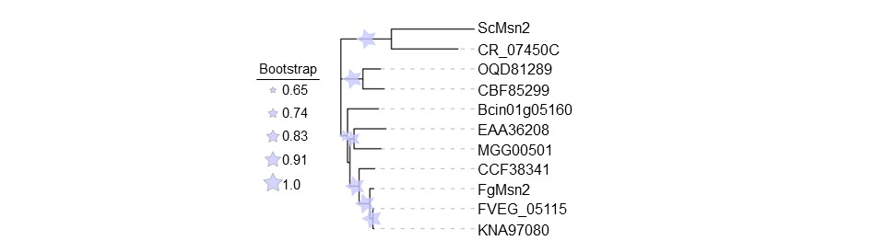Figure S1 Msn2 is conserved across fungi. The protein sequences were retrieved from the EnsemblFungi database (http://fungi.ensembl.org/index.html), and the phylogenetic tree constructed by MEGA11(Tamura, Stecher et al. 2021) using neighbor-joining methods was visualized by iTOL (Interactive Tree Of Life).

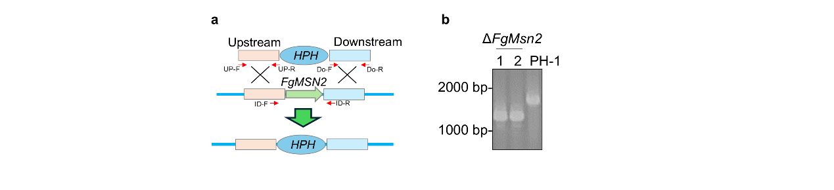
Figure S2 Generation of FgMsn2 deletion mutants. a Schematic representation of the FgMSN2 gene disruption strategy. The binding positions of PCR primers (arrows) used to construct the FgMSN2 gene deletion mutant is illustrated. b Identification of FgMSN2 gene deletion mutant using PCR. The PCR assay was performed using the primer pairs ID-F/ ID-R indicated in Figure S2a and listed in Additional file 2: Table S1.

Figure S3 FgMsn2 represses the transcription of FgATG8. The strains were grown in the YEPD for 12h and then subjected to RNA extraction. The expression levels of FgATG8 were normalized to ACTIN and presented as fold change relative to PH-1 (n = 3). The different letters denote a statistically significant difference (P < 0.05, one-way ANOVA followed by Tukey test).

