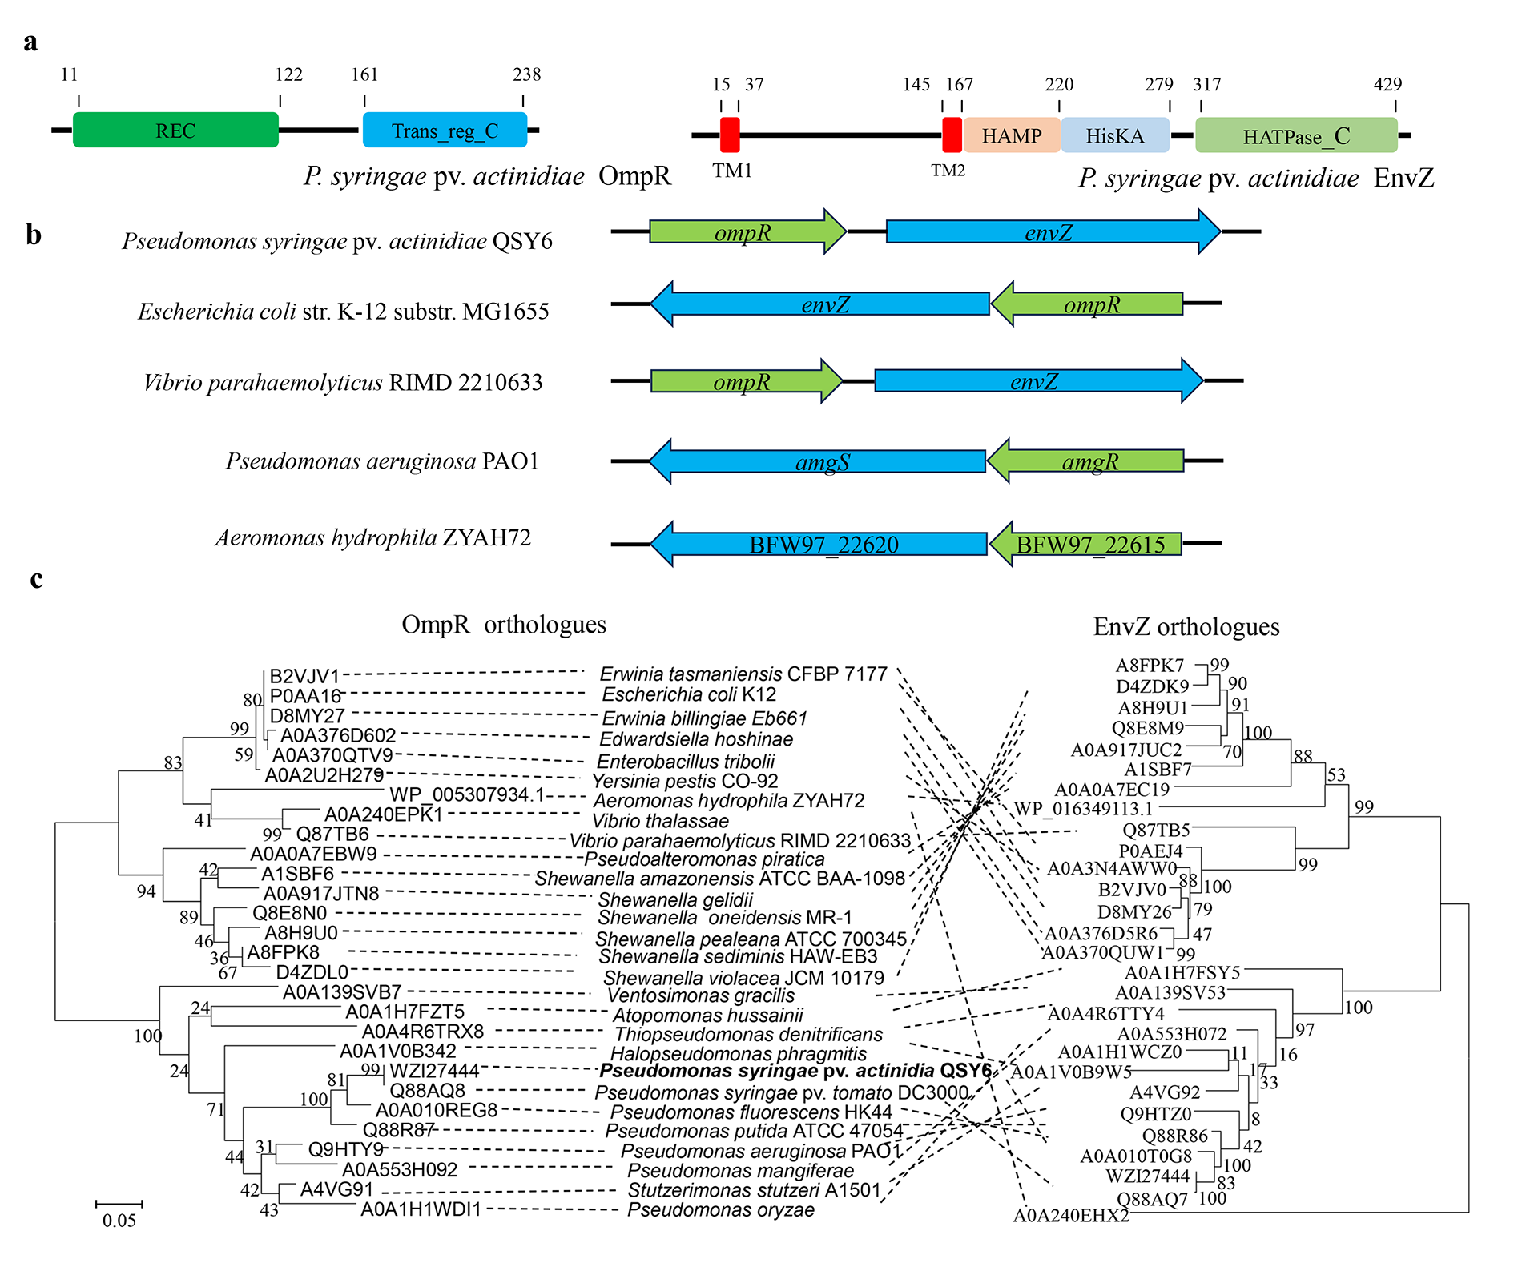
Figure S1 Domain architectures and phylogenetic tree of EnvZ/OmpR. a Domain architecture of P. syringae pv. actinidiae OmpR and EnvZ. The numbers represent amino acid residues where the predicted domains start and end. TM, transmembrane domain. b Genetic organization of the EnvZ/OmpR TCS in Psa QSY6, Aeromonas hydrophila ZYAH72, Escherichia coli str. K-12 substr. MG1655, Vibrio parahaemolyticus RIMD 2210633 and P. aeruginosa PAO1. TCS response regulators are shown in green, the histidine kinases are shown in blue, and the arrows indicate the direction of transcription. c Phylogenetic tree of OmpR, EnvZ and their orthologues.
Twenty-eight TCSs from 15 genera were selected and constructed based on a maximum likelihood method.
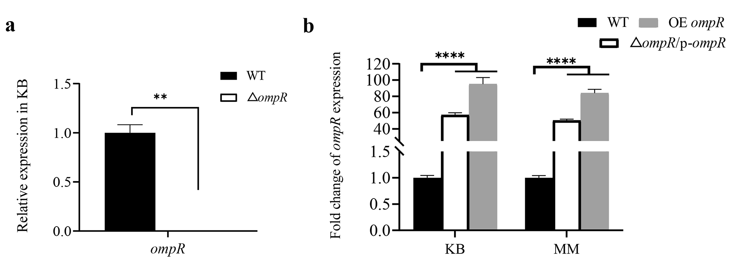
Figure S2 Relative expression of ompR was measured with qRT-PCR, including in ΔompR mutant in KB (a), and in ΔompR/p-ompR and OE ompR in KB and MM (b) compared to that of wild-type. Error bars indicate standard deviations. Statistical difference was analyzed using Student's t-test. **P < 0.01, **** P < 0.0001.
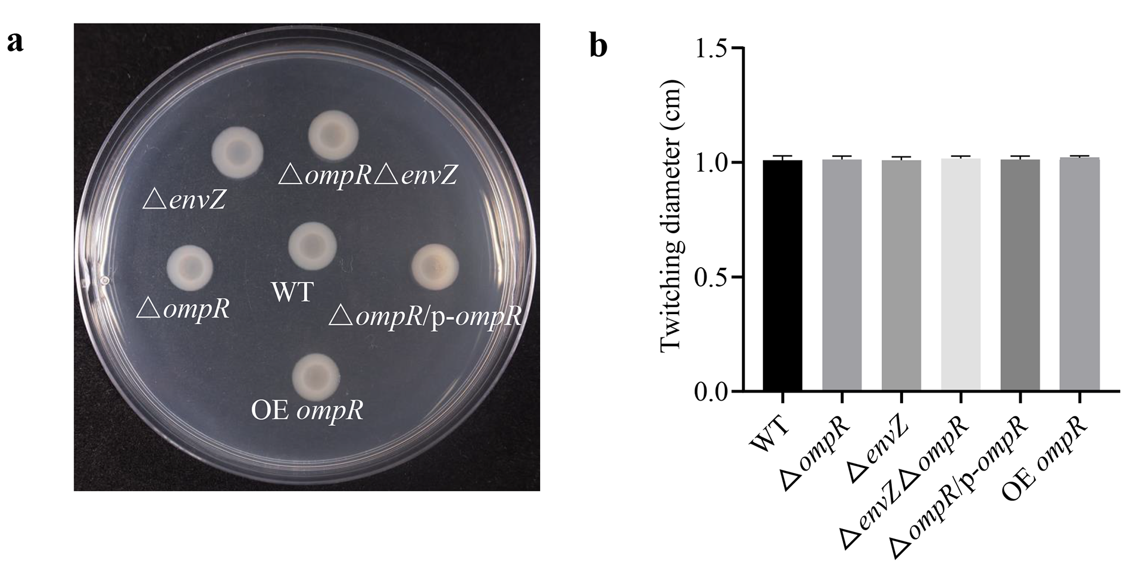
Figure S3 OmpR/EnvZ does not affect Psa twitching motility. a Twitching of wild-type QSY6 and mutants after incubation for 72h. b Twitching diameter of wild-type QSY6 and mutants. Differences were determined with Student’s t-test.
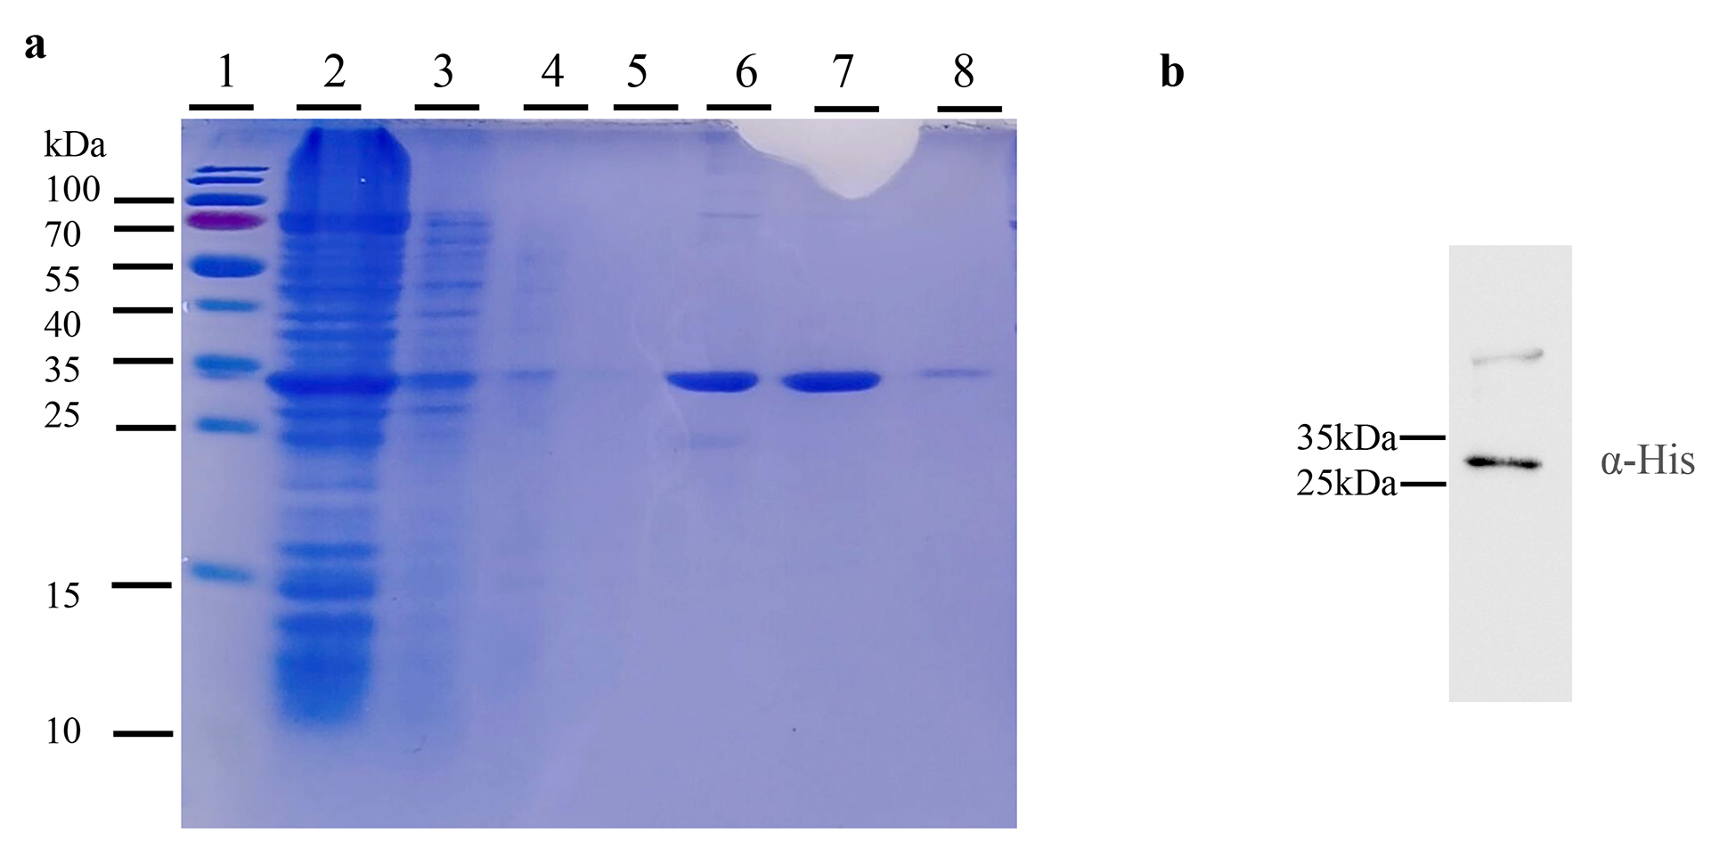
Figure S4 Purification and verification of OmpR protein. a SDS-PAGE gel of OmpR after Ni-NTA column affinity chromatography purification. They are shown as standard protein marker (lane 1), the supernatant of OmpR protein (lane 2), the flow-through of the supernatant (lane 3), eluates of washing buffer (lane 4 and 5), and eluates of elution buffer (lane 6–8), respectively. b Purified OmpR protein (30.8KDa) detected by Western blotting.

