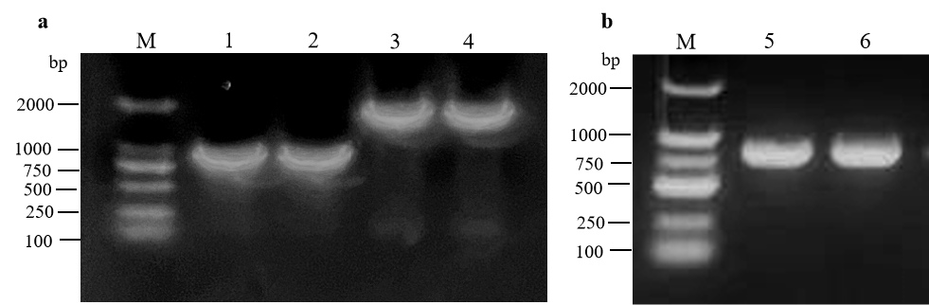
Figure S1 Colony PCR identification of Yeast two-hybrid recombinant vectors.
M, DL2000 DNA Marker; 1, Colony PCR of APV1 CP gene from pGBKT7-CP/DH5α; 2, Colony PCR of APV1 CP gene from pGADT7-CP/DH5α; 3, Colony PCR of APV1 CPm gene from pGBKT7-CPm/DH5α; 4, Colony PCR of APV1 CPm gene from pGADT7-CPm/DH5α; 5, Colony PCR of APV1 CP^{R211A-R212A} gene from pGBKT7-CP^{R211A-R212A}/DH5α; 6, Colony PCR of APV1 CP^{R211A-R212A} gene from pGADT7-CP^{R211A-R212A}/DH5α.

