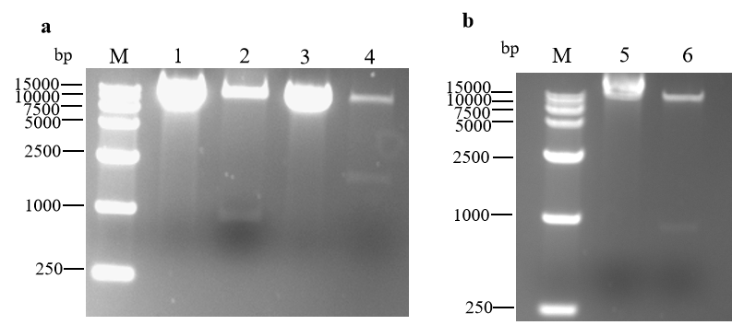
Figure S3 Enzyme digestion verification of GV1300 recombinant plasmids.
M, DL2000 DNA Marker; 1, GV1300-CP plasmid; 2, GV1300-CP plasmid digested with Spe Ⅰ and BamH Ⅰ; 3, GV1300-CPm plasmid; 4, GV1300-CPm plasmid digested with Spe Ⅰ and BamH Ⅰ; 5, GV1300-CP^{R211A-R212A} plasmid; 6, GV1300-CP^{R211A-R212A} plasmid digested with Spe Ⅰ and BamH Ⅰ.

