Figure S1. BiFC analysis of the interaction between CsATG8c and SDE04, SDE08, SDE11. SDEs-nCFP was coexpressed with CsATG8c-cCFP or nCFP in N. benthamiana leaves. CFP signals were visualized by confocal microscopy. Scale bars: 60 μm.

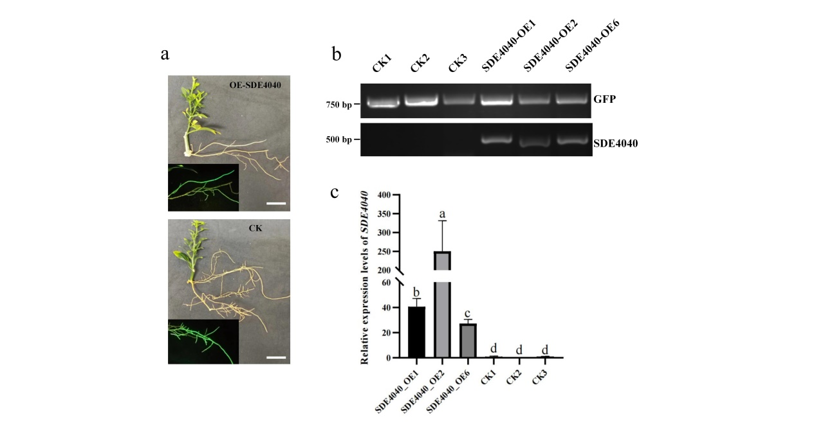
Figure S2. Identification of transgenic citrus plants exhibiting overexpression of SDE4040. a The green fluorescence signal in transgenic citrus root tissues was visualized using a portable excitation lamp. Scale bars: 4 cm. b Transgenic plants were identified through PCR analysis. c The relative expression levels of SDE4040 in transgenic plants were determined by normalizing against its expression in the control group (CK), using the citrus β-actin gene as an internal reference. Different letters indicate statistically significant differences (P < 0.01; Duncan’s multiple range tests).

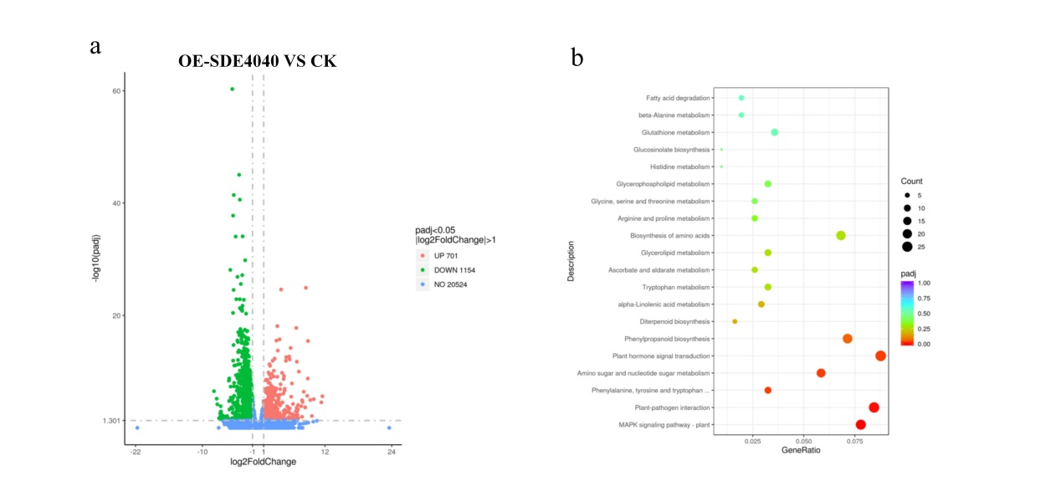
Figure S3. Transcriptomic analysis of citrus plants with SDE4040 overexpression. a Volcano plot illustrates the differential expression of genes in SDE4040 overexpressing hairy roots compared to CK hairy roots. b Kyoto Encyclopedia of Genes and Genomes (KEGG) were utilized for conducting enrichment analysis on differentially expressed genes. The x-axis represents the enrichment factor, while the y-axis displays the pathway names. The q-value is represented by color, and gene number is indicated by dot size.

