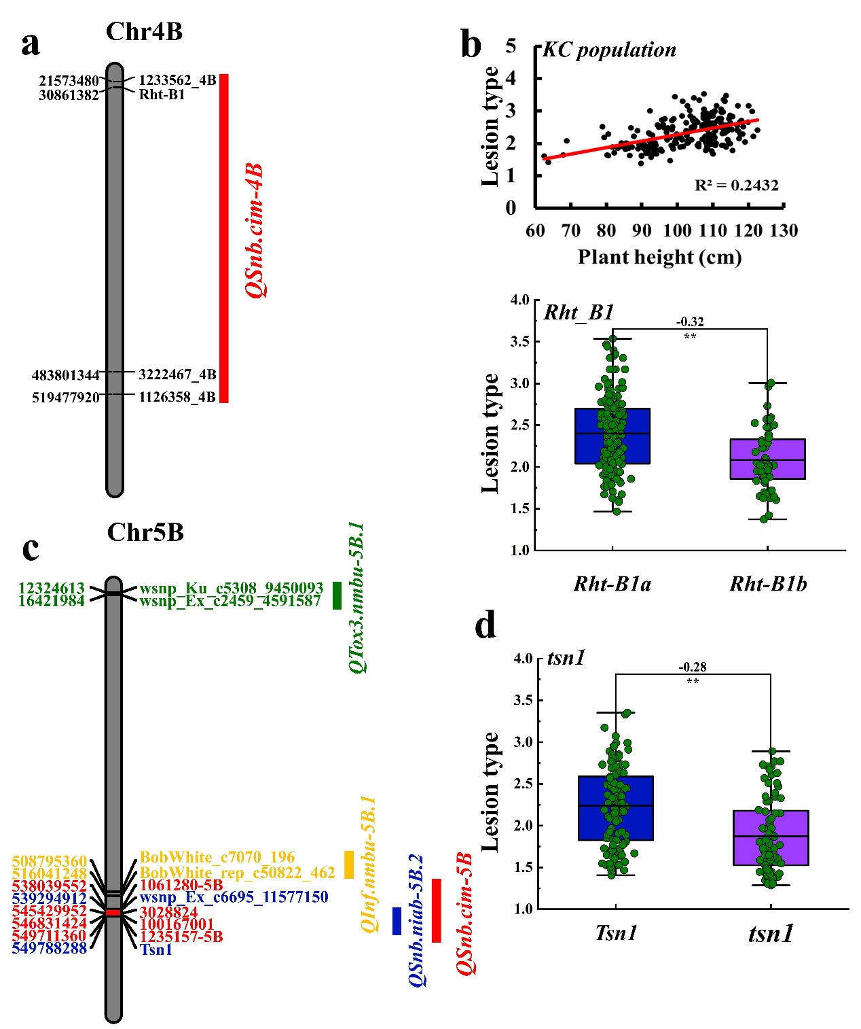
Figure S1 Analysis of QSnb.cim-4B and QSnb.cim-5B. a The QTL region of QSnb.cim-4B harboring Rht-B1. b Regression analysis of SNB and plant height (top) and the effect of Rht-B1 on SNB (bottom). c Comparison of QSnb.cim-5B (delimited by markers in red) with previously reported QTL on chromosome 5B. d The effect of tsn1 on SNB.

