Supplemental materials
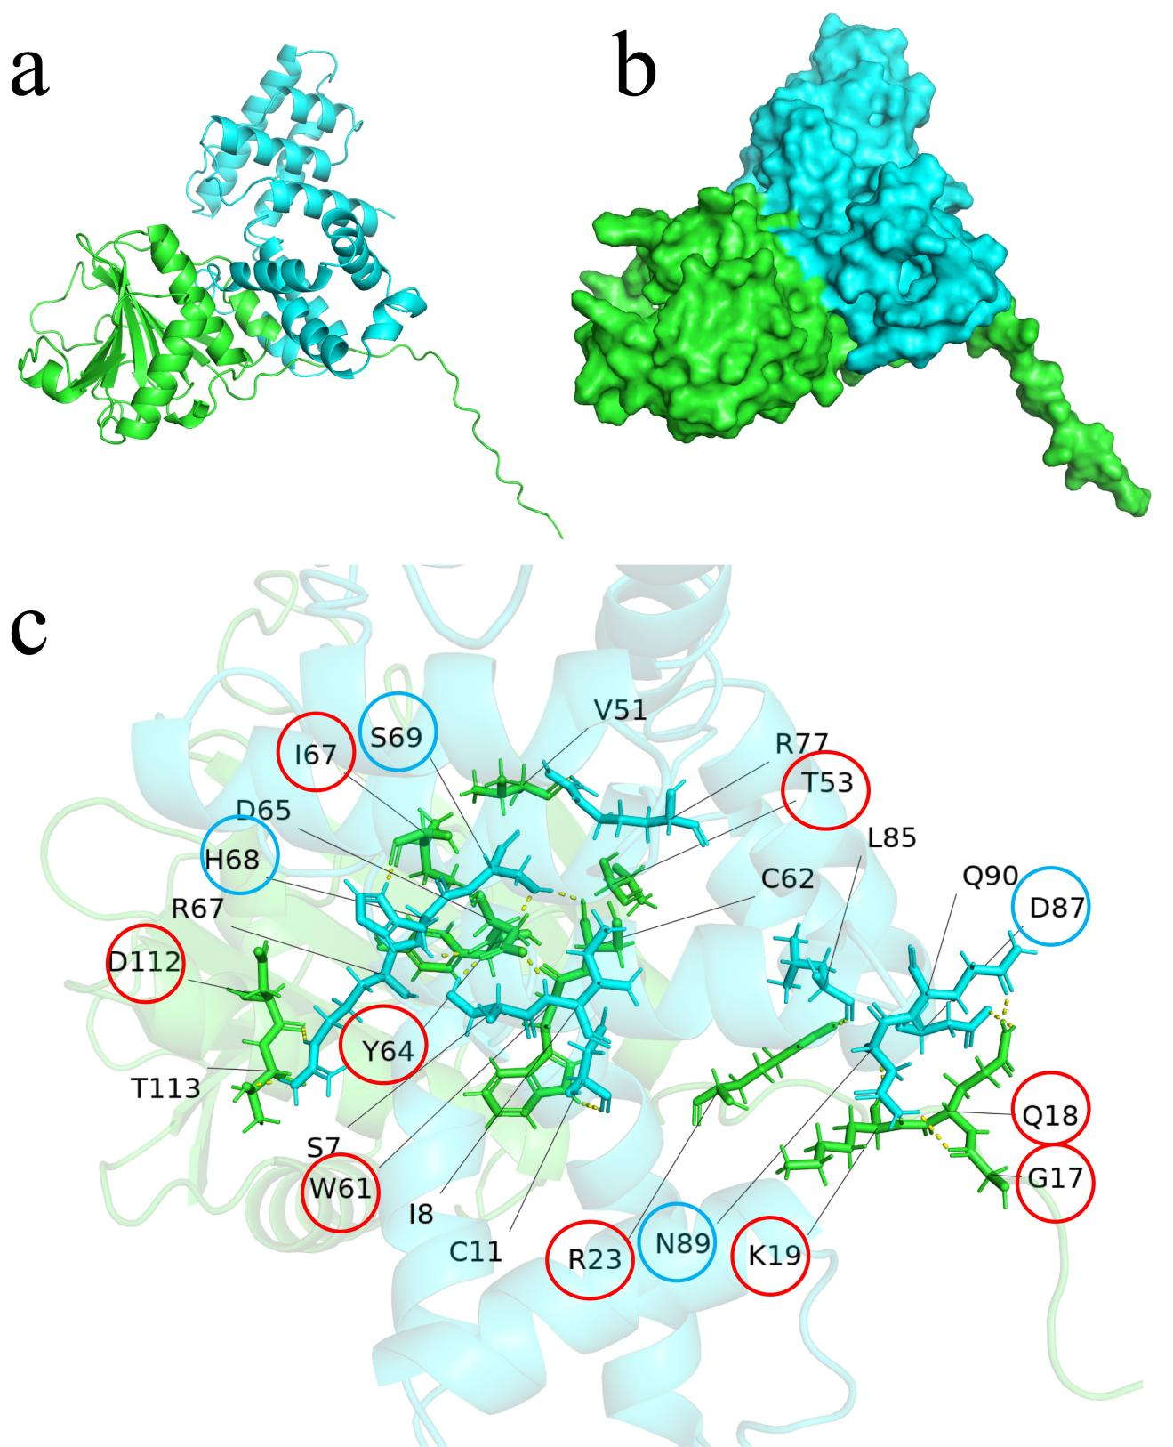

Figure S1. Three-dimensional prediction model of interaction between P25 and eIF4E. a, b The potential interaction mechanism between eIF4E and P25 proteins was predicted by the multimer module of Alphafold v2.3.2. All parameters were set to default, and the versions of the databases used included: Uniprot and Uniref90 as of March 1, 2023, and pdb_mmcif and pdb_seqres as of March 3, 2023. The databases were all default versions. Green represents eIF4E and blue represents P25. c The predicted multimeric structure was then visualized and analyzed using PyMOL v2.5.0, which identified potential hydrogen bonds and other key interaction sites between the two proteins. The key residues of eIF4E and P25 were marked with red rings and blue rings, respectively.

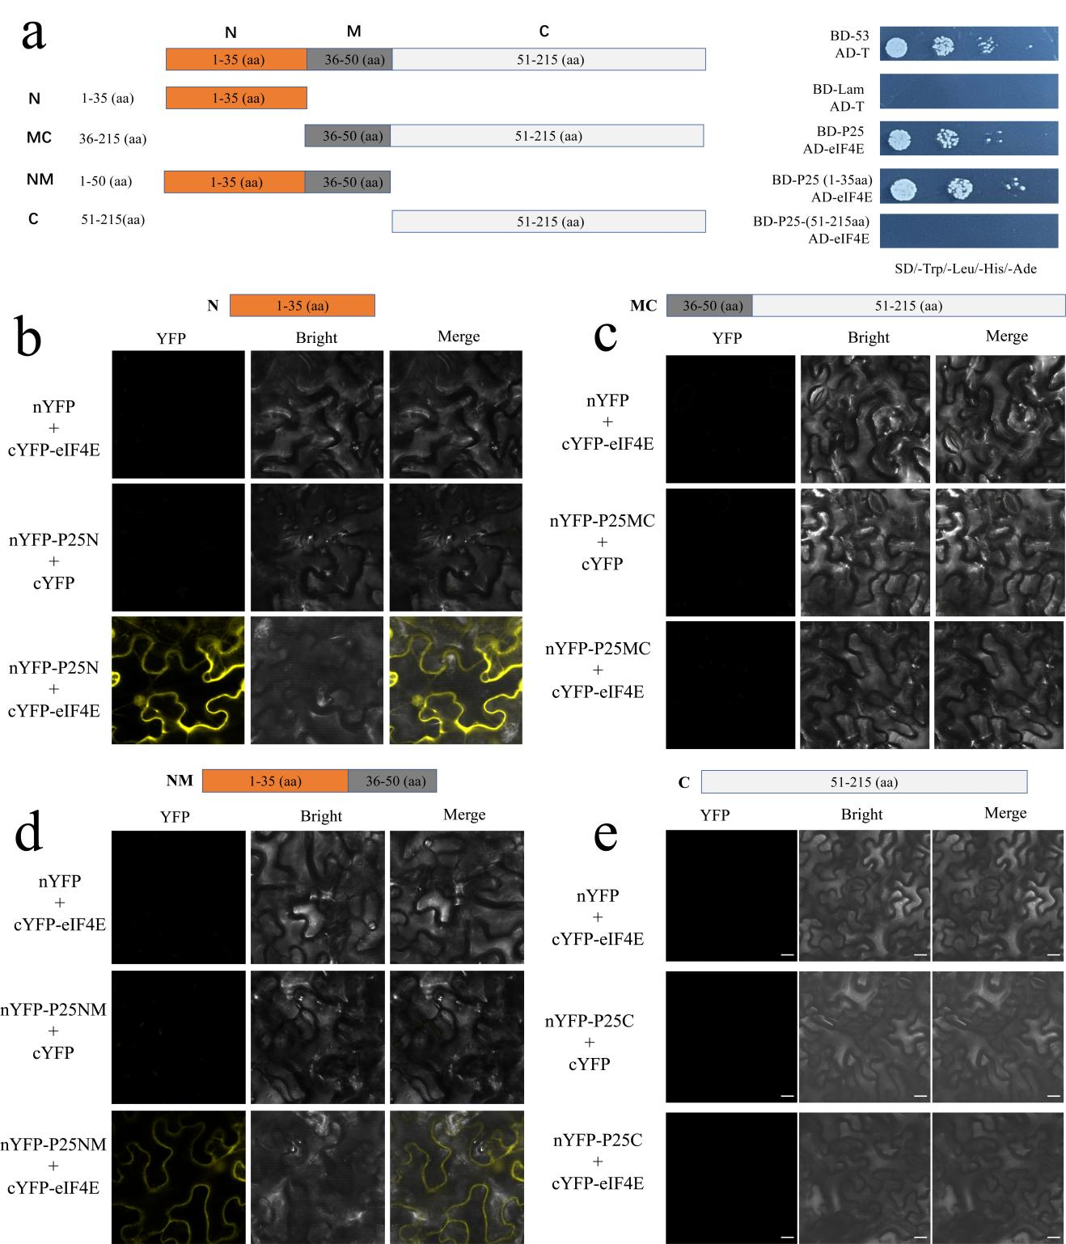

Figure S2. Interaction between eIF4E and truncated P25. The truncated fragments were represented a. Bimolecular fluorescence complementation (BiFC) assay demonstrating the interaction between the N-terminal fragments of YFP fused to the truncated P25 fragments b 1-35 aa, c 36-215 aa, d 1-50 aa , and e 51-215 aa, and eIF4E fused with C-terminal of YFP, respectively. Leaves of N. benthamiana was harvested at 72 h post-infiltration (hpi). Scale bars = 50 μm.
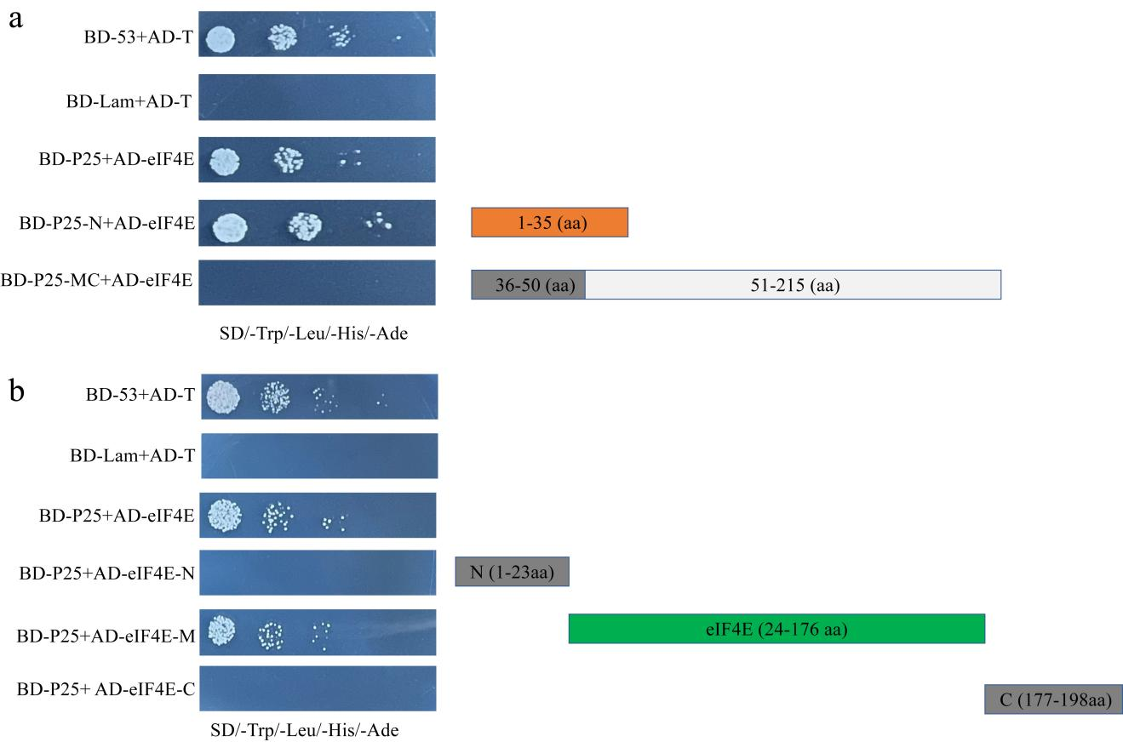

Figure S3. Determination of the domains of interaction between eIF4E and P25. Yeast two-hybrid assay demonstrating the interaction between a truncated P25 and eIF4E and between the b truncated eIF4E and P25. pGBK-Lam+pGAD-T serves as a negative control, and pGBK-53+pGAD-T as a positive control. Samples were plated on quadruple drop-out (QDO) medium (SD/-Trp/-Leu/-His/-Ade) with X-α-Gal.

a b

c d
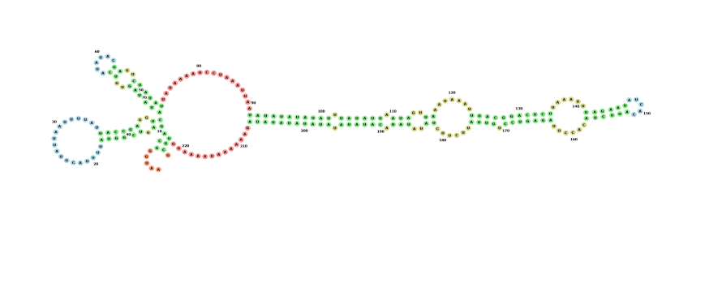

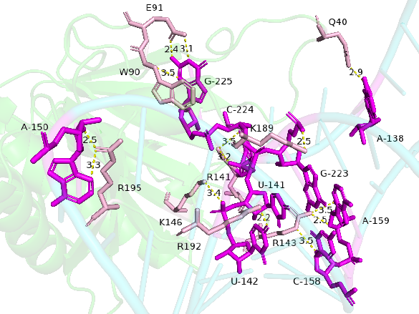
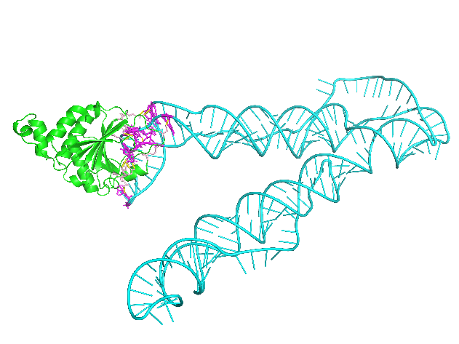

Figure S4. Prediction of secondary structure APV1-3′UTR and the interaction with eIF4E. a, b RNAfold tool were used to predict the RNA secondary structure of APV1-3′UTR and the energy and nucleotide conservancy of RNA secondary structure. The red (Minimum Free Energy, MFE), green (Partition Function Boltzmann ensemble, PF), and blue (Centroid) curves indicate the levels of stable RNA secondary structure and reliable folding in that region b. c, d The APV1-3′UTR-eIF4E binding model, and the key interacted sites were predicted by the Alphafold Multimer module. Green represents eIF4E, and blue represents RNA.

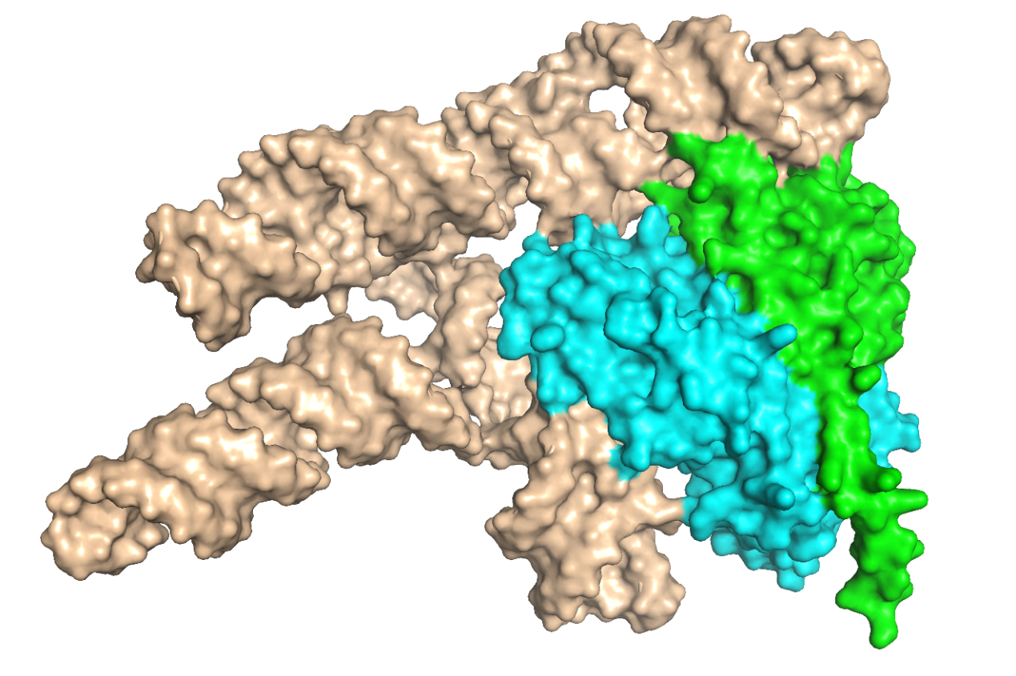
Figure S5. Predicted structural model of the ternary complex of APV1-3′-UTR, P25, and eIF4E. The potential interaction mechanism APV1-3’UTR, P25, and eIF4E was predicted by the multimer module of Alphafold 3. In the predicted structure, all parameters were set to default, and the versions of the databases used included: Uniprot and Uniref90 as of March 1, 2023, and pdb_mmcif and pdb_seqres as of March 3, 2023. The databases were all default versions. Green, blue, and brown represent eIF4E, P25 and APV1-3′-UTR, respectively.

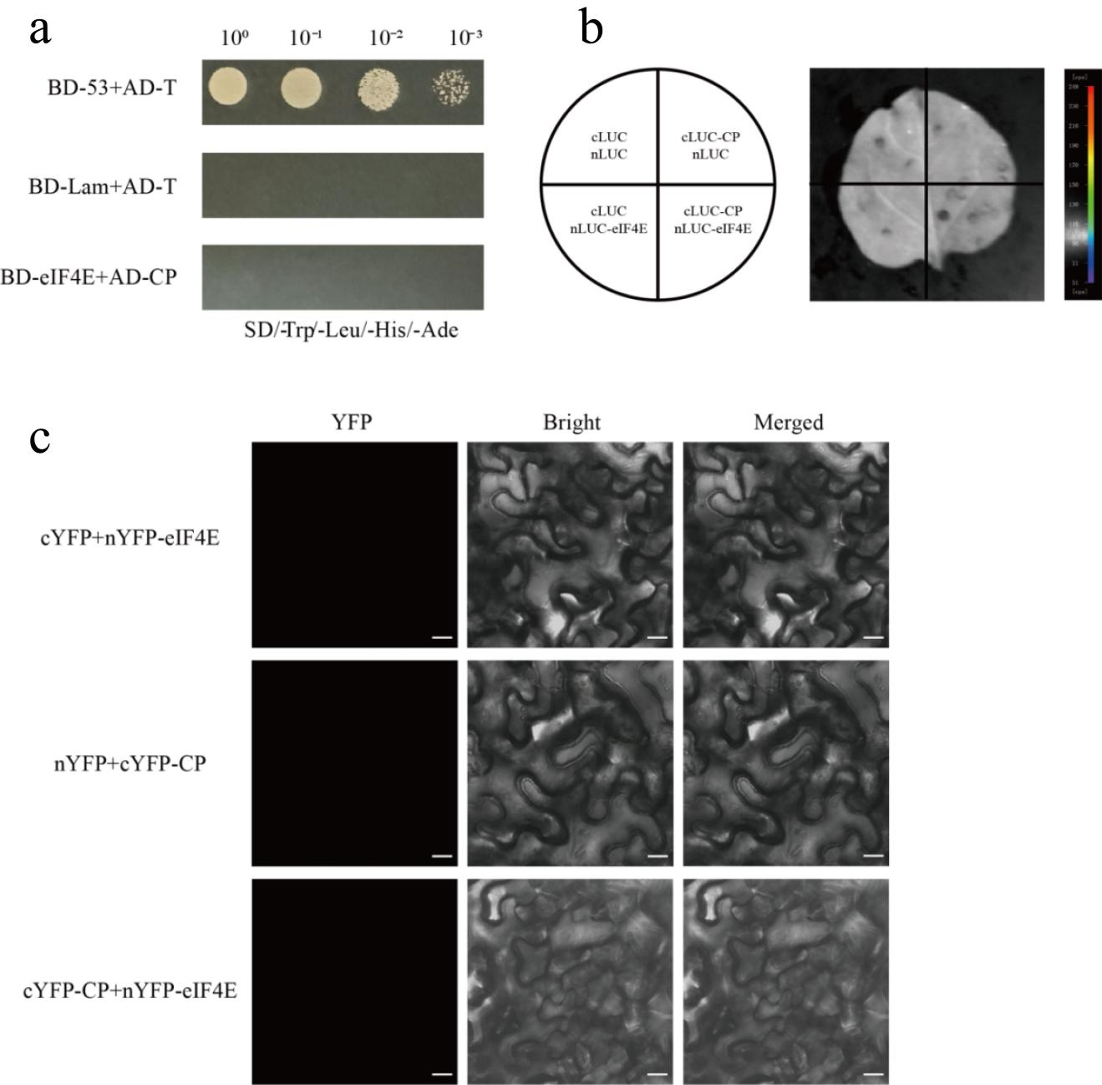

Figure S6. Determination of interaction between eIF4E and CP. a Yeast two-hybrid assay of the interaction between CP and eIF4E. pGBK-Lam+pGAD-T serves as a negative control, and pGBK-53+pGAD-T as a positive control. Samples were plated on quadruple drop-out (QDO) medium (SD/-Trp/-Leu/-His/-Ade). b Luciferase complementation assay (LCA) for the interaction between CP and eIF4E. Combinations of cLuc-CP and nLuc-eIF4E, cLuc-CP and nLuc, nLuc-eIF4E and cLuc, or cLuc and nLuc were infiltrated into a quarter section of N. benthamiana leaves. Luciferase activity was measured using the NightShade LB 985 In Vivo Plant Imaging System (Berthold Technologies, Germany) 72 hpi. c Bimolecular fluorescence complementation (BiFC) assay showing the interaction between CP and eIF4E. The vector was agroinfiltrated into N. benthamiana leaves, and fluorescence was observed using confocal microscopy 72 hpi. Scale bars =50 μm.
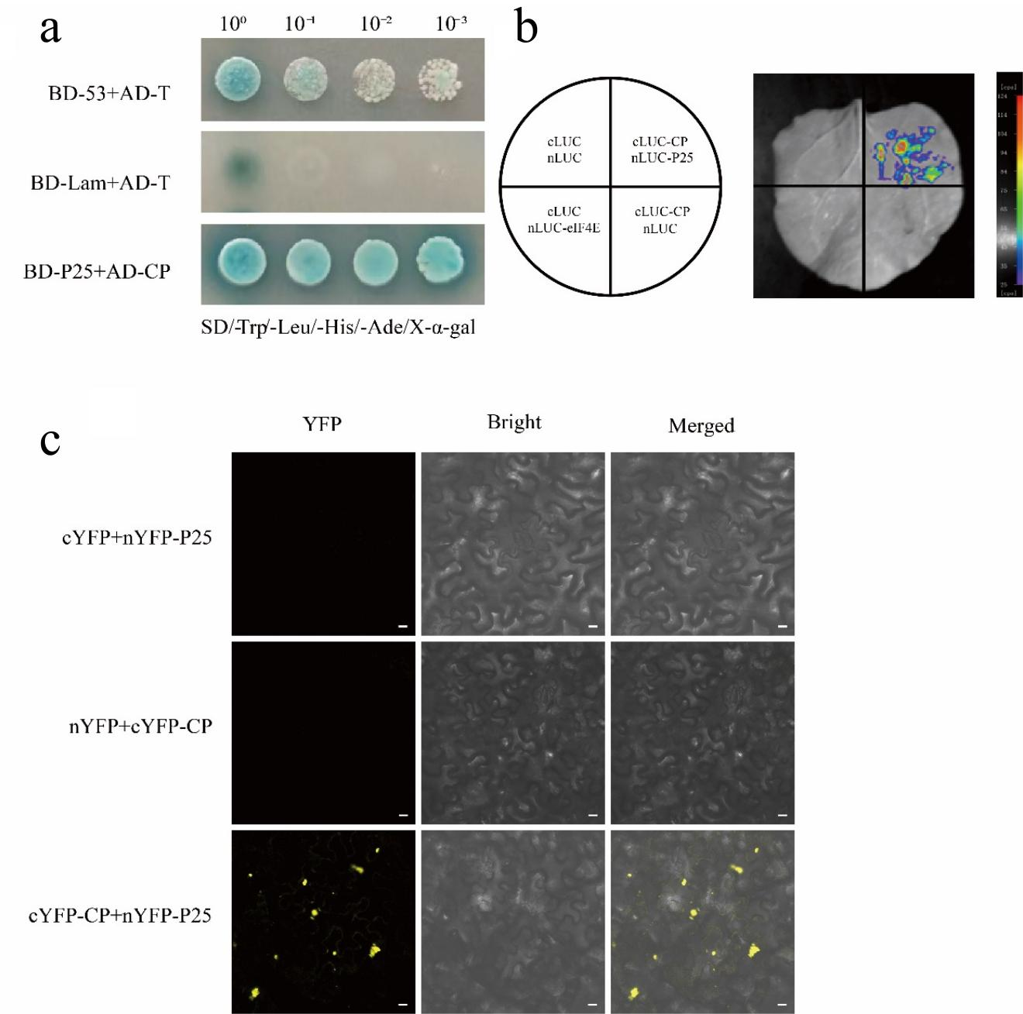

Figure S7. Determination of the interaction between CP with P25. a Yeast two-hybrid assay of the interaction between CP and P25. pGBK-Lam+pGAD-T and pGBK-53+pGAD-T serves as negative and positive control, respectively. Samples were plated on quadruple drop-out (QDO) medium. b Luciferase complementation assay (LCA) for the interaction between CP and eIF4E. Combinations of cLuc-CP and nLuc-P25, cLuc-CP and nLuc, nLuc-P25 and cLuc, or cLuc and nLuc were infiltrated into a quarter section of N. benthamiana leaves and measured using the NightShade LB 985 In Vivo Plant Imaging System (Berthold Technologies, Germany) 72 hpi. c Bimolecular fluorescence complementation (BiFC) assay showing the interaction between CP and P25. The vector was agroinfiltrated into N. benthamiana leaves, and fluorescence was observed using confocal microscopy 72 hpi. Scale bars=50 μm.

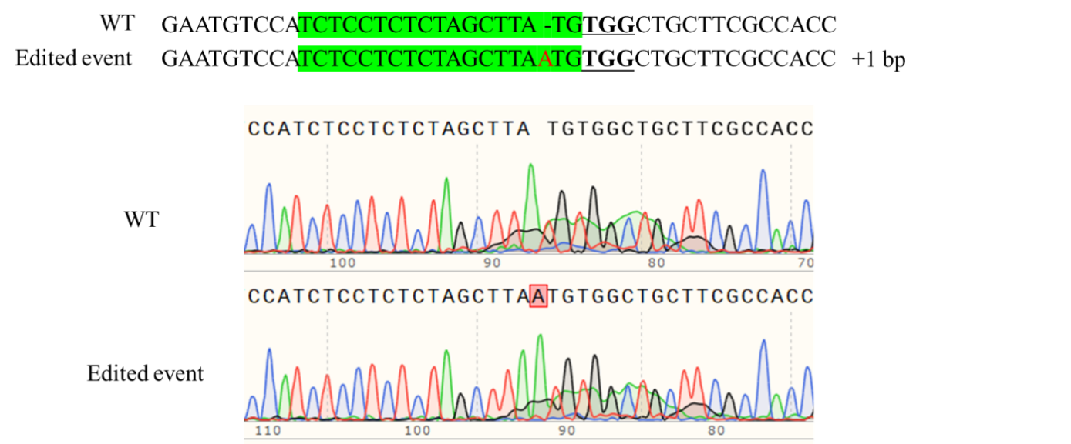
Figure S8. Alignment of the Cas9/CRISPR-mediated NbeIF4E mutant plant with the wild-type sequence. The sequences of each plant represented clones from undigested fragments. The target sequence is marked with green and the protospacer adjacent motif (PAM) is marked by bold underlined letters. DNA insertion marked with red letter. Chromosomal fragment deletion in NbeIF4E mutant plant in T1 generation was shown below.

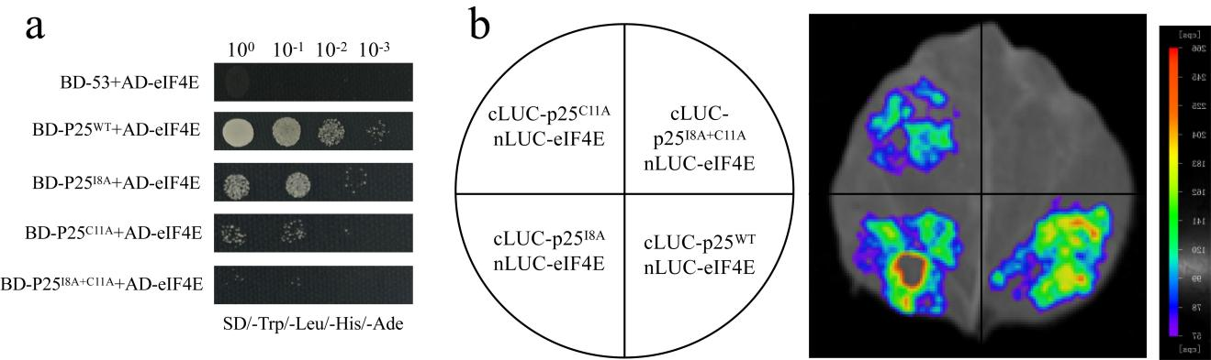

Figure S9. Mutation of key residues of P25 abolishes the interaction with eIF4E. a Yeast-two-hybrid assay of the interaction of eIF4E with wild type P25, P25^{I8A}, P25^{C11A}, and P25^{I8A+C11A}. Samples were plated on quadruple drop-out (QDO) medium. b Luciferase complementation assay (LCA) for the interaction between eIF4E and mutated P25. Combinations of nLuc-eIF4E with cLuc-p25, cLuc-p25^{I8A}, cLuc-p25^{C11A}, and cLuc-p25^{I8A+C11A} were infiltrated into a quarter section of N. benthamiana leaves, respectively, and measured using the NightShade LB 985 In Vivo Plant Imaging System (Berthold Technologies, Germany) 72 hpi.

