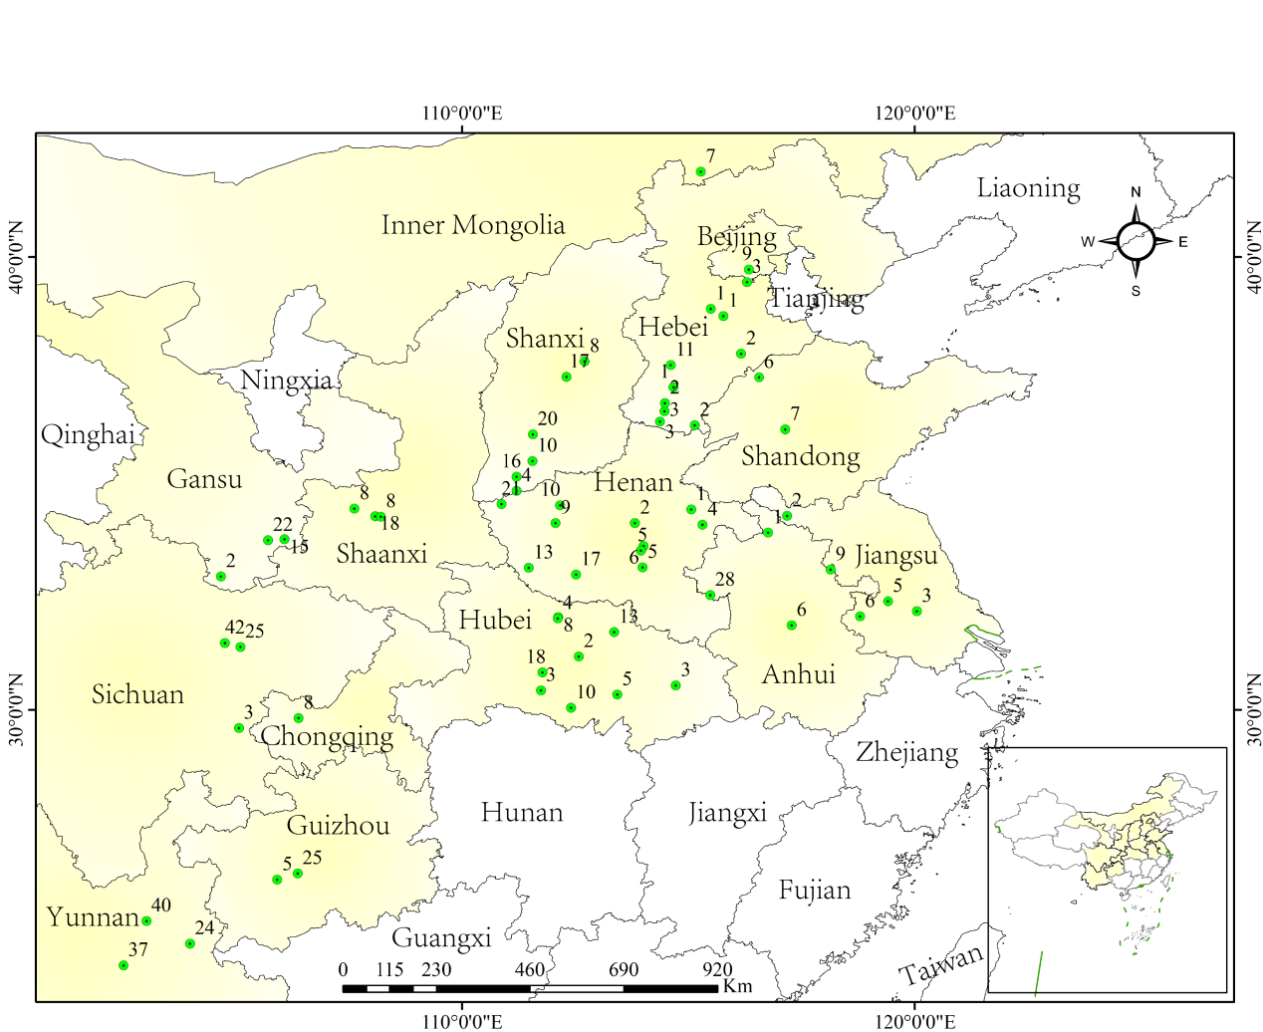
Figure S1. Sampling locations of Pst isolates during the 2019–2020 growing season.
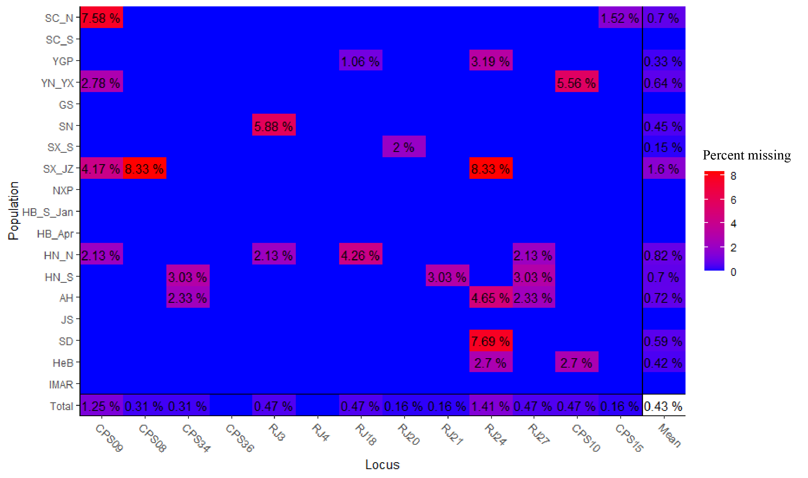
Figure S2. Percentage of missing data across 13 SSR markers. No loci exhibited missing data exceeding 10%.
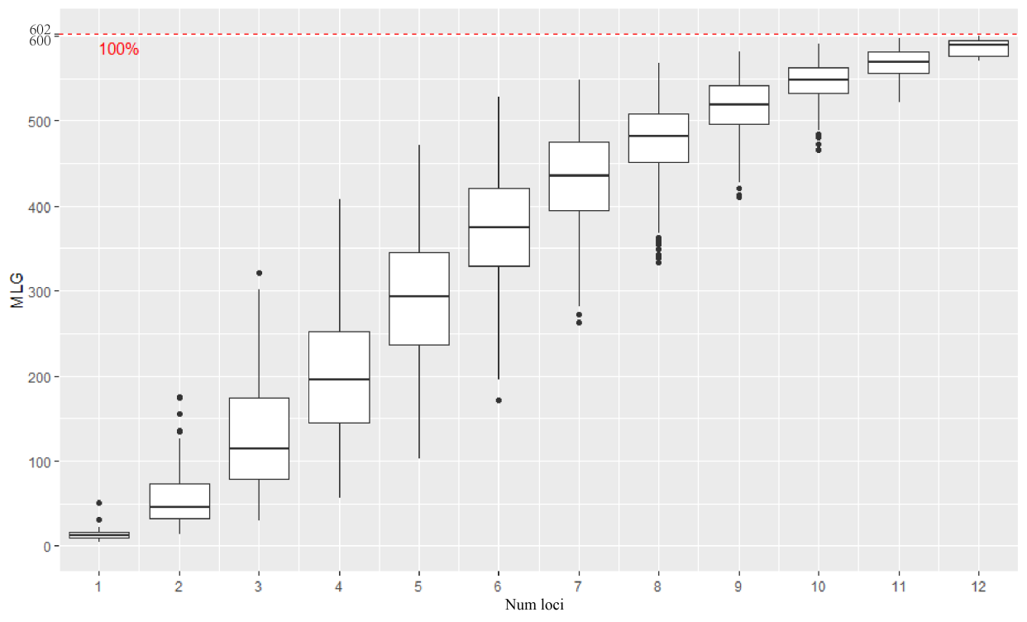
Figure S3. Genotype accumulation curve based on 13 SSR primer pairs for Pst. MLG, multilocus genotypes.
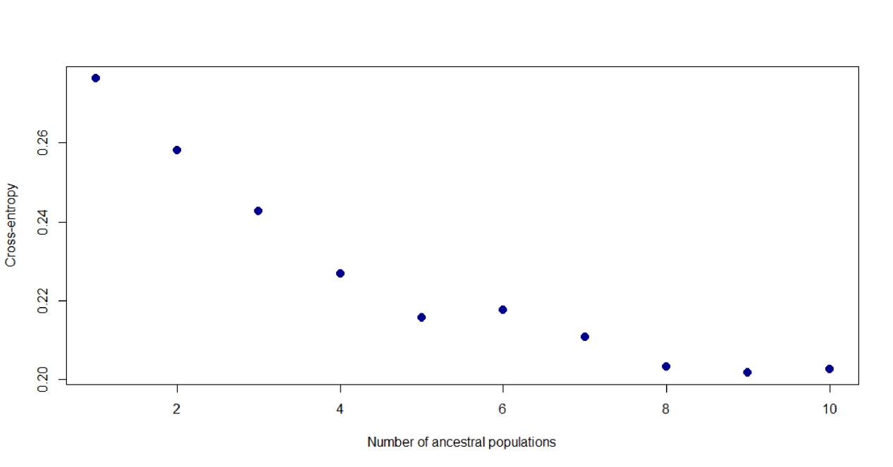
Figure S4. Cross-entropy criterion values from 10 replicate sNMF runs.
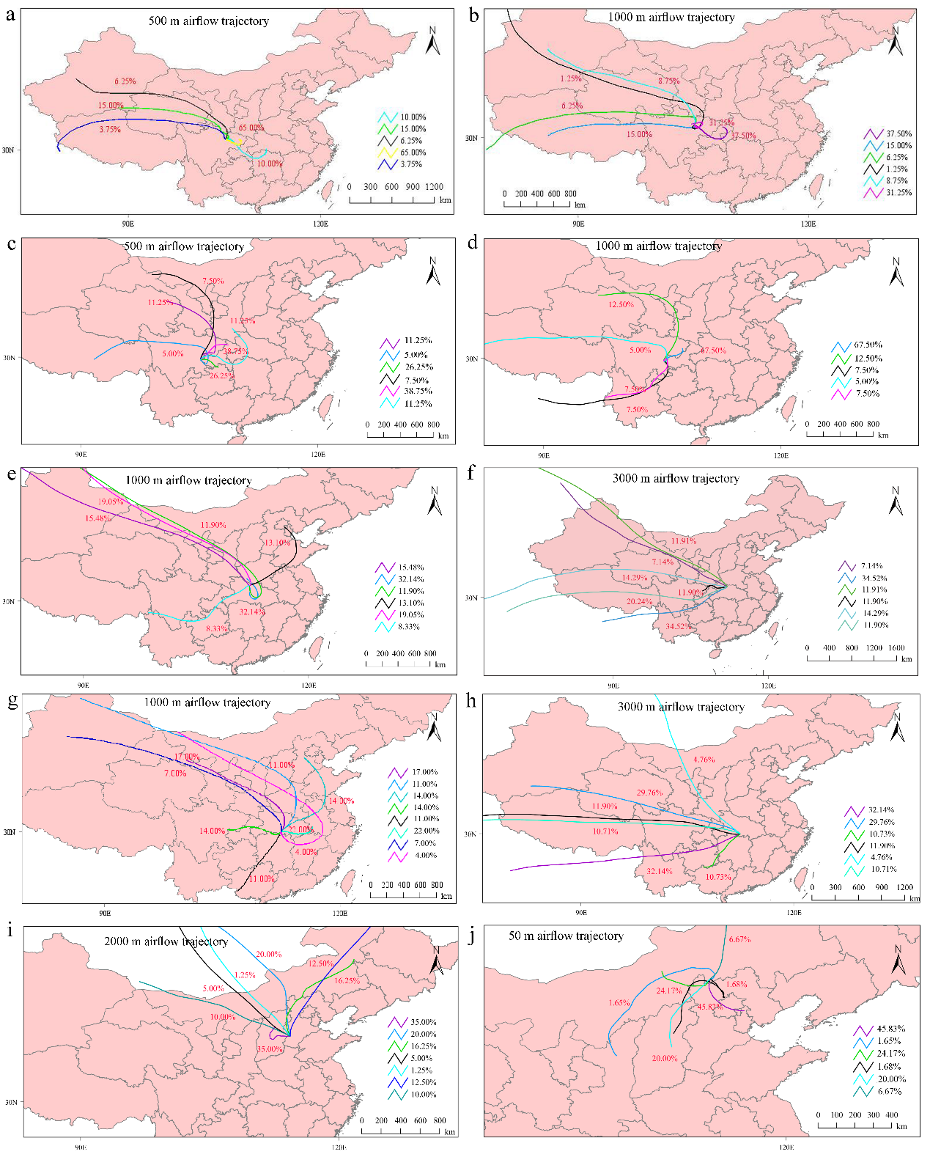
Figure S5. Backward trajectory simulation results of partial initial Pst inoculum sources. a, b Airflow trajectory simulation results of northern Sichuan (Mianyang), c, d Airflow trajectory simulation results of southern Sichuan (Neijiang), e, f Airflow trajectory simulation results of northern Hubei (Jingzhou), g, h Airflow trajectory simulation results of southern Hubei (Xiangyang), i Airflow trajectory simulation results of Hebei (Shijiazhuang), j Airflow trajectory simulation results of Inner Mongolia (Taipusiqi).
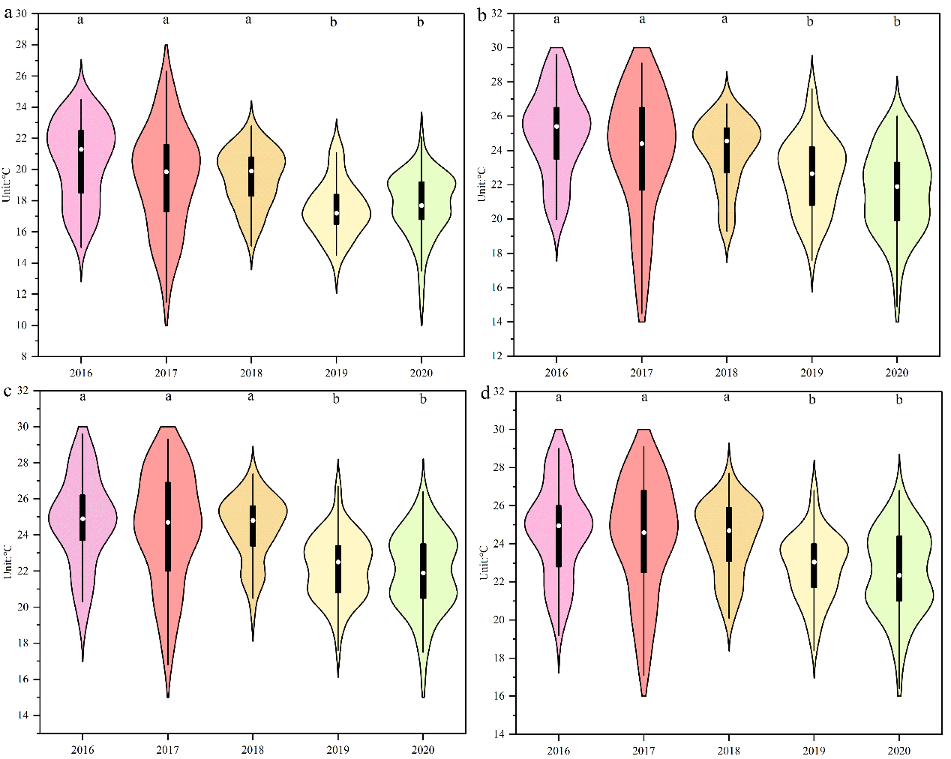
Figure S6. Violin plots of daily summer temperatures (July to August) in the over-summering regions of Pst from 2016 to 2020. a–d it represent four meteorological stations: Lintao, Tianshui, Huixian, and Chengxian in Gansu province, respectively. Values labeled with different lowercase letters are significantly different (P<0.05) as determined by the Kruskal-Wallis test.
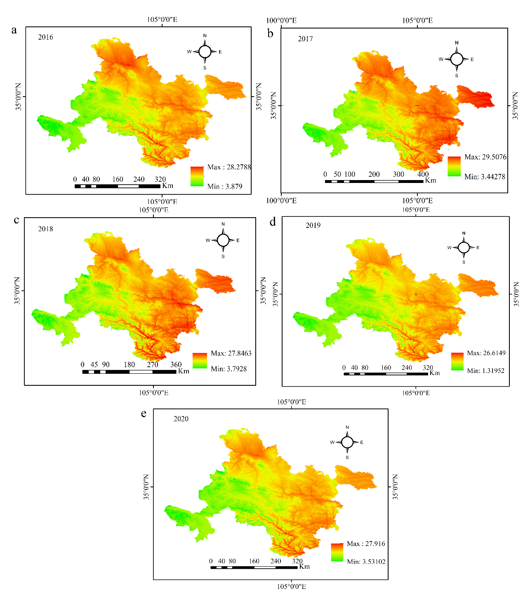
Figure S7. Oversummering area regionalization of Pst in seven prefecture-level cities of northwest China. Panels a–e represent the oversummering distribution maps of Pst from 2016 to 2020.
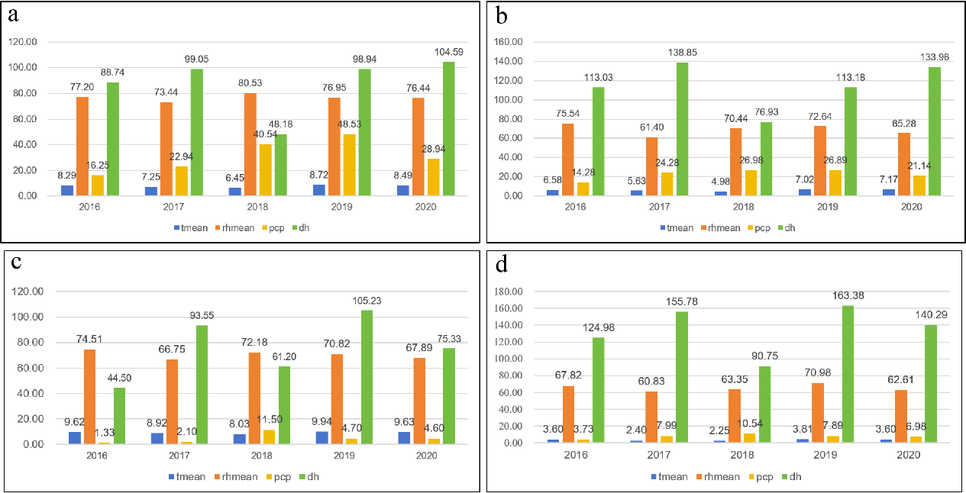
Figure S8. Statistical plots of meteorological variables associated with Pst host infection from 2016 to 2020. It represent statistical plots of monthly mean meteorological data during the winter (November–December and January–February of the following year) for the a Jianghan Plain, b Nanyang-Xiangyang Plain, c Sichuan Basin, and d Guanzhong Plain, respectively. tmean, air temperature; rhmean, mean relative humidity; pcp, precipitation; dh, sunshine duration.

