Appendix 1: Ethical consideration
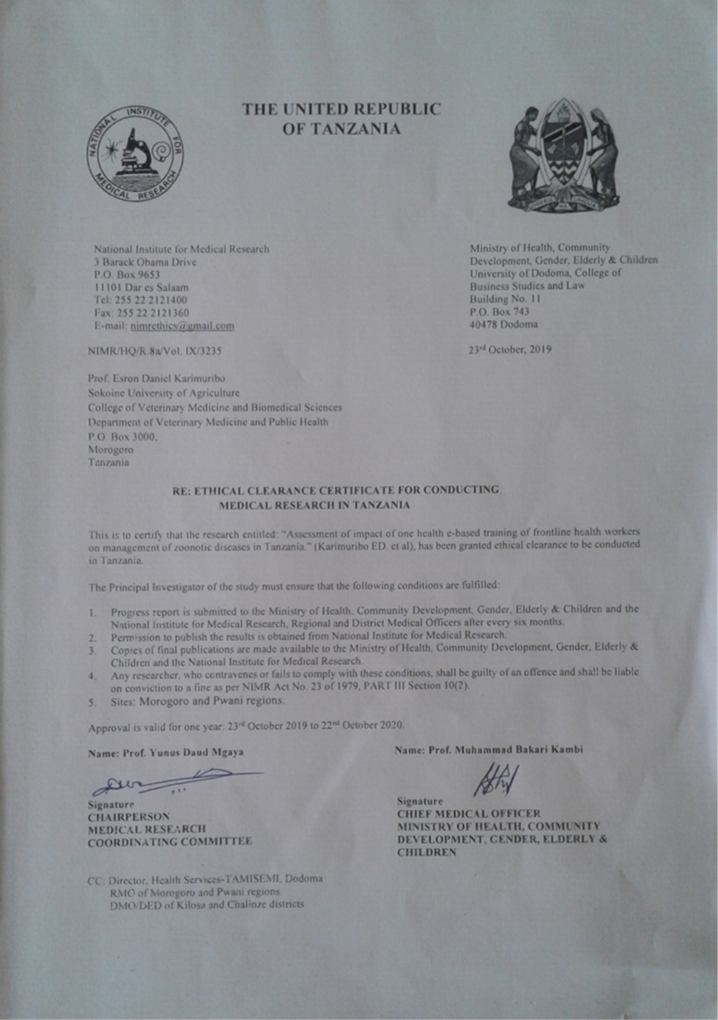

Appendix 2: Questionnaire
District name…………………. Date of interview ……………………
- FACILITY DETAILS
  - Name of the facility………………….
  - Type of health facility
- Dispensary
- Health center
- Hospital
  - Ward name …………………….
- PARTICIPANTS DETAILS
  - Name of participant………………...
  - Education
- Primary
- Secondary
- College/university
- No formal education
- Incomplete primary education
  - Profession
- Medical assistant (clinical officer)
- Medical officer
- Assistant medical officer
- Medical doctor
- Other
  - Position
- Officer in charge
- Clinician
- Other
  - Number of months in your position…………………….
  - Number of months in your work station……………………
  - Sex
- Female
- Male
2.6. Age (years)…………………………
- GENERAL KNOWLEGDE ON BRUCELLOSIS
  - Have you heard of a disease called brucellosis?
- Yes
- No
  - What organism causes brucellosis …………………...
  - Where did you get informed about brucellosis?
- Training program
- Co-worker
- Veterinary officials
- Friends
- Radio/Television/newspaper
- Other
- Brucellosis transmission: On the scale shown, how much do you agree /disagree with the following statements
  - Brucellosis affects domestic ruminants (cattle, sheep, and goats)
- Strongly agree
- Agree
- Neither agree nor disagree (neutral)
- Disagree
- Strongly disagree
  - brucellosis affects humans
- Strongly agree
- Agree
- Neither agree nor disagree (neutral)
- Disagree
- Strongly disagree
  - brucellosis can be transmitted from cattle to humans
- Strongly agree
- Agree
- Neither agree nor disagree (neutral)
- Disagree
- Strongly disagree

  - Brucellosis can be transmitted from sheep/goats to humans
- Strongly agree
- Agree
- Neither agree nor disagree (neutral)
- Disagree
- Strongly disagree
  - A person could acquire brucellosis by drinking raw/unpasteurized milk
- Strongly agree
- Agree
- Neither agree nor disagree (neutral)
- Disagree
- Strongly disagree
  - A person could acquire brucellosis by contact with aborted foetus or placenta
- Strongly agree
- Agree
- Neither agree nor disagree (neutral)
- Disagree
- Strongly disagree
  - A person could acquire brucellosis by eating meat, liver or spleen not well cooked
- Strongly agree
- Agree
- Neither agree nor disagree (neutral)
- Disagree
- Strongly disagree
  - Sexual transmission of brucellosis can occur in humans
- Strongly agree
- Agree
- Neither agree nor disagree (neutral)
- Disagree
- Strongly disagree

  - A person can acquire brucellosis by inhaling aerosolized bacteria
- Strongly agree
- Agree
- Neither agree nor disagree (neutral)
- Disagree
- Strongly disagree
  - A person can acquire brucellosis through breaks in the skin or mucous membrane
- Strongly agree
- Agree
- Neither agree nor disagree (neutral)
- Disagree
- Strongly disagree
  - A person can acquire brucellosis through blood transfusion from infected person
- Strongly agree
- Agree
- Neither agree nor disagree (neutral)
- Disagree
- Strongly disagree
  - A person can acquire brucellosis through contact with menstrual blood from the infected person
- Strongly agree
- Agree
- Neither agree nor disagree (neutral)
- Disagree
- Strongly disagree

- Clinical sign and symptoms of brucellosis in human: on the scale shown, how much do you agree /disagree with the following statements. The common clinical signs and symptoms of brucellosis include
  - Continuous or intermittent fever
- Strongly agree
- Agree
- Neither agree nor disagree (neutral)
- Disagree
- Strongly disagree
  - fatigue
- Strongly agree
- Agree
- Neither agree nor disagree (neutral)
- Disagree
- Strongly disagree
  - sweating
- Strongly agree
- Agree
- Neither agree nor disagree (neutral)
- Disagree
- Strongly disagree
  - Loss of appetite
- Strongly agree
- Agree
- Neither agree nor disagree (neutral)
- Disagree
- Strongly disagree
5.5. muscular and joint pain
- Strongly agree
- Agree
- Neither agree nor disagree (neutral)
- Disagree
- Strongly disagree
  - Pain in the back
- Strongly agree
- Agree
- Neither agree nor disagree (neutral)
- Disagree
- Strongly disagree
  - Weight loss
- Strongly agree
- Agree
- Neither agree nor disagree (neutral)
- Disagree
- Strongly disagree
  - Headache
- Strongly agree
- Agree
- Neither agree nor disagree (neutral)
- Disagree
- Strongly disagree
  - coughing
- Strongly agree
- Agree
- Neither agree nor disagree (neutral)
- Disagree
- Strongly disagree

  - Swollen lymph nodes
- Strongly agree
- Agree
- Neither agree nor disagree (neutral)
- Disagree
- Strongly disagree

  - Abortion
- Strongly agree
- Agree
- Neither agree nor disagree (neutral)
- Disagree
- Strongly disagree
  - Inflammation of the epididymis and/testicles
- Strongly agree
- Agree
- Neither agree nor disagree (neutral)
- Disagree
- Strongly disagree
- Awareness on Diagnosis of brucellosis: on the scale shown, how much do you agree /disagree with the following statements. Diagnosis of brucellosis can be made through
  - history of prolonged at least a week by presence of clinical signs like repeated fever
- Strongly agree
- Agree
- Neither agree nor disagree (neutral)
- Disagree
- Strongly disagree
  - patient’s history of exposure to likely sources of the diseases
- Strongly agree
- Agree
- Neither agree nor disagree (neutral)
- Disagree
- Strongly disagree
  - serological test
- Strongly agree
- Agree
- Neither agree nor disagree (neutral)
- Disagree
- Strongly disagree
  - culture technique
- Strongly agree
- Agree
- Neither agree nor disagree (neutral)
- Disagree
- Strongly disagree

  - Diagnosis and reporting practices in healthcare workers
  - Do you advice clients/patients to get tested for brucellosis
- Yes
- No
  - Do you provide any test that can be used to diagnose brucellosis in humans in this facility?
 Yes
 No
  - If yes to Qn 7.2 mention the test……………………
  - What human samples do you take for diagnosis of brucellosis?
- Blood
- Cerebrospinal fluid
- Others
  - How many cases of brucellosis have you ever suspected in patients who attended this facility during the past 1 month? …………………………..
  - How many cases of brucellosis have you ever confirmed in patients who attended this facility during the past 1 month? …………………………….
  - How frequently do you consider brucellosis diagnosis for patients attending this facility?
- Frequently
- Rarely
- None at all
  - Do you have test reagents for brucellosis in this facility?
- Yes
- No
  - If yes to Qn 7.8, what reagent do you have in place………………………
  - Do you refer samples elsewhere for brucellosis testing?
- Yes
- No
  - If you yes to Qn. 7.10, where do you refer …………….
  - If you refer sample to testing elsewhere, do you get feedback on results
- Yes
- No
- NA
  - How long it usually takes to receive resulting from referral point
- Within a day
- 2-3 days
- 4-7 days
- `1-2 weeks
- 3-4 weeks
- >month
- NA
  - How do you receive results from referral point?
- Phone calls/sms
- Collected physically on paper
- Digital technology
- Not applicable
  - Do you communicate results from referral point to patients?
- Yes
- No
  - How do you communicate test result to patients? (1mark)
- Phone calls/sms
- Collected physically on paper
- Digital technology
- Not applicable
  - Do you have guidelines for diagnosis and management of brucellosis?
- Yes
- No
  - If yes to Qn 7.17, ask to see the guidelines: guidelines seen?
- Yes
- No
- Detection and Reporting practices in community health workers
8.1. Do you advice /refer patients to visit health facilities when they experience clinical manifestation suggestive of brucellosis?
- Yes
- No
  - How do you provide referral to health facility?
- Verbal
- Written
- Do not provide referral
  - Do you advise farmers to consult veterinary officers when their animals experience clinical manifestation suggestive of brucellosis?
- Yes
- No
  - Do you keep record of suspected brucellosis cases in animals?
- Yes
- No
  - Do you keep record of suspected brucellosis cases in human?
- Yes
- No
  - Where do you keep record?
- Note book
- Records forms
- Phone
- NA
  - How frequently do you submit reports for human cases to higher levels?
- Daily
- Weekly
- Monthly
- Quarterly
- Other
- Not submitting
  - How frequently do you submit reports for animal cases to higher levels?
 Daily
 Weekly
 Monthly
 Quarterly
 Other
 Not submitting
  - How do you submit reports to higher levels?
- Phone call/sms
- Physical visitation
- Digital technology
- Other
  - How long it usually takes to receive feedback from higher level?
- Within a day
- 2-3 days
- 4-7 days
- 1-2 weeks
- 3-4 weeks
- >month
- Never receive feedback
  - How do you receive feedback from higher level?
 Phone call/sms
 Physical visitation
 Digital technology
 Other
  - How do you communicate feedback to patients/community members?
- Phone call/sms
- Physical visitation
- Digital technology
- Gathering/meeting
- Not communicating
  - Have ever receive training on the detection of diseases transmissible between animals and humans?
- Yes
- No
  - Do you have guidelines or references materials for detection, recording and submission of clinical manifestation suggestive of brucellosis?
- Yes
- No
  - If yes to last Qn; ask to see guidelines/references materials: seen
- Yes
- No
- Prevention and control of brucellosis: on the scale shown, how much do you agree /disagree with the following statements. Brucellosis can be prevented by:
9.1. Drinking boiled/pastoralized milk
- Strongly agree
- Agree
- Neither agree nor disagree (neutral)
- Disagree
- Strongly disagree
  - Eating meat, liver or spleen well cooked
- Strongly agree
- Agree
- Neither agree nor disagree (neutral)
- Disagree
- Strongly disagree
  - Control of brucellosis in human depends much on control of the disease in animals
- Strongly agree
- Agree
- Neither agree nor disagree (neutral)
- Disagree
- Strongly disagree
  - Wearing gloves when handling aborted fetuses or placenta
- Strongly agree
- Agree
- Neither agree nor disagree (neutral)
- Disagree
- Strongly disagree
  - Washing hands after close contact with animals and/their products
- Strongly agree
- Agree
- Neither agree nor disagree (neutral)
- Disagree
- Strongly disagree
  - Proper disposal of infected materials
- Strongly agree
- Agree
- Neither agree nor disagree (neutral)
- Disagree
- Strongly disagree

- Attitude: on the scale shown, how much do you agree /disagree with the following statements.
10.1. Brucellosis is an important public health disease in Tanzania
- Strongly agree
- Agree
- Neither agree nor disagree (neutral)
- Disagree
- Strongly disagree
  - Brucellosis affects mostly the pastoral communities
- Strongly agree
- Agree
- Neither agree nor disagree (neutral)
- Disagree
- Strongly disagree
  - Brucellosis can be successfully cured
- Strongly agree
- Agree
- Neither agree nor disagree (neutral)
- Disagree
- Strongly disagree
  - Inadequate knowledge and awareness of brucellosis amongst the FHWs contribute to misdiagnosis of the disease
- Strongly agree
- Agree
- Neither agree nor disagree (neutral)
- Disagree
- Strongly disagree
  - Brucellosis can be prevented and controlled through collaborative strategy between animal and human sectors
- Strongly agree
- Agree
- Neither agree nor disagree (neutral)
- Disagree
- Strongly disagree
  - Use of guidelines or references materials can be enhanced appropriate diagnosis and management of brucellosis
- Strongly agree
- Agree
- Neither agree nor disagree (neutral)
- Disagree
- Strongly disagree
  - Engagement of community health workers in event-based surveillance can enhanced early detection and reporting of brucellosis suspected cases
- Strongly agree
- Agree
- Neither agree nor disagree (neutral)
- Disagree
- Strongly disagree
  - Public awareness is important for disease prevention and control
- Strongly agree
- Agree
- Neither agree nor disagree (neutral)
- Disagree
- Strongly disagree
  - Use of mobile phone-based technology can enhance early detection and communication of test results compared with paper-based system
- Strongly agree
- Agree
- Neither agree nor disagree (neutral)
- Disagree
- Strongly disagree
11. What type of mobile phone do you own
- Ordinary phone
- Smart phone
- None

List of abbreviation
SPSS: Statistical package for the social sciences.
HWs – Healthcare workers
FHW – Frontline health workers
CHW – Community health workers
KAP – Knowledge, Attitude and Practices
SD – Standard deviation
SAT–Standard tube Agglutination Test
OIE – World Organization for Animal Health
WHO – World Health Organization

