Supplementary Table 1: List of birds tested for the presence of Usutu and West Nile virus RNA

Sample code | Species | Locality | Date of death/  finding | Wild or captive | Sampled tissues
277TM | Turdus merula | Černošice | 8/2022 | wild | blood/coagulum, brain, kidneys, lung, liver, spleen
278TM | Turdus merula | Brno | 7/2024 | wild | brain, kidneys, lung, liver, spleen
279TM | Turdus merula | Mokré | 7/2024 | wild | brain
280TM | Turdus merula | České Budějovice | 9/2024 | wild | brain
281NP | Nothoprocta perdicaria | Brno Zoo | 18/8/2024 | captive | brain, heart, kidneys, lungs, liver, spleen
282NP | Nothoprocta perdicaria | Brno Zoo | 17/8/2024 | captive | blood/coagulum, brain, lungs, liver
283NP | Nothoprocta perdicaria | Brno Zoo | 25/8/2024 | captive | brain, lungs, liver
284NP | Nothoprocta perdicaria | Brno Zoo | 21/8/2024 | captive | brain, liver
285 | Alectroenas madagascariensis | Plzeň Zoo | 6/9/2024 | captive | brain, liver
286AF | Aegolius funereus | Olomouc Zoo | 20/8/2024 | captive | heart, liver
287BB | Bubo bubo | Kroměříž | 4/2024 | captive | spleen
288PF | Poicephalus flavifrons | Prostějov | 8/2024 | captive | brain
289PP | Perdix perdix | Vyškov | 8/2024 | captive | liver
290EoR | Eolophus roseicapilla | Břeclav | 7/2024 | captive | multiple internal organs
291ER | Erithacus rubecula | Brno | 9/2024 | wild | brain
292SP | Sturnia pagodarum | Ostrava Zoo | 6/9/2024 | captive | brain, cloacal swab, choanal swab, heart, kidneys, lungs, liver
293SS | Sturnia sinensis | Ostrava Zoo | 10/9/2024 | captive | brain, heart, kidney, liver, spleen
294GP | Glaucidium passerinum | Ostrava Zoo | 8/9/2024 | captive | brain, heart, kidney, lungs, liver, spleen
295FF | Falco femoralis​ | Hodonín | 9/2024 | captive | brain, kidney, lungs, spleen
296FF | Falco femoralis​ | Hodonín | 9/2024 | captive | brain, kidneys, lungs
CU700 | Aegolius funereus | Ostrava Zoo | 29/7/2024 | captive | choanal/cloacal swabs
CU701 | Sturnia pagodarum | Ostrava Zoo | 26/8/2024 | captive | choanal/cloacal swabs

Supplementary Table 2. Sequences of primer and probes used for multiplex one-step RT-qPCR detection of Usutu and West Nile virus RNA in the bird samples.

Target | Primer/probe | Sequence | Reference
Usutu virus | UsuFP | CAAAGCTGGACAGACATCCCTTAC | Nikolay et al. 2014
Usutu virus | UsuP | FAM-AAGACATATGGTGTGGAAGCCTGATAGGCA-BHQ | Nikolay et al. 2014
Usutu virus | UsuRP | CGTAGATGTTTTCAGCCCACGT | Nikolay et al. 2014
West Nile virus | INEID F1 | AGTAGTTCGCCTGTGTGAGC | Eiden et al. 2010
West Nile virus | INEID probe | CY5-AATCCTCACAAACACTACTAAGTTTGTCA-BHQ2 | Eiden et al. 2010
West Nile virus | INEID R1 | GCCCTCCTGGTTTCTTAGA | Eiden et al. 2010

Supplementary Table 3. Serum samples from zoos and private owners used for the detection of anti-flaviviral antibodies.
Sample ID | Species | Origin | ELISA
218 | Mikado pheasant (Syrmaticus mikado) | Brno Zoo | positive
223 | Mikado pheasant (Syrmaticus mikado) | Brno Zoo | positive
226 | Mikado pheasant (Syrmaticus mikado) | Brno Zoo | borderline
230 | Mikado pheasant (Syrmaticus mikado) | Brno Zoo | positive
1 | Galah (Eolophus roseicapilla) | private owner | negative
2 | Grey parrot (Psittacus erithacus) | private owner | negative
3 | Burrowing parrot (Cyanoliseus patagonus) | private owner | negative
4 | Grey parrot (Psittacus erithacus) | private owner | negative
5 | Senegal parrot (Poicephalus senegalus) | private owner | negative
6 | Blue-fronted amazon (Amazona aestiva) | private owner | negative
7 | Red-spectacled amazon (Amazona pretrei) | private owner | negative
8 | Grey parrot (Psittacus erithacus) | private owner | negative
9 | Blue-fronted amazon (Amazona aestiva) | private owner | negative
10 | Blue-fronted amazon (Amazona aestiva) | private owner | negative
11 | Grey parrot (Psittacus erithacus) | private owner | negative
12 | Grey parrot (Psittacus erithacus) | private owner | negative
13 | Blue-and-yellow macaw (Ara ararauna) | private owner | negative
14 | Black-headed parrot (Pionites melanocephalus) | private owner | negative
15 | Black-headed parrot (Pionites melanocephalus) | private owner | negative
16 | Moluccan eclectus (Eclectus roratus) | private owner | negative
17 | Yellow-crowned amazon (Amazona ochrocephala) | private owner | negative
18 | White cockatoo (Cacatua alba) | private owner | negative
19 | Senegal parrot (Poicephalus senegalus) | private owner | negative
20 | Hyacinth macaw (Anodorhynchus hyacinthinus) | private owner | negative
21 | Grey parrot (Psittacus erithacus) | private owner | negative
22 | Grey parrot (Psittacus erithacus) | private owner | negative
23 | Grey parrot (Psittacus erithacus) | private owner | negative
24 | Blue-and-yellow macaw (Ara ararauna) | private owner | negative
25 | Grey parrot (Psittacus erithacus) | private owner | negative
26 | Blue-fronted amazon (Amazona aestiva) | private owner | negative
27 | Blue-winged macaw (Primolius maracana) | private owner | negative
28 | Grey parrot (Psittacus erithacus) | private owner | negative
29 | Grey parrot (Psittacus erithacus) | private owner | negative
30 | Grey parrot (Psittacus erithacus) | private owner | negative
31 | Grey parrot (Psittacus erithacus) | private owner | negative
32 | Gyrfalcon (Falco rusticolus) | private owner | positive
33 | Senegal parrot (Poicephalus senegalus) | private owner | negative
34 | Blue-and-yellow macaw (Ara ararauna) | private owner | negative
35 | Grey parrot (Psittacus erithacus) | private owner | negative
36 | Tawny owl (Strix aluco) | private owner | positive
N1H | Snow leopard (Panthera uncia) | Olomouc Zoo | negative
N2H | Lar gibon (Hylobates lar) | Plzeň Zoo | negative
N3H | African buffalo (Syncerus caffer) | Dvůr Králové nad Labem Zoo | negative
N4H | Common blackbird (Turdus merula) | Hluboká nad Vltavou Zoo | negative
N2 | Cheetah (Acinonyx jubatus) | Olomouc Zoo | negative
N3 | Reindeer (Rangifer tarandus) | Olomouc Zoo | borderline
N5 | Leopard (Panthera pardus) | Olomouc Zoo | negative
N6 | Elk (Alces alces) | Olomouc Zoo | negative
N27 | Red lechwe (Kobus leche) | Plzeň Zoo | negative
N28 | Wapiti (Cervus canadensis) | Plzeň Zoo | negative
N29 | Mountain goat (Oreamnos americanus) | Plzeň Zoo | negative
N30 | Mountain goat (Oreamnos americanus) | Plzeň Zoo | negative
N31 | Mountain goat (Oreamnos americanus) | Plzeň Zoo | negative
N36 | Blesbok (Damaliscus pygargus phillipsi) | Plzeň Zoo | negative
N39 | Mountain goat (Oreamnos americanus) | Plzeň Zoo | negative
N40 | Black-backed jackal (Lupulella mesomelas) | Plzeň Zoo | negative
N41 | Wolf (Canis lupus) | Plzeň Zoo | negative
N42 | Wolf (Canis lupus) | Plzeň Zoo | borderline
N43 | Wolf (Canis lupus) | Plzeň Zoo | negative

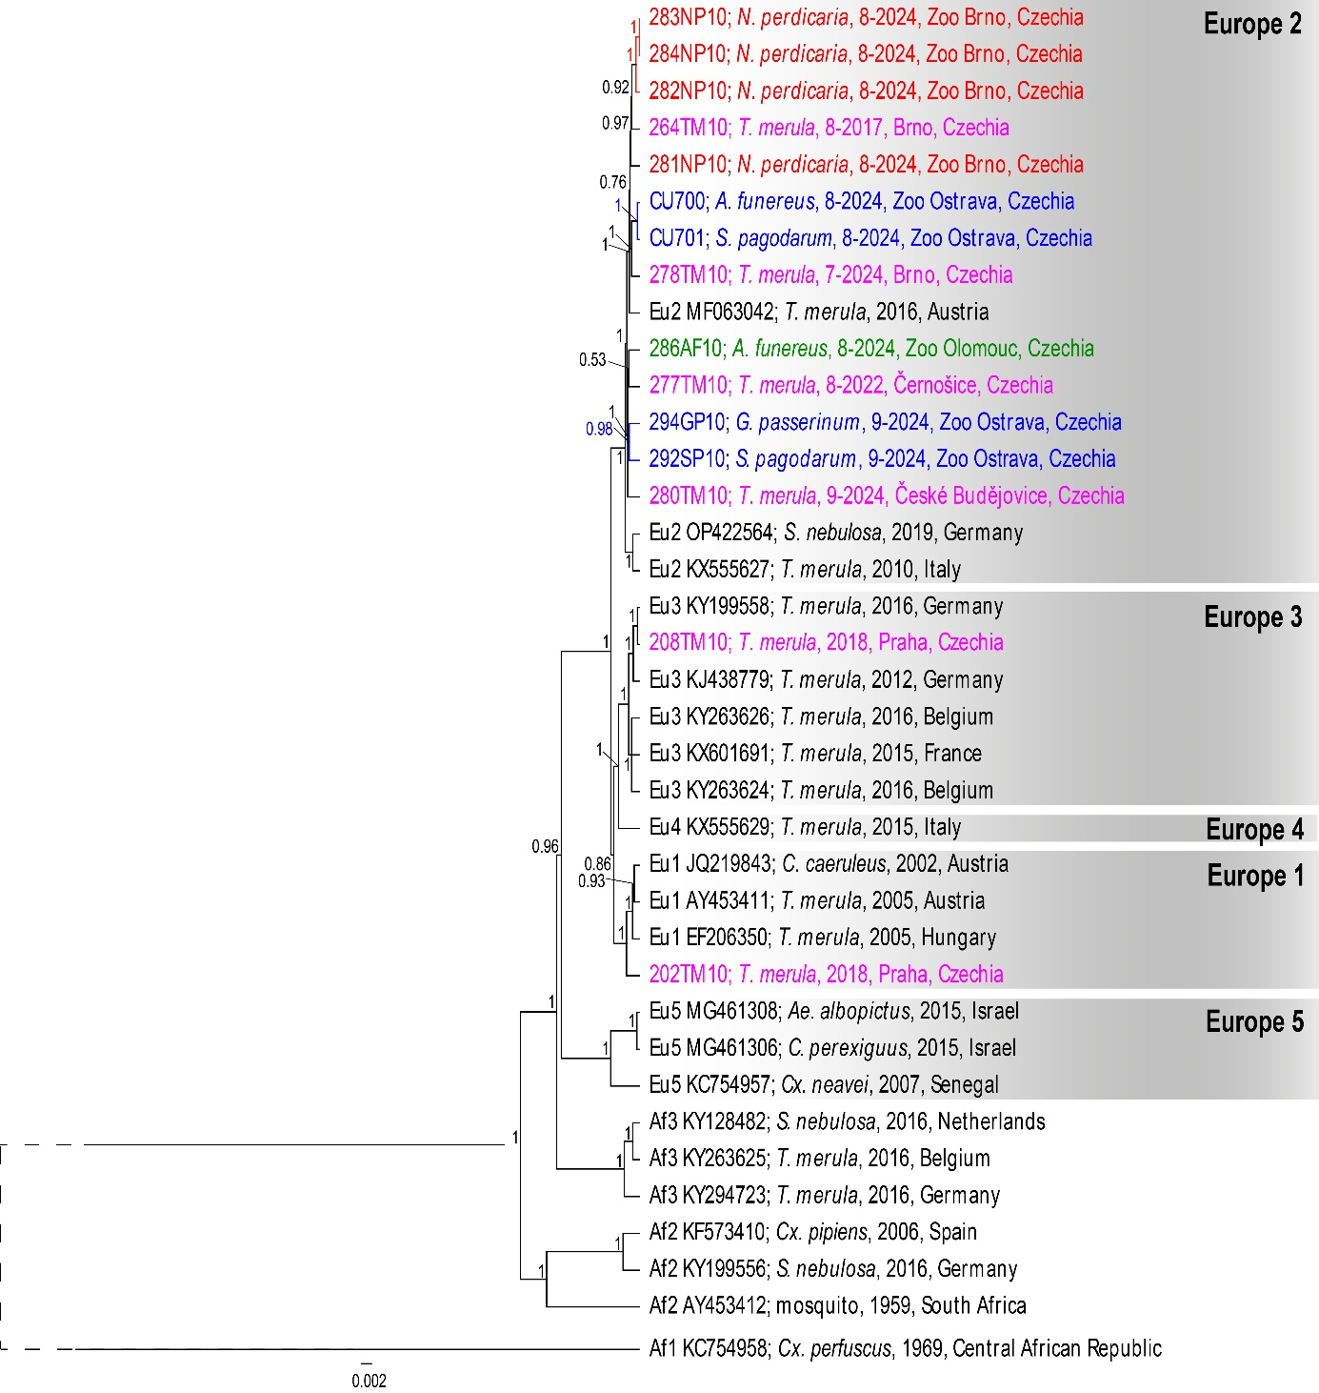
Supplementary Figure 1: Bayesian inference phylogenetic trees based on nearly whole genome (10,936 nt) nucleotide sequences of Usutu virus. Sequences obtained in this study are indicated by colour (red –Brno Zoo; blue–Ostrava Zoo; green –Olomouc Zoo; violet – free-living birds), sequences downloaded from the GenBank database are in black. Tip labels include GenBank accession number/sample code, locality, date and host species. Bootstrap supports are shown only for nodes with value <0.5.

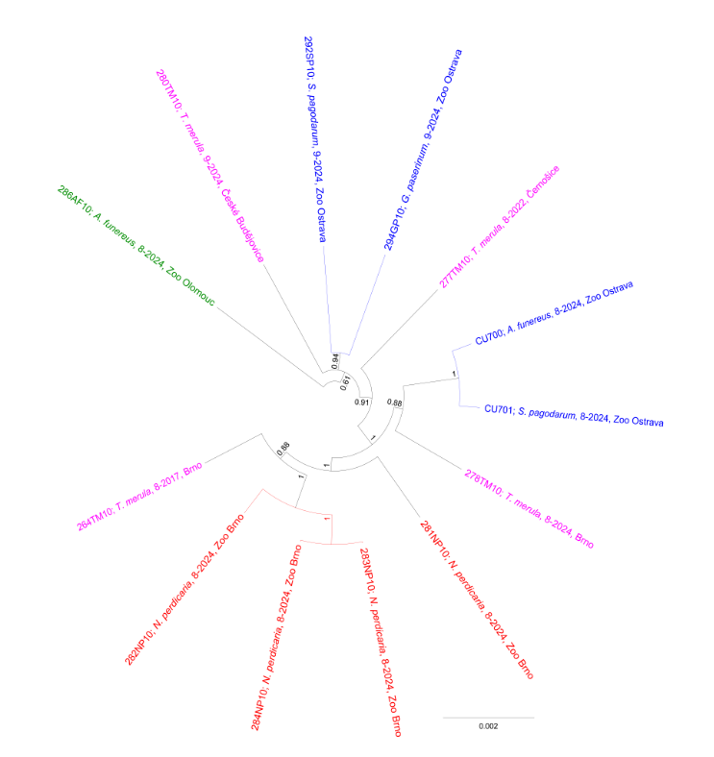Supplementary Figure 2. Unrooted Bayesian inference phylogenetic based on nearly whole genome nucleotide sequences of Usutu virus sequences from this study; red –Brno Zoo; blue –Ostrava Zoo; green –Olomouc Zoo; violet – free-living birds). Bootstrap supports are shown only for nodes with value <50.

