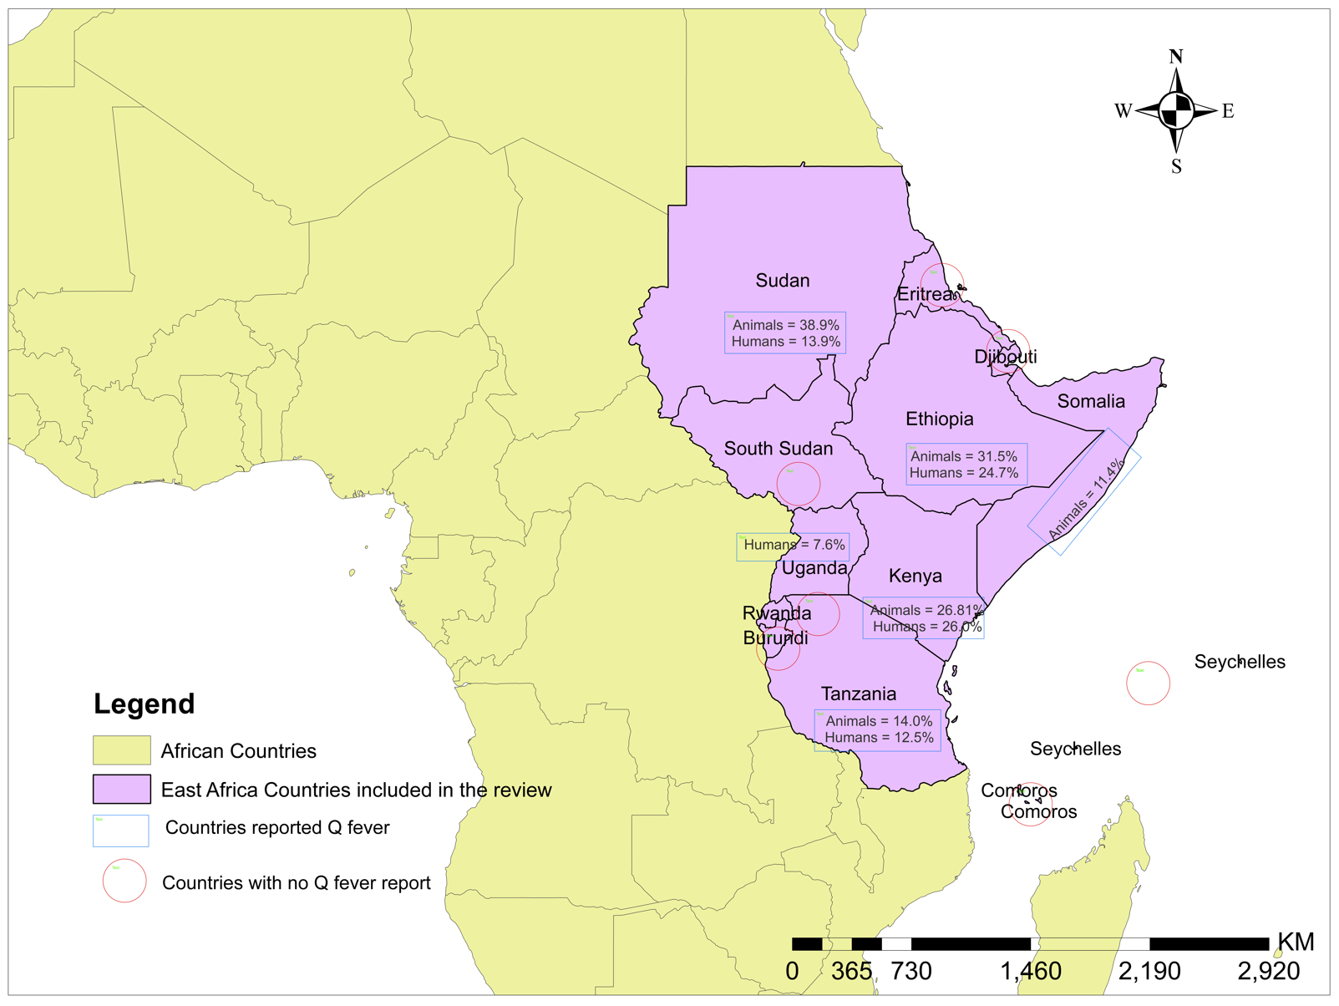
Fig. S1. The countries of East Africa with and without Q fever reports

Fig. S2. Forest plot showing Q fever seroprevalence in animals
Fig. S3. Forest plot showing subgroup analysis of Q fever seroprevalence by animal species
Fig. S4. Forest plot showing subgroup analysis of Q fever seroprevalence in animals by country.
Fig. S5. Forest plot showing subgroup analysis of Q fever seroprevalence in animals by detection method.
Fig. S6. Forest plot showing subgroup analysis of Q fever seroprevalence in animals by study period
Fig. S7. Forest plot showing subgroup analysis of Q fever seroprevalence in animals by sample size category

Fig. S8. Forest plot showing Q fever seroprevalence in humans.
Fig. S9. Forest plot showing subgroup Q fever seroprevalence in humans by detection methods.

Fig. S10. Forest plot showing subgroup Q fever seroprevalence in humans by sample size category.
Fig. S11. Forest plot of Q fever seroprevalence in humans with subgroup study period.

Fig. S12. Trim and fill analysis (Duval and Tweedie’s method) of Q fever seroprevalence studies in animals.
Fig. S13. Trim and fill analysis (Duval and Tweedie’s method) of Q fever seroprevalence studies in humans.

Fig. S14. Baujat diagnostic plot showing influential studies to the overall Q fever seroprevalence and heterogeneity in animals.

Fig. S15. Baujat diagnostic plot showing influential studies to the overall Q fever seroprevalence and heterogeneity in humans.

