Supplemental Information:
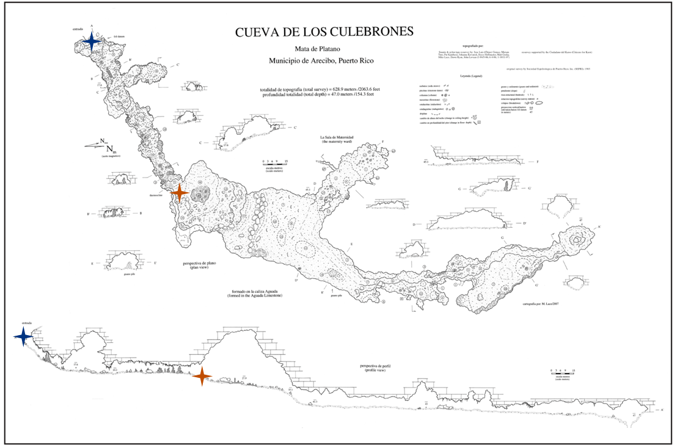
Supplemental Figure 1: Map of Cueva de los Culebrones (Culebrones Cave), Mata de Plátano Natural Reserve, Puerto Rico. This cave was first surveyed by La Sociedad Espeleológica de Puerto Rico (SEPRI) and resurveyed by Ciudadanos del Karso (CDK) and is published here with their permission. The blue star corresponds to the air sampling done at the cave entrance and the orange star corresponds to the air sampling done inside the cave.
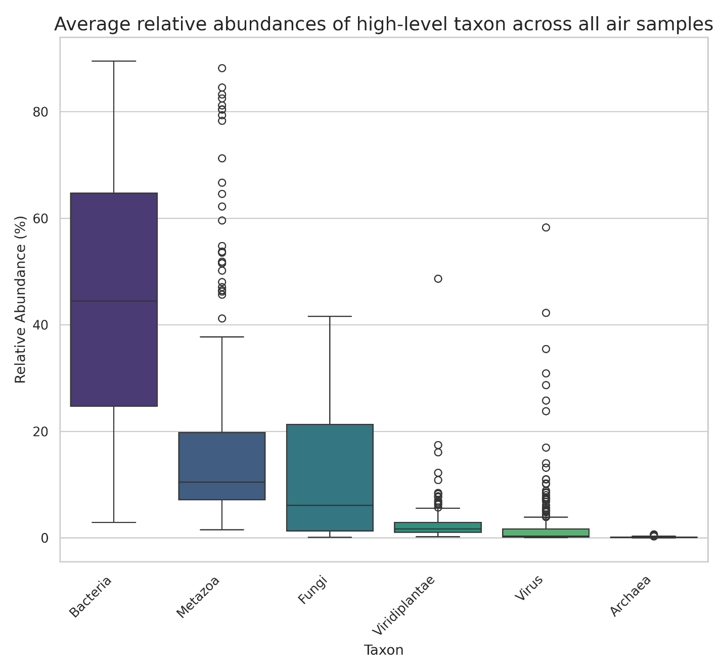
Supplemental Figure 2: High-taxon classification by Kraken2 shows the relative abundance of select domains and kingdoms across all air samples.

