The Following Supplementary accompanies the manuscript
Parrotfish predation drives distinct microbial communities in reef-building corals
Leïla Ezzat^{1*}, Thomas Lamy¹, Rebecca L. Maher², Katrina S. Munsterman¹, Kaitlyn M. Landfield¹, Emily R. Schmeltzer², Cody S. Clements³, Rebecca Vega Thurber² and Deron E. Burkepile^{1,4}

¹Department of Ecology, Evolution and Marine Biology, University of California Santa Barbara, Santa Barbara, CA 93106, USA
²Department of Microbiology, Oregon State University, Corvallis, OR, USA
³School of Biological Sciences and Aquatic Chemical Ecology Center, Georgia Institute of Technology, Atlanta, GA, USA
⁴Marine Science Institute, University of California Santa Barbara, Santa Barbara, CA, USA
*corresponding author: leila.ezzat@gmail.com

Figure S1. Relative abundance (Phyla) of taxa present in mechanically wounded, predated corals and fish mouths for the manipulative experiment at T48h.

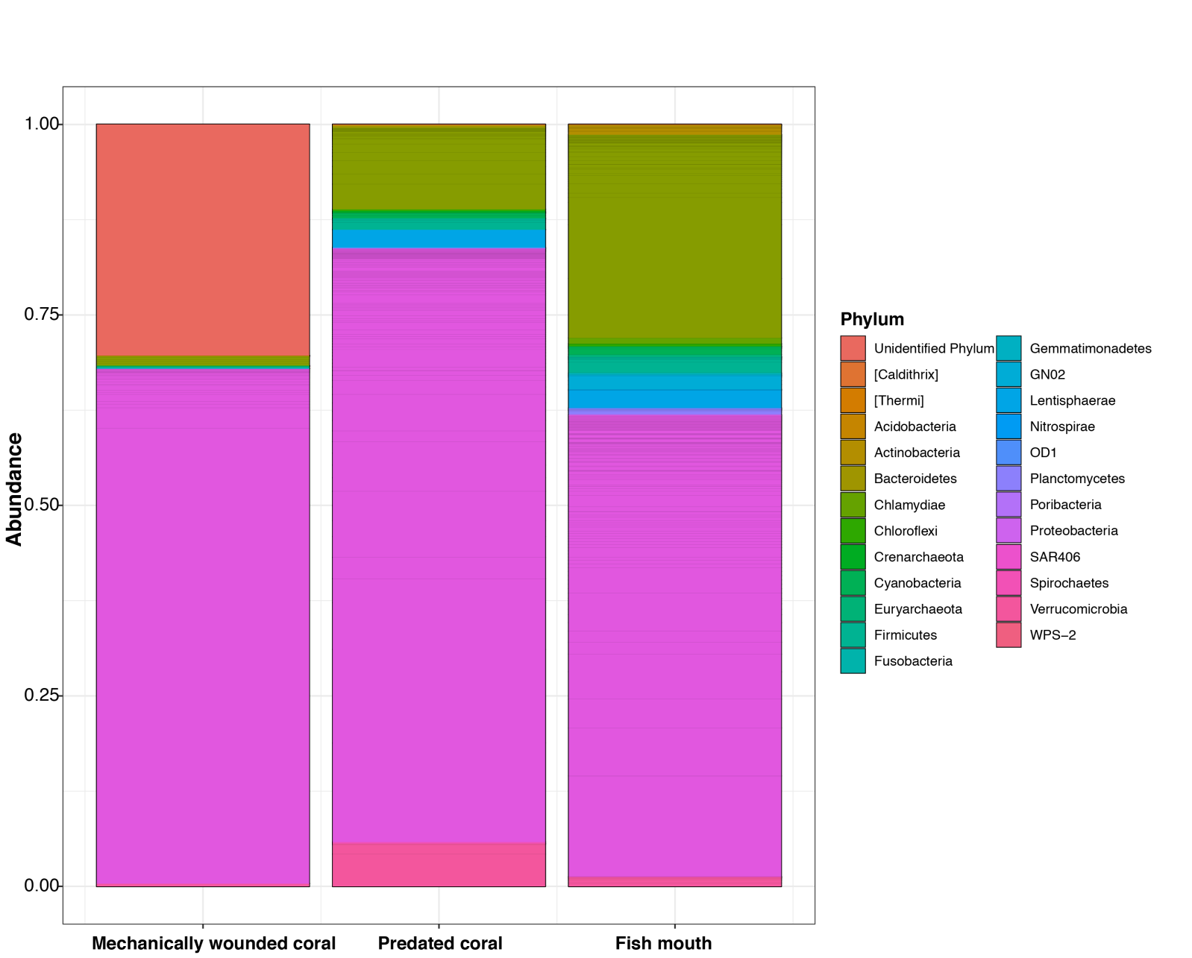
Figure S2. Relative abundance (Phyla) of taxa present in unbitten, bitten corals and fish mouths in the field.
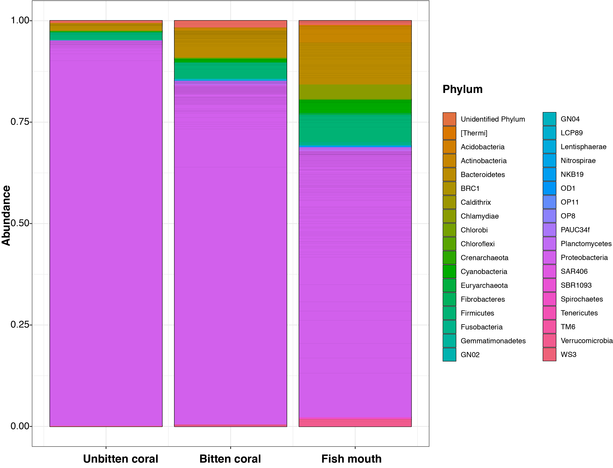
Figure S3. NMDS displaying the microbial assemblages according to the sample type at T48h for the mesocosm experiment

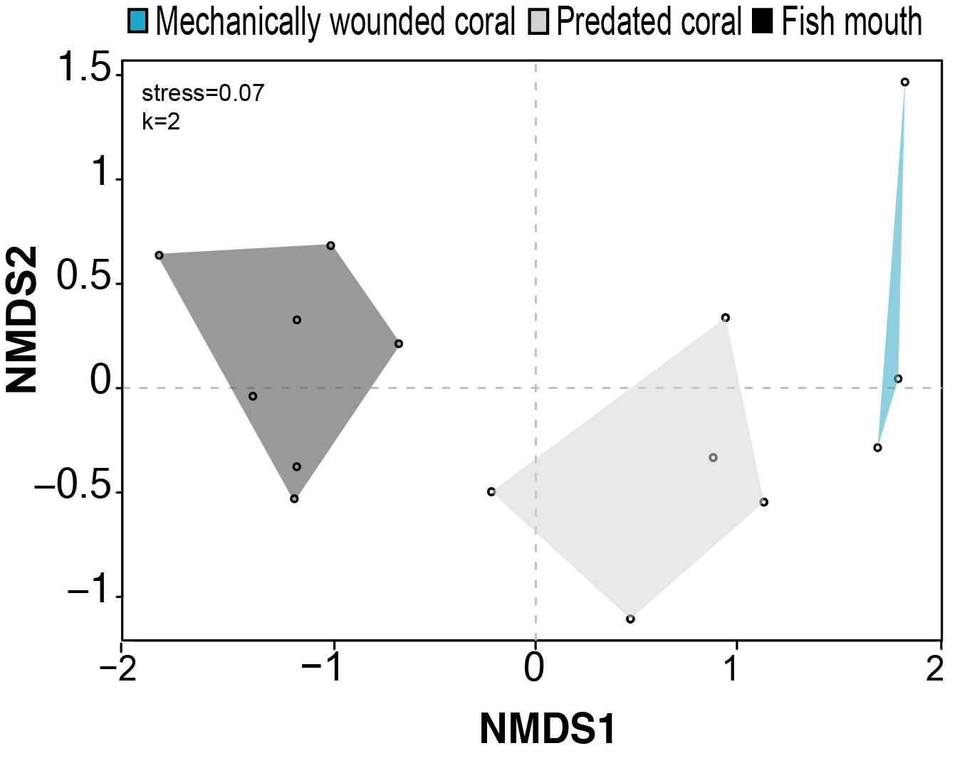

Figure S4. NMDS displaying the microbial assemblages according to the sample type for the field experiment.

